**Introduction**

**License Plate Recognition Project**

**Image Processing**

**TI2716-B**

**TU Delft**

Nikki Bouman

4597648

Issa Hanou

4574591

*Prototype 1*

*12-1-18*

We use a Sobel operator to get the license plate out of the background. We then use dilation and erosion and the difference of those to get only the edges in the license plate.

To show an example, if we take in this photo:

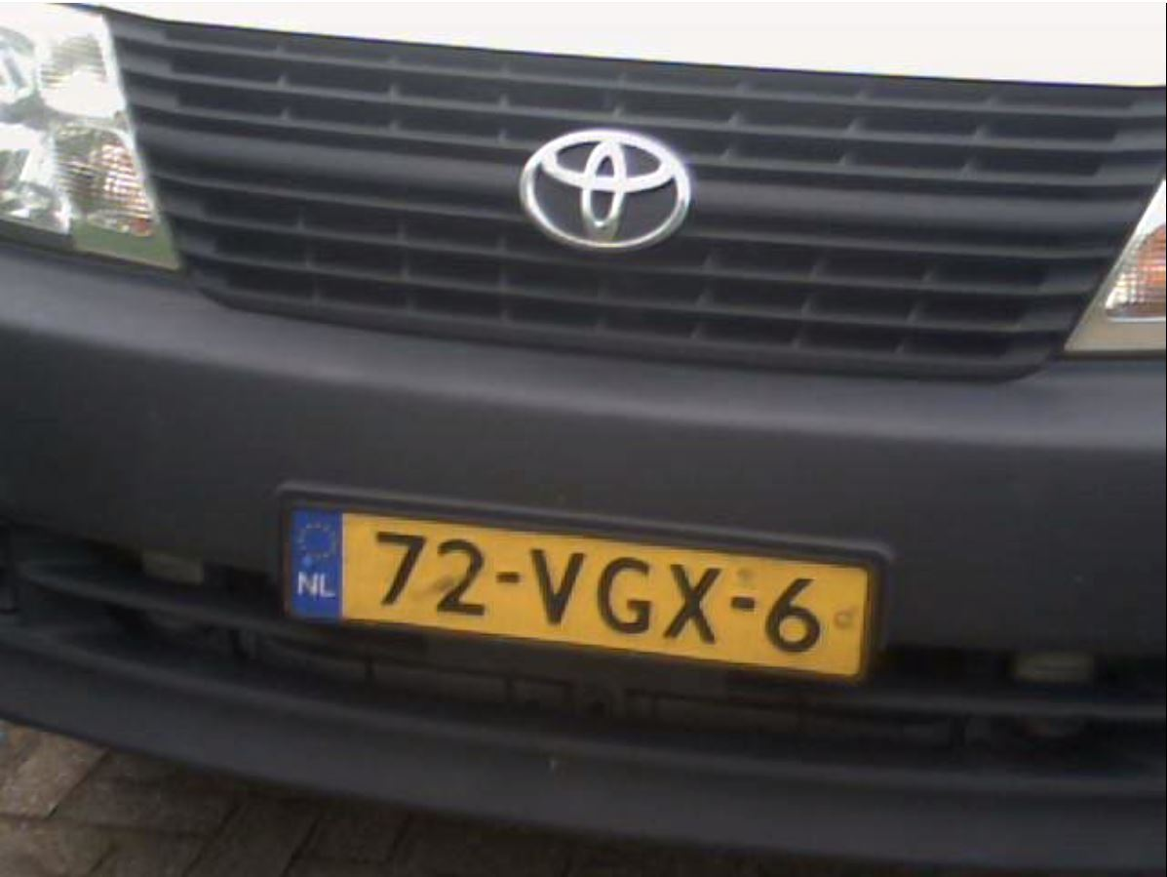

This is the result we get:

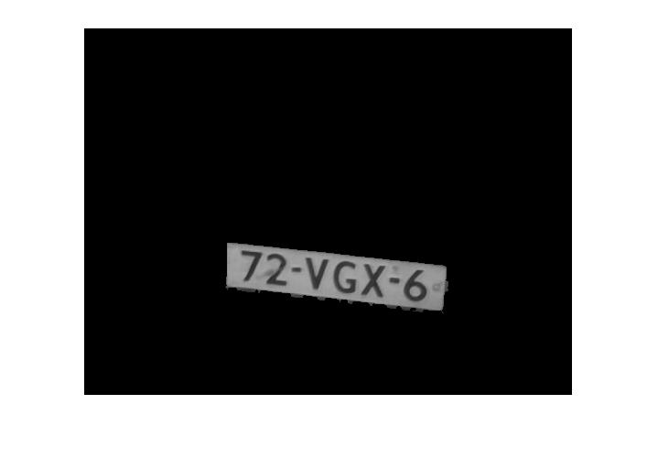

We created a GUI with two buttons: Load video, which will load the video into ‘axes1’, and a button Start Processing, which will start the video and start recognizing plates. There is also a table in which the results will be printed.

We have not yet created the functionality for this since we first wanted to focus on the actual recognition coding first.

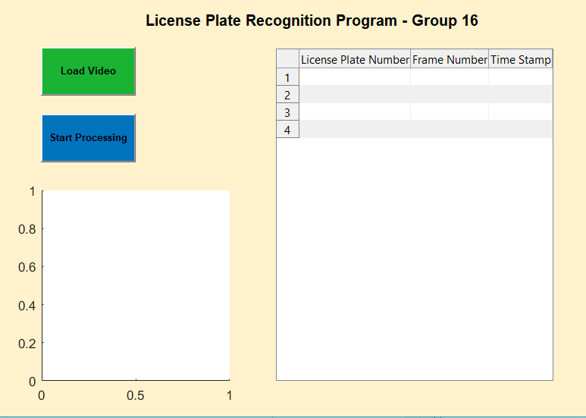

We did not get far with the recognition for now. We have tried some different methods with bounding boxes and labelling, but so far that did not work the way we wanted, so we will continue this next week.

**Recognition**

**Segmentation**

We started the project this week and focused mainly on getting some segmentation and recognition to work.

**GUI**