**Segmentation**

**License Plate Recognition Project**

**Image Processing, TI2716-B, TU Delft**

**Nikki Bouman – 4597648**

**Issa Hanou – 4574591**

**Prototype 1 - 12-1-18**

We continued with the segmentation from last week, we tried a lot of different techniques this week to get the letters from the plate image. Finally we used some gray scale thresholding to get only the letters in small boxes from the image, however we were not yet able to narrow this down to one threshold for all pictures:

We got this plate out and these are two of the letters we got out:

**GUI**

During the second week we continued with improving our segmentation and started with getting the GUI to work.

**Introduction**

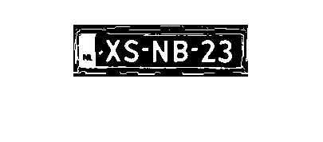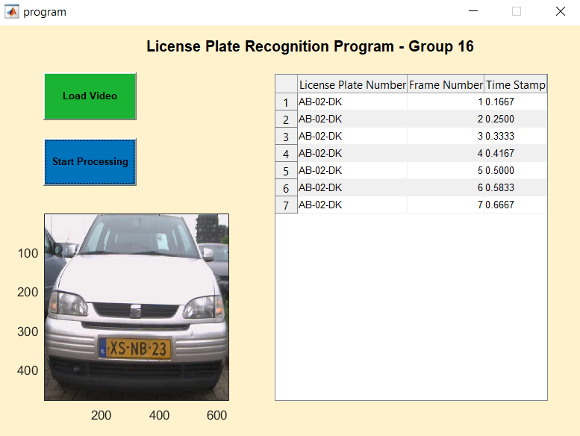

**Recognition**

We now have a GUI that will load the video and display the License Plate, Frame Number and Time Stamp in table once processing has started. The license plate is not yet gathered from the video as we have not yet completed the function, though we can easily start using the real video data.

The timestamp doesn’t work correctly just yet and the video only shows frames but this should be easy to fix and we will do this next week.

On the right you can see the result of a test run with only one string as example for the license plate: