Issac Vilchis

Data Science Bootcamp

October 2, 2019

WeatherPy

In the WeatherPy assignment in Pandas, certain types of information were required to find the results. Before getting the data, the api for the weather and the list of cities had to be generated. Api calls were then performed to get the location, or city, cloudiness, country, date, humidity, latitudes, longitudes, max temperature, and wind speed. After getting the data for each city, the raw data was then inserted into a data frame. The final set of data to get was the plotting of the data as a scatterplot by comparing the latitude to the max temperature, humidity cloudiness, and wind speed.

When looking at the plot data, the temperature goes to the max when the latitude is around 20 degrees while the lowest of the temperature is when the latitude is at 60 degrees. The hottest temperature is closer to the equator while it is colder when the latitude is further away from it.

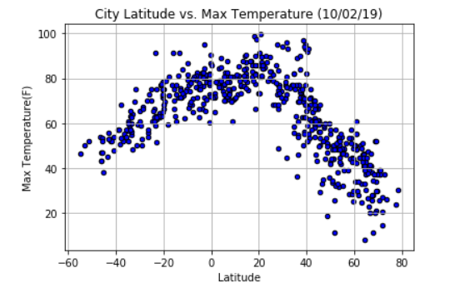

When comparing the latitude to the humidity, the max percentage is at 100% no matter where the latitude is. The lowest humidity is between (-40) - (-20) and 20-40 degrees of latitude.

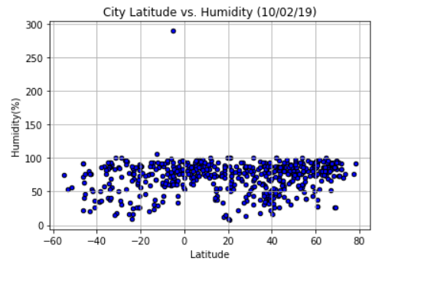

When the latitude is compared to the cloudiness, the plot of the data is too scattered to make an accurate fact. The most that can be said is that the there is more cloudiness when the latitude is at 0 degrees and higher.

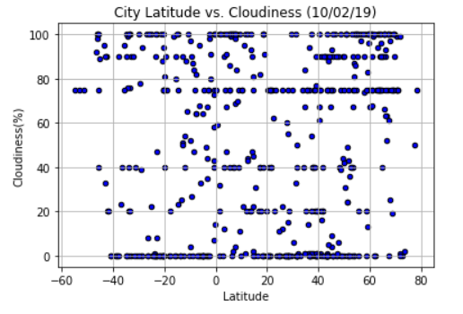

The final comparison for the latitude against the wind speed will present how much wind speed there is at the latitude sections. The closer the latitude is to the equator, the less wind there is. If the latitude is further, there is more wind speed.

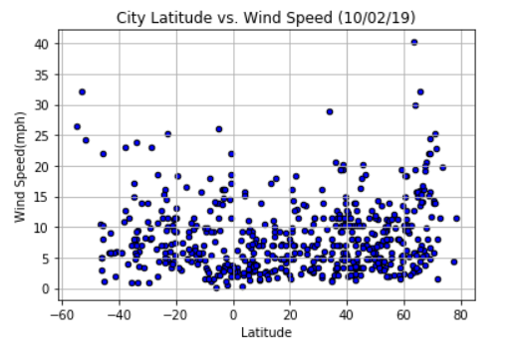

The conclusion of the data presents that fact that the max temperature, humidity, cloudiness, and wind speed are affected by where the location of the latitude is whether it would be closer or further from it. There can be a significant difference for the max temperature and wind speed and when they are closer or further away from the equator. For the humidity and cloudiness, there is not as much difference is there is when compared to the other parts of the data. What’s also important to note is that generate the api for the weather and generating the cities and the parts of the data for the cities are required to gather the necessary information. Otherwise, it would be difficult to gather the information as accurately as possible.