Group Project 1 Report

Martin Chen (bc3517)

Yuan Huang (yh2741)

Jingdan Zou (jz5898)

Sitong Zou (sz4548)

## 8) Perform an analysis of variance with your data.

* 1. Plot the data using scatterplot, Y axis-flying time, X axis-wing length, and indicate the overall mean and the group means. 3’’ (2½”, 2”, 1½”) ¼’’ ~2½ ”

The group means and overall mean are in the following table.

| wing_length | group mean | overall mean |
| --- | --- | --- |
| 1.5 | 3.398 | 3.842 |
| 2 | 3.900 | NA |
| 2.5 | 4.634 | NA |
| 3 | 3.439 | NA |

The dashed lines stands for the overall mean. The colored dots indicate the the mean flying time (y) for each wing length (x).

|  |
| --- |
|  |

* 1. Report the F test results. What percent of the variance is explained by wing length variation? Does the wing length make a difference in the flying time of a paper helicopter?
  + The percent of the variance explained by wing length variation is **75.73**.
  + If we set the significance level at .05, we can believe that wing length made a difference since the p-value of F Test is **9.351e-09**.

|  | Df | Sum Sq | Mean Sq | F value | Pr(>F) |
| --- | --- | --- | --- | --- | --- |
| wing_length | 3 | 7.923375 | 2.6411250 | 29.13053 | 0 |
| Residuals | 28 | 2.538625 | 0.0906652 | NA | NA |

* 1. Check the equal variance and normality assumptions with residual plots.
  + The equal variance and normality assumption was not violated in this model.

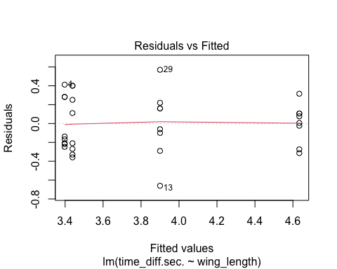

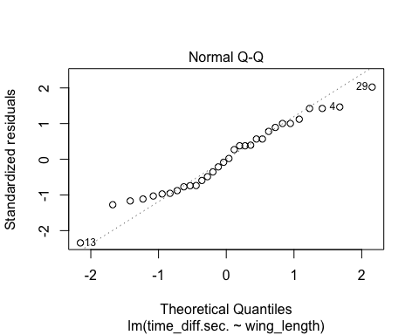

* 1. Test whether there is a significant linear or quadratic trend in flight times as the wing length increases using a polynomial contrast.
  + It seems there is an quadratic trend in flight times as the wing length increases. The p-value of quadratic trend is smaller than 0.05 (1.11e-08) while the p-value of linear trend is larger than 0.05 (0.0825).

Df Sum Sq Mean Sq F value Pr(>F)   
wing_length 3 7.923 2.641 29.131 9.35e-09 ***  
 wing_length: Linear 1 0.294 0.294 3.244 0.0825 .   
 wing_length: Quadratic 1 5.763 5.763 63.564 1.11e-08 ***  
Residuals 28 2.539 0.091   
---  
Signif. codes: 0 '***' 0.001 '**' 0.01 '*' 0.05 '.' 0.1 ' ' 1