Student Info table:

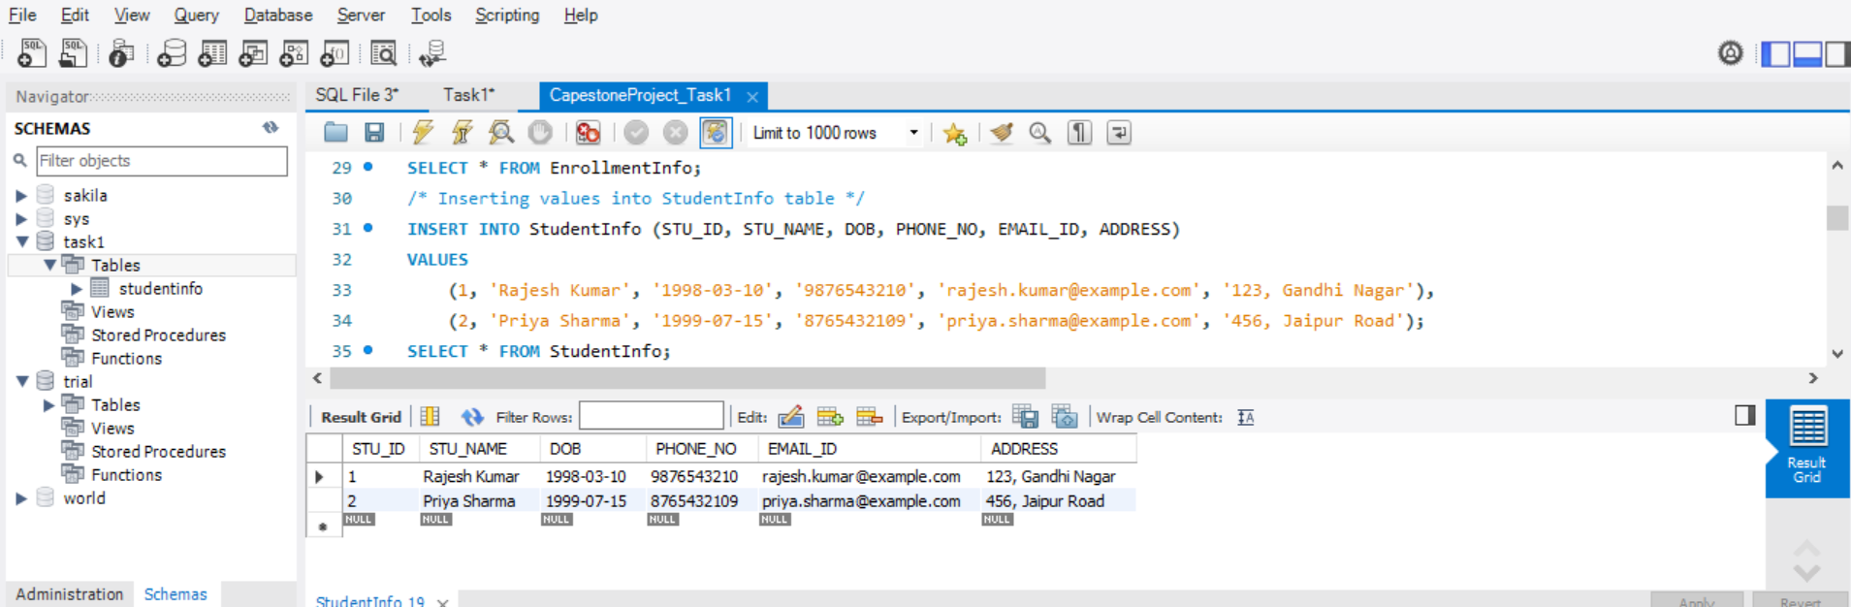

Courses Info Table:

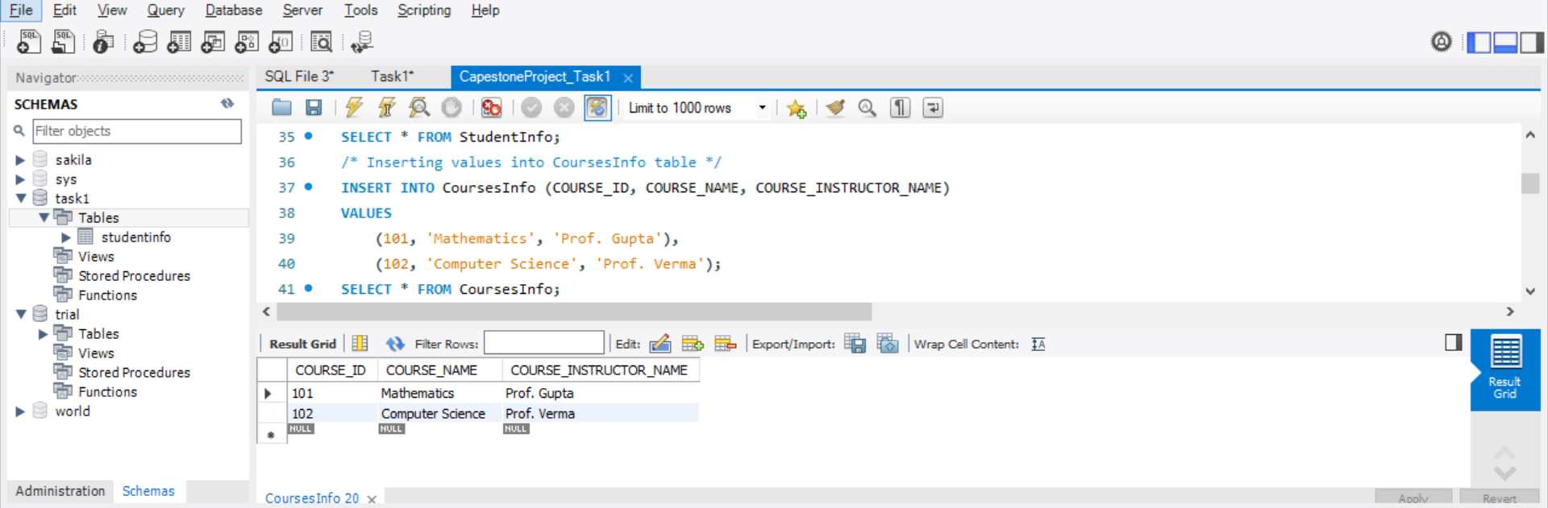

Enrollment Info Table:

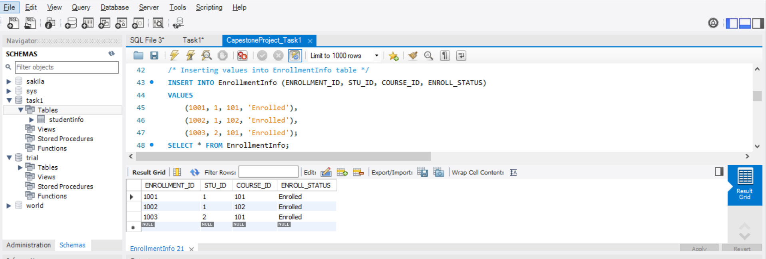

To retrieve student details, including their name, contact information, and enrollment status

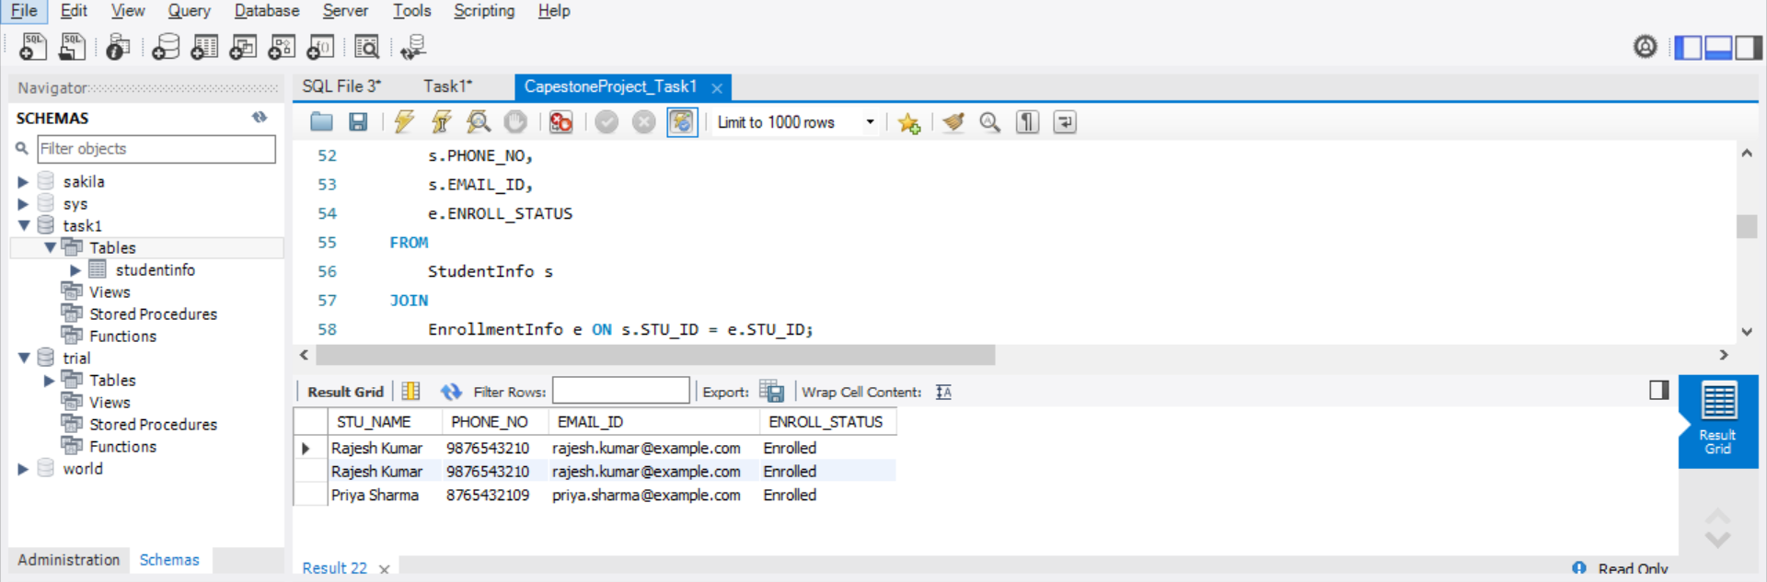

To retrieve a list of courses in which a specific student (with STU_ID = 1) is enrolled

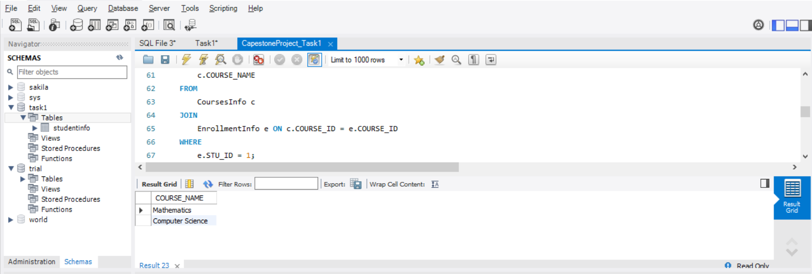

To retrieve course information, including course name and instructor details

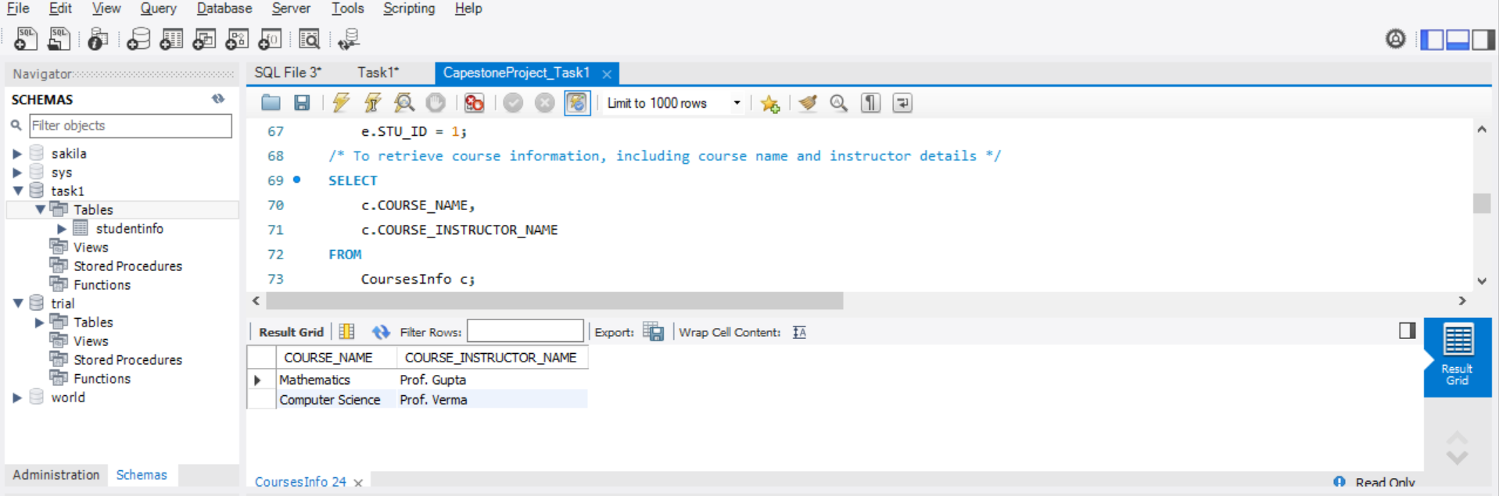

To retrieve course information for a specific course (with COURSE_ID = 101)

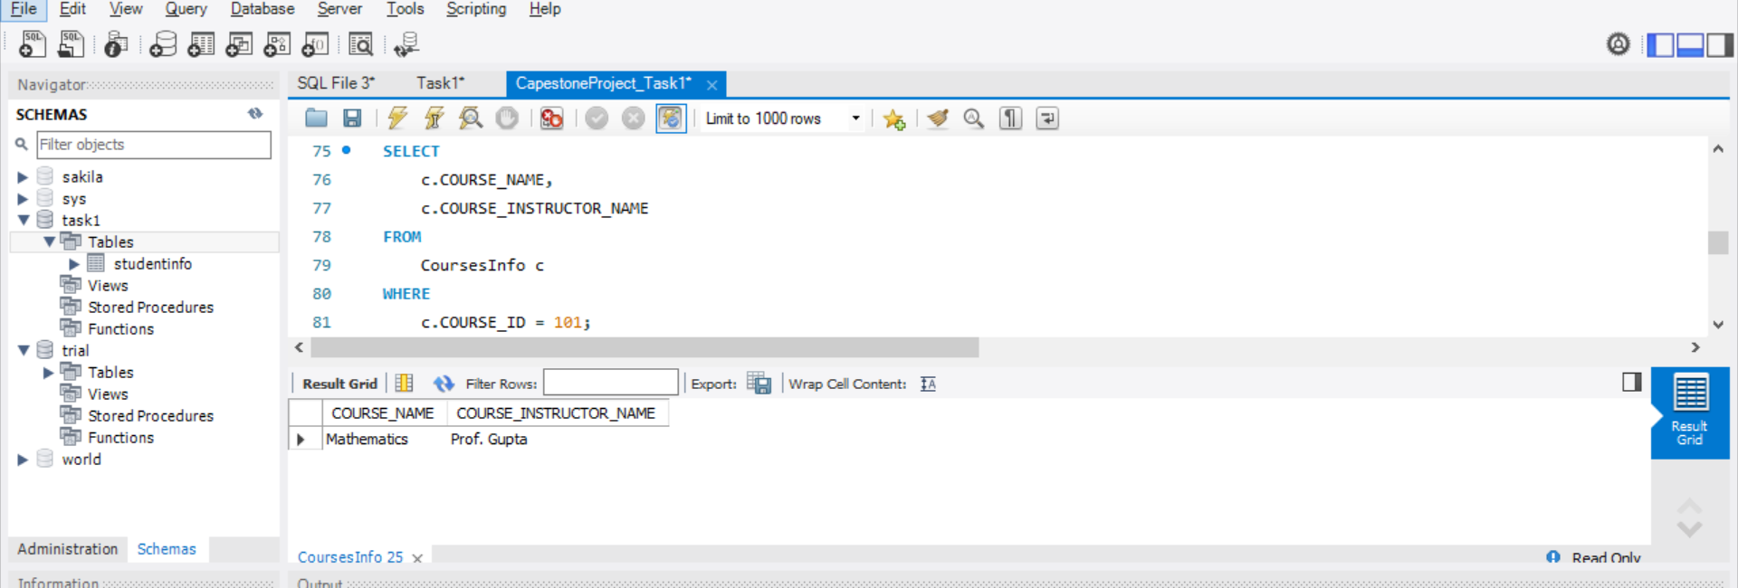

To retrieve information for specific courses (with course IDs 101, 102)

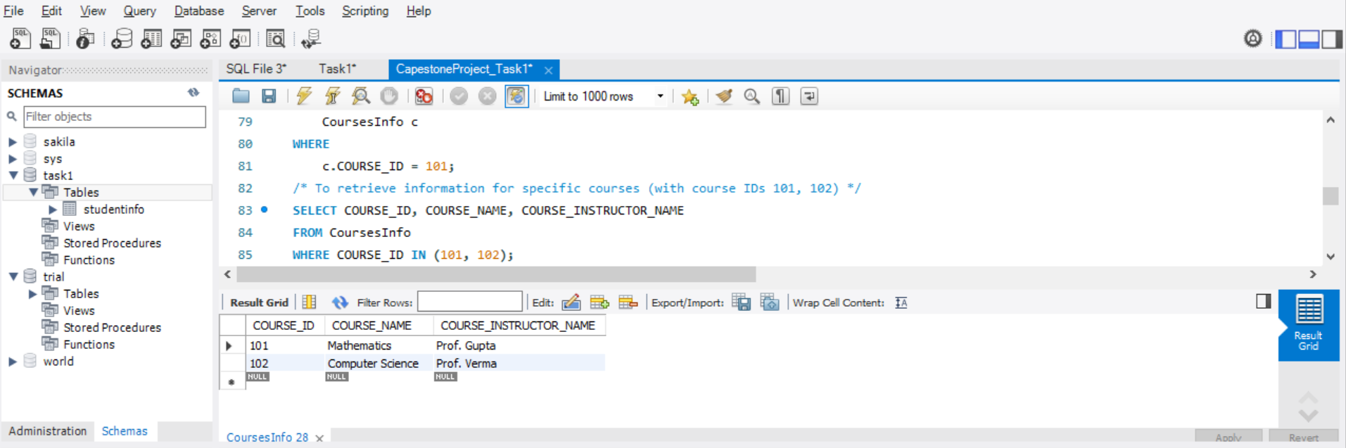

To retrieve the number of students enrolled in each course

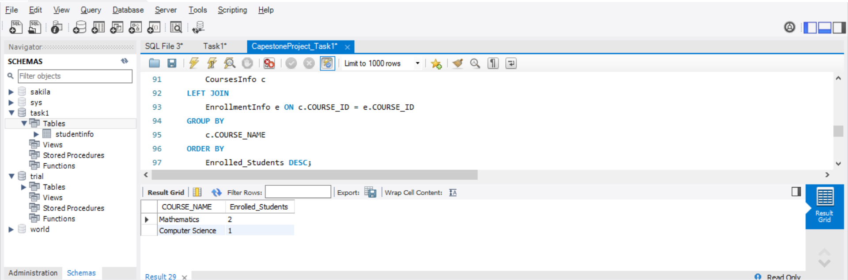

To retrieve the list of students enrolled in a specific course (with COURSE_ID = 101)

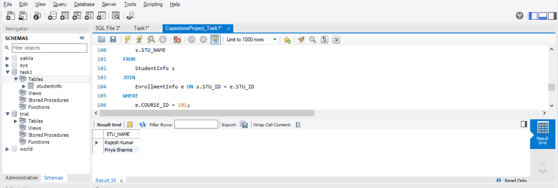

To retrieve the count of enrolled students for each instructor

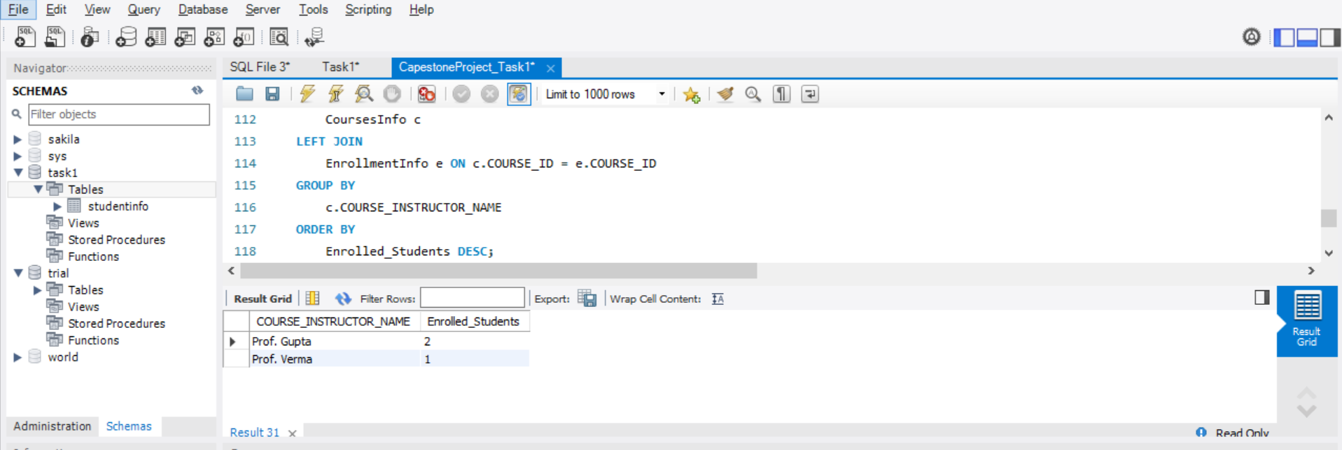

To retrieve the list of students who are enrolled in multiple courses

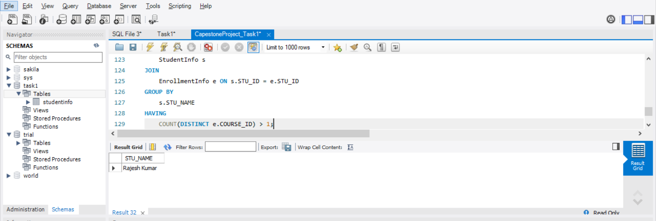

To retrieve the courses with the highest number of enrolled students (arranged from highest to lowest)

