1. **Database Setup**

Create a database named "student_database."

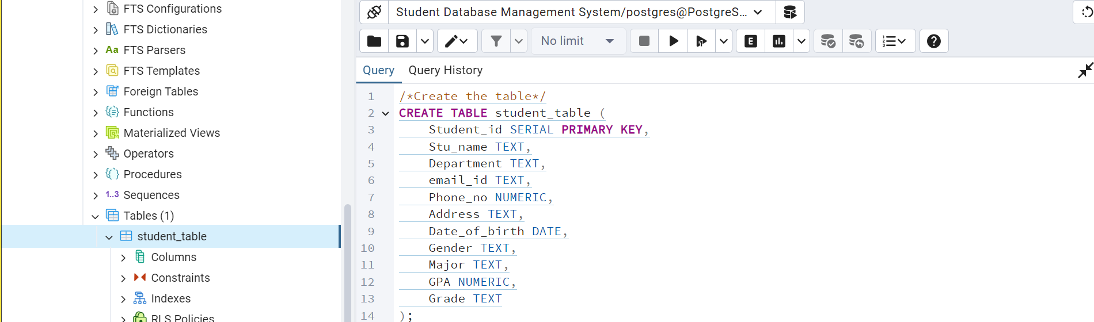

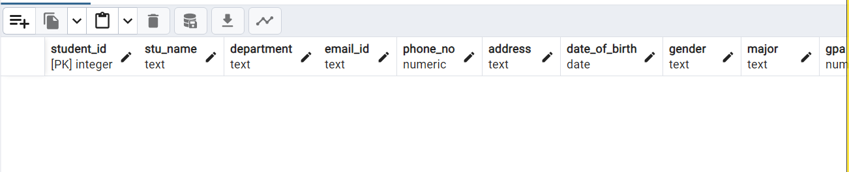

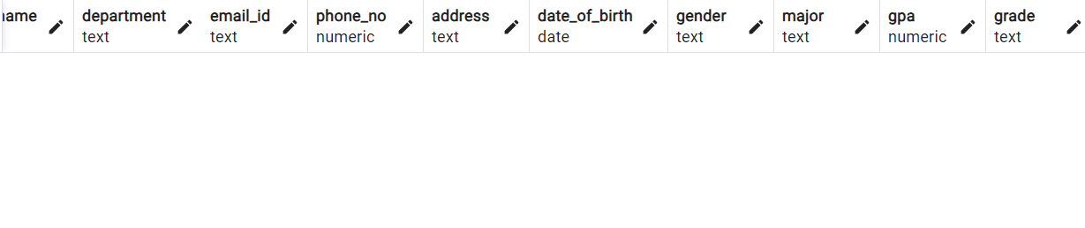

**2. Data Entry**

Insert 10 sample records into the "student_table" using INSERT command

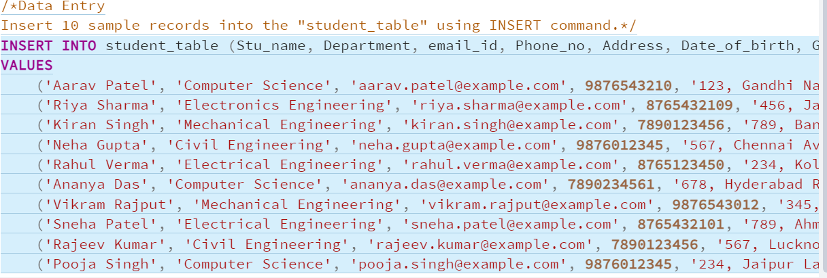

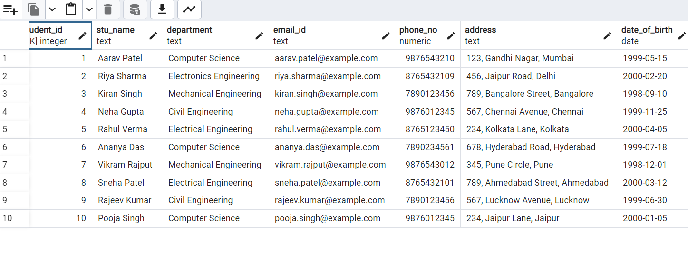

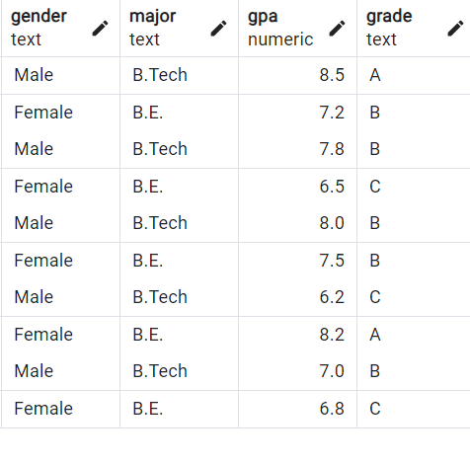

**3. Student Information Retrieval**

Develop a query to retrieve all students' information from the "student_table" and sort them in

descending order by their grade.

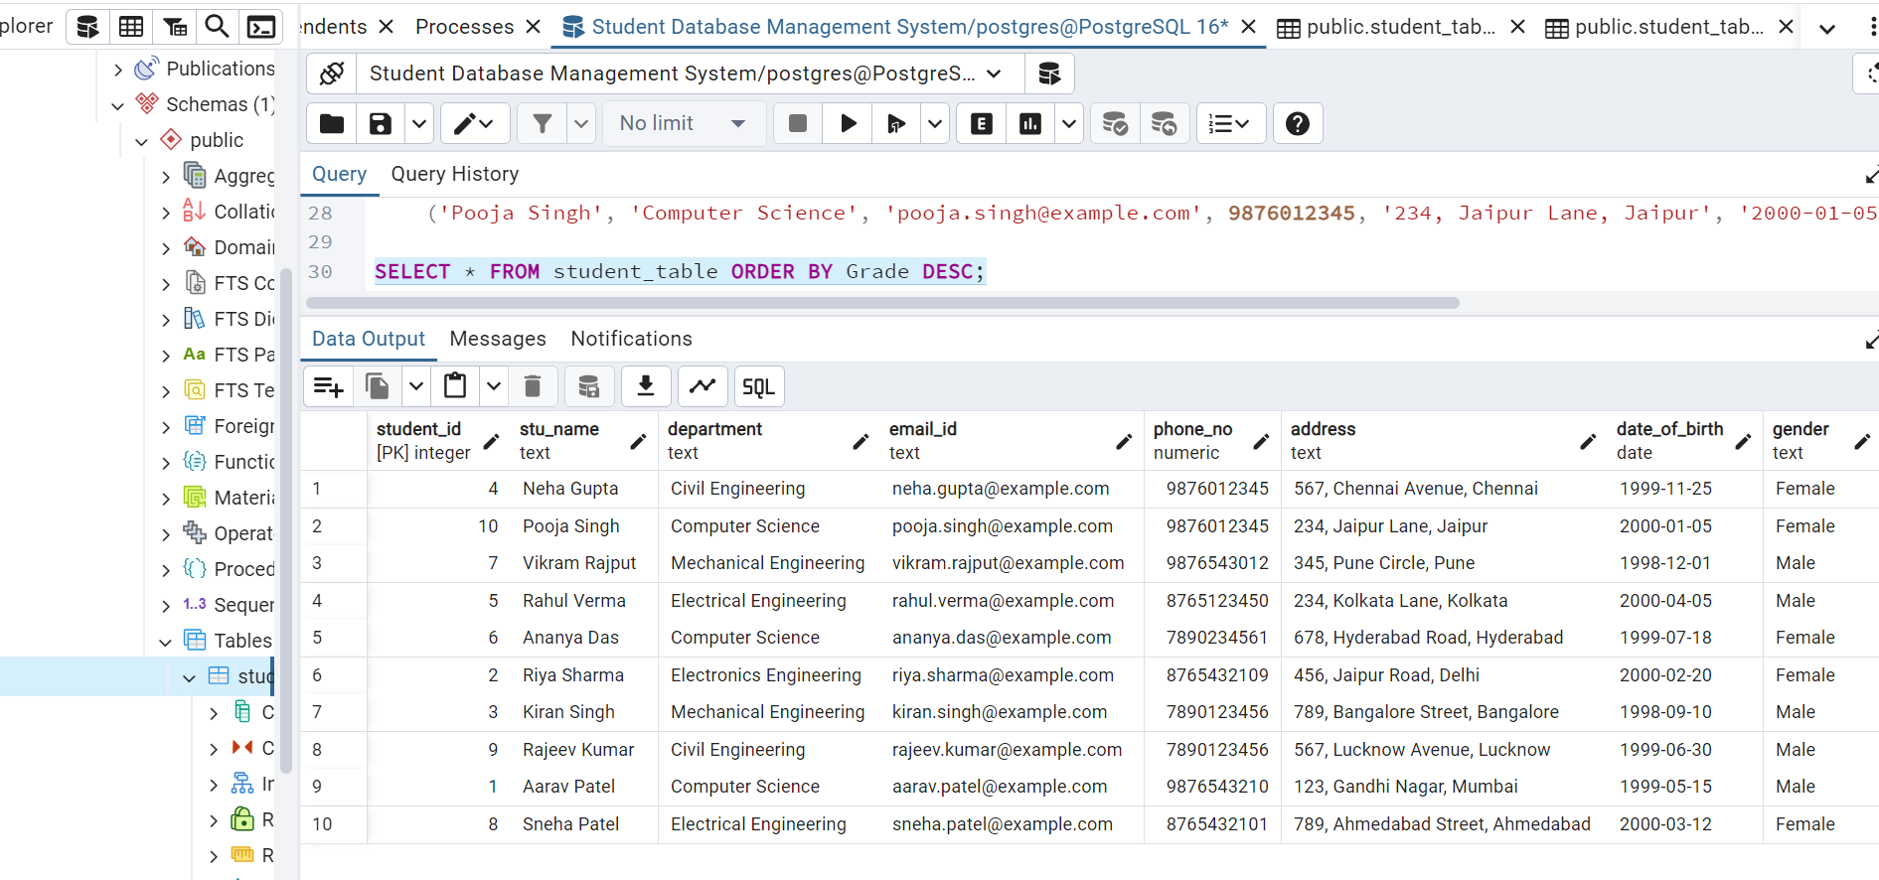

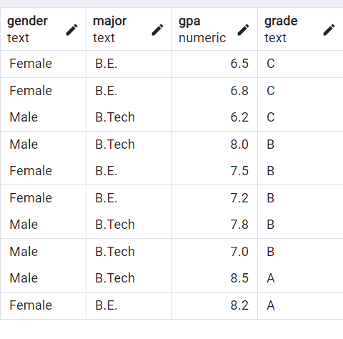

**4. Query for Male Students:**

.Implement a query to retrieve information about all male students from the "student_table."

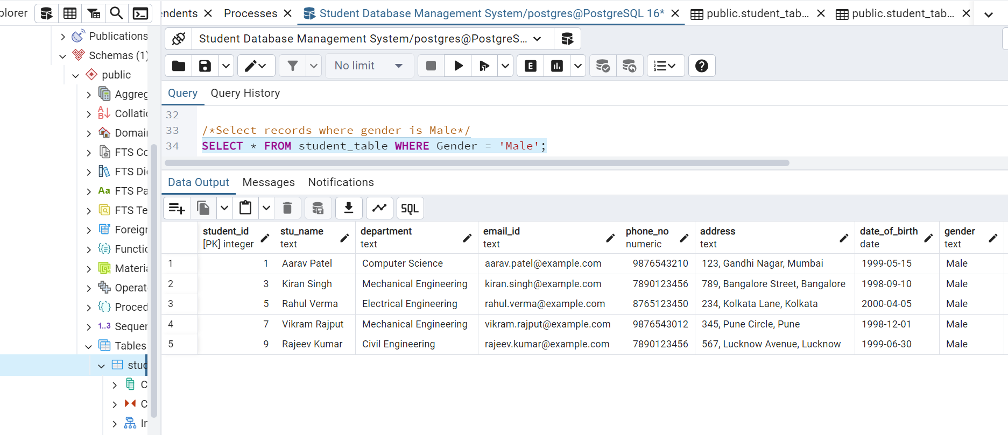

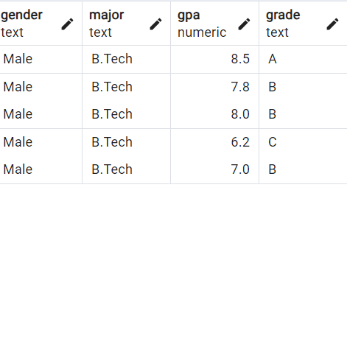

**Query for Students with GPA less than 5.0**

Create a query to fetch the details of students who have a GPA less than 5.0 from the

"student_table."

**Note**: Since no student is less that 5.0 GPA there is no output in the table.

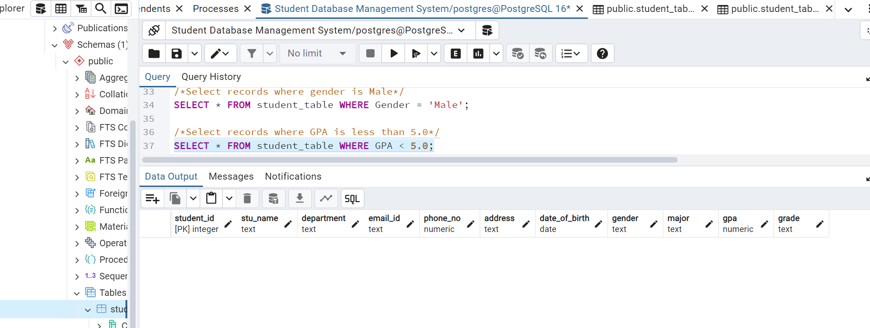

**6. Update Student Email and Grade**

Write an update statement to modify the email and grade of a student with a specific ID in the

"student_table."



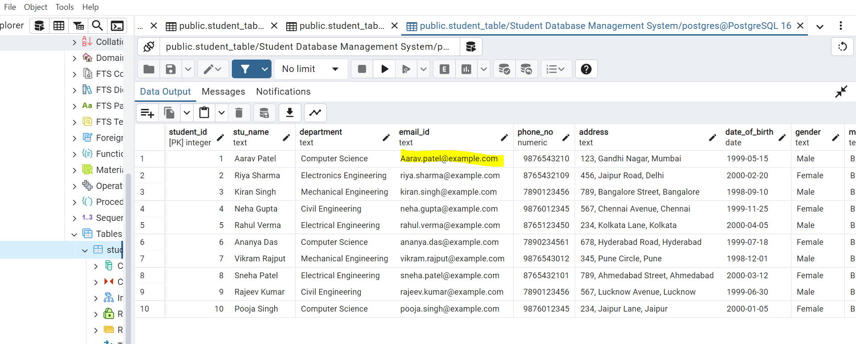

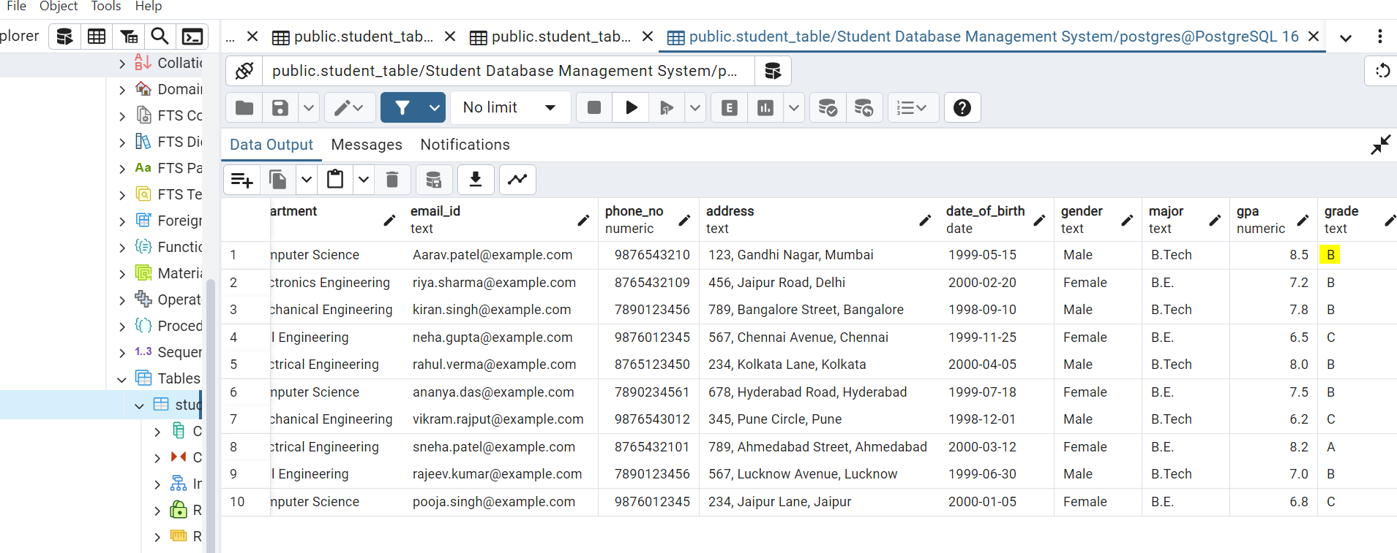

**7. Query for Students with Grade "B"**

Develop a query to retrieve the names and ages of all students who have a grade of "B" from

the "student_table."

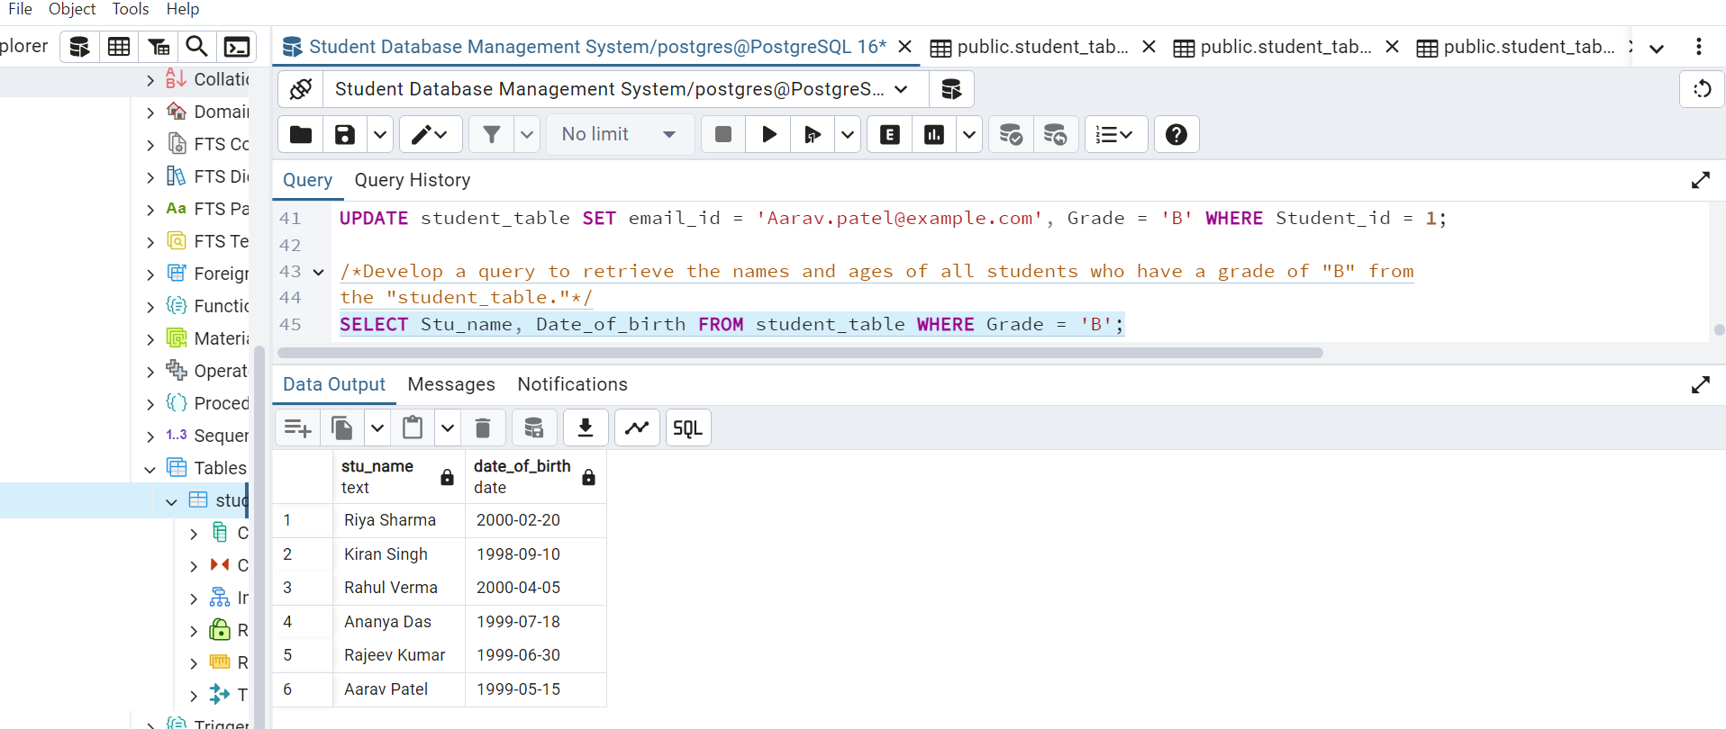

**8. Grouping and Calculation**

Create a query to group the "student_table" by the "Department" and "Gender" columns and

calculate the average GPA for each combination.

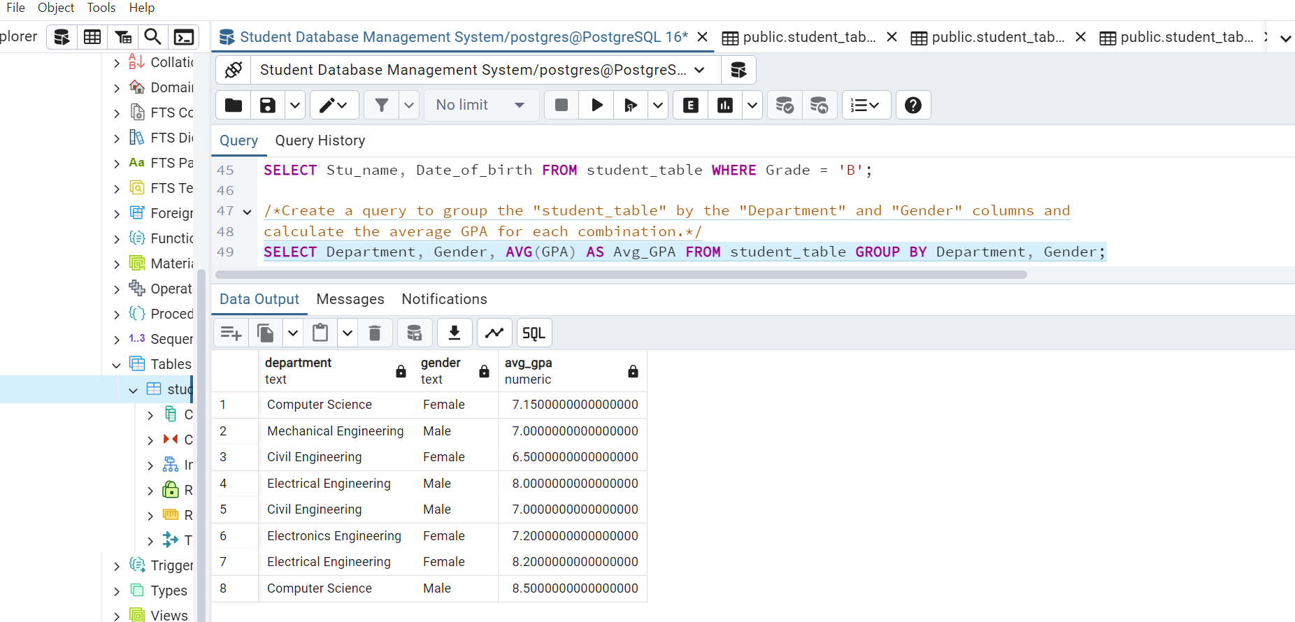

**9. Table Renaming**

Rename the "student_table" to "student_info" using the appropriate SQL statement.

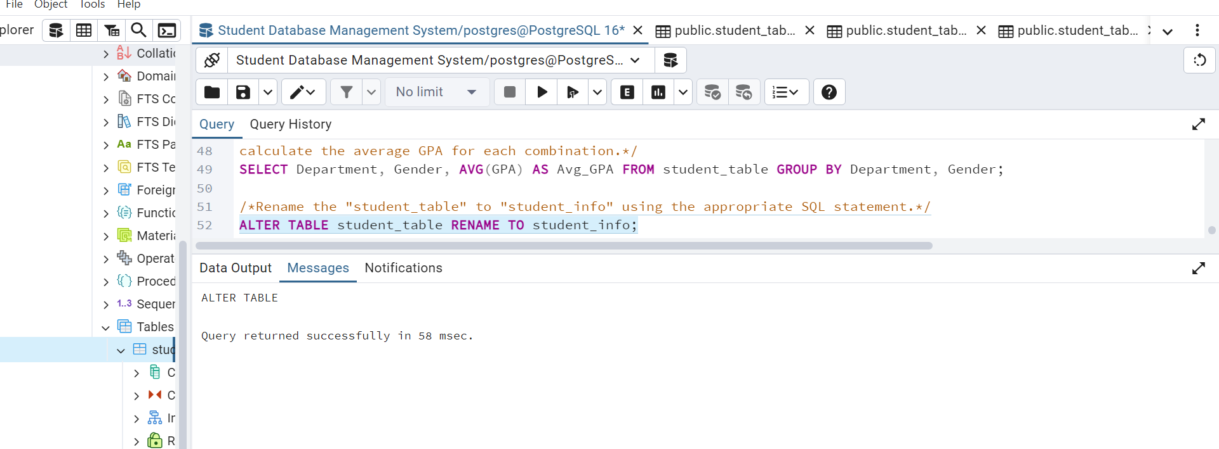

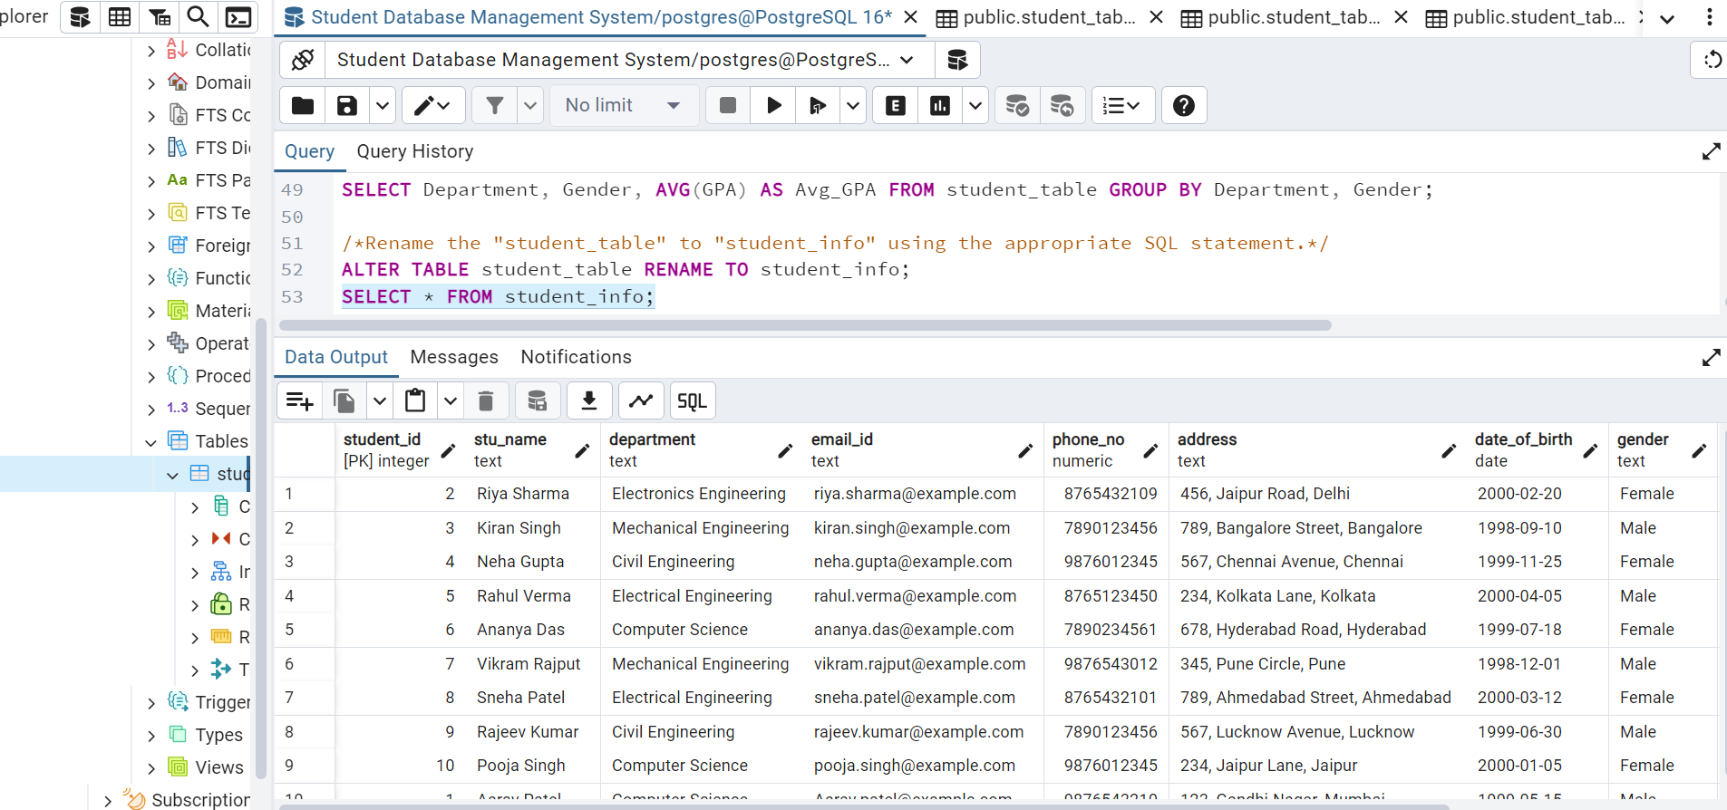

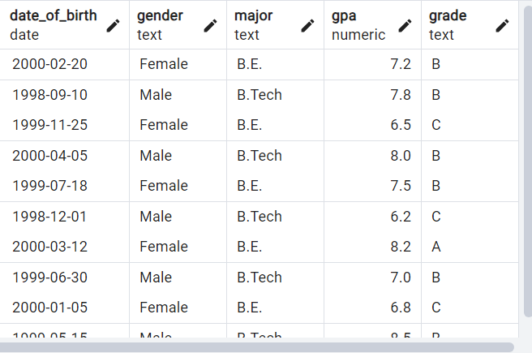

**10. Retrieve Student with Highest GPA**

Write a query to retrieve the name of the student with the highest GPA from the

"student_info" table.

