1. **Database Creation (PostgreSQL)**

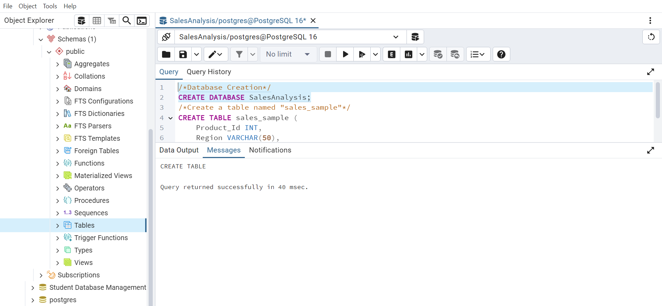

Create a table named "sales_sample" with the specified columns:

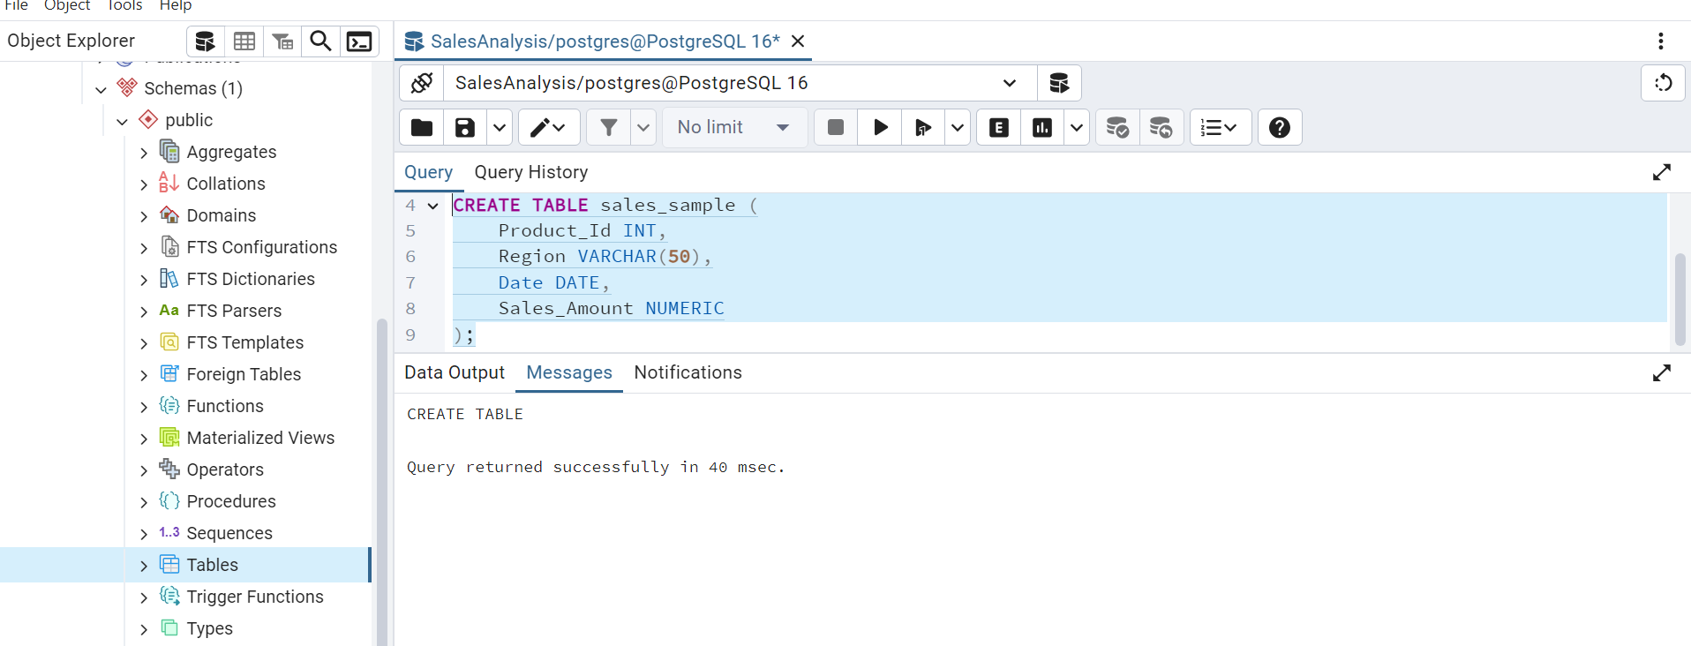

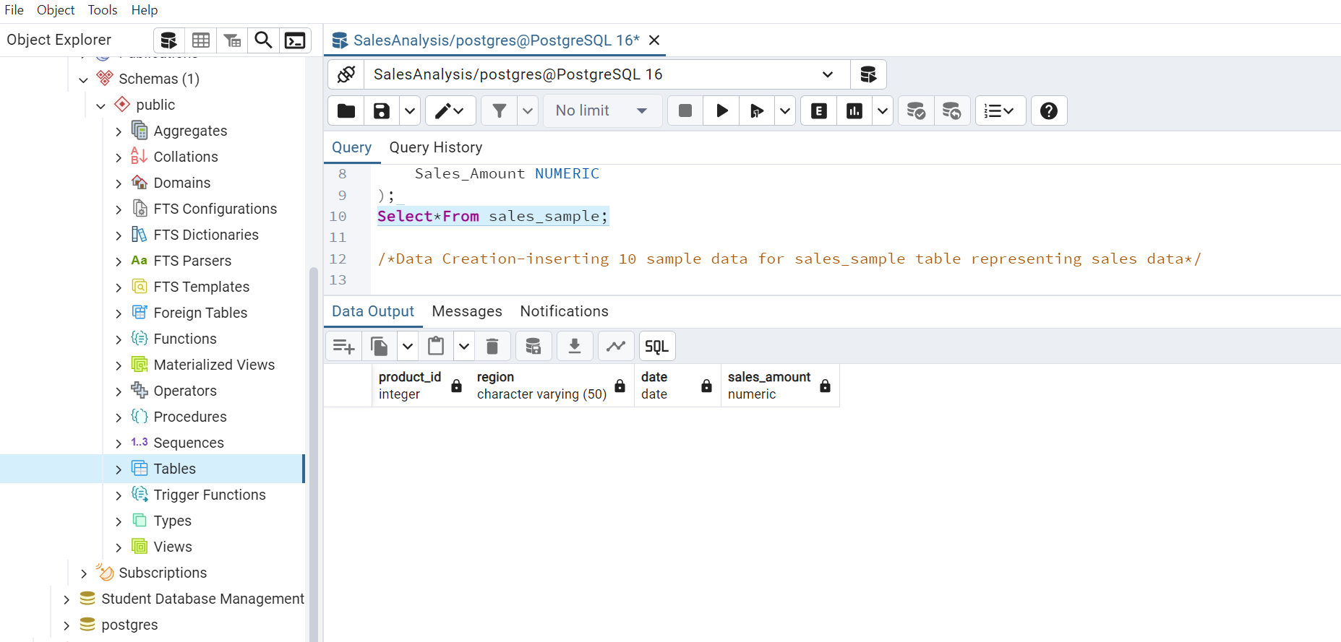

**Data Creation**

Insert 10 sample records into the "sales_sample" table, representing sales data.

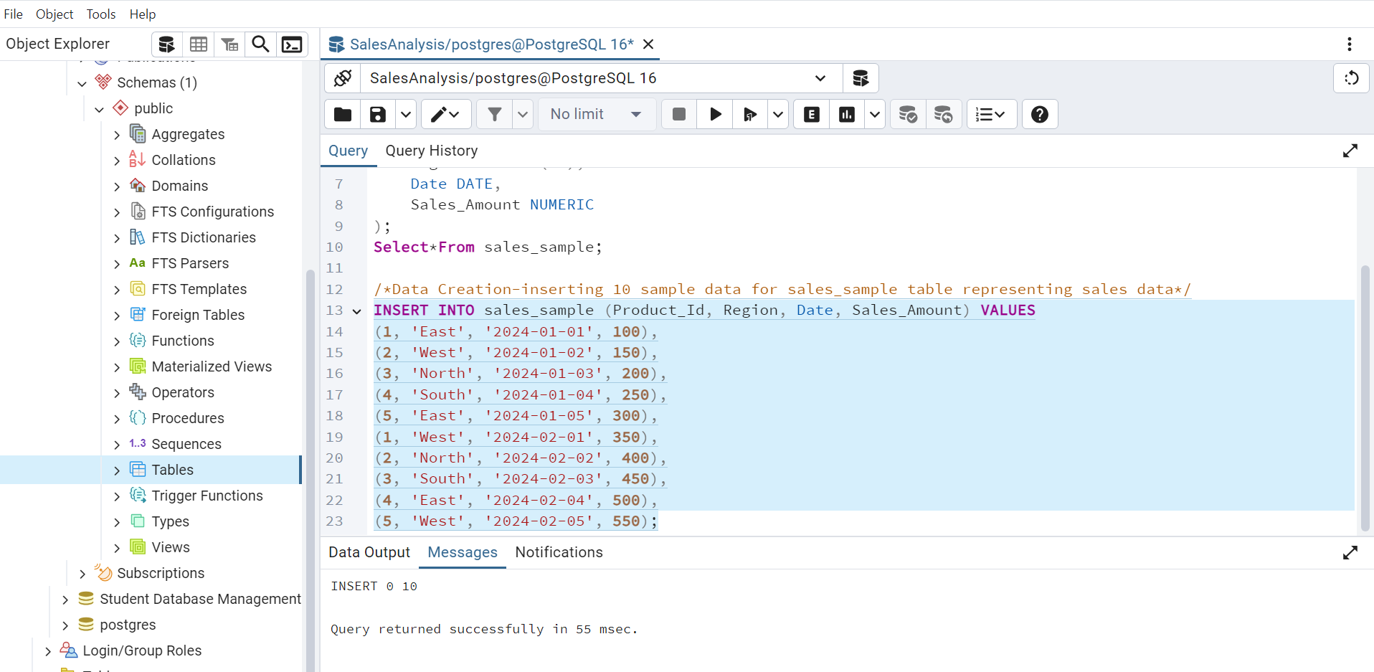

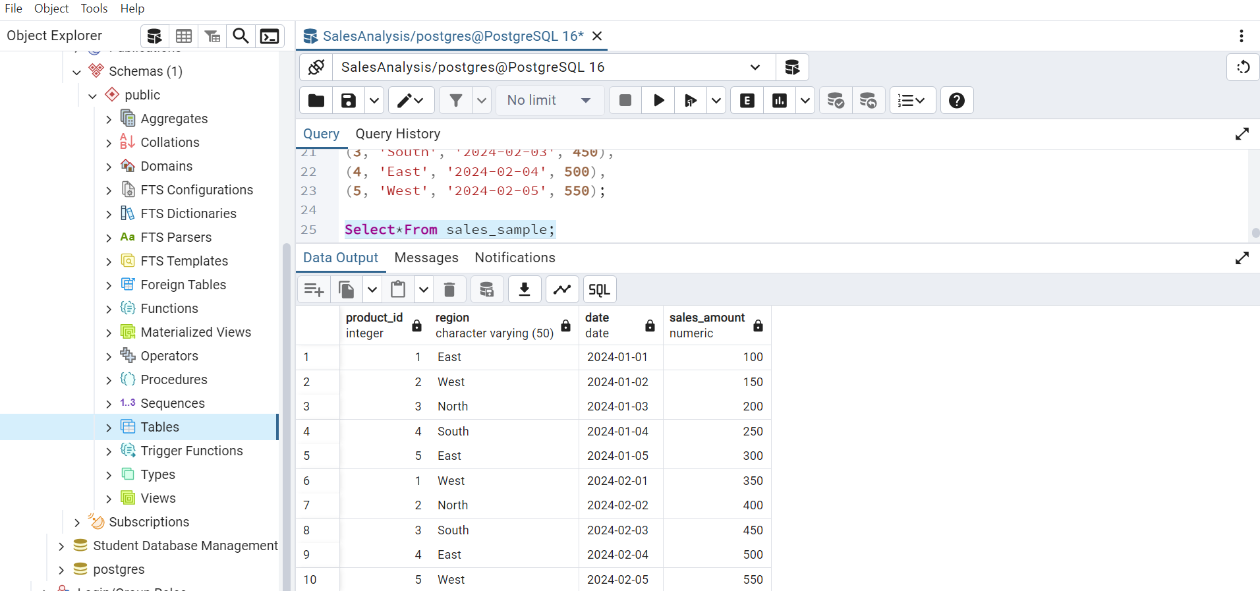

**3. Perform OLAP operations**

a) Drill Down-Analyze sales data at a more detailed level. Write a query to perform drill down

from region to product level to understand sales performance.

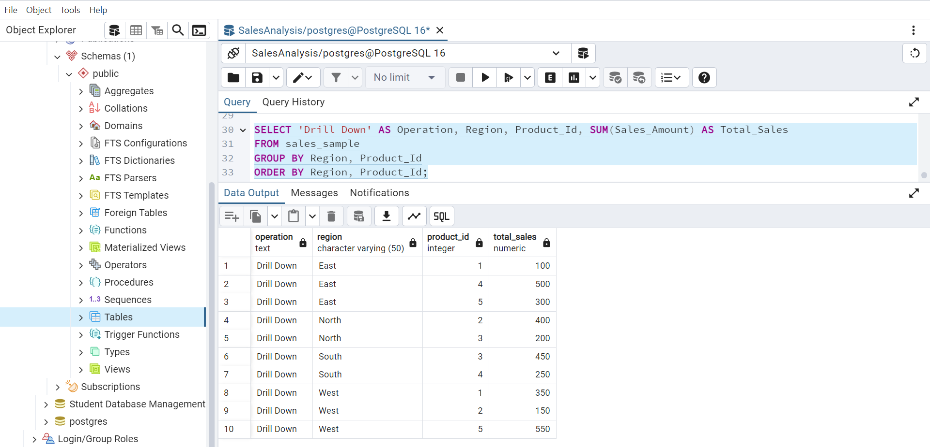

b) Rollup- To summarize sales data at different levels of granularity. Write a query to perform

roll up from product to region level to view total sales by region.

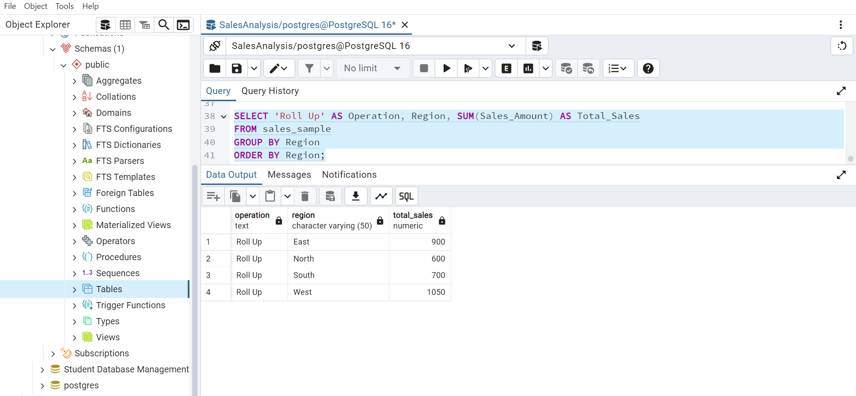

c) Cube - To analyze sales data from multiple dimensions simultaneously. Write a query to

Explore sales data from different perspectives, such as product, region, and date.

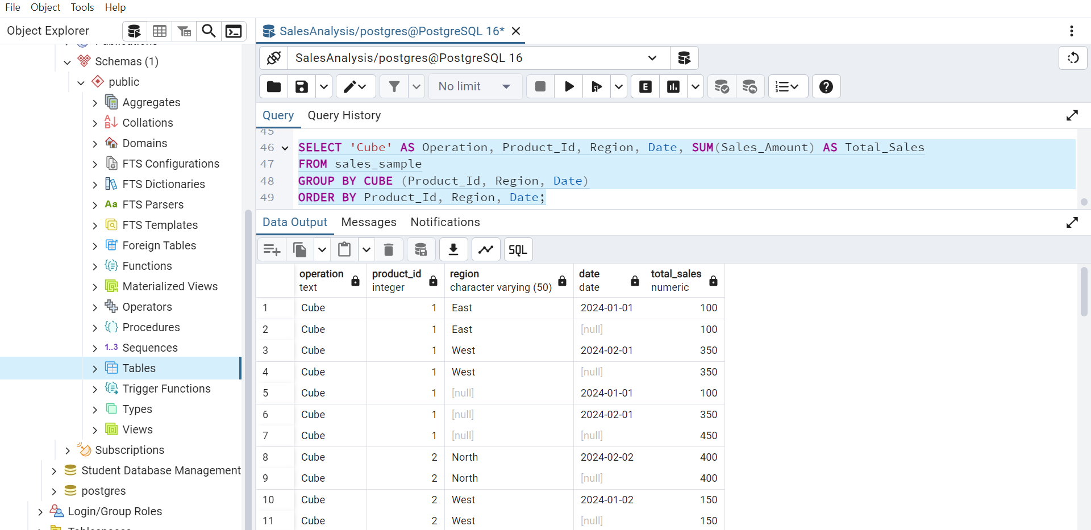

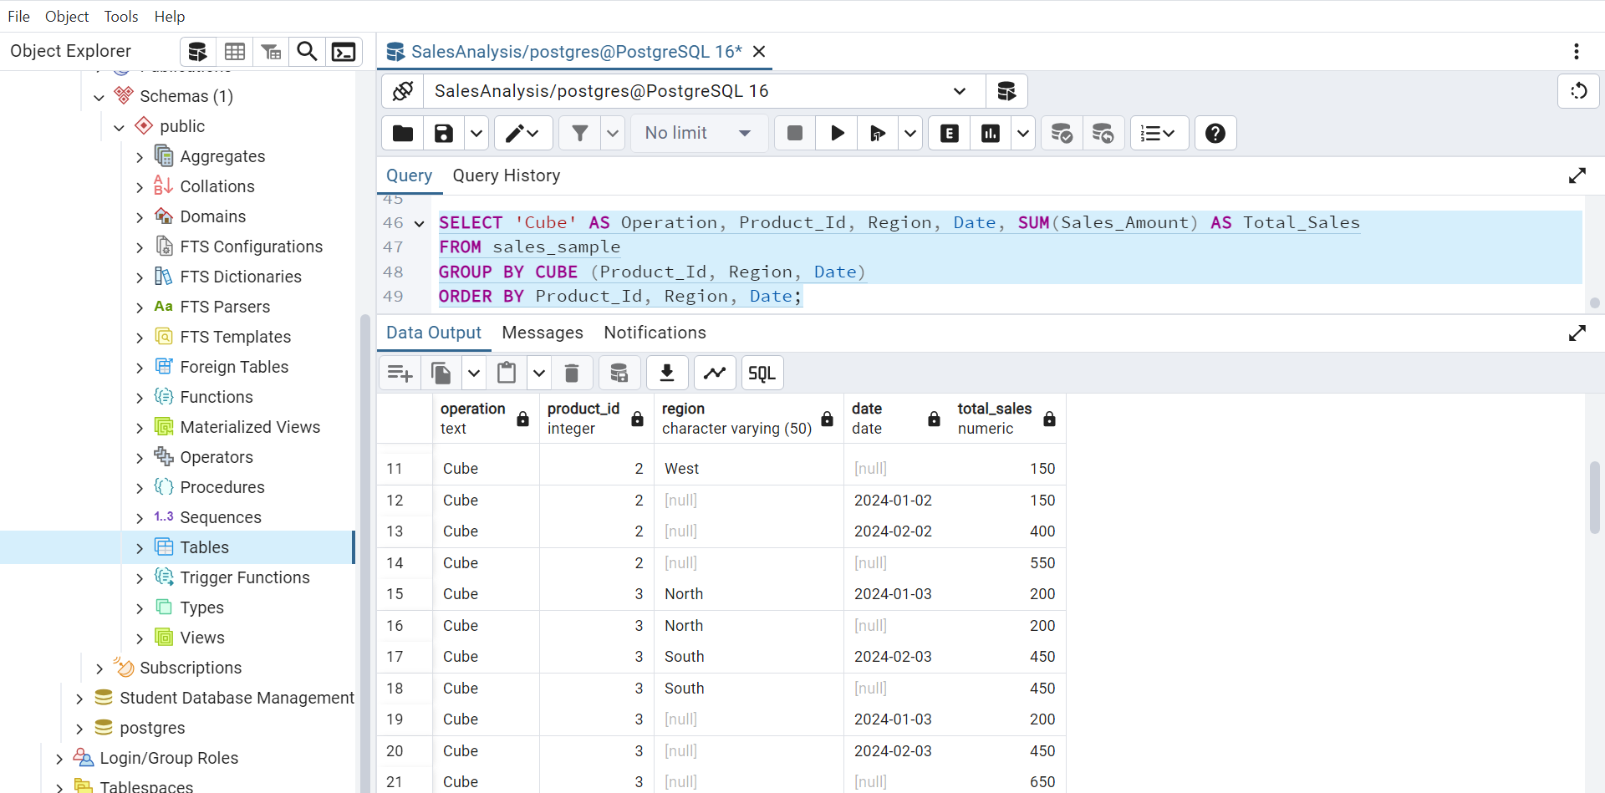

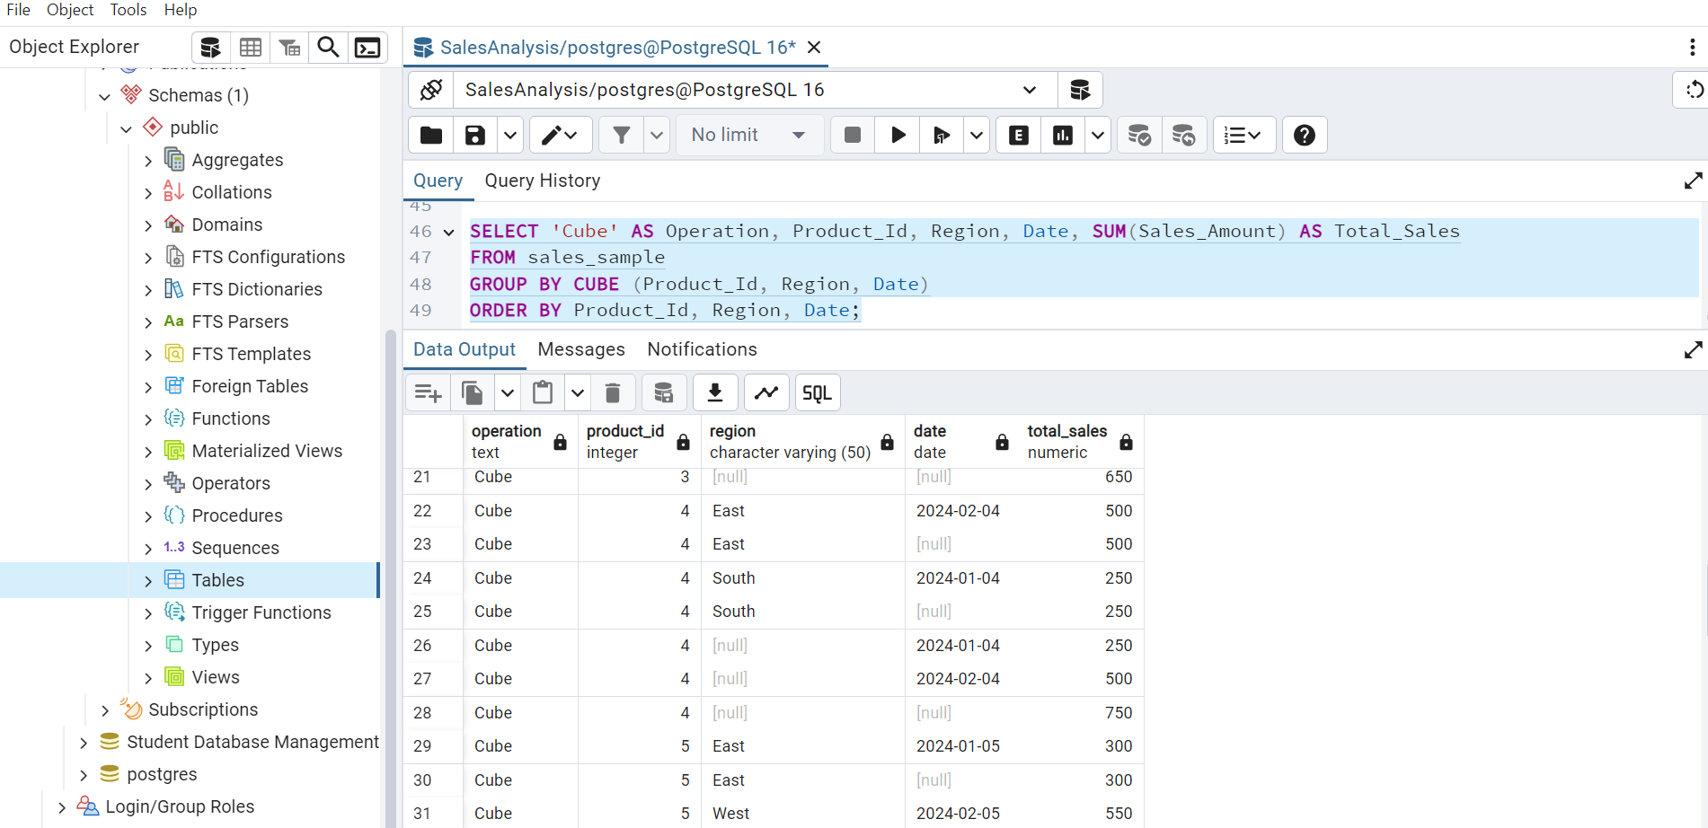

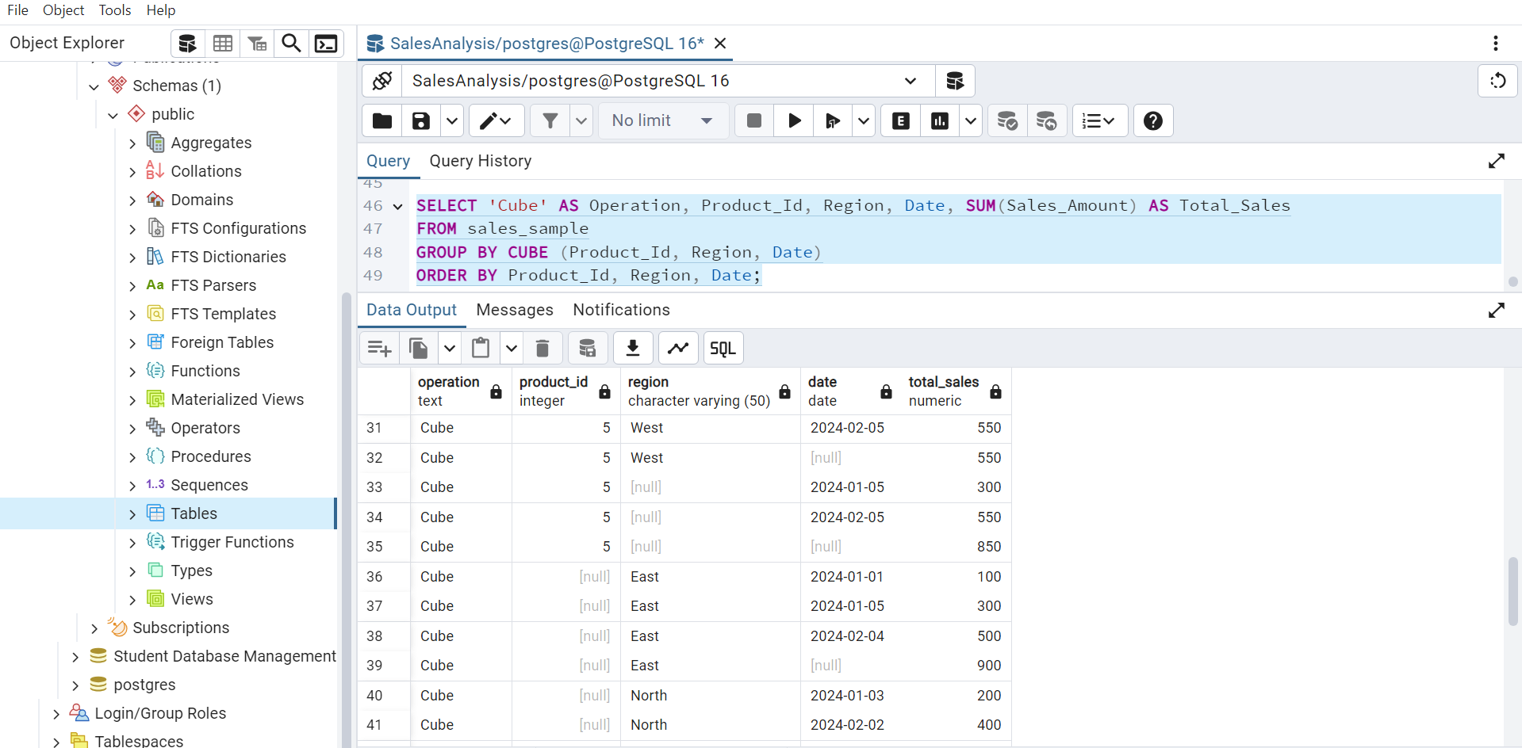

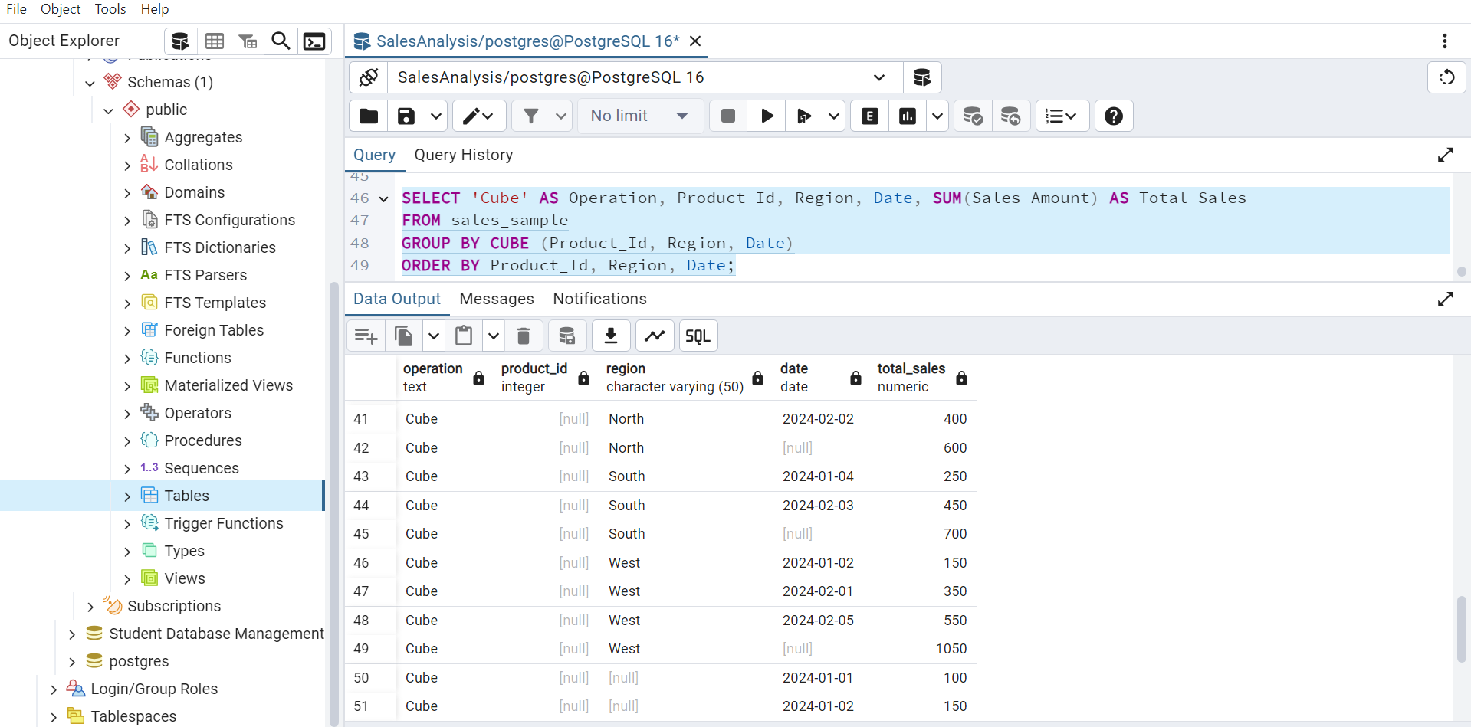

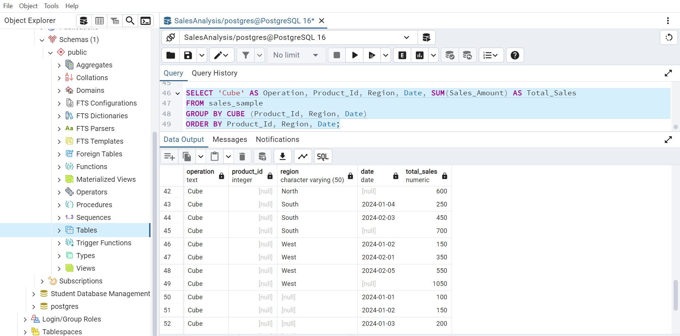

d) Slice- To extract a subset of data based on specific criteria. Write a query to slice the data to

view sales for a particular region or date range.

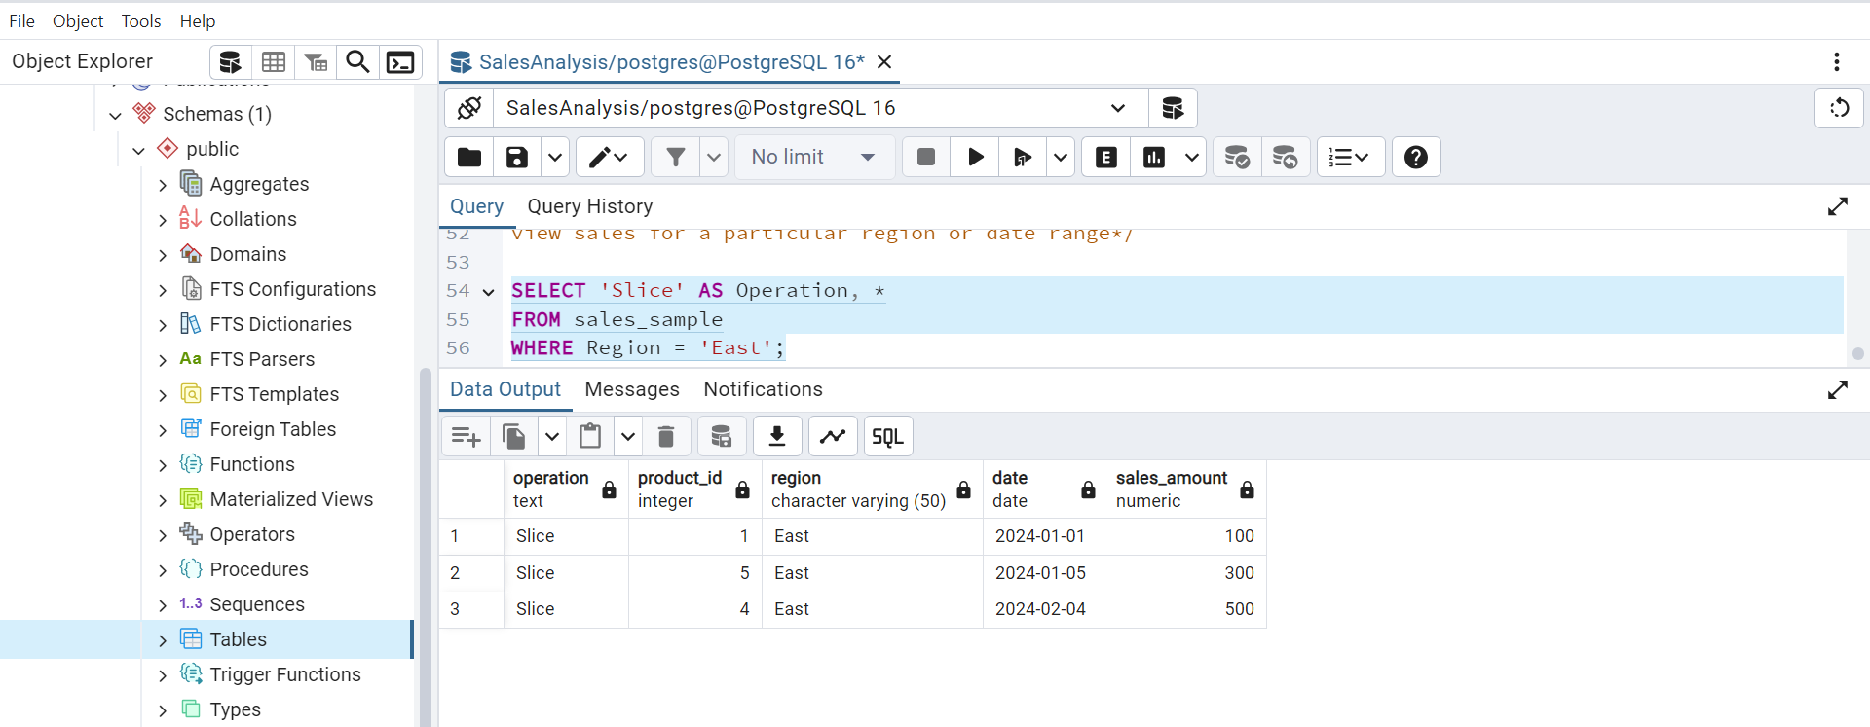

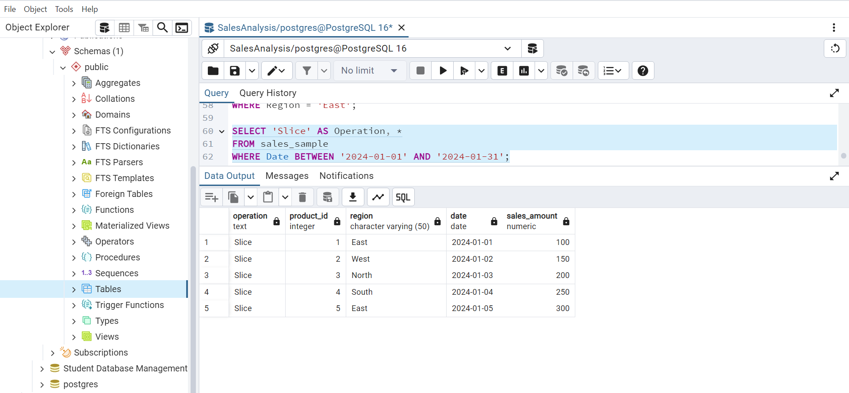

e) Dice - To extract data based on multiple criteria. Write a query to view sales for specific

combinations of product, region, and date

