1A. The current practice tests for the written test to get the Learners license is currently not engaging, motivating or fun. There is no current problem functionality wise, but there is no enjoyment and motivation to do these tests other than to remember the answers; not necessary *learn* them.

1B. The target demographic is men and women between the ages of 15-24. There is no limitation to job, background, location but the main audience will be students in either secondary or tertiary education. This has been chosen because this is the majority of age that are looking to get their leaners. The age of 15 has been set as the bottom limit as people at that age will start looking at the learners test to be competent in passing the test once they are of the legal age. The age of 24 is the upper limit as after the age of 25, the rules of learners change and the test will be less useful.

The current behaviour of the audience is a de-motivated attitude towards to practicing the learners test and thus are less knowledgeable about the facts and figures needed to know the test. It is completed to know the answers to the test as opposed to learning the concept behind the questions.

1C. By making the test more enjoyable to complete and do, the user learns the rules of the road more fully, rather than memorising test answers. Making the test more engaging and interactive gives more motivation to do something and learn. This will both have positive effects for the users enjoyment of the gamification as well as the teaching the user more effectively than a boring quiz.

1D. The challenge is that not enough people are learning the road rules and passing their learners test, in particular a demographic of 15 to 25 year olds are the main focus of the gamification. A more engaging and interactive learning experience will be offered to help improve the passing rate of the learners test. Some values that are to be improved are self-motivation, encourage and fun when beginning to learn the road rules.

2. A persona is Mike, and is 16 years old male, who likes playing games, he is a highschool student. He is usually quite lazy, he plays soccer in the goalie position. He drinks redbull and likes to fill up his spare time by building things. This gamification would be more motivating for Mike as the new learners practice test as aspects of video games, which he already enjoys, would be present.

3.A

Novice Really only applies to these people. What to appeal and what to keep

Phil -

Soc –

Free – Likes idea of finding areas, normal people can’t get

Intermediate

Phil -

Soc –

Free -

Master – becoming a mod, know intricacies

Phil -

Soc –

Free -

When players start the gamification, they will have rather limited knowledge of road rules and driving etiquette. As they progress through the gamification, they will gain knowledge on the related topics to ultimately pass the learners test. At the start, each player will start at Level 1 and will gain experience points by answering questions and. Tracking the way each user answers every question and seeing where their strengths and weaknesses in the road rules are.

4.1A

1) User would want to complete everything, they want to find everything.

2) To encourage the need of mastery, the implementation of the badges and achievements would give players who thrive to achieve and complete things motivation to continue using the gamification until they have completed it.

3) They are able to see how they are progressing through the gamification and are provided feedback on in the form of badges. Intrinsic motivation.

4.1B

1) They are motivated by how related they are to the gamification. They are the driver of the car and they are the ones making the decisions.

2) The ability to customise their avatar (the car), and the customisability of the users profile supports the need of relatedness.

3) Motivating the player with customisation of the players avatar (the car) and the players user profile.

4.1C

1)

4.2.1A

Achievers, in Bartles 4 players types is seen as a mix of acting and world. These players aim to complete the gamification, by ways such as gaining badges, the most points, the highest levels or getting all the challenges 100% correct. To encourage achievers to partake in the gamification, the use of the badges/achievements, levels as well as extrinsic rewards such as more driver ed hours or a boost of a certain amount of hours to start off the learners booklet and also the learner licence. Fun motivators will be tied in with the process of attaining the certain milestones.

4.2.1B

The socialiser player type is are interested in players and interacting. To cater to these players, this gamification will have a direct account link to other social networks like Facebook, Twitter, Instagram and Google + to share achievements and milestones. While there is no direct social interaction through this gamification, the inclusion of the social networks will encourage socializing on another platform about the gamification. This will allow users to have fun to have friends and socialiser on another platform.

4.2.1C

4.2.1D

The players that want to share knowledge and help other users, a mix of ‘acting’ and ‘users’, are the philanthropists. To both share knowledge and help other users, the gamification will input a sign-posting element in the quizzes that is completely user created. A more experienced user will be able to leave a tip or suggestion in a quiz or a specific question and these tips will be moderated and then be shown to users who are struggling with a certain quiz/question, hence sign-posting. This will allow the player to share their knowledge about the questions and also n turn help other users.

4.2.1B Enrol

* allow to sign up with a social media account and link it to the game account
  + Socializers will want to be social over everything so if they know they can be attached to a social network to share information and such, they will be more motivated to sign up/enrol
  + Complete profile with info from social media ie facebook?
  + Find friends add and interact with others

4.2.2B Enthuse

* Socialisers want to
* Allow a feed of activities/progress on friends. Socialisers can like and comment on them. (Friend can only be added by having their username, no search for friends.
  + Social pressure (maybe competition) and some other element
    - Pressure from trying to do as good as afriend.
  + Reward is being popular and getting likes/comments/any recognition about what they do

4.2.3B Engage

* Have a challenge type game (competition element)
  + 1v1 another person to see who gets the most correct in the time allocated
    - Motivate player with the chance of playing against another person cause socializer
    - Will make users engage with the quiz more and remember answer and questions better
    - Social network element. Socialisers will be able to play with other people and/or friends so they will want to gamify more. (more fun to play with others than on your own)
    - Player wins or loses but gets feedback on results of test.
    - Fun cause playing against another user/friend
* Have badges/achievements that can be displayed.
  + Player can choose to display their top 3 favourite badges?
  + Social status element

4.2.4B Endear

* (No idea, its most likely they will finish, leave it, becomes a special part of their life and continue socializing on facebook and twitter and Instagram and YouTube ect. )

6.1

* Tools for gamification
  + Limited to Online/ web, mobile browser, no app
  + Uses government profile type thingy, need to track for government purposes
  + Can’t do any other platforms as it needs to all be easily monitored and if it’s on the Government web, it’s much easier to do these things?
  + Replaces current quiz section in the website, and also makes it easier to find.
* Deploying involes setting up a online web, not web, nvironment suitable for
* Assign a team to monitor and maintain the gamification
  + Look at the user added notes and add them?

6.2

* User metrics
  + Feedback through levels and achievements
    - Levels can show how ready a person is to doing a test
      * Lvl 1, it is not advised you test just yet
      * Lvl 2, getting better abi more practise and you can try
      * Lvl3 can do it
      * Lvl4 You know your shiz, go do a teset
      * Lvl5 master of the pokemons, go do the test and get your L’s
  + How fun the gamification was
  + (For socialisers, how much they enjoyed socialising within and about the gamification)
  + Did they learn what they needed to learn about driving a car and the rules ect.

**FROM POWERPOINT**

* **Gamification success to users means** 
  + **fun, rewarding, allows socialising, right level of challenges, learning opportunities**
* **How to measures theses?** 
  + **fun motivators, number of collected items, how ofter rewards, number of connections, interactions between players**
* Owner metrics
  + Monitor how many people do the gamification
  + Find if there is an improvement in the L plate learners tests
    - Compare the two
      * Same age, same income, same super contribution. This does not pay commission, this does. This has lower fees, this has higher fees, Industry Superfund® …..
    - Comparing the amount of people passing the test before the rollout of the gamification to the passing rates after the gamification.

**FROM POWERPOINT – CORPORATE METRICS**

* **Engagement is one of the metrics that organisations want to improve, but how do we measure it ?**
* **Engagement is a composite metric:**
  + **time-dependent:**
    - **recency, frequency, duration**
  + **activity-dependent**
    - **number of likes, shares, blogs, rating, or uploads**
* Describe a challenge/issues/problem of an existing business/education/social service or system
  + No existing problem functionality wise, only its boring
* Identify the current users
  + Doing it cause they have to practise and not getting real use from it
* Describe behaviours of current users
  + Bored and have to do it
* Evaluated the suitability of usinggamification to solve the challenge/issues/problem.
* Define the objectives of the gamification
  + To increase the pass rate of L platers written test
* Identify user characterises of the gamification.
* Delineate the target behaviours and values of the gamification
* Design and justify the designs of the motivations, emotions, activities, feedbacks, rewards, and progression of the gamification.
* Design and justify the designs the game elements/fun motivators of the gamification.
* Design and justify the designs of the platform/technologies to be used in the gamification.
* Design the metrics to measure the values created by the gamification
* Justify how the metrics are aligned with the objectives.

Human and animals have **drive for play**.

Hunzingas

1. Play is free, is in fact **freedom**
2. Play is **not “ordinary”** or “real” life
3. Play is distinct from “ordinary” life both as to **locality and duration**
4. Play creates order, **is order,** play demands order absolute and supreme
5. Play is connected with **no material interest**, and no profit can be gained from it

**Gamification is a process of enhancing a service with affordances for gameful experiences in order to support user’s overall value creation.  
~Kai Huotari, Juho Hamari**

Aaah, Aha, Haha effect

PBL

Elements are not the game

**Motivation is the psychological feature that arouses an organism to act toward a desired goal and elicits controls and sustains certain goal directed behaviour.**

**~ Henry Murray**

Extrinisc/Intrinsic motivations

|  |  |
| --- | --- |
| Extrinsic motivation refers to behaviour that is driven by extrinsic rewards such as money, fame, grades, and praise (carrot stick). | Intrinsic motivation involves engaging in a behaviour because it is personally rewarding.  Intrinsically motivated individual performs an activity for its own sake rather than the desire for some external reward. |
| **Extrinsic rewards can:**   * + - Extinguish intrinsic motivation   • Diminish performance  • Crush creativity  • Crowd out good behaviour  • Encourage cheating, shortcuts and unethical behaviour  • Become addictive  • Foster short-term thinking |  |

**People Fun**

Amusement from competition and cooperation

**Easy Fun**

Curiosity from exploration, role play, and creativity

**Hard Fun**

Fiero, the epic win, from achieving a difficult goal

**Serious Fun**

Excitement from changing the player and their world

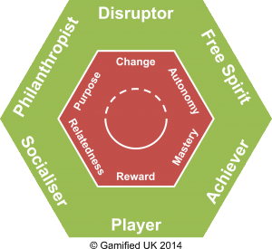 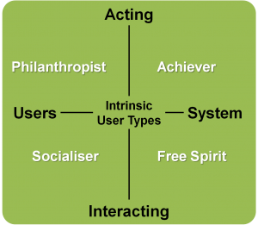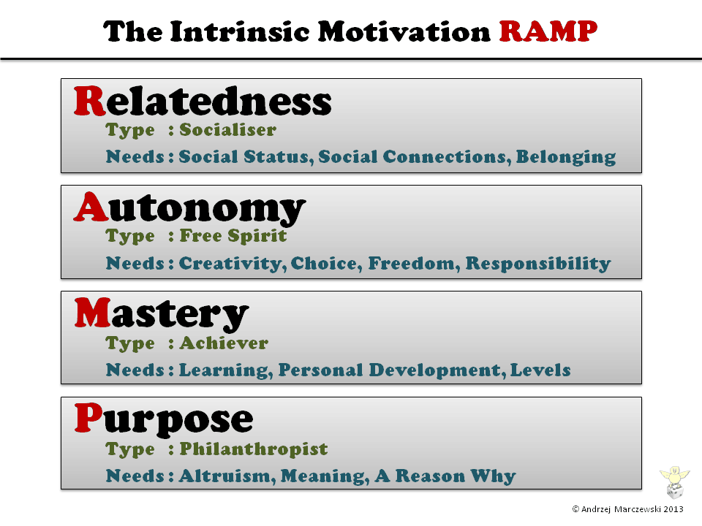 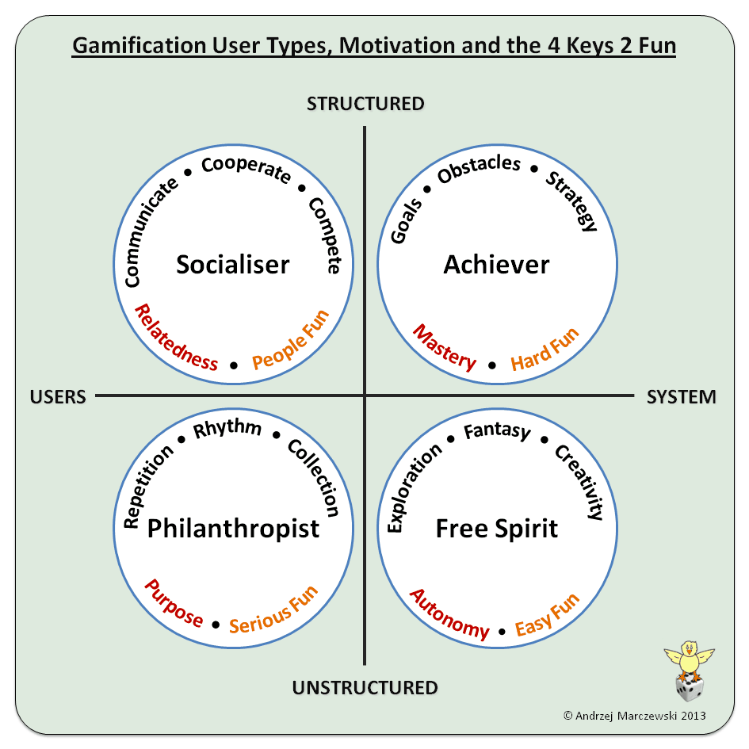

Flow Theory

**Flow-theory is a concept that states that activities that are in the balance between difficulty and skill are creating a state of flow.**

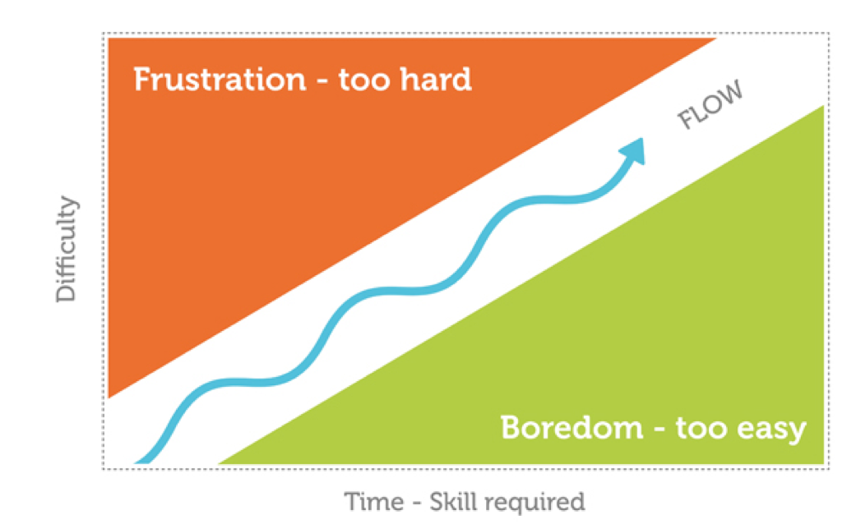

Enrol

Enthuse

Engage

Ender

This is not proposal type.