Análisis exploratorio

Tamara Ricardo

2023-10-30

### Valores ausentes

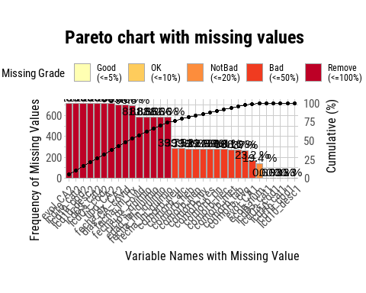

### Descripción de la muestra

| **Characteristic** | **N = 716**1 |
| --- | --- |
| sexo |  |
| Femenino | 410 (57%) |
| Masculino | 306 (43%) |
| edad | 60 (50, 68) |
| edad_cat |  |
| 18-39 | 66 (9.2%) |
| 40-59 | 275 (38%) |
| 60-79 | 332 (46%) |
| 80+ | 43 (6.0%) |
| comorb_met |  |
| No | 355 (80%) |
| Si | 88 (20%) |
| comorb_cvg |  |
| No | 291 (65%) |
| Si | 160 (35%) |
| comorb_rin |  |
| No | 428 (98%) |
| Si | 9 (2.1%) |
| comorb_res |  |
| No | 399 (91%) |
| Si | 38 (8.7%) |
| comorb_neu |  |
| No | 429 (99%) |
| Si | 3 (0.7%) |
| comorb_hiv |  |
| No | 417 (96%) |
| Si | 18 (4.1%) |
| comorb_heb |  |
| No | 430 (99%) |
| Si | 5 (1.1%) |
| comorb_hec |  |
| No | 434 (99%) |
| Si | 4 (0.9%) |
| comorb_alc |  |
| No | 408 (94%) |
| Si | 25 (5.8%) |
| comorb_hep |  |
| No | 431 (99%) |
| Si | 4 (0.9%) |
| comorb_tab |  |
| No | 329 (74%) |
| Si | 114 (26%) |
| icd10_cat1 |  |
| Leukemias and related conditions | 8 (1.1%) |
| Malignant neoplasms of bone and articular cartilage | 6 (0.8%) |
| Malignant neoplasms of breast | 154 (22%) |
| Malignant neoplasms of digestive organs | 159 (22%) |
| Malignant neoplasms of eye, brain and other parts of central nervous system | 18 (2.5%) |
| Malignant neoplasms of female genital organs | 98 (14%) |
| Malignant neoplasms of ill-defined, other secondary and unspecified sites | 62 (8.7%) |
| Malignant neoplasms of lip, oral cavity and pharynx | 21 (2.9%) |
| Malignant neoplasms of male genital organs | 22 (3.1%) |
| Malignant neoplasms of respiratory and intrathoracic organs | 89 (12%) |
| Malignant neoplasms of thyroid and other endocrine glands | 24 (3.4%) |
| Malignant neoplasms of urinary tract | 20 (2.8%) |
| Melanoma and other malignant neoplasms of skin | 33 (4.6%) |
| tipo_CA1 |  |
| Sólido | 690 (96%) |
| Hematológico | 26 (3.6%) |
| evol_CA1 |  |
| Distante | 61 (11%) |
| In Situ | 50 (9.1%) |
| Localizado | 234 (43%) |
| Regionalizado | 205 (37%) |
| ecog_num |  |
| 0 | 233 (40%) |
| 1 | 268 (46%) |
| 2 | 69 (12%) |
| 3 | 7 (1.2%) |
| gravedad_CA |  |
| Grave | 266 (37%) |
| Leve | 450 (63%) |
| mas_un_tumor |  |
| No | 704 (98%) |
| Si | 12 (1.7%) |
| metastasis |  |
| No | 643 (90%) |
| Si | 73 (10%) |
| trat_quimio_rtx |  |
| Ninguno | 581 (81%) |
| Quimioterapia | 114 (16%) |
| Quimioterapia y radioterapia | 18 (2.5%) |
| Radioterapia | 3 (0.4%) |
| trat_rtx |  |
| No | 695 (97%) |
| Si | 21 (2.9%) |
| trat_quimio |  |
| No | 584 (82%) |
| Si | 132 (18%) |
| ciclos_quimio | 7.0 (4.0, 11.0) |
| dx_covid_estudio |  |
| No | 699 (98%) |
| Si | 17 (2.4%) |
| 1n (%); Median (IQR) | |

### Compara pacientes con y sin diagnóstico de COVID-19

| **Characteristic** | **No**, N = 6991 | **Si**, N = 171 | **p-value**2 |
| --- | --- | --- | --- |
| **sexo** |  |  | 0.4 |
| Femenino | 402 (58%) | 8 (47%) |  |
| Masculino | 297 (42%) | 9 (53%) |  |
| **edad** | 61 (51, 69) | 55 (42, 66) | 0.084 |
| **edad_cat** |  |  | 0.14 |
| 18-39 | 63 (9.0%) | 3 (18%) |  |
| 40-59 | 266 (38%) | 9 (53%) |  |
| 60-79 | 328 (47%) | 4 (24%) |  |
| 80+ | 42 (6.0%) | 1 (5.9%) |  |
| **comorb_met** |  |  | >0.9 |
| No | 344 (80%) | 11 (79%) |  |
| Si | 85 (20%) | 3 (21%) |  |
| **comorb_cvg** |  |  | 0.8 |
| No | 281 (64%) | 10 (71%) |  |
| Si | 156 (36%) | 4 (29%) |  |
| **comorb_res** |  |  | >0.9 |
| No | 386 (91%) | 13 (93%) |  |
| Si | 37 (8.7%) | 1 (7.1%) |  |
| **comorb_hiv** |  |  | >0.9 |
| No | 403 (96%) | 14 (100%) |  |
| Si | 18 (4.3%) | 0 (0%) |  |
| **comorb_alc** |  |  | 0.6 |
| No | 395 (94%) | 13 (93%) |  |
| Si | 24 (5.7%) | 1 (7.1%) |  |
| **comorb_tab** |  |  | 0.4 |
| No | 320 (75%) | 9 (64%) |  |
| Si | 109 (25%) | 5 (36%) |  |
| **tipo_CA1** |  |  | 0.12 |
| Sólido | 675 (97%) | 15 (88%) |  |
| Hematológico | 24 (3.4%) | 2 (12%) |  |
| **evol_CA1** |  |  | >0.9 |
| Distante | 59 (11%) | 2 (13%) |  |
| In Situ | 49 (9.2%) | 1 (6.3%) |  |
| Localizado | 226 (42%) | 8 (50%) |  |
| Regionalizado | 200 (37%) | 5 (31%) |  |
| **ecog_num** |  |  | 0.8 |
| 0 | 225 (40%) | 8 (50%) |  |
| 1 | 261 (47%) | 7 (44%) |  |
| 2 | 68 (12%) | 1 (6.3%) |  |
| 3 | 7 (1.2%) | 0 (0%) |  |
| **gravedad_CA** |  |  | 0.7 |
| Grave | 259 (37%) | 7 (41%) |  |
| Leve | 440 (63%) | 10 (59%) |  |
| **mas_un_tumor** |  |  | >0.9 |
| No | 687 (98%) | 17 (100%) |  |
| Si | 12 (1.7%) | 0 (0%) |  |
| **metastasis** |  |  | 0.7 |
| No | 628 (90%) | 15 (88%) |  |
| Si | 71 (10%) | 2 (12%) |  |
| **trat_quimio_rtx** |  |  | 0.056 |
| Ninguno | 571 (82%) | 10 (59%) |  |
| Quimioterapia | 107 (15%) | 7 (41%) |  |
| Quimioterapia y radioterapia | 18 (2.6%) | 0 (0%) |  |
| Radioterapia | 3 (0.4%) | 0 (0%) |  |
| **trat_rtx** |  |  | >0.9 |
| No | 678 (97%) | 17 (100%) |  |
| Si | 21 (3.0%) | 0 (0%) |  |
| **trat_quimio** |  |  | **0.023** |
| No | 574 (82%) | 10 (59%) |  |
| Si | 125 (18%) | 7 (41%) |  |
| **ciclos_quimio** | 7.0 (4.0, 11.0) | 8.0 (6.5, 9.5) | 0.5 |
| 1n (%); Median (IQR) | | | |
| 2Pearson's Chi-squared test; Wilcoxon rank sum test; Fisher's exact test | | | |

### Curvas de supervivencia

#### Modelo solo intercepto

## Call: survfit(formula = surv ~ 1, data = data)  
##   
## n events median 0.95LCL 0.95UCL  
## [1,] 716 17 NA NA NA

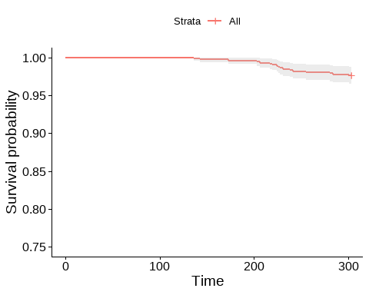

#### Sexo

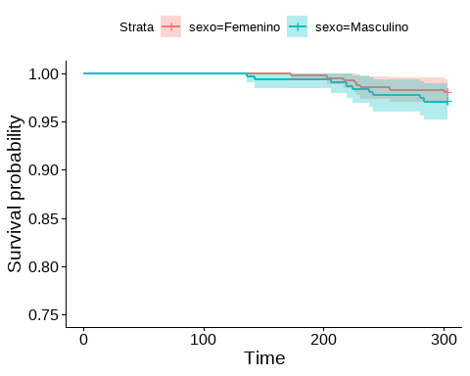

## Call:  
## survdiff(formula = surv ~ sexo, data = data)  
##   
## N Observed Expected (O-E)^2/E (O-E)^2/V  
## sexo=Femenino 410 8 9.76 0.316 0.743  
## sexo=Masculino 306 9 7.24 0.426 0.743  
##   
## Chisq= 0.7 on 1 degrees of freedom, p= 0.4

#### Grupo etario

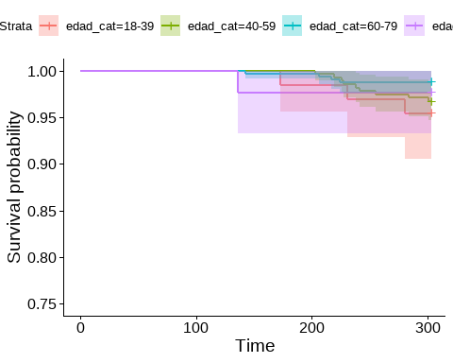

## Call:  
## survdiff(formula = surv ~ edad_cat, data = data)  
##   
## N Observed Expected (O-E)^2/E (O-E)^2/V  
## edad_cat=18-39 66 3 1.55 1.35e+00 1.482021  
## edad_cat=40-59 275 9 6.53 9.33e-01 1.515749  
## edad_cat=60-79 332 4 7.91 1.93e+00 3.606638  
## edad_cat=80+ 43 1 1.01 9.74e-05 0.000104  
##   
## Chisq= 4.2 on 3 degrees of freedom, p= 0.2

#### Tipo de cáncer

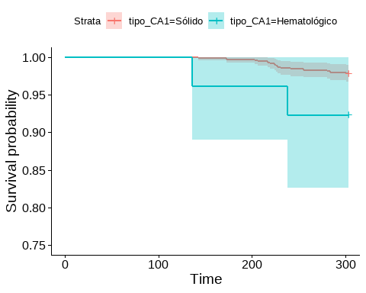

## Call:  
## survdiff(formula = surv ~ tipo_CA1, data = data)  
##   
## N Observed Expected (O-E)^2/E (O-E)^2/V  
## tipo_CA1=Sólido 690 15 16.405 0.12 3.44  
## tipo_CA1=Hematológico 26 2 0.595 3.32 3.44  
##   
## Chisq= 3.4 on 1 degrees of freedom, p= 0.06

#### Tipo de tratamiento

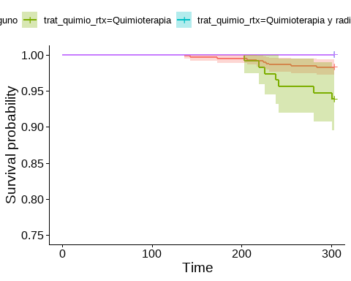

## Call:  
## survdiff(formula = surv ~ trat_quimio_rtx, data = data)  
##   
## N Observed Expected (O-E)^2/E  
## trat_quimio_rtx=Ninguno 581 10 13.818 1.055  
## trat_quimio_rtx=Quimioterapia 114 7 2.678 6.977  
## trat_quimio_rtx=Quimioterapia y radioterapia 18 0 0.432 0.432  
## trat_quimio_rtx=Radioterapia 3 0 0.072 0.072  
## (O-E)^2/V  
## trat_quimio_rtx=Ninguno 5.6361  
## trat_quimio_rtx=Quimioterapia 8.2812  
## trat_quimio_rtx=Quimioterapia y radioterapia 0.4435  
## trat_quimio_rtx=Radioterapia 0.0723  
##   
## Chisq= 8.5 on 3 degrees of freedom, p= 0.04

#### Quimioterapia

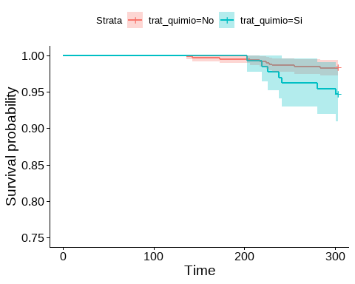

## Call:  
## survdiff(formula = surv ~ trat_quimio, data = data)  
##   
## N Observed Expected (O-E)^2/E (O-E)^2/V  
## trat_quimio=No 584 10 13.89 1.09 5.96  
## trat_quimio=Si 132 7 3.11 4.87 5.96  
##   
## Chisq= 6 on 1 degrees of freedom, p= 0.01

#### Más de un tumor

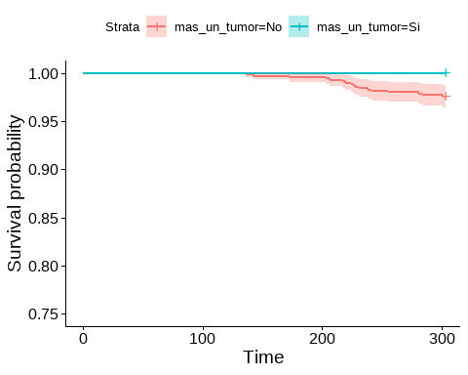

## Call:  
## survdiff(formula = surv ~ mas_un_tumor, data = data)  
##   
## N Observed Expected (O-E)^2/E (O-E)^2/V  
## mas_un_tumor=No 704 17 16.712 0.00497 0.293  
## mas_un_tumor=Si 12 0 0.288 0.28815 0.293  
##   
## Chisq= 0.3 on 1 degrees of freedom, p= 0.6

#### Metástasis

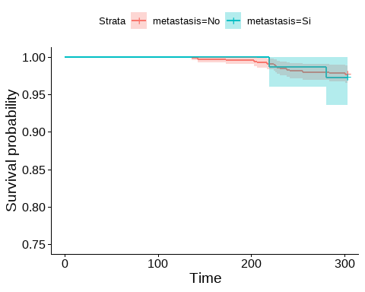

## Call:  
## survdiff(formula = surv ~ metastasis, data = data)  
##   
## N Observed Expected (O-E)^2/E (O-E)^2/V  
## metastasis=No 643 15 15.26 0.00457 0.0448  
## metastasis=Si 73 2 1.74 0.04019 0.0448  
##   
## Chisq= 0 on 1 degrees of freedom, p= 0.8

#### Gravedad

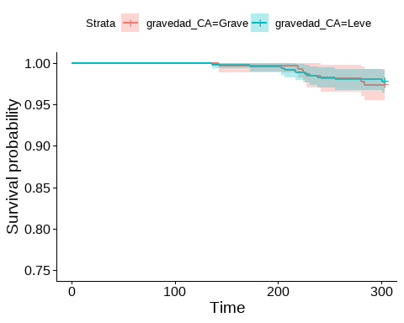

## Call:  
## survdiff(formula = surv ~ gravedad_CA, data = data)  
##   
## N Observed Expected (O-E)^2/E (O-E)^2/V  
## gravedad_CA=Grave 266 7 6.32 0.0734 0.117  
## gravedad_CA=Leve 450 10 10.68 0.0434 0.117  
##   
## Chisq= 0.1 on 1 degrees of freedom, p= 0.7

### Regresión de Cox

## Call:  
## coxph(formula = surv ~ tipo_CA1 + trat_quimio, data = data)  
##   
## n= 716, number of events= 17   
##   
## coef exp(coef) se(coef) z Pr(>|z|)   
## tipo_CA1Hematológico 1.0797 2.9438 0.7613 1.418 0.1561   
## trat_quimioSi 1.0697 2.9146 0.4984 2.146 0.0318 *  
## ---  
## Signif. codes: 0 '***' 0.001 '**' 0.01 '*' 0.05 '.' 0.1 ' ' 1  
##   
## exp(coef) exp(-coef) lower .95 upper .95  
## tipo_CA1Hematológico 2.944 0.3397 0.6621 13.089  
## trat_quimioSi 2.915 0.3431 1.0974 7.741  
##   
## Concordance= 0.637 (se = 0.062 )  
## Likelihood ratio test= 6.34 on 2 df, p=0.04  
## Wald test = 7.69 on 2 df, p=0.02  
## Score (logrank) test = 8.71 on 2 df, p=0.01

## Analysis of Deviance Table  
## Cox model: response is surv  
## Model 1: ~ tipo_CA1 + trat_quimio  
## Model 2: ~ trat_quimio  
## loglik Chisq Df Pr(>|Chi|)  
## 1 -108.39   
## 2 -109.17 1.5491 1 0.2133

## # Indices of model performance  
##   
## AIC | BIC | Nagelkerke's R2 | RMSE  
## -------------------------------------------  
## 220.336 | 224.909 | 0.025 | 0.154

| **Characteristic** | **HR**1 | **95% CI**1 | **p-value** |
| --- | --- | --- | --- |
| trat_quimio |  |  |  |
| No | — | — |  |
| Si | 3.13 | 1.19, 8.21 | 0.021 |
| 1HR = Hazard Ratio, CI = Confidence Interval | | | |

