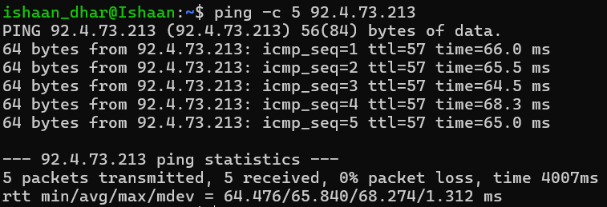
Here, there is a TTL of 57. It is lower in this case as the VM runs Ubuntu, and Linux has a default assigned TTL of 64. So, doing the math, I find that the number of hops undertaken by the packets to reach the destination from the source comes to 7 hops (64-57=7). This is easy to understand, because instead of a ‘distant’ google server, my request is being transferred straight to Oracle’s Mumbai server, which needs the packets to not go through as many routers to reach the destination on the way back. The average RTT IS 65.840 which is significantly higher than the RTT for pinging google.com, as in this case, the traffic has to go through multiple channels, instead of straightaway going to google.com through direct connections as in that case. Here, the traffic has to go through the ISP and its channels before actually being routed to the target server.
Below, the commands that could have been run have been shown.
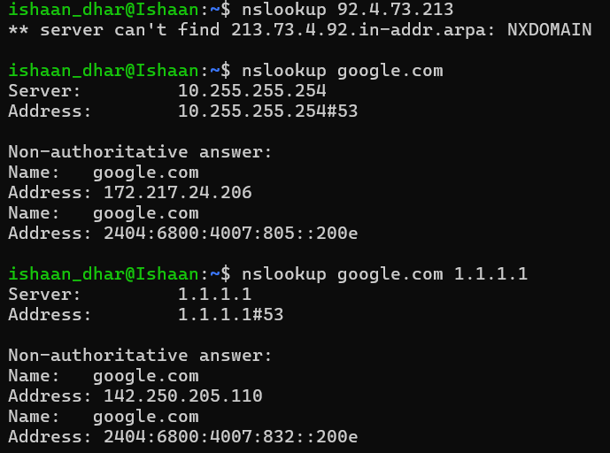
There is no actual DNS server for the VM, so it shows a can’t find message.
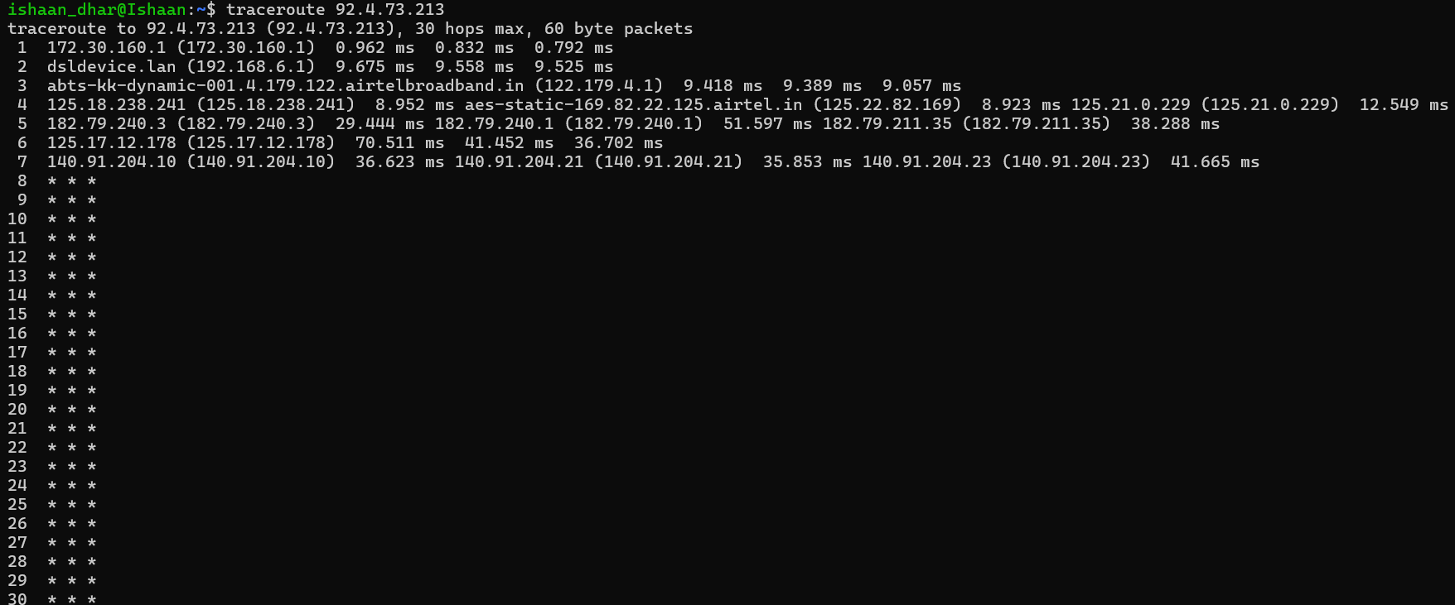
The route here probably shows the packet reaching the Oracle server, which then leads to unresponsive * * * messages, likely due to Oracle not allowing UDP traffic inside the server, which is a common method.
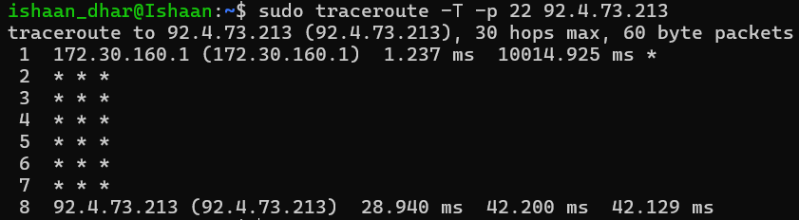
Here, I am sending TCP SYN packets to port 22, which means it looks like an ssh request to the server, which then allows the traffic through. Here, it shows that on the 8th hop it reaches the target, which corresponds with my previously calculated hop count of 7.
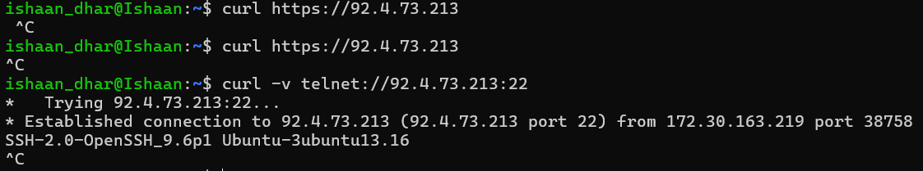
Here, there is no response from the server because there is no SSL certificate or web server ‘listening’ for https connections on port 443, which is the port number for https. I additionally used the telnet feature to force a SYN, SYN-ACK, ACK (TCP 3 way handshake), which caused my VM to send me the OpenSSH version string before the connection just hanged.

