Chapter 3 Homework

3.1) EMPLOYEE TABLE: Primary key – EMP_CODE, foreign key – STORE_CODE

STORE TABLE: Primary key – STORE_CODE, foreign key – REGION_CODE, EMP_CODE

REGION TABLE: Primary key – REGION_CODE, foreign key - none

3.2) Yes, all of the tables exhibit entity integrity because none of the primary keys have a null value and all the values in the primary key are unique.

3.3) EMPLOYEE TABLE: Yes it exhibits referential integrity because each STORE_CODE points to a STORE_CODE in STORE.

STORE TABLE: Yes, because each REGION_CODE points to a value in the REGION table for REGION_CODE. The same applies for the EMP_CODE. Every value in the STORE table points to an existing value in the EMPLOYEE table.

REGION TABLE: No this table does not have a foreign key.

3.4) STORE and REGION have a M:1 relationship. The REGION can contain more than one store because the REGION_CODE values in the STORE table occur more than once. However, each STORE can only be located in one REGION; therefore, the STORE and REGION have a M:1 (many-to-one) relationship.

3.5)

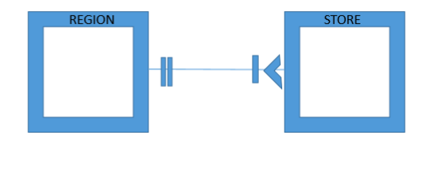

3.6)

Chapter 4 Homework

4.1) 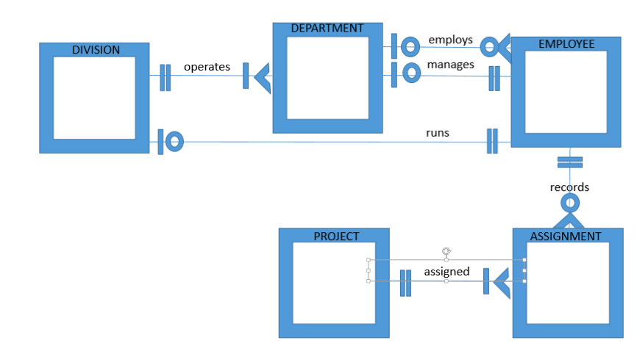

4.2)

4.4)

4.5)

4.8)

4.9)