**Blinkit Project**

Database Name: blinkitdb

CREATE DATABASE blinkitdb;

USE blinkitdb

See all the data imported:

SELECT * FROM blinkit_data;

how much record present in the blinkit_data table:

select count(*) as no_of_records from blinkit_data;

**DATA CLEANING:**

Cleaning the Item_Fat_Content field is important for maintaining consistency and accuracy in our analysis. Variations like “LF,” “low fat,” and “Low Fat” can lead to confusion and incorrect results when filtering, grouping, or reporting. By standardizing these values, we improve data quality, ensure more reliable insights, and make our dataset cleaner and easier to work with.

UPDATE blinkit_data

SET Item_Fat_Content =

CASE

WHEN Item_Fat_Content in ('LF','low fat') THEN 'Low Fat'

WHEN Item_Fat_Content ='reg' THEN 'Regular'

ELSE Item_Fat_Content

END

After executing this query check the data has been cleaned or not using below query

SELECT DISTINCT(Item_Fat_Content) FROM blinkit_data;

**KPI’s**

**1.Total Sales**

SELECT CAST(SUM(Total_Sales)/1000000 AS decimal(10,2)) AS Total_Sales_in_Millions FROM blinkit_data;

**2.Average Sales**

SELECT CAST(AVG(Total_Sales) AS int)AS Avg_Sales FROM blinkit_data;

**3.No_of_Items**

SELECT COUNT(*) AS No_of_Orders FROM blinkit_data;

**4.Avg Rating**

SELECT CAST(AVG(Rating) AS decimal(10,1)) AS Avg_Rating FROM blinkit_data;

**Total Sales by Fat Content**

SELECT

Item_Fat_Content,

CAST(SUM(Total_Sales)AS decimal(10,2)) AS Total_Sales

FROM blinkit_data

GROUP BY Item_Fat_Content;

**Total Sales by Item Type**

SELECT

Item_Type,

CAST(SUM(Total_Sales)AS decimal(10,2)) AS Total_Sales

FROM blinkit_data

GROUP BY Item_Type;

**Fat Content by Outlet for Total Sales**

SELECT

*

FROM (

SELECT

Outlet_Location_Type,

Item_Fat_Content,

CAST(SUM(Total_Sales)AS decimal(10,2)) AS Total_Sales

FROM blinkit_data

GROUP BY Outlet_Location_Type,Item_Fat_Content

)AS Source_Table

PIVOT

(

SUM(Total_Sales) FOR Item_Fat_Content IN ([Low Fat],[Regular])

)AS Pivot_Table

ORDER BY Outlet_Location_Type;

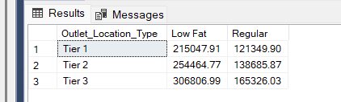

**Total Sales by Outlet Establishment**

SELECT

Outlet_Establishment_Year,

CAST(SUM(Total_Sales) AS decimal(10,2))AS Total_Sales

FROM blinkit_data

GROUP BY Outlet_Establishment_Year;

**Percentage of Sales by Outlet Size**

WITH SalesByOutletSize AS(

SELECT

Outlet_Size,

SUM(Total_Sales)AS Total_Sales

FROM blinkit_data

GROUP BY Outlet_Size

),

TotalSales AS (

SELECT

SUM(Total_Sales)AS Overall_Sales

FROM blinkit_data

)

SELECT

s.Outlet_Size,

s.Total_Sales,

ROUND((s.Total_Sales*100.0/t.Overall_Sales),2) AS Sales_Percentage

FROM SalesByOutletSize AS s,

TotalSales AS t

ORDER BY Sales_Percentage DESC;

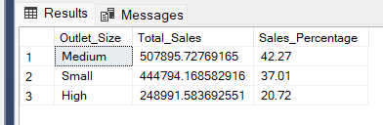

**Sales by Outlet Location**

SELECT

Outlet_Location_Type,

CAST(SUM(Total_Sales)AS decimal(10,2)) AS Total_Sales

FROM blinkit_data

GROUP BY Outlet_Location_Type;

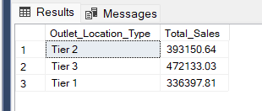

**All Metrics by Outlet Type**

SELECT

Outlet_Type,

CAST(SUM(Total_Sales)AS decimal(10,2))AS Total_Sales,

CAST(AVG(Total_Sales)AS decimal(10,2)) AS Avg_Sales,

COUNT(*) AS No_of_Items,

CAST(AVG(Rating)AS decimal(10,2)) AS Avg_Rating,

CAST(AVG(Item_Visibility)AS decimal(10,2))AS Avg_Item_Visibility

FROM blinkit_data

GROUP BY Outlet_Type

ORDER BY Total_Sales DESC;

