

IKB21503 - SECURE SOFTWARE DEVELOPMENT
Mini Project - Technical Report

Section 2: System Architecture

Secure Microservice-Based Web Application

Prepared by Member 1 - Core Developer (Functionality)

Muhammad Najwan Bin Shukor
Student ID: 52215225191
Group: L03_B03
Lecturer: Sir Muhammad Bakhtiar (Lab)
UniKL MIIT - 2026 / March Semester

Table of Contents
2. System Architecture 3
2.1 Overview 3
2.2 Architectural Style: Modular Monolith 3
2.3 Technology Stack 4
2.4 Request Lifecycle and Security Layers 4
2.5 Data Flow Diagram with Trust Boundaries 5
2.6 Role-Based Access Control (RBAC) Model 6
2.7 Data Model 6
2.8 How the Architecture Supports the Security Requirements 7
2.9 Deployment View 7
2.10 Summary 7
References 8

2. System Architecture

2.1 Overview
This section will explain how the Secure Inventory application is built. It covers four things. The first one is how we organize the code, how a web request move, where we store data, and where security check happen. The design was structured by Member 1 and the other members can use it to do their security testing and fixing work.
We built the app with Django 5.2. We chose Django because it already has many built in security control that the project requirements want. For example, Django use Object-Relational Mapper (ORM) that stop SQL injection attack automatically. Also, the template engine stop cross-site scripting (XSS) by cleaning the output data. Other feature like CSRF token, session control, and password hashing are already inside. Using these ready to use tool help us avoid human mistakes (OWASP, 2021).

2.2 Architectural Style: Modular Monolith
The project assignment say that this project is microservice based. So, we have to think about this carefully. Our app is small and made by four students in a few week. If we split everything into many separate service with network gateway, it will cause a lot of effort. It also give almost no security benefit and give us more part to defend. So, our team choose a modular monolith instead.
The app runs as one program. But in inside, the code is divided into clear module and each module do one job. We still get thing that people like about microservice, like separation of duty and clear ownership. At the same time, the project stay small so it easy to secure and easy to show. Each module is a Django app. The line between them are made on purpose. If more than one module need the same rule, we keep it in a single place so the rule do not fall out of step. The table below list the four module.

Module | Responsibility | Key security role
config | Project settings, URL routing, error handlers | Central place for all security configuration
accounts | Custom user model, registration, login, RBAC, profile | Authentication and access control
inventory | The CRUD module (stock items) | Input validation and authorised data changes
auditlog | Records security events like admin-only viewer | Logging and monitoring

Table 2.1 - Application modules and their responsibilities

2.3 Technology Stack
Layer | Technology | Reason
Language | Python 3 | Team already know this language and it have many good library.
Framework | Django 5.2 | It already have secure setting inside like ORM, CSRF, auth, and escaping.
Templating | Django Templates | It can clean HTML data automatically to stop XSS attack.
Database | SQLite (dev) / PostgreSQL (prod) | ORM always keep the query safe no matter we use SQLite or PostgreSQL
Password hashing | Argon2 (argon2-cffi) | Very strong password hashing that OWASP recommend to use.
Configuration | python-dotenv (.env) | Keep our secret key safe outside from the application code.

Table 2.2 - Technology stack and rationale

2.4 Request Lifecycle and Security Layers
Before a request reach the code that answer it, the request must move through a fixed chain of middleware. Every layer add one more check. So, by the time the request arrive, it already inspected several times. Order is very matter here. The security check run first on the way in, and the response is handled again on the way back out. The main layer are listed below:
- Security middleware: It add good HTTP header to protect the app and make HTTPS force when need.
- Session middleware: It load user session from a signed and HttpOnly cookie safely.
- CSRF middleware: It block any unsafe POST request if it do not have a valid CSRF token.
- Authentication middleware: It attach the logged in user to the request automatically.
- View level access control: The mixin will check if user is logged in and have the right role before touch any data.
The role check sit at the view layer, so it can guard every page and every action behind it. For example, if a normal user tries to open an admin page by typing its address. The server will answer with a 403 error, and the audit log will record that attempt automatically.

2.5 Data Flow Diagram with Trust Boundaries
A trust boundary is a line where the trust level change. When data cross from the public internet into the server, it cross this line. Also, when data move from the application into database, it cross another line too. Many attack always happen right at these lines, so each line must have its own control. Figure 2.1 show how data move through the app and it mark three trust boundaries.
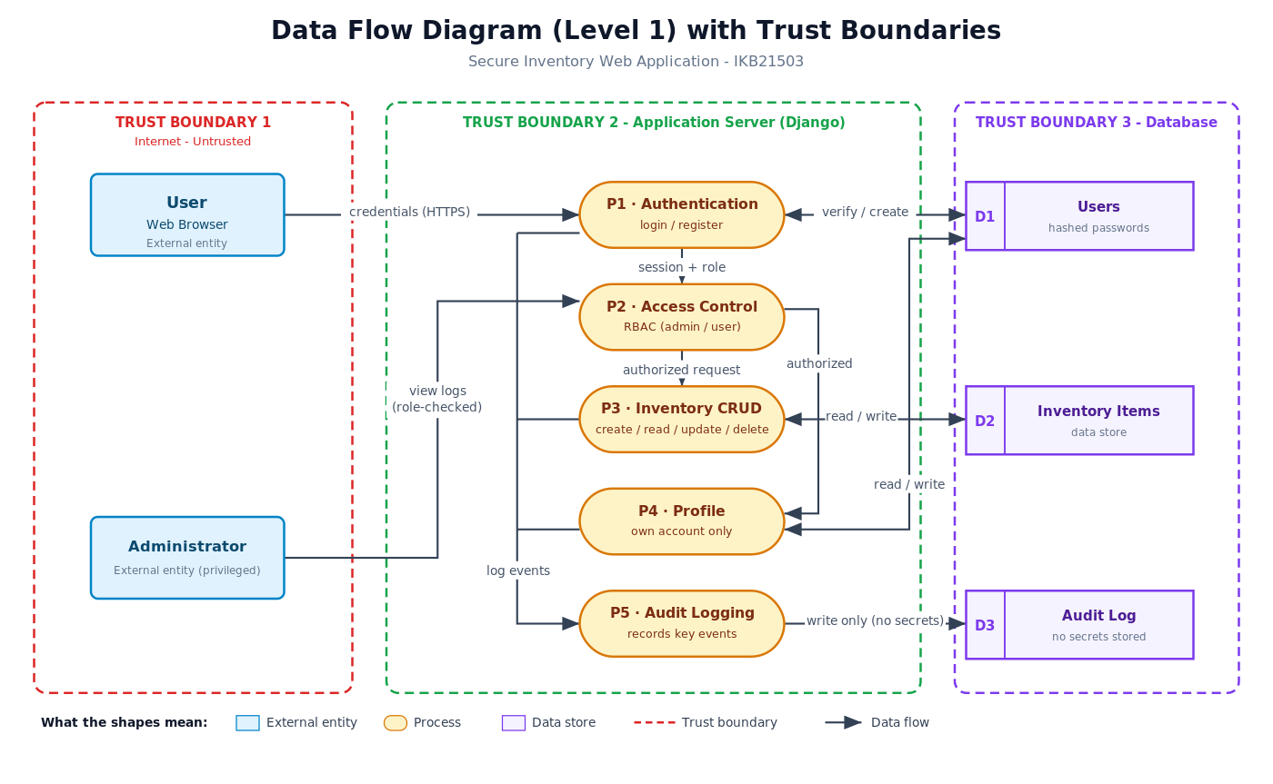
Figure 2.1 - Level 1 Data Flow Diagram with trust boundaries
Trust boundary | Crossing | Controls applied at the boundary
TB1 (Internet / Server) | User browser to the application | HTTPS, CSRF token, login, input validation on server side
TB2 (Application / logic) | Request to protected process | Role-based access control, session timeout, output encoding
TB3 (App / Database) | Application to stored data | ORM with parameterized queries, hashed password, no secret in log file

Table 2.3 - Trust boundaries and their controls

2.6 Role-Based Access Control (RBAC) Model
The system have two roles, which is Administrator and Normal User. We save the role inside the user record field so our app can check it every time request happen. We do the access control check at the view layer, not inside the page template. The reason is because if we just hide a button, a smart user can still type the URL address by hand. The table below show what each role can do.
Action | Normal User | Administrator
Register / login / logout | Yes | Yes
View inventory list and item details | Yes | Yes
Create / edit / delete items | No (403) | Yes
View and edit own profile | Yes | Yes
View the audit log | No (403) | Yes

Table 2.4 - RBAC permission matrix
This same rule will protect regular web page now and also API route that we add in the future. It work because we write the check only one time inside a shared mixin, then we reuse it everywhere. When we keep it in one place, it is easy to check and hard to break by mistake. This also help Member 3 when he do the manual code review later.

2.7 Data Model
The data is stored inside three main table. We make the link between them simple on purpose. When the relation is simple, the database query will become more clear. It also make the access control rule very easy to understand. The table below show our core data entities.
Entity | Important fields | Notes
User | username, email, password (hash), role, phone, avatar | Password is never stored in plain text format
Item | name, sku (unique), category, quantity, unit_price, created_by | created_by field will link to the user who add that item.
AuditLog | user, action, detail, ip_address, success, timestamp | This table is append-only and it do not hold any password or token.

Table 2.5 - Core data entities

2.8 How the Architecture Supports the Security Requirements
The security requirements from the project assignment have shape this design from the start. The table below link each main requirement to the part of the architecture that handles it. The full secure coding evidence belongs to Member 3 section. Here, we only want to show where each security control that sits inside the structure.
Requirement (OWASP) | Where it lives in the architecture
Input validation (A03) | Form classes in each module and server-side check
Authentication & session (A07) | accounts module with session and CSRF middleware
Access control (A01) | Shared RBAC mixin at the view layer
Sensitive data (A02) | Argon2 hashing, secret key in .env file and HTTPS settings
Security misconfiguration (A05) | Single config module and turn off DEBUG in production
Logging & monitoring (A09) | auditlog module with viewer for admin only
Output encoding (A03/XSS) | Template engine auto-escaping feature

Table 2.6 - Mapping of security requirements to architecture

2.9 Deployment View
During development, the app run on one machine using built-in server and SQLite database. But in production, the same code sits behind a real web server over HTTPS, with debug mode turn off and a stronger database like PostgreSQL. The only thing that change between them is the .env file, nothing else. We do not edit any code and no secret key is committed to the repository. Keeping configuration separate from code is a good security control. It can stop secret key from leaking by accident and stop debug pages from showing internal details when the app is live.

2.10 Summary
In conclusion, our architecture is a modular monolith built on Django. It splits into four modules and each module has a clear duty. All the shared security rules live in one spot. There are three trust boundaries to protect the data flow. Access control is settled by user role at the view layer. Every important action will land in the audit log. Together, these choices give our project a stable and secure base so the team can test, harden, and show it off in the demo presentation.

References
Adkins, H., Beyer, B., Blankinship, P., Lewandowski, P., Oprea, A., & Stubblefield, A. (2020). Building Secure and Reliable Systems. O’Reilly Media.
Kohnfelder, L. (2021). Designing Secure Software: A Guide for Developers. No Starch Press.
OWASP Foundation. (2021). OWASP Top 10:2021. https://owasp.org/Top10/
OWASP Foundation. (2019). OWASP Application Security Verification Standard (ASVS) v4.0. https://owasp.org/www-project-application-security-verification-standard/
National Institute of Standards and Technology. (2022). Secure Software Development Framework (SSDF) Version 1.1, SP 800-218. https://doi.org/10.6028/NIST.SP.800-218
Django Software Foundation. (2024). Security in Django. https://docs.djangoproject.com/en/5.2/topics/security/

