

Faculty of Computers and Artificial Intelligence

Computer Science Department

2021/2022

**CS 395 Selected Topics in CS-1**

**Research Project**

Report Submitted for Fulfillment of the Requirements and ILO’s for Selected Topics in CS-1 course for Fall 2021

Team No. 22

|  |  |  |  |
| --- | --- | --- | --- |
|  | ID | Name | Grade |
|  | 201900128 | اسراء سعيد هاشم |  |
|  | 201900125 | استبرق محمد صبحي |  |
|  | 201900171 | امال خالد السيد |  |
|  | 201900139 | اسلام خالد محمد سعيد |  |
|  | 201900182 | اميره علاء الدين عبد الله عبد الخالق |  |
|  | 201900135 | اسلام حامد احمد حامد |  |
|  | 201900137 | اسلام خالد السيد احمد |  |

Delivered to:

**Dr. Wessam El-Behaidy**

**Eng. Islam Gamal**

**Eng. Muhammed Kamal**

I. NUMERICAL DATASET

1. Project Introduction

* 1. **Dataset Name**

Credit Card Customers

* 1. **Number of classes and their labels**

(10127, 23)

CLIENTNUM',

'Attrition_Flag',

'Customer_Age',

'Gender',

'Dependent_count ' ,

'Education_Level',

'Marital_Status',

'Income_Category',

'Card_Category',

'Months_on_book',

'Total_Relationship_Count',

'Months_Inactive_12_mon',

'Contacts_Count_12_mon',

'Credit_Limit', 'Total_Revolving_Bal',

'Avg_Open_To_Buy',

'Total_Amt_Chng_Q4_Q1',

'Total_Trans_Amt',

'Total_Trans_Ct',

'Total_Ct_Chng_Q4_Q1',

'Avg_Utilization_Ratio',

'Naive_Bayes_Classifier_Attrition_Flag_Card_Category_Contacts_Count_12_mon_Dependent_count_Education_Level_Months_Inactive_12_mon_1', 'Naive_Bayes_Classifier_Attrition_Flag_Card_Category_Contacts_Count_12_mon_Dependent_count_Education_Level_Months_Inactive_12_mon_2'],

* 1. **Dataset Samples Numbers**

10127

* 1. **Training, Validation and Testing**

80% for Training , 20% for validation and testing

1. Implementation Details
   * 1. **Extracted Features**

*bin_age extracted to 6 features (0,30), (30,40), (40,50) , (50,60) , (60,70) , (70,90)

*IncomeCategory extracted to 6 features ,(less than 40k) ,(40k,60k),(60k,80k),(80k,120k),,(512k+),( (Unknown)

*CardCategory extracted to 4 features (Blue) , (Gold) ,(Platinum) , (Silver)

* bin_Credit_Limit extracted to 5 features (0,5k) , (5k,10k),(10k,20k),(20k,30k),(30k.40k)

* TotalRelationshipCount extracted to 6 features (1), (2), (3), (4), (5), (6)

MonthsInactive12mon extracted to 7 features (0),(1), (2), (3), (4), (5), (6)

* + 1. **Cross-validation**

None

* + 1. **Artificial Neural Network (ANN)**
* **Hyper-parameters**

Optimizer = Adam (Learning_rate = 0.00009)

Loss = 'binary_crossentropy'

Batch_size = 32 ,

Epochs = 200,

* + 1. **Support Vector Machine** **(SVM)**
* **Hyper-parameters**

Kernal = ‘linear ’

random_state = 0

1. Models Results

**For each model you should show all these results for your model on testing data** (loss curve, accuracy, confusion matrix, ROC curve)

* 1. **ANN Results**

**Model loss:**

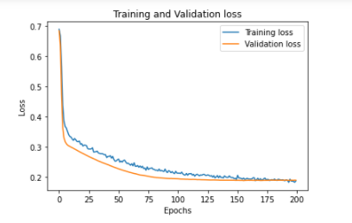

**Model accuracy:**

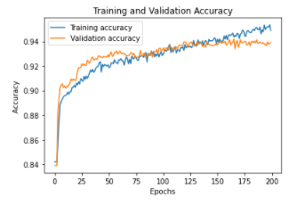

**Confusion matrix:**

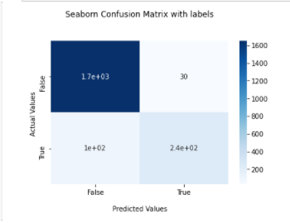

**ROC:**

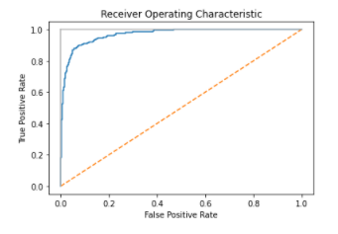

* 1. **SVM Results**

**Confusion matrix:**

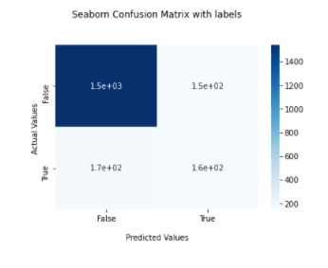

**ROC:**

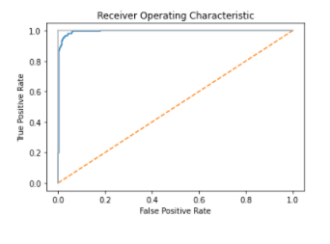

II. IMAGE DATASET

1. Project Introduction

* 1. **Dataset Name**

Rock ,Paper and Scissors

* 1. **Number of classes and their labels**

3 , (Rock ,Paper and Scissors )

* 1. **Dataset Images Numbers and size**

**5080 (300x200)**

* 1. **Training, Validation and Testing**

80% for Training , 20% for validation and testing

2. Implementation Details

* + 1. **Extracted Features**

Gray_scaled

* + 1. **Cross-validation**

None

* + 1. **Artificial Neural Network (ANN)**
* **Hyper-parameters**

Optimizer = SGD (learning_rate=0.001, momentum=0.999, decay=0.001)

loss='mean_squared_error'

batch_size = 10,

epochs =100,

* + 1. **Support Vector Machine** **(SVM)**
* **Hyper-parameters**

kernel='linear'

,gamma='auto'

3. Models Results

**For each model you should show all these results for your model on testing data** (loss curve, accuracy, confusion matrix, ROC curve)

* 1. **ANN Results**

**Model Loss :**

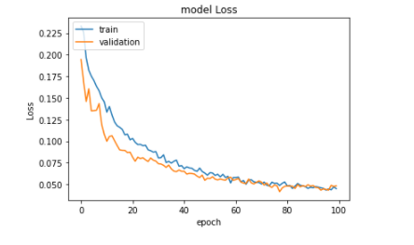

**Model accuracy:**

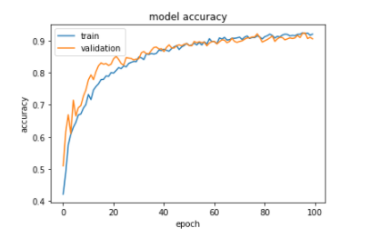

**Confusion matrix:**

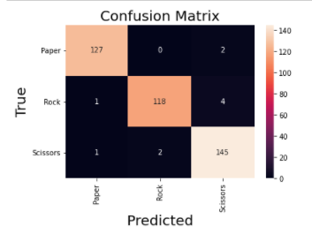

**ROC:**

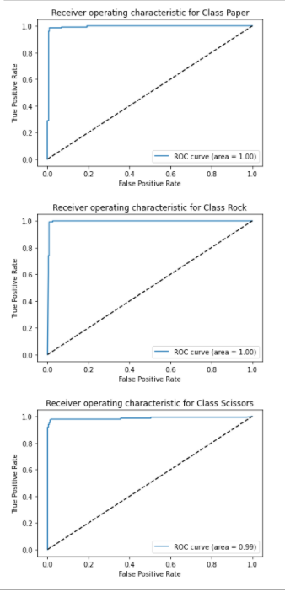

* 1. **SVM Results**

**Confusion matrix:**

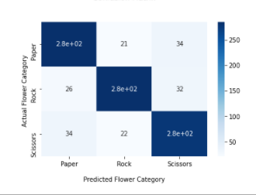

**ROC:**