Clustering basics: Clustering is the process of dividing a dataset into groups, or clusters, where data points within the same cluster are more similar to each other than to those in other clusters. Doesn't rely on labeled data but finds patterns.
Used for customer segmentation, anomaly detection, image segmentation

in supervised learning we try to predict an unknown variable from known variable. ( regression , classification)
in unsupervised learning we are trying to fidn patterns in data and not predict.

Types of clustering: two main types

- Hierarchical clustering: This method creates a tree-like structure of clusters, which can be visualized as a dendrogram. It can be one of the below
- agglomerative (starting with individual data points as clusters and merging them)
- divisive (starting with all data points in a single cluster and dividing them).
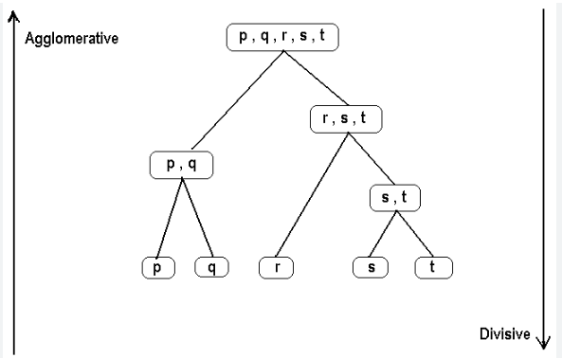
- Partitioning clustering: In this approach, data points are directly assigned to clusters, and it often involves iterative optimization. Examples include K-Means, DBSCAN, and Gaussian Mixture Models (GMM).
- K means: It aims to partition data into K clusters (groups) based on their similarity , where K is a predefined number.To group 2 rows together we need to see how close they are from each other. We group thye closest rows. We use eucledian distance to find the distance between 2 rows. Each cluster is assigned a centre and the eucledian distance from each datapoint to centre is calculated.
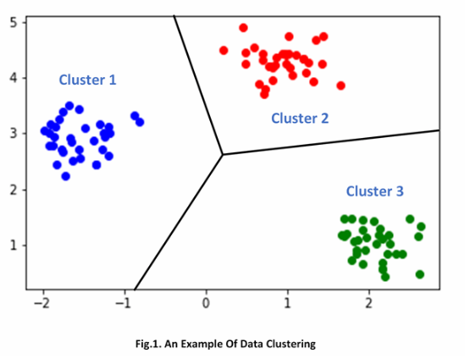

- DBSCAN (Density-Based Spatial Clustering of Applications with Noise): algorithm that works on the assumption that clusters are dense regions in space separated by regions of lower density. It groups 'densely grouped' data points into a single cluster.
These clusters can have arbitrary shapes, as long as long data points are in densed region they will be separate from region of lower density. Unlike k-means these don't ask me for a cluster numbe priorly but identifies clusters based on density of data points.
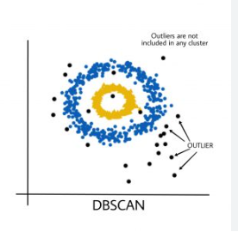
- Gaussian Mixture Models (GMM):

K - Mean clustering:

Theory:
- k-means select k data points as initial centroid.
- assign each data point to the nearest cluster centroid using eucledian distance
- for each cluster , the algo will calculate the mean of all data points in that cluster and this mean becomes new centroid.
- if the centroid have changed the algo repeats calculation as long as it doesn't change . centroid stabilized
- so the target is to reduce/minimzes the distance between centroids and data points in that cluster.

Dataset: dataset is unlabelled, means target variable is not there. so we have to find relationship with all columns and eventually plot 1 variable against another
GOAL: study the characteristics of an unlabelled dataset and find pattern/relationship between variables.

Create synthetic dataset:

Create blobs with sk learn: blobs = cluster= group

below we will create a synthetic dataset with specified blobs:
synthetic datasets: Artificially generated datasets that are created for specific purposes, such as model testing, experimentation

How to find optimal K:
Elbow method: more cluster I have less sum of squared error I wil get. For example 10 poitns but 2 cluster has bigger error (distance) than 10 points and 10 cluster where each centroids has a point for it. So more cluster less error.
So I keep increasing cluster until the point where the error decreases less than previous increase of clusters.

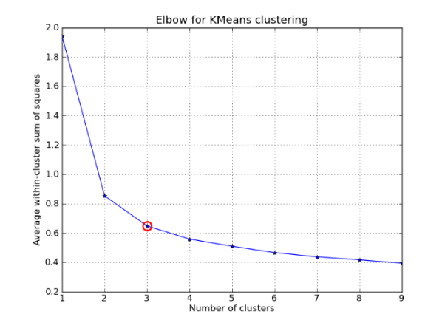

GOAL:

Complete setps from scratch:

- Clean data
- Drop irrelevant column
- Convert all columns to numerical value (work on categorical/datetime)
- normalize/standardize SCALE columns
- Find optimal K using elbow method
- from creating k-means to finding centre point I let python find relationship between all data columns. I get all the avriables
- create an additional column using cluster labels value for each data point. ( we know which data assigned to which cluster)

visualization goal:
even if it's a plot of 2 features our graph will give all the data points (from 2 features) that belong to k number of clusters.
