RankSim Learning Notes
Deep Imbalanced Regression for Significant Wave Height Estimation
Project-focused self-learning reference | PyTorch implementation + intuition + industry relevance

1. One-sentence idea
RankSim encourages samples that are close in continuous label space to have a similar neighbor ordering in learned feature space.
For SWH estimation, if a 0.20 m sample is closer in SWH to 0.30 m than to 1.20 m or 2.40 m, RankSim tries to make the learned feature representation preserve that same ordering.

2. Why RankSim exists
Deep regression models trained on imbalanced data can become biased toward densely populated target regions. In SWH estimation, calm or low-wave conditions may be common while high-SWH conditions are rare.
A conventional regression loss such as MSE or Huber asks whether the final predicted SWH is numerically close to the target. RankSim adds a second objective: the relative neighborhood structure in feature space should follow the relative neighborhood structure in SWH label space.
Therefore, RankSim is a regularizer. It does not replace the base regression loss.

3. Visual intuition
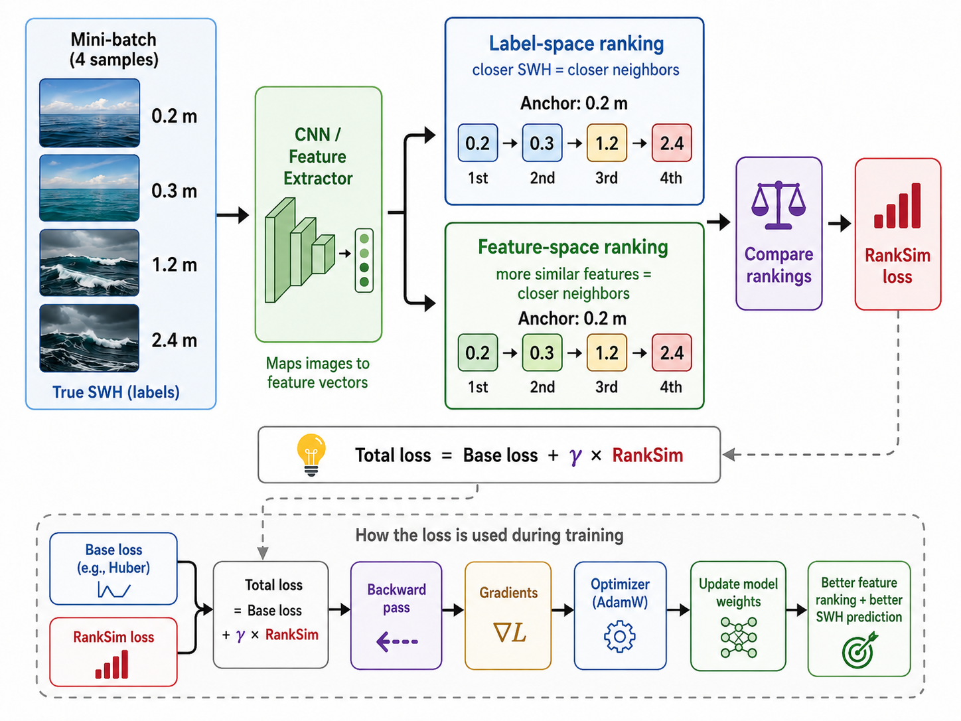
Figure 1. RankSim workflow for SWH estimation and training optimization.

4. RankSim versus other imbalance mechanisms
Method type | What it changes
Plain Huber / MSE / MRE | How prediction error is penalized
Stratified Sampler | Which samples enter each mini-batch
LDS | How much each sample's base loss is weighted
RankSim | How learned feature relationships are organized
ConR | Adds a contrastive-style representation regularizer

5. Mathematical notation
M = {(x_i, y_i)} for i = 1,...,M
- x_i: input image
- y_i: continuous target, here SWH in meters
- z_i = f(x_i; θ): learned feature representation
- S^y: pairwise similarity matrix in label space
- S^z: pairwise similarity matrix in feature space
- rk(·): ranking operator
- L_RankSim: ranking-similarity regularization loss
- γ (gamma): weight of the RankSim regularizer in the total loss
- λ (lambda): interpolation strength used by the differentiable ranking operator

6. Step 1: Build label-space relationships
For scalar regression labels, RankSim uses negative absolute distance as label similarity:
S^y_ij = -|y_i - y_j|
The negative sign converts a distance into a similarity score: smaller label distance becomes larger similarity.

Toy SWH batch
y = [0.20, 0.30, 1.20, 2.40] m
Using 0.20 m as the anchor:
|0.20-0.20| = 0.00
|0.20-0.30| = 0.10
|0.20-1.20| = 1.00
|0.20-2.40| = 2.20
Desired neighbor order:
0.20 m -> 0.30 m -> 1.20 m -> 2.40 m
closest farthest

7. Step 2: Extract deep features
In the project's InceptionV3 RankSim model, the network exposes the penultimate embedding before the final regression head. The embedding dimension is 2048.
Image
↓
InceptionV3 backbone
↓
2048-D feature z
↓
Regression head
↓
Predicted SWH
The base regression loss uses the scalar prediction. RankSim uses the 2048-D features.
features = model.forward_features(images)
pred = model.forward_head(features)

8. Step 3: Build feature-space similarities
The project uses cosine similarity between feature vectors:
S^z_ij = (z_i^T z_j) / (||z_i||_2 ||z_j||_2)
- Cosine similarity near 1: highly similar feature direction.
- Near 0: weak relationship.
- Near -1: opposite direction.
The implementation normalizes the feature vectors and uses matrix multiplication to obtain the full pairwise similarity matrix.
z = F.normalize(features, dim=1)
S_z = z @ z.T
features: [B,D] → S^z: [B,B]

9. Step 4: Convert similarities into rankings
RankSim does not require exact similarity values to match. It asks whether the order of neighbors is correct.
For an anchor at 0.20 m, suppose the desired label-space order is:
[0.20, 0.30, 1.20, 2.40]
but the current feature-space order is:
[0.20, 1.20, 0.30, 2.40]
Then 1.20 m has incorrectly been ranked closer than 0.30 m, so the ranking regularizer becomes non-zero.

10. Normalized ranks used in the implementation
With four items, the normalized ranks are:
[0.25, 0.50, 0.75, 1.00]
- 0.25: most similar
- 0.50: second most similar
- 0.75: third
- 1.00: least similar

11. Step 5: Calculate RankSim loss
For each anchor, the implementation compares the label-space rank vector and the feature-space rank vector using mean squared error.
L_i^RankSim = MSE(r_i^z, r_i^y)
L_RankSim = (1/M) Σ_i L_i^RankSim

Numeric example
r^y = [0.25, 0.50, 0.75, 1.00]
r^z = [0.25, 0.75, 0.50, 1.00]
L_i = [(0)^2 + (0.25)^2 + (-0.25)^2 + (0)^2] / 4
L_i = (0 + 0.0625 + 0.0625 + 0) / 4 = 0.03125
If both rankings match exactly, the RankSim loss for that anchor is zero.

12. Duplicate target handling inside a batch
The actual reference implementation first finds unique target values. If a target value appears multiple times, it randomly keeps at most one sample for that target in the ranking subset.
- This reduces ties in label-space ranking.
- It boosts the relative representation of less frequent target values inside the ranking subset.
- It is not the same as Stratified Sampling because it does not construct the DataLoader batch; it operates after the batch already exists.

13. Why differentiable ranking is needed
Ordinary sorting/ranking is piecewise constant. Small changes to the inputs often do not change the rank, so the ordinary derivative is zero or uninformative almost everywhere.
RankSim uses a black-box differentiable ranking technique. The project's `TrueRanker` computes the real rank in the forward pass and uses a perturbed ranking in the backward pass to obtain an informative gradient approximation.
a_λ = a + λ (∂L/∂rk)
∂L/∂a ≈ -(1/λ) [rk(a) - rk(a_λ)]

14. Lambda and gamma: do not confuse them
Parameter | Role | Current project value
λ (lambda) | Interpolation/perturbation strength in differentiable ranking; NOT a loss weight. | 1.0
γ (gamma) | Weight multiplying RankSim in the total objective. | 1.0

15. Current SWH RankSim configuration
Setting | Value
Backbone | InceptionV3
Input size | 299 × 299
Pretrained | ImageNet
Penultimate feature | 2048-D
Regression target | Raw SWH in meters
Base loss | Huber
Batch size | 32
Optimizer | AdamW
Learning rate | 1e-4
Weight decay | 1e-4
RankSim λ | 1.0
RankSim γ | 1.0
Validation monitor | val_huber
Implementation note: some inherited comments in the configuration/docstrings mention MSE because the RankSim mechanism was reused across multiple loss experiments. The actual provided configuration explicitly sets the current base loss to Huber.

16. Full training flow in this experiment
1. Load webcam images and raw SWH targets
↓
2. InceptionV3 forward_features()
↓
2048-D feature vectors
↙ ↘
3A. Regression head 3B. RankSim branch
↓ ↓
Predicted SWH Label and feature rankings
↓ ↓
4A. Huber loss RankSim loss
↘ ↙
5. Total loss
L = Huber + γ RankSim
↓
6. backward()
↓
Gradients through head + backbone
↓
7. AdamW step
↓
Updated weights

17. Does RankSim itself get optimized?
Yes, in the sense that the model is optimized to reduce the RankSim term. But RankSim is a loss term, not a separate trainable neural network.
- RankSim loss is computed from the current CNN features.
- Backward computes gradients of RankSim with respect to those features.
- Those gradients propagate into the feature extractor.
- AdamW updates the model parameters.
- Future feature representations tend to produce rankings that better match SWH-label rankings.
The precise statement is: the model parameters are optimized to reduce both the base regression loss and the RankSim regularization loss.

18. How the two gradient signals combine
L_total = L_Huber + γ L_RankSim
∇_θ L_total = ∇_θ L_Huber + γ ∇_θ L_RankSim
Huber gradient:
"Make the predicted SWH numerically correct."
RankSim gradient:
"Make the learned representation respect SWH ordering."
Combined gradient:
"Improve prediction while learning a meaningful SWH-aware feature space.

19. Why this can help imbalanced regression
A rare high-SWH sample may appear only a few times. RankSim can still exploit its position relative to other continuous labels. The training signal becomes richer than simply asking the network to predict the rare scalar value correctly.
Direct regression instruction:
"Predict 2.30 m correctly."
Additional RankSim instruction:
"2.30 m should be more similar to nearby high-SWH conditions
than to calm 0.20-0.30 m conditions.

20. Local versus global relationships
The RankSim paper emphasizes that the method captures both nearby and distant relationships. For an anchor at 0.30 m:
0.35 m → very close
0.60 m → somewhat close
1.20 m → farther
2.40 m → much farther
The method tries to preserve the whole relative ordering rather than only a local neighborhood.

21. When RankSim is useful
- Continuous and naturally ordered targets such as age, depth, SWH, temperature, price, or severity.
- Imbalanced target distributions with dense common regions and sparse rare/extreme regions.
- Tasks where learned representation quality matters for generalization or downstream use.
- Problems where label distance contains meaningful information.
- Models where penultimate features can be accessed during training.

22. When RankSim may be less useful
- Very small batches: fewer meaningful pairwise relationships are available.
- Very noisy labels: target ordering may contain unreliable supervision.
- Problems where closeness in target value does not correspond to meaningful representational similarity.
- Large batches with memory constraints: the pairwise similarity matrix scales as B × B.
- Poor hyperparameter balance: an excessively strong ranking term may compete with direct regression learning.

23. Relation to other representation-learning methods
RankSim is related to metric learning, contrastive learning, learning to rank, and ordinal regression, but it is not identical to them.
Typical contrastive idea:
positive pair → pull together
negative pair → push apart
RankSim idea:
for each anchor → preserve the complete relative ordering of neighbors

24. Real-world applications

Computer vision
- Age estimation
- Depth estimation
- Crowd-density regression
- Medical severity estimation
- Material/property regression from images

Robotics and perception
- Range/depth estimation
- Terrain roughness
- Traversability scores
- Environmental-state estimation

Marine and ocean engineering
- Significant wave height
- Wave period / sea-state severity
- Wind-wave condition estimation
- Underwater visibility or turbidity estimation

Industrial AI
- Remaining useful life
- Equipment degradation
- Quality scores
- Manufacturing process variables
- Demand or price regression

25. Why this matters for an ML / Deep Learning Engineer

Loss design
You learn to separate prediction loss, sample weighting, sampling strategy, and representation regularization.

Representation learning
Modern deep learning depends not only on final predictions but also on the geometry and organization of internal embeddings.

Pairwise computation
The B × B similarity pattern appears in contrastive learning, retrieval, metric learning, graph construction, and nearest-neighbor systems.

Differentiability
RankSim is a concrete example of making a useful discrete operation trainable. Similar problems appear with top-k selection, assignment, matching, sorting, and structured prediction.

Tensor-shape reasoning
features [B,D] → normalized features [B,D] → similarity [B,B] → rank row [1,B]

Experimental design
A fair ablation keeps the backbone, data split, optimizer, augmentation, and evaluation protocol fixed while adding or removing the RankSim term.

26. Questions a professor may ask
Q: What is the motivation? A: Close continuous labels should produce a consistent neighbor ordering in feature space.
Q: Does RankSim replace Huber/MSE? A: No. It is added as a regularization term.
Q: Where does RankSim act? A: On the penultimate learned features.
Q: How is label similarity measured? A: Negative absolute distance between targets.
Q: How is feature similarity measured? A: Cosine similarity in this implementation.
Q: What is actually compared? A: Label-space neighbor ranking versus feature-space neighbor ranking.
Q: What compares the rankings? A: MSE between normalized rank vectors.
Q: Why special differentiation? A: Ordinary ranking is non-differentiable / piecewise constant.
Q: What is gamma? A: The regularizer weight in total loss.
Q: What is lambda? A: The differentiable-ranking interpolation strength.
Q: Does RankSim explicitly upweight rare samples? A: No. Its main mechanism is representation-structure regularization.
Q: Does it need WMO bins? A: No. The core ranking uses continuous SWH labels directly.

27. ML / DL interview questions to prepare
- What is regularization and why can it improve generalization?
- Why can a meaningful embedding space help a regression model?
- Cosine similarity versus Euclidean distance?
- Ranking loss versus direct regression loss?
- Why is sorting/ranking non-differentiable?
- What is a custom torch.autograd.Function?
- Why does z @ z.T give pairwise cosine similarity after L2 normalization?
- How do gradients from two losses combine?
- What happens if features are detached before the RankSim branch?
- How would you tune gamma and diagnose instability?
- How does batch size affect pairwise representation learning?
- What is the computational/memory complexity of a B × B similarity matrix?

28. Practical debugging checklist
- ☐ Confirm features have shape [B, D].
- ☐ Confirm targets have shape [B].
- ☐ Confirm features require gradients.
- ☐ Ensure there is no accidental detach before RankSim.
- ☐ Confirm cosine-similarity matrix is [B, B].
- ☐ Verify label-rank and feature-rank direction conventions match.
- ☐ Confirm RankSim loss is finite.
- ☐ Check that RankSim creates non-zero feature gradients when rankings disagree.
- ☐ Confirm total loss = base_loss + gamma × ranksim_loss.
- ☐ During development, log base loss and RankSim loss separately.
- ☐ Check sensitivity to gamma, lambda, and batch size.
- ☐ Evaluate rare/few-shot SWH regions separately.

29. One-minute verbal explanation
RankSim is a representation regularizer for imbalanced regression. Continuous labels contain ordering information. For each sample in a mini-batch, RankSim ranks the other samples according to their distance in label space and also ranks them according to cosine similarity of their learned features. It penalizes disagreement between these rankings. In the SWH experiment, InceptionV3 produces a 2048-dimensional feature vector, and RankSim encourages samples with similar SWH to have a consistent neighbor ordering in that feature space. The RankSim term is added to the base Huber loss, so training optimizes both accurate SWH prediction and an SWH-aware representation.

30. Five things to remember
- RankSim aligns neighbor ranking between label space and feature space.
- It is a regularizer, not a replacement for the base loss.
- Label similarity is negative absolute target distance.
- Feature similarity is cosine similarity in this implementation.
- Total loss is base loss + gamma × RankSim loss.

31. Source-grounded project implementation
The provided project implementation uses the following core operations:
batch_unique_targets = torch.unique(targets)
xxt = torch.matmul(
F.normalize(x_flat, dim=1),
F.normalize(x_flat, dim=1).permute(1, 0)
)
for i in range(n):
label_ranks = rank_normalised(
(-torch.abs(y[i] - y)).unsqueeze(0)
)
feature_ranks = TrueRanker.apply(
xxt[i].unsqueeze(0),
interp_strength_lambda
)
loss = loss + F.mse_loss(
feature_ranks,
label_ranks
)
return loss / n

32. References
- Gong, Y., Mori, G., & Tung, F. (2022). RankSim: Ranking Similarity Regularization for Deep Imbalanced Regression. Proceedings of the 39th International Conference on Machine Learning (ICML), PMLR 162.
- Vlastelica, M., Paulus, A., Musil, V., Martius, G., & Rolínek, M. (2020). Differentiation of Blackbox Combinatorial Solvers. International Conference on Learning Representations (ICLR).
- Yang, Y., Zha, K., Chen, Y.-C., Wang, H., & Katabi, D. (2021). Delving into Deep Imbalanced Regression. International Conference on Machine Learning (ICML).
- Project files: src/ranksim_loss.py; src/ranking.py; split src/model.py; configs/inceptionv3_full_raw_huber_ranksim.yaml.

33. Learning checkpoint before moving to LDS
You should be able to answer these without notes:
- What does RankSim compare?
- Why is it useful for continuous labels?
- Why does it operate on features?
- Why is cosine similarity used?
- Why is ranking difficult to differentiate?
- What is the difference between gamma and lambda?
- How does RankSim combine with Huber?
- How is RankSim different from Stratified Sampling and LDS?

