Q. What is the Definition of operating system?
=> Definition of Operating System (OS):
An Operating System (OS) is system software that acts as an interface between the user and computer hardware, managing resources and providing services for application programs.
Key Points:
- It controls and coordinates hardware components (CPU, memory, I/O devices).
- It provides an environment for program execution.
- It manages system resources efficiently.
Example:
Common operating systems include Windows, Linux, and macOS.
Q. Architecture of OS.
=> 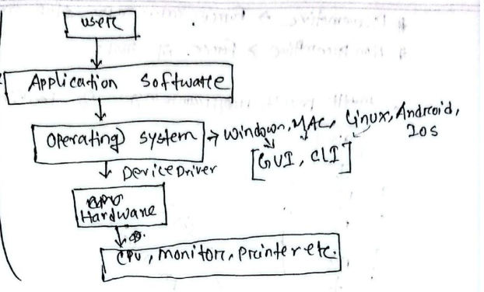

Q. What are the main functions of OS?
=> Main Functions of Operating System (OS):
- Process Management
Handles creation, scheduling, and termination of processes. It ensures the CPU is used efficiently.
- Memory Management
Allocates and deallocates memory to programs and manages primary memory (RAM).
- File System Management
Organizes and manages files and directories on storage devices.
- Device Management
Controls input/output devices (keyboard, printer, disk) using drivers.
- Security & Protection
Protects data and resources by preventing unauthorized access.
- User Interface
Provides interaction between user and system (CLI or GUI).
Example:
Operating systems like Windows and Linux perform all these functions.
Q. Types of operating system.
=> Types of Operating System (OS):
- Batch Operating System
In this system, similar jobs are grouped into batches and executed sequentially without user interaction. It reduces idle time but has no immediate response.
- Multiprogramming Operating System
Several programs are loaded into memory simultaneously. When one program waits for I/O, the CPU switches to another, increasing CPU utilization and reducing idle time.
- Multiprocessing Operating System
Uses two or more CPUs to execute multiple processes at the same time, improving performance and reliability.
- Multitasking Operating System
Allows a single user to run multiple programs concurrently (e.g., browsing and typing at the same time).
Example:
Operating systems like Linux and Windows support multitasking and multiuser features.
Q. Define program, process.
=> Definition of Program and Process:
1. Program:
A program is a set of instructions written in a programming language and stored on disk. It is a passive entity (not executing).
2. Process:
A process is a program that is currently being executed. It is an active entity and includes the program code, data, and current state (like program counter, registers).
Key Difference:
- Program → Passive (stored)
- Process → Active (running)
Example:
A file like a .exe in Windows is a program, but when you run it, it becomes a process.
Q. Define of HD, RAM, ROM, Cache, register.
=> Definitions of HD, RAM, ROM, Cache, and Register:
1. Hard Disk (HD)
A hard disk is a secondary storage device used for permanent storage of data, programs, and files. It is non-volatile, meaning data is not lost when power is off.
2. RAM (Random Access Memory)
RAM is the primary memory used to store data and instructions currently being used by the CPU. It is volatile, so data is lost when the system is turned off.

3. ROM (Read Only Memory)
ROM is a type of permanent memory that stores essential instructions for starting the computer. It is non-volatile and cannot be easily modified.
4. Cache Memory
Cache memory is a very fast memory located close to the CPU. It stores frequently used data and instructions to speed up processing.
5. Register
A register is the smallest and fastest memory inside the CPU used to temporarily store data and instructions during processing.

Summary:
Speed order: Register > Cache > RAM > Hard Disk
Q. Definition of preemptive and non-preemptive.
=> Preemptive and Non-Preemptive Scheduling (Definitions):
1. Preemptive Scheduling
Preemptive scheduling is a CPU scheduling method in which the CPU can be taken away (interrupted) from a running process and assigned to another process with higher priority or shorter burst time.
Key Point:
- A running process can be stopped in between execution.
Example:
If a high-priority process arrives, it can interrupt the current process.
2. Non-Preemptive Scheduling
Non-preemptive scheduling is a method in which once a process starts executing, it cannot be interrupted until it completes its execution or moves to waiting state.
Key Point:
- A running process runs until completion.
Example:
First-Come First-Served (FCFS) is a non-preemptive scheduling algorithm.

Difference (Quick):
- Preemptive → CPU can be taken away
- Non-preemptive → CPU cannot be taken away once assigned
Q. How Multiprogramming, Multitasking & Multiprocessing Works?
=>
1. Multiprogramming
Multiprogramming is a technique where multiple programs are kept in main memory at the same time. The CPU executes one program, and when that program waits for I/O (like disk or input), the CPU switches to another program.
How it works:
- Several programs are loaded into RAM.
- CPU starts executing one program.
- If that program goes into waiting state (e.g., I/O request), CPU switches to another ready program.
- This continues to ensure CPU is always busy.
Goal: Maximize CPU utilization (reduce CPU idle time).
2. Multitasking
Multitasking is an extension of multiprogramming where a single user can run multiple tasks (applications) simultaneously.
How it works:
- CPU divides time into small time slices (time-sharing).
- Each task gets a small CPU time.
- CPU switches rapidly between tasks (context switching).
- It creates the illusion that all tasks are running at the same time.
Goal: Provide fast response and smooth user experience.
Key Difference:
- Multiprogramming: Focus on CPU efficiency (background process switching when waiting)
- Multitasking: Focus on user interaction (multiple apps running at same time)
3. Multiprocessing
Multiprocessing is a technique where a computer system uses two or more CPUs (processors/cores) to execute multiple processes at the same time.
How it works:
- The system has multiple CPUs or multi-core processors.
- The operating system divides processes and assigns them to different CPUs.
- Each CPU executes a different process simultaneously.
- Processes run in true parallel execution (not switching like single CPU systems).
- This improves overall system speed and performance.
Goal:
Increase processing speed, efficiency, and system reliability by executing multiple tasks at the same time.
Example:
In modern operating systems, multiprogramming, multitasking, and multiprocessing work together. For example, several programs are loaded into memory (multiprogramming), a user can play music, browse Chrome, and edit a document at the same time (multitasking), and in a multi-core system, different CPUs can execute these tasks simultaneously (multiprocessing).
Q. Definition of service/function.
=> Definition of Service/Function (Operating System):
A service (or function) of an operating system is a set of operations provided by the OS to users and application programs to help them perform tasks efficiently and easily.
Example:
Services like file creation, program execution, and memory allocation are provided by operating systems such as Windows and Linux.
Q. Explain dead lock.
=> Deadlock (Definition and Explanation):
A deadlock is a situation in an operating system where two or more processes are permanently blocked, because each process is waiting for a resource held by another process, and none of them can proceed.
How Deadlock Occurs:
- Process A holds Resource 1 and waits for Resource 2
- Process B holds Resource 2 and waits for Resource 1
- Both processes keep waiting forever → deadlock
Necessary Conditions for Deadlock (Coffman Conditions):
- Mutual Exclusion – Only one process can use a resource at a time
- Hold and Wait – A process holds one resource and waits for another
- No Preemption – Resources cannot be forcibly taken
- Circular Wait – A circular chain of processes waiting for each other
Result:
- System gets stuck
- No process can move forward
- CPU resources are wasted

Example:
Two processes waiting for each other’s locked files or printers in operating systems like Windows or Linux.
Q. Define system call, user mode, kernel mode.
=> 1. System Call
A system call is a mechanism that allows a user program to request a service from the operating system kernel. It provides an interface between user applications and hardware resources.
Example: file operations like open(), read(), write().
2. User Mode
User mode is a restricted mode in which normal applications run. In this mode, programs cannot directly access hardware or critical system resources. They must request services through system calls.
3. Kernel Mode
Kernel mode is a privileged mode where the operating system kernel runs with full access to system resources and hardware. It can execute any instruction and manage all system operations.
Key Difference:
- User Mode → Limited access, safe execution
- Kernel Mode → Full access, controls entire system
Q. Explain system call sequences to copy the content of one file to another.
=> 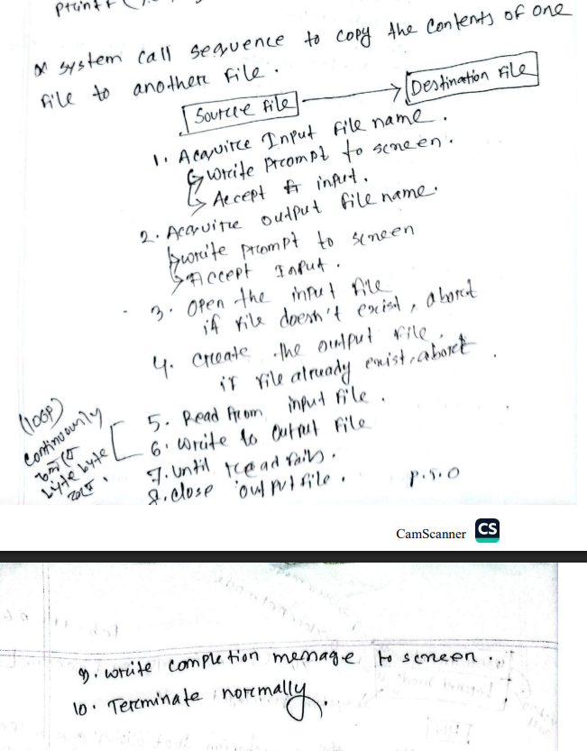
Q. Types of system call.
=> 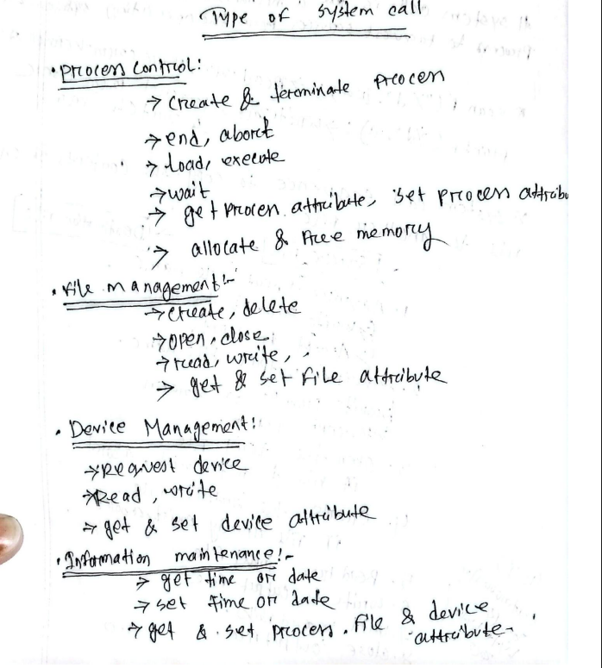
Q. Why is an Operating System platform dependent?
=> An operating system is called platform dependent because it is designed to work with a specific hardware architecture and processor type. Different hardware systems (such as x86, ARM, etc.) have different instruction sets and hardware designs, so the OS must be specially built or modified to match that platform.
Explanation:
- The OS directly interacts with hardware components like CPU, memory, and I/O devices.
- Since hardware architectures differ, the OS must be compatible with the specific platform.
- Therefore, an OS written for one platform cannot directly run on another without changes or re-compilation.
Example:
An OS designed for x86 processors cannot directly run on ARM-based devices without modification.
Q. Explain simple structure with diagram.
=> Simple Structure (Definition):
A simple structure operating system is an OS where all components are combined into a single system without clear separation of modules. All services run in one large kernel, making it easy to design but difficult to maintain.
Example: MS-DOS
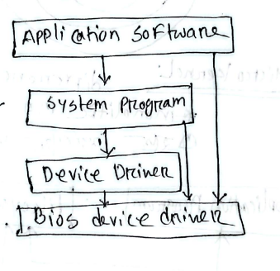
Q. Explain Monolithic Kernel with diagram.
=> Monolithic Kernel (Definition):
A monolithic kernel is an operating system structure where all OS services (process management, memory management, file system, device drivers, etc.) run in a single kernel space as one large program.
Key Point:
All services are tightly integrated and communicate directly within the kernel.
Example: Linux (traditional monolithic kernel)
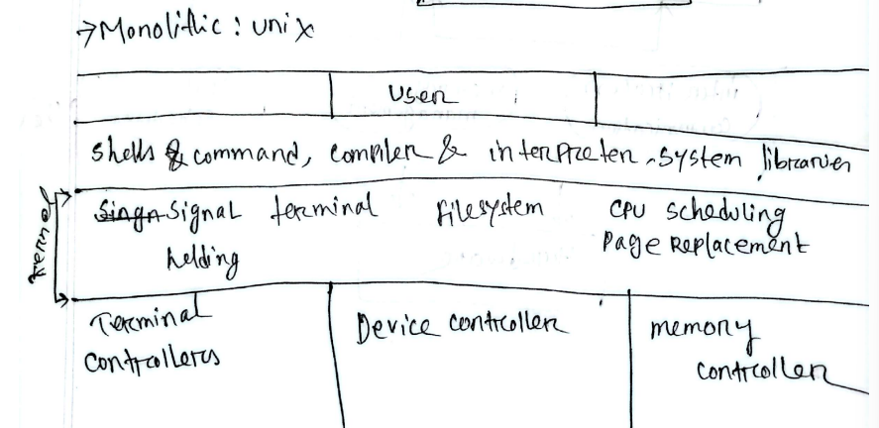
Q. Explain layered structure with diagram.
=> Layered Structure (Operating System):
A layered structure is an OS design where the operating system is divided into different layers, and each layer performs a specific function. Each layer communicates only with the layer above and below it.
Key Points:
- Bottom layer → hardware
- Middle layers → OS services (memory, process, file management)
- Top layer → user interface
- Easier to design, debug, and maintain
Example: Some versions of Windows use layered design concepts.
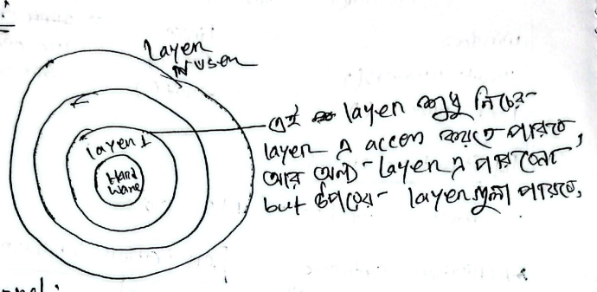
Q. Explain micro kernel structure with diagram.
=> Microkernel (Definition):
A microkernel is an operating system structure in which only the most basic services (like process management, memory management, and inter-process communication) run in the kernel, while other services (like file system and device drivers) run in user space.
Key Points:
- Minimal kernel size
- More secure and reliable
- If one service fails, it does not crash the whole system
- Communication between services happens via message passing
Example: macOS uses a microkernel-based design (XNU kernel).
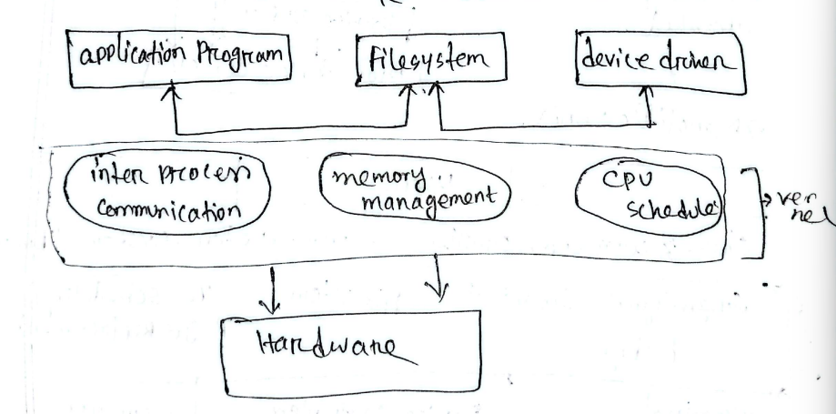
Q. Explain module structure with diagram.
=> Modular Structure (Operating System):
A modular structure is an OS design where the kernel is divided into separate modules, and each module performs a specific function. These modules can be added, removed, or updated independently.
Key Points:
- Flexible and easy to maintain
- Each module works independently but communicates with the kernel
- Improves scalability and debugging
- Combines advantages of monolithic and layered systems
Example: Modern versions of Linux support modular kernel design (loadable kernel modules).
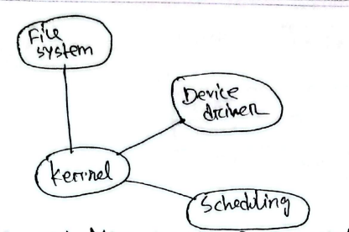

Q. Explain state of process. With diagram.
=> A process is a program in execution, and it goes through different states depending on its activity and resource availability. Modern operating systems often include suspended states to handle memory or scheduling constraints.
1. New
The process is being created. The OS is allocating necessary resources (like memory, process ID).
2. Ready
The process is loaded into main memory and waiting for CPU time. It is ready to run but not yet executing.
3. Running
The CPU is executing the process instructions. Only one process per CPU can be in this state at a time.
4. Waiting (Blocked)
The process cannot proceed until some event occurs (e.g., I/O completion, resource availability).
5. Suspended Waiting
The process is in secondary memory because it cannot proceed, usually waiting for I/O or some condition. It is not in main memory but will return to waiting when swapped back.
6. Suspended Ready
The process is in secondary memory but ready to execute when CPU becomes available. It will return to the ready state when swapped into main memory.
7. Terminated
The process has completed execution and is removed from memory. All resources are released.

Summary (Life Cycle):
New → Ready → Running → Waiting → Suspended Waiting → Suspended Ready → Terminated
This extended model helps the OS manage memory efficiently and handle more processes than available memory.
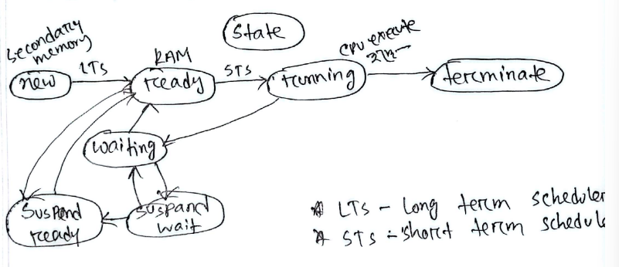
Q. Define LTS and STS.
=> LTS and STS (Definition):
1. LTS (Long-Term Scheduler)
The Long-Term Scheduler is responsible for selecting processes from the job pool (secondary memory) and loading them into main memory (ready queue) for execution.
Key Points:
- Controls the degree of multiprogramming
- Runs less frequently
- Decides which processes enter the system
2. STS (Short-Term Scheduler)
The Short-Term Scheduler (CPU Scheduler) selects a process from the ready queue in main memory and assigns it to the CPU for execution.
Key Points:
- Runs very frequently
- Responsible for CPU scheduling
- Decides which process executes next

Difference (Quick):
- LTS → Job pool to ready queue (controls system load)
- STS → Ready queue to CPU (controls execution)
Q. Explain process address space (memory layout of a process).
=> 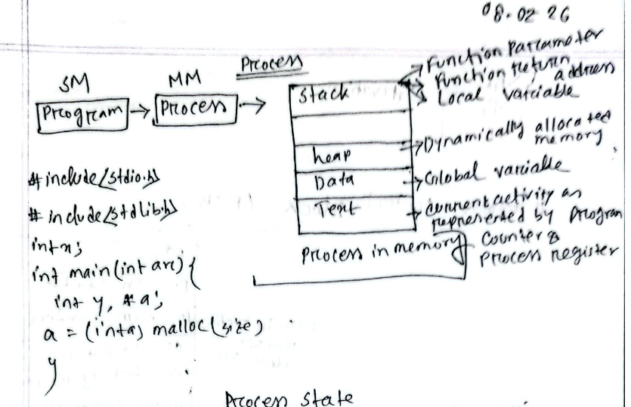
Q. Define starvation.
=> Starvation (Definition):
Starvation is a situation in an operating system where a process waits for a long time or indefinitely to get the required CPU time or resources, because other high-priority processes keep getting preference.
Explanation:
- It usually occurs in priority scheduling systems.
- Low-priority processes are continuously ignored.
- The process never gets a chance to execute.
Example:
A low-priority process keeps waiting while high-priority processes keep entering the system and getting CPU time, causing starvation.

Q. Draw and explain the structure of a Process Control Block.
=> Process Control Block (PCB) – Definition + How it Works:
A Process Control Block (PCB) is a data structure used by the operating system to store all important information about a process. Each process has its own PCB, which acts as a complete record of the process.
Information in PCB:
- Process ID (PID)
- Process State (ready, running, waiting)
- Program Counter (next instruction)
- CPU Registers
- Scheduling Information (priority, queue)
- Memory Management Info
- I/O Status Info
- Accounting Info
How PCB Works:
- When a process is created, the OS creates a PCB for it.
- The PCB is stored in a process table or linked in queues (like ready queue).
- When the CPU switches from one process to another (context switching), the OS:
  - Saves the current process state into its PCB
  - Loads the next process state from its PCB
- The OS uses the PCB to track execution, allocate resources, and manage processes efficiently.
In short:
PCB helps the OS manage, monitor, and switch processes smoothly during execution.
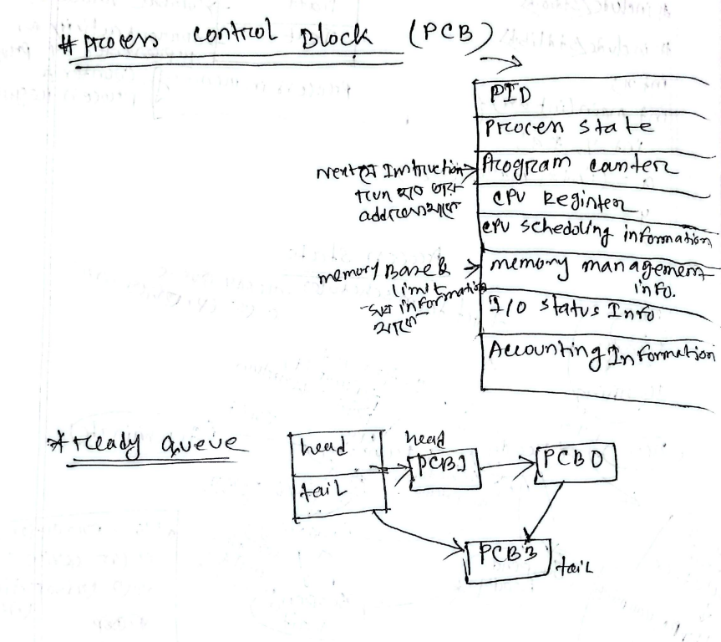
Q. Relation between ready queue and PCB.
=> Relation between Ready Queue and PCB:
The ready queue is a collection of processes that are ready to execute, and it is made up of PCBs (Process Control Blocks).
Explanation:
- Each process has a PCB that stores its information.
- When a process is in the ready state, its PCB is placed in the ready queue.
- The ready queue is usually implemented as a linked list of PCBs.
- The CPU scheduler selects one PCB from the ready queue and assigns the CPU to that process.
In short:
The ready queue contains PCBs, and the OS uses these PCBs to select and manage processes for execution.

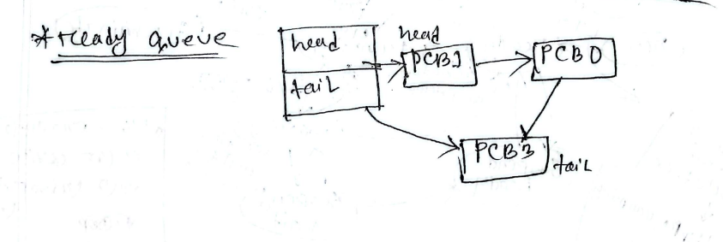
Q. Explain process scheduling representation with diagram.
=> Process scheduling in an operating system is the mechanism that decides which process gets CPU time and when, ensuring efficient multitasking and responsiveness. It manages transitions between states like ready, running, waiting, and terminated, keeping the CPU busy and balancing fairness among processes.
🔑 Core Idea of Process Scheduling
- Definition: Process scheduling is the activity of the OS process manager that removes the running process from the CPU and selects another process based on a scheduling strategy.
- Goal: Maximize CPU utilization, minimize response time, and ensure fairness among processes.
- Context: Essential in multiprogramming systems where multiple processes compete for CPU time.
📊 Process States & Queues (as shown in your diagram)
- Ready Queue → CPU
  - Processes waiting for CPU time are placed in the ready queue.
  - Scheduler picks one to run on the CPU.
- CPU → I/O Request → I/O Wait Queue
  - If a process needs input/output, it leaves the CPU and waits in the I/O queue until the operation completes.
- CPU → Time Slice Expired → Ready Queue
  - In preemptive scheduling, a process is interrupted after its time slice ends and placed back in the ready queue.
- CPU → Create Child Process → Child Termination Wait Queue
  - A process may spawn child processes.
  - Parent waits in the child termination queue until the child finishes.
- CPU → Wait for Interrupt → Interrupt Wait Queue → Interrupt Occur
- A process may pause until an external event (interrupt) occurs.
- Once the interrupt is handled, it resumes execution.
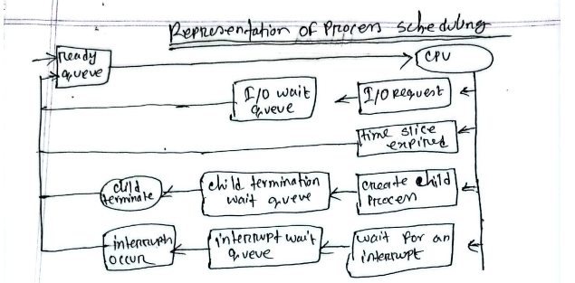
Q. How to work OS between two processes. Explain with diagram.
=> When two processes (say Process 0 and Process 1) need CPU time, the OS acts as the manager. Since the CPU can only execute one process at a time, the OS switches between them by saving and restoring their states.
🔄 Steps of Context Switching
- Process 0 is executing
  - It runs on the CPU until an event occurs (like an interrupt or system call).
- Interrupt/System Call occurs
  - The OS steps in and pauses Process 0.
  - It saves the current state (registers, program counter, etc.) into PCB0 (Process Control Block 0).
- Switch to Process 1
  - The OS loads the saved state of Process 1 from PCB1.
  - Now Process 1 starts executing on the CPU.
- Another Interrupt/System Call occurs
  - The OS pauses Process 1.
  - It saves Process 1’s state into PCB1.
  - Then reloads Process 0’s state from PCB0.
- Cycle repeats
- The OS keeps alternating between processes, giving the illusion that both are running “simultaneously” (this is multitasking).
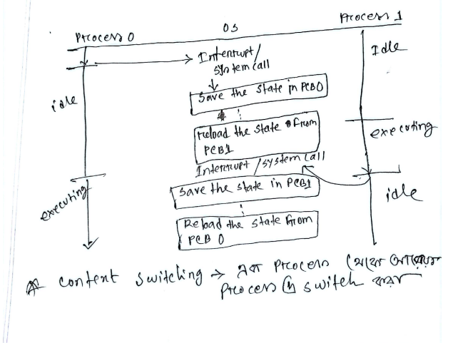
Q. Definition of thread.
=> A thread is the smallest unit of execution within a process. It is a lightweight subprocess that can run independently but shares the same memory and resources of its process.
Key Points:
- A process can have multiple threads
- Threads share code, data, and memory
- Each thread has its own program counter and registers
- Faster and more efficient than processes
In short:
A thread is a part of a process that executes a task independently while sharing resources with other threads.
Q. Explain Operations on Process.
=> Operations on a process are the basic actions performed by the operating system to manage processes during their life cycle.
Main Operations:
1. Process Creation
The OS creates a new process when a program is executed. It allocates memory and creates a PCB (Process Control Block).
2. Process Termination
When execution is complete, the process is terminated, and all resources are released.
3. Terminate
Termination is the operation where a process finishes its execution and is removed from the system, and all its resources are released by the operating system.
4. Cascading Termination
Cascading termination is a situation where termination of one process causes the termination of its child processes automatically.
5. Zombie Process
A zombie process is a process that has completed execution but still has an entry in the process table (PCB) because its parent has not yet read its exit status.

Q. Explain inter process communication.
=> Inter-Process Communication (IPC) is a mechanism that allows processes to communicate and share data with each other while executing in an operating system.
Why IPC is needed:
- Processes often need to exchange information
- Helps in coordination and synchronization
- Improves overall system efficiency
Types of IPC:
1. Shared Memory
- Multiple processes share a common memory space
- Processes can read/write data directly
- Fast communication but needs synchronization 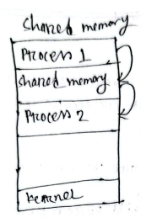
2. Message Passing
- Processes communicate by sending and receiving messages
- No shared memory required
- Easier to implement but slower than shared memory
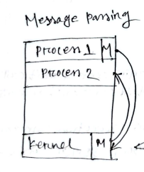
In short:
IPC enables processes to work together, share data, and coordinate execution in a system.
Q. Explain message passing methods.
=> Message Passing Methods (IPC):
Message passing is a method of inter-process communication where processes send and receive messages to exchange data.
Types of Message Passing Methods:
1. Direct Communication
- Processes directly send messages to each other
- Sender and receiver must know each other’s process ID
- Example: send(P, message) and receive(Q, message)
2. Indirect Communication
- Messages are sent through a mailbox (or port)
- Processes do not need to know each other directly
- Multiple processes can share a mailbox
3. Blocking (Synchronous) Communication
- The sending or receiving process waits until the message is delivered
- Ensures synchronization between processes
4. Non-Blocking (Asynchronous) Communication
- Processes do not wait after sending or receiving messages
- Execution continues immediately
5. Buffering
- Messages are temporarily stored in a queue
- Helps sender and receiver communicate smoothly
- Allows processes to send and receive messages without immediate synchronization
In short:
Message passing methods define how processes send, receive, and synchronize messages during communication.

