

University of Asia Pacific
Department of Computer Science and Engineering
CSE 450: VLSI Lab

LAB REPORT

Experiment Number: 1
Experiment Title: Design and Simulation of a CMOS NOR Gate

Submitted by:
Name: Md Istiak Ahammed Nabil
Student ID: 22201133
Section: C

Submitted to:
Md. Rasheduzzaman
Lecturer
Department of Computer Science and Engineering

Date of Submission: 09/04/2026

1. Experiment Name
Design and Simulation of a Two-Input CMOS NOR Gate using Cadence Virtuoso.

2. Objective
- To design the schematic of a two-input CMOS NOR gate using PMOS and NMOS transistors in Cadence Virtuoso.
- To create a schematic symbol for the designed NOR gate.
- To verify the logical (Boolean) behavior of the NOR gate through DC analysis / simulation.
- To observe the voltage transfer characteristics and confirm correct CMOS switching behavior.

3. Apparatus / Hardware & Software Requirements
- Cadence Virtuoso Studio (Schematic Editor, Symbol Editor, ADE Explorer)
- Cadence Spectre / Pegasus simulator for DC analysis
- PMOS transistor (pmos1v, model: g45p1svt, W = 120 nm, L = 45 nm)
- NMOS transistor (nmos1v, model: g45n1svt, W = 120 nm, L = 45 nm)
- Computer with 45 nm GPDK technology library installed

4. Circuit Diagram / Schematic
The NOR gate was implemented using standard CMOS logic: a pull-up network of two PMOS transistors (PM0, PM1) connected in series between VDD and the output node Y, and a pull-down network of two NMOS transistors (NM0, NM1) connected in parallel between the output node Y and GND. Inputs A and B are connected to the gates of the corresponding PMOS-NMOS transistor pairs. The output Y is high only when both A and B are low, and low otherwise, which realizes the Boolean function Y = (A + B)'.
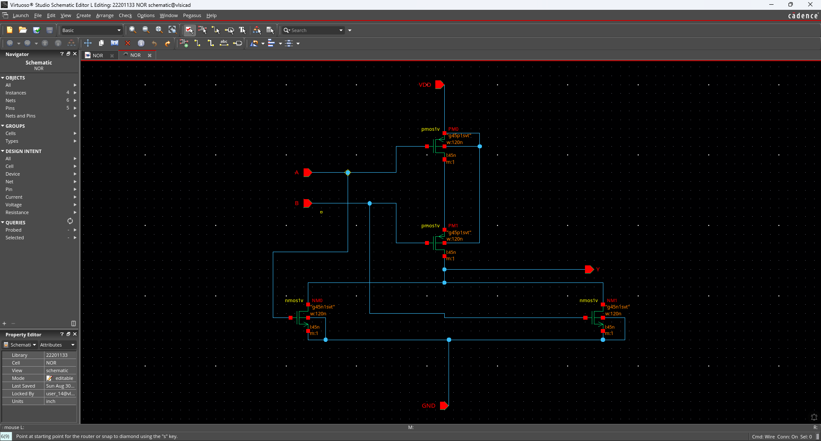
Figure 1: CMOS NOR gate schematic (PM0, PM1 in series; NM0, NM1 in parallel)
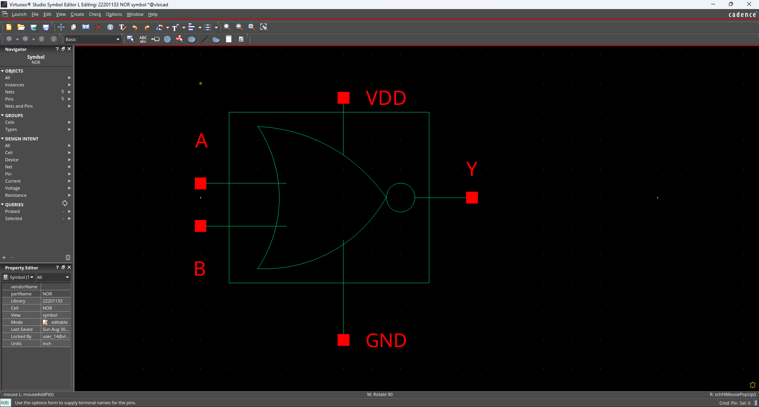
Figure 2: Schematic symbol of the designed NOR gate with pins A, B, Y, VDD, and GND

6. Output Analysis / Observations
A DC analysis testbench (Dc_analysis) was built around the NOR gate symbol to sweep the input combinations and verify the output logic. Based on the CMOS NOR topology implemented:
When both inputs A and B are LOW (0V), both PMOS transistors (PM0, PM1) are ON while both NMOS transistors (NM0, NM1) are OFF, pulling the output Y HIGH (VDD).
When either A or B (or both) is HIGH, at least one PMOS in the series pull-up network turns OFF while the corresponding NMOS in the parallel pull-down network turns ON, pulling the output Y LOW (0V).
The resulting truth table observed/expected from the design is summarized below:
A | B | Y = (A + B)'
0 | 0 | 1
0 | 1 | 0
1 | 0 | 0
1 | 1 | 0

[Insert the DC sweep / voltage transfer characteristic (VTC) plot and transient waveform obtained from the ADE Explorer simulation here, showing output Y switching in accordance with the truth table above.]

7. Result
The CMOS NOR gate was successfully designed and simulated in Cadence Virtuoso. The output logic obtained followed the expected NOR truth table, i.e., Y = (A + B)', confirming that the pull-up (series PMOS) and pull-down (parallel NMOS) networks were correctly implemented. The objective of the experiment was achieved.

8. Github Repository Commits
https://github.com/IstiakNabil/Vlsi-Lab-Report

9. Conclusion
Through this experiment, the CMOS implementation of a two-input NOR gate was studied and realized using series-connected PMOS transistors in the pull-up network and parallel-connected NMOS transistors in the pull-down network. Designing and simulating the gate in Cadence Virtuoso reinforced the understanding of complementary CMOS logic design, transistor sizing, and how the physical arrangement of transistors determines the Boolean function realized at the output.

