**MISSION HACKERS**

**BANGLADESH**

**Assignment No-04**

**Assignment Title: Man In The Middle Attack**

**Course Title: Cybersecurity & Ethical Hacking**

**Submitted by:**

**Name: Istiak Alam**

**Phone: 01765376101**

**Submission Date: 08-07-25**

**Lab Task Topic: Attacking using MITM tools**

**Submitted to:**

**MD Sha Jalal**

**Founder of Mission Hackers Bangladesh**

* **What is Man in The Middle Attack..?**

A **Man-in-the-Middle (MITM) Attack** is a type of cyberattack where the attacker **secretly intercepts, alters, or relays communication between two parties** who believe they are communicating directly with each other.

**Common MITM Techniques**

| ****Technique**** | ****Description**** |
| --- | --- |
| **ARP Spoofing** | Attacker tricks local network into sending packets to their device instead of the real gateway. |
| **DNS Spoofing** | Redirects victim to a fake website by giving wrong IP address for a domain. |
| **HTTPS Downgrade** | Forces victim to use unencrypted HTTP instead of HTTPS. |
| **Wi-Fi Eavesdropping** | Attacker sets up a rogue Wi-Fi hotspot to intercept traffic. |

**Tools we use :**

1. **Beef-xss**
2. **Bettercap**

**Installing Required Tools :**

**Beef-xss :** sudo apt install beef-xss

**Bettercap :** sudo apt install bettercap

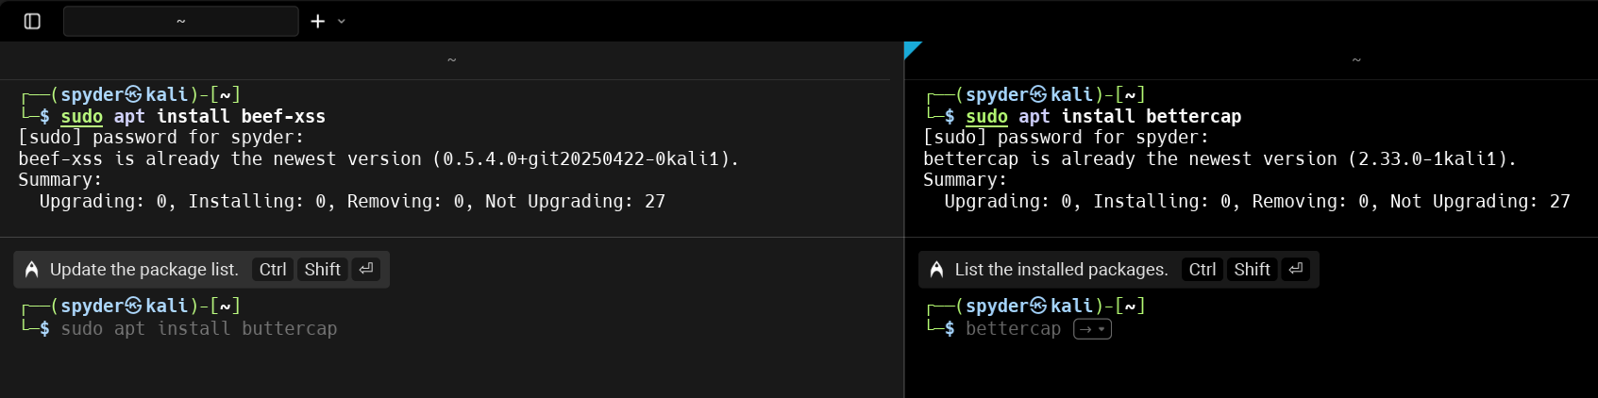

**Runing Beef-xss :**

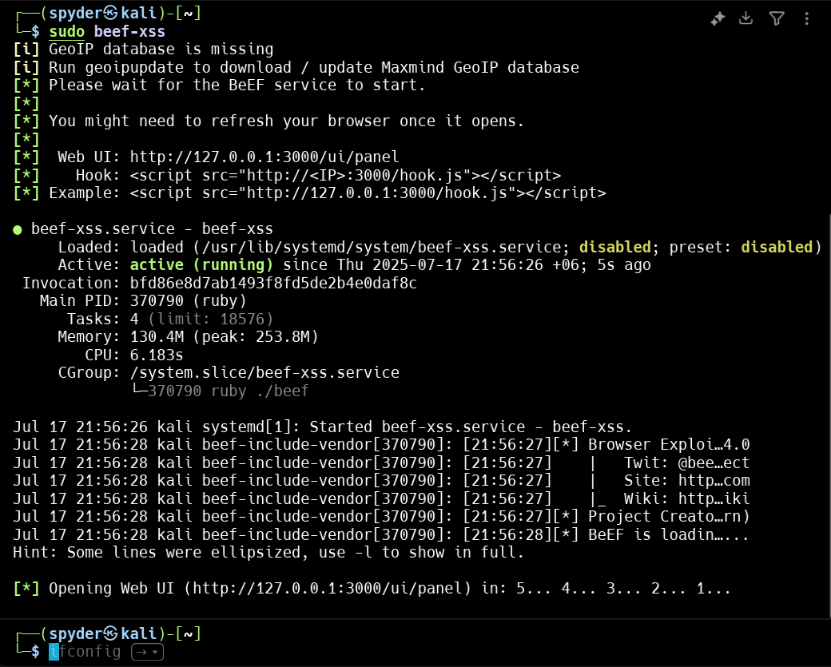

**It will redirect to browser -**

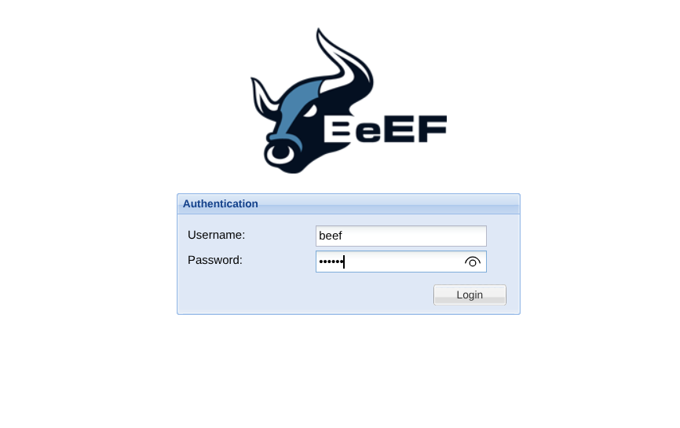

**After login successfully It will show the UI Panel**

