install angular in visual code

npm install -g @angular/cli

instal plugin form

ng add @angular/material

compiling angular and open port 4200

ng s --o

source API Angular

https://www.youtube.com/watch?v=ZJejjL1Iev0

https://devblogs.microsoft.com/premier-developer/getting-started-with-node-js-angular-and-visual-studio-code/

generate component new

ng g c auth/login

generate modul

ng g module bulog

Login

Name, type, name html

username :v_user

password :v_pass

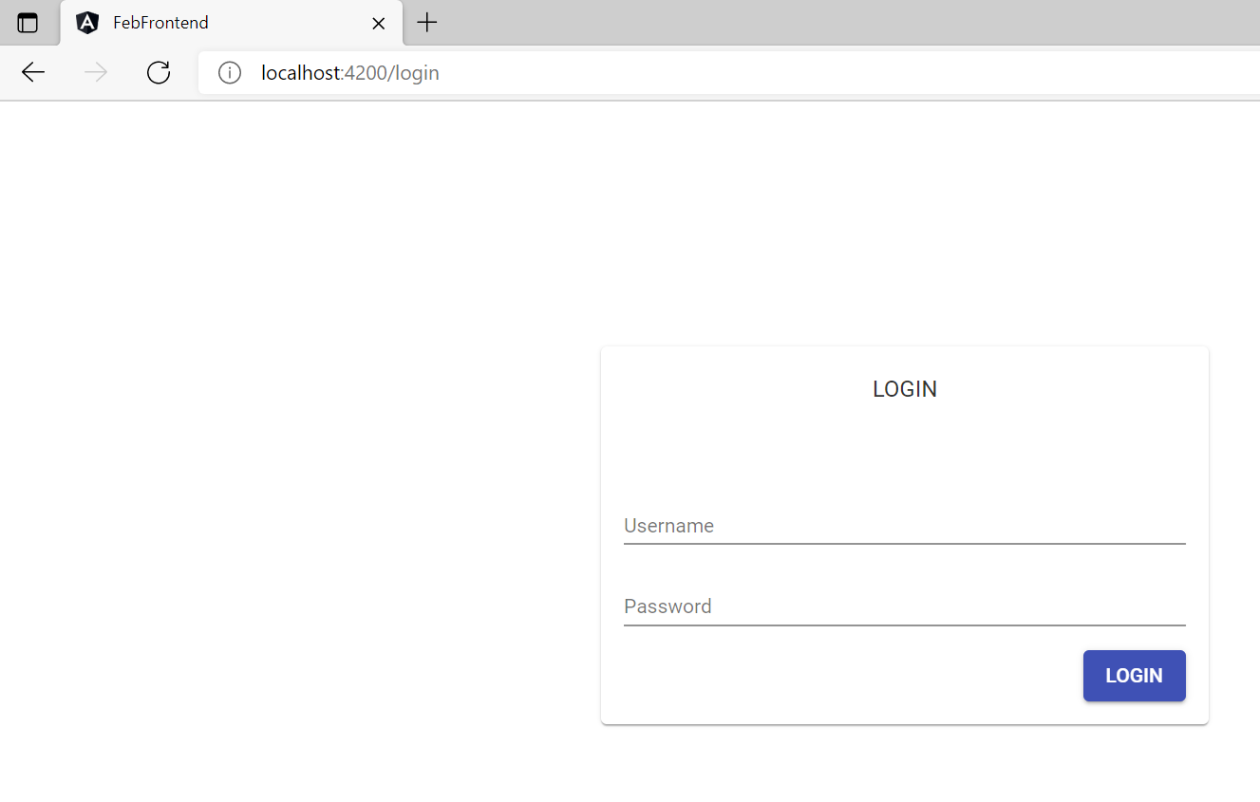

addNewBeras

Name, type, name html

berasID: string, v_berasID

tipe: string, v_tipe

quality: string, v_quality

storedLocation: string, v_storedLocation

tanggalPanen: string, v_tanggalPanen

regionOrigin: string, v_regionOrigin

quantity: number, v_quantity

fromRecipient: string, v_fromRecipient

toRecipient: string, v_toRecipient

pricePerKg: string, v_pricePerKg

totalPrice: string,v_totalPrice

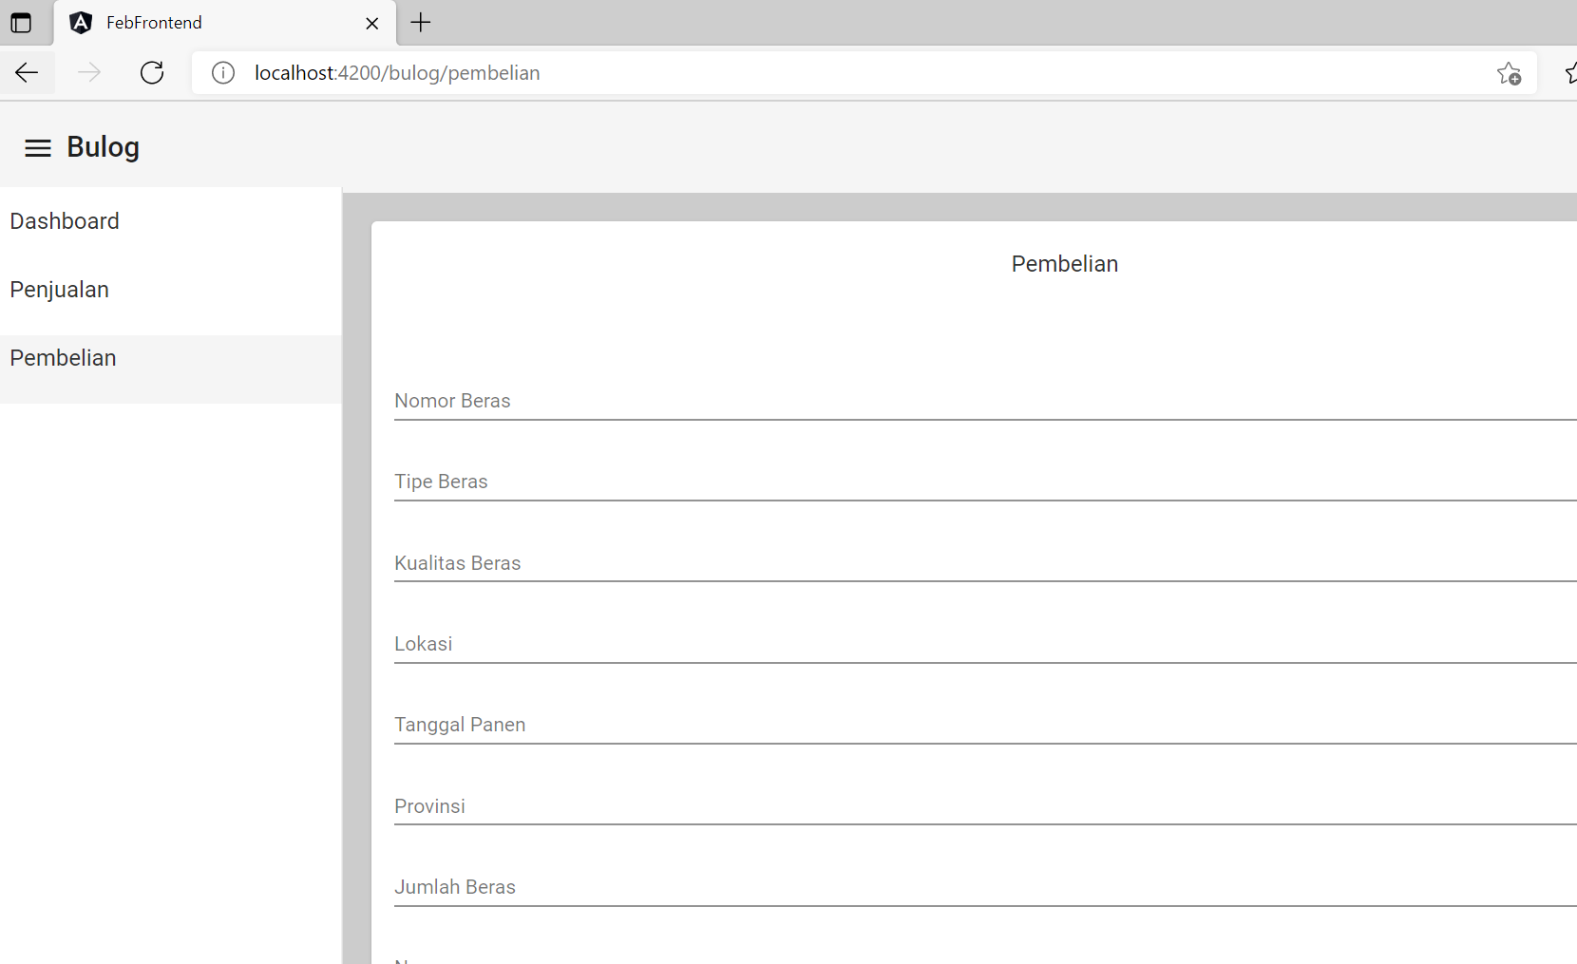

sellBeras

Name, type, name html

berasID: string, s_berasID

tipe: string, s_tipe

quality: string, s_quality

regionOrigin: string, s_regionOrigin

quantity: number, s_quantity

fromRecipient: string, s_fromRecipient

toRecipient: string, s_toRecipient

pricePerKg: string, s_pricePerKg

totalPrice: string,s_totalPrice

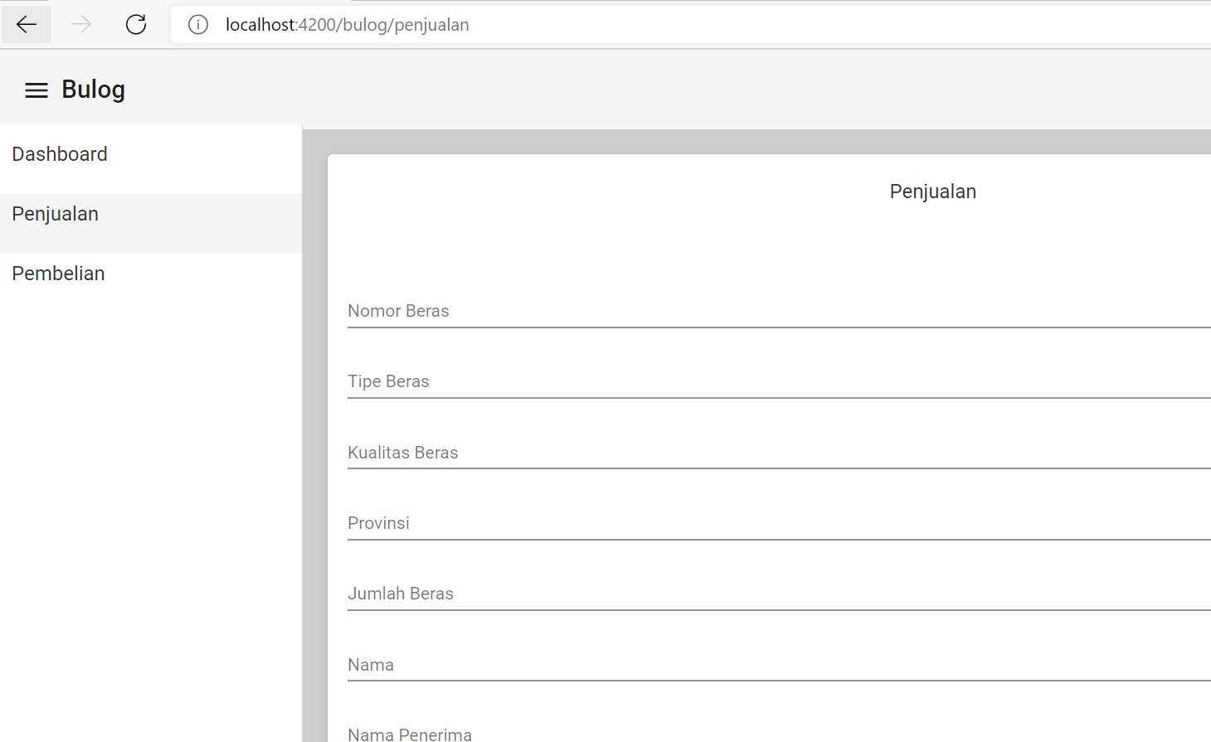

kemendag

Name, type, name html

hargaEceran: string, m_hargaEceran

hargaAcuan: string,m_hargaAcuan

hargaProdusen: string,m_hargaProdusen

hargaPembelianPemerintah: string; m_hargaPembelianPemerintah

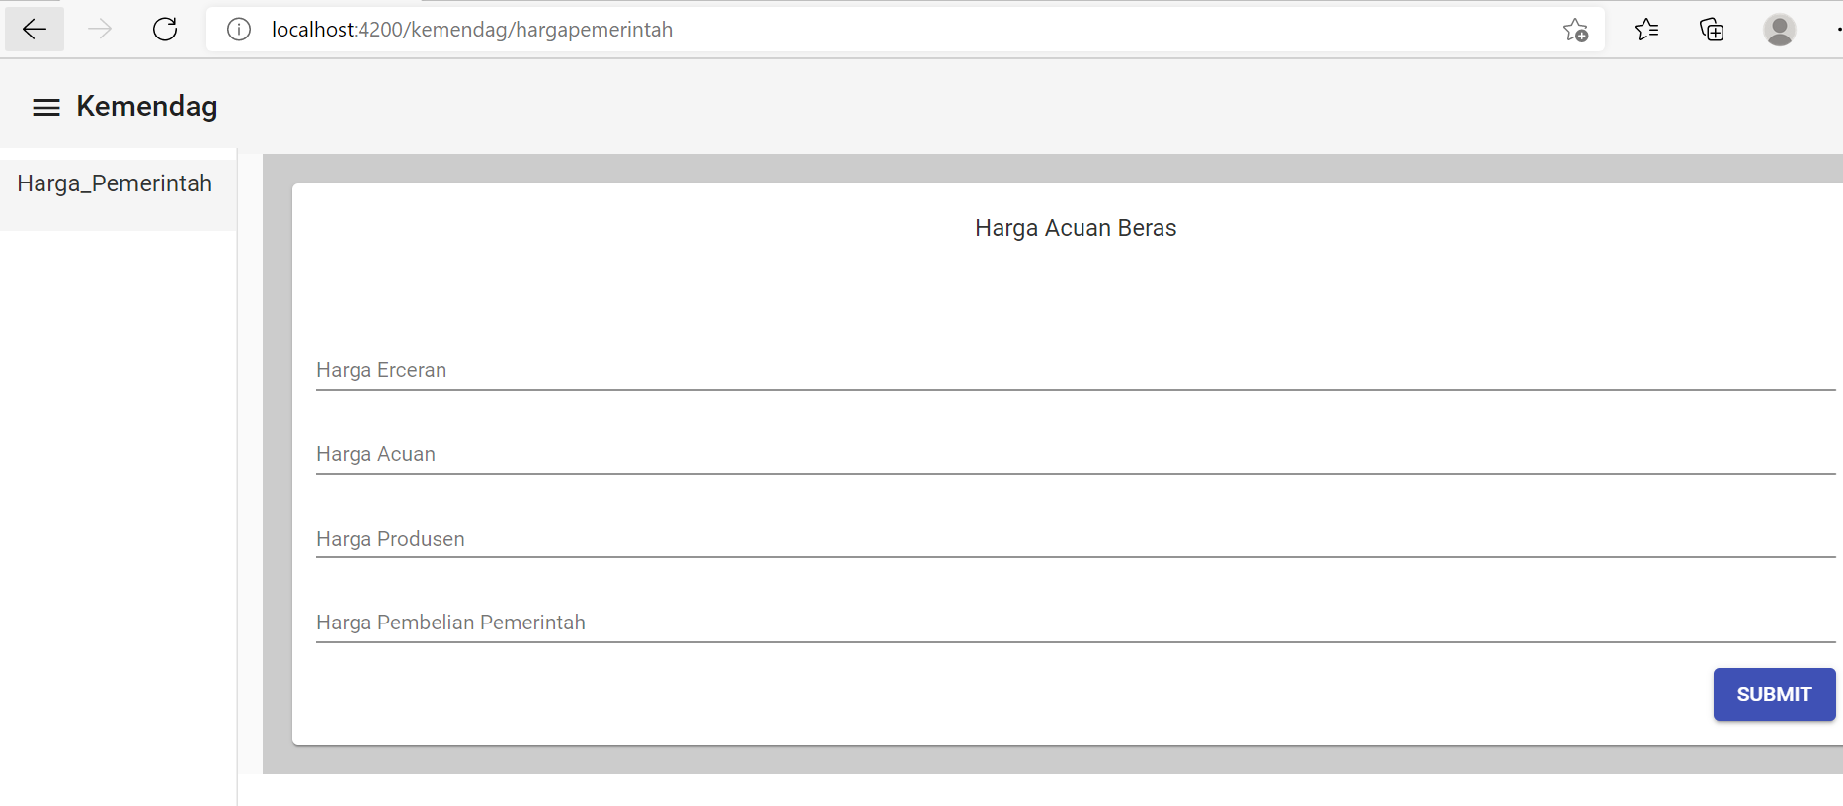

kementan

name html

m_cadangan

