**REFERENCE GLOBAL**

Mobile App - FLUTTER

* Flutter is Google’s UI toolkit for building beautiful, natively compiled applications for [mobile](https://flutter.dev/docs), [web](https://flutter.dev/web), and [desktop](https://flutter.dev/desktop) from a single codebase.
* Fast Development: Paint your app to life in milliseconds with Stateful Hot Reload. Use a rich set of fully-customizable widgets to build native interfaces in minutes.
* Expressive and Flexible UI: Quickly ship features with a focus on native end-user experiences. Layered architecture allows for full customization, which results in incredibly fast rendering and expressive and flexible designs.
* Native Performance: Flutter’s widgets incorporate all critical platform differences such as scrolling, navigation, icons and fonts, and your Flutter code is compiled to native ARM machine code using [Dart's native compilers](https://dart.dev/platforms).

What Flutter is?

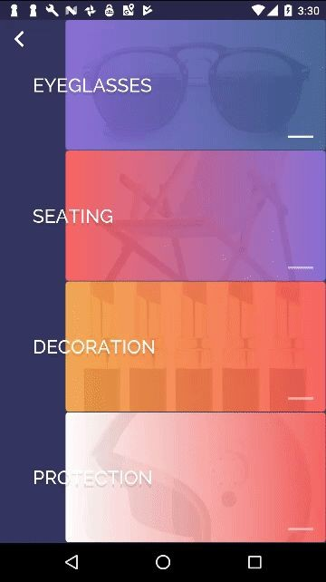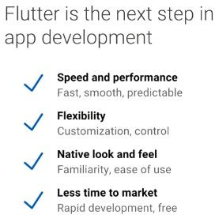



Page Detail

1. Login: For user, faculty etc.
2. Registration page.
3. Forget password page.
4. Reset password page.
5. Course rack page: Required multiple pages base on page layout type. Ex. Maths will one page, Science will another page etc. Or one page layout will cover all type.
6. Academic created by admin:   
   Ex.   
    1. My courses  
    2. All courses   
    3. Completed
7. My courses- courses opted by admin or HOD
8. All courses, all courses related to particular host dept.
9. Completed course
10. Manage or edit course detail.
11. Faculty can edit basic course details in my courses' manage courses.
12. Schedules, Reschedule and Bulk-schedule pages to get details about the classes.
13. Announcement: whenever host wants to send text or mail.  
     1. Send by faculty  
     2. HOD.
14. Candidate’s page: students who have opted for particular course.
15. Content: Faculty can post or add course material and its type.  
     Options: View and Delete content.
16. Add content page: add through youtube,Url.
17. Tasking: practice test view and manage.
18. Assesments: similar as task. The only difference here is user can not watch tasks multiple times.
19. Preview questions
20. Preview assignments by student
21. Faculty: View and Edit page.
22. Reports: all kind of tracking records will be tracked here like attendance status of student, watched videos by students etc.
23. About course page.
24. Messages and notification page.
25. Course search page.
26. Course by top, faculty etc search page.
27. Payment page. (If required)

Timing estimation

According to the video given to us its look there would be total of 40 – 50 pages we need to develop.

To complete UX and UI it required:

UX: 15 – 20 working days.

UI: 45 – 60 working days.

Android: 60 days to deliver the installable file.

IOS: 20 days to deliver the installable file.

**Note:** Android and IOS development we will do but publishing it to the android store and apple store will be taken care from **Reference Global** end. If client required us to publish it then extra time and cost will be there.

Detail given by **Reference Global**:

1. All the api and backend support will be given by **Reference Global.**
2. Apple store and Android store detail.
3. Gateway detail. SMS and Payment both

Development Cost

Please checkout the below detail for entire development expenses.

1. UX development: Will charge Rs. 1000/page
2. UI development: Will charge Rs. 2500/page.