Project ID: | Division:
Name & Employee ID of the Associate:  Relinquishing the task: (handing over)  Contact phone, email-Id | Name & Employee ID of the Associate: Accepting the task: (Taking over)
Signature: 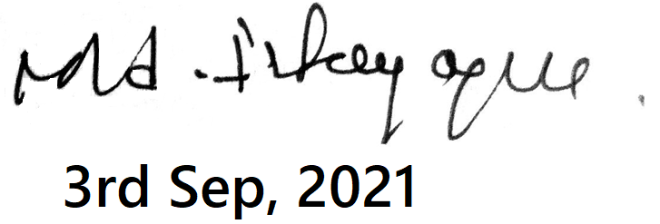 | Signature:

Name & Employee ID Reporting Manager (Approved By): RAVI KORIDA

Signature:

Date: (Handing and Taking over)

Reason for handover:

S.No. | Issues | Details | Remark*
1 | Current status of the project: (Schedules, Milestones, back up information, Project Health, Metrics tool entries, etc) | Currently not associated to any project.
2 | Database File / Folder locations. (Inputs received, data base created, communications, etc) | No database of file available.
3 | Project File: (Documentation –Technical. Quality etc….) | All the project files and document are present in the company system only.
4 | Any pending customer issues? (To be responded & resolved) | No
5 | Status of customer supplied products: (Available with associate handing over) | All done.
6** | A brief note about the prerequisites and procedures to execute the remaining part of project:  (Without the note the document stands null & void. Please Append reference documents, technical, quality, specifications etc) |  | In my current project, it’s all under development and there is no specific set of document or file required to run it. Entire project is cloud base.

(*Mandatory field should be verified for process continuity.)

