Please follow these instructions in case you are **not** seeing Releases under the Pipelines menu as below. As you can see this screenshot is missing Releases sub menu.

This happens because Microsoft has changed the default organization Settings for some type of subscriptions.

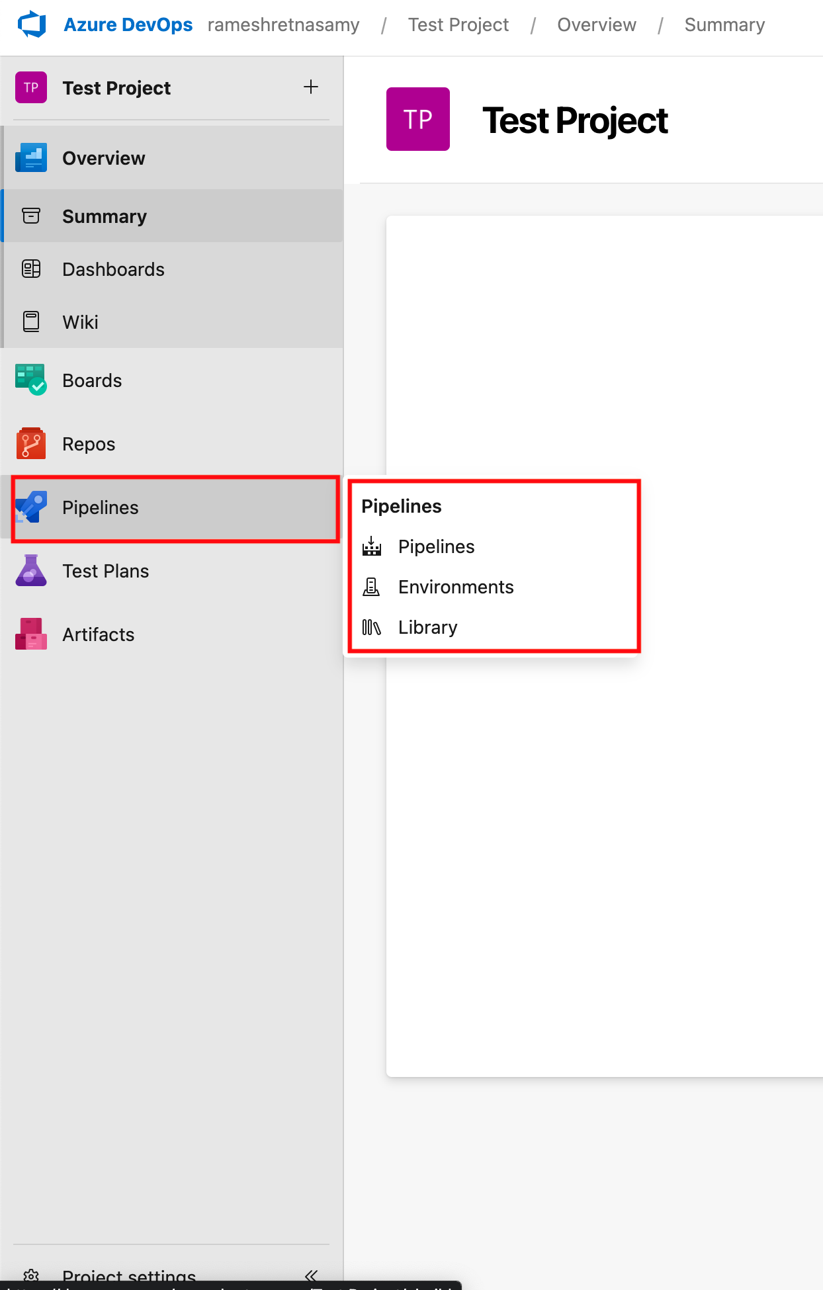

1. Navigate to the Organization Settings as shown below

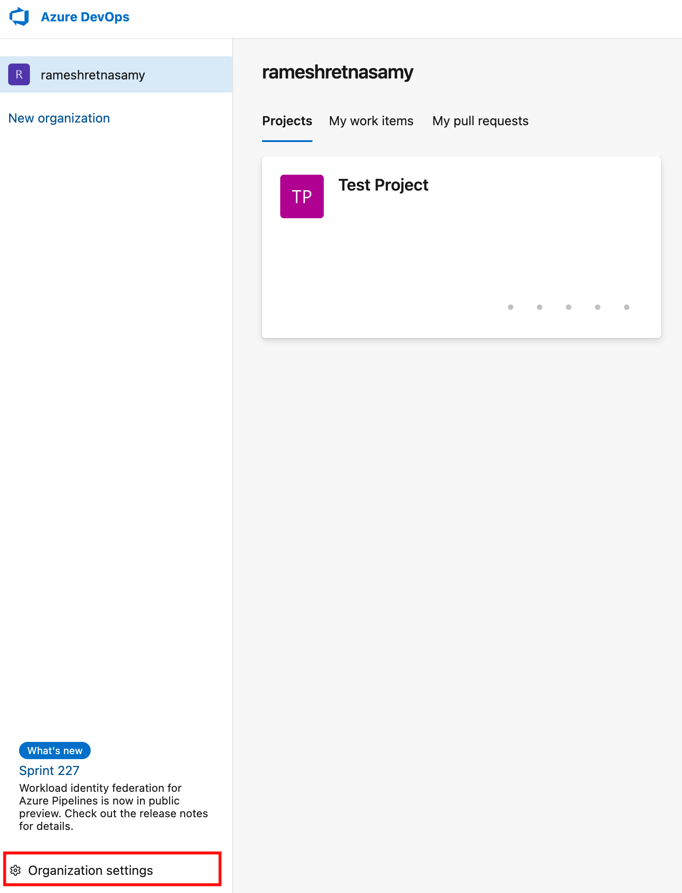

1. Select Settings under the Project menu as below and ensure that both Disable creation of classic build & release pipelines are set to off as shown here.

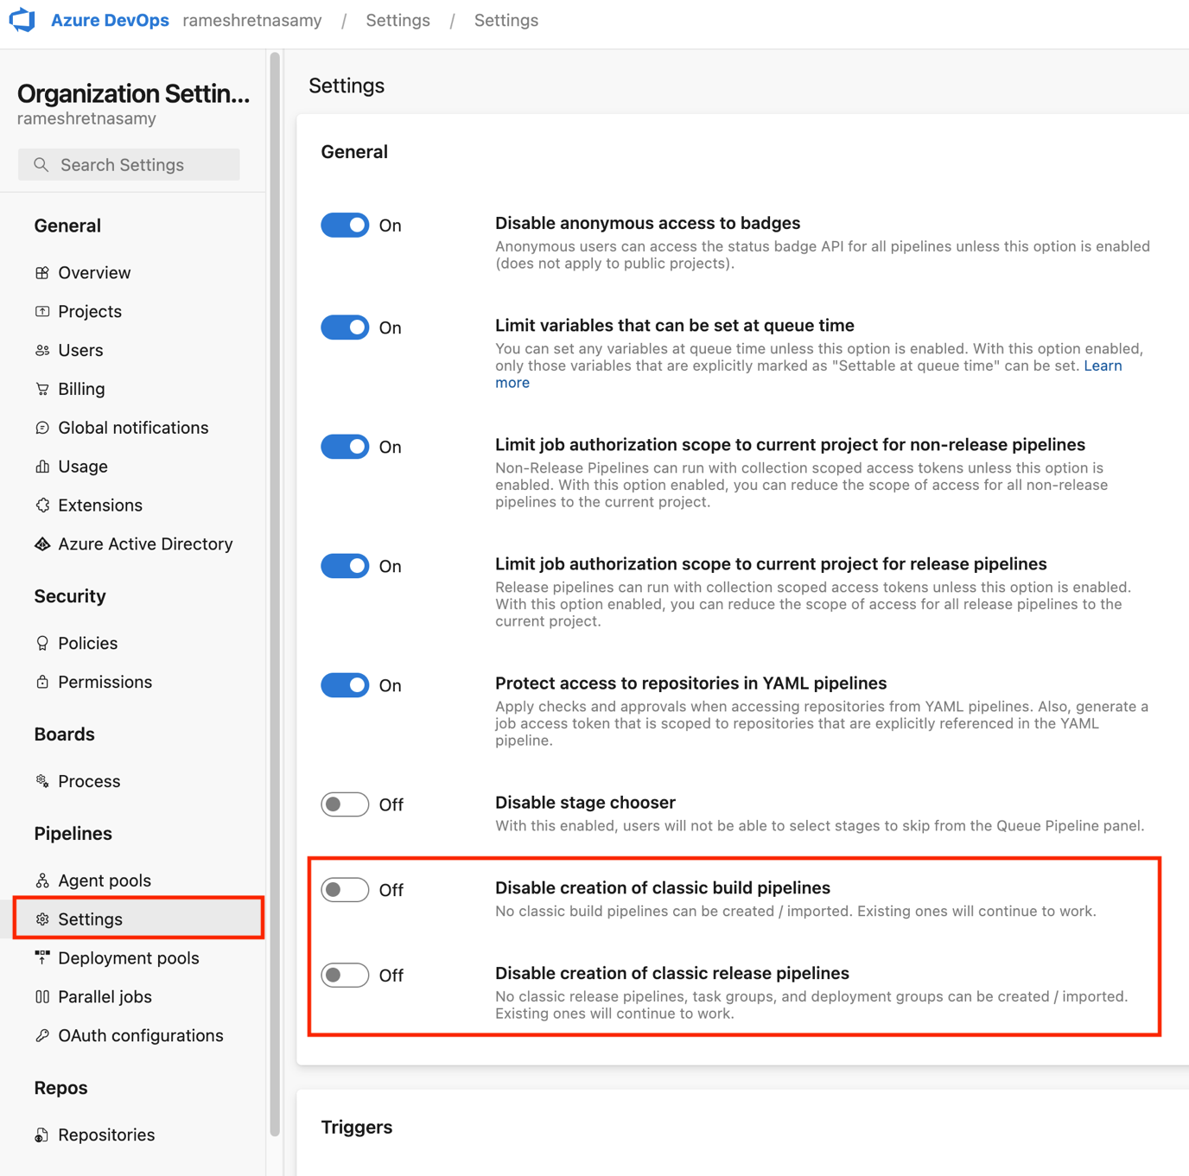

1. Once the settings are turned off, please navigate back to the project and you should see the Pipeline menu as below

