An EnCase image file is encoded with the disk image storage and compression standards used in the E01 format. These E01 files are affixed with the .e01 extension and are used by the EnCase application. The EnCase software and E01 disk image format was developed by Guidance Software to provide forensic scientists and forensic scientists with a set of useful features to store, organize and update technical text and image data recorded in these E01 files.

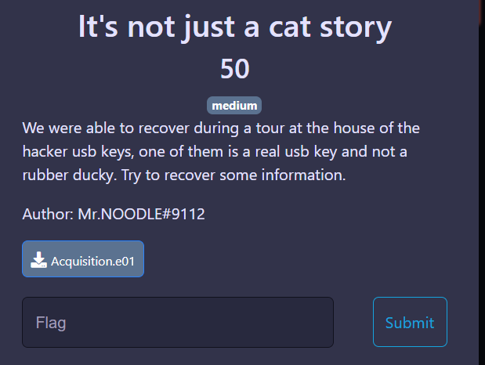

For this type of challenge, we can use one of the famous forenseic tool : Autopsy

No encyption for this chall, we have full access to the disk with the deleted file.

We just have to go to $carvesfile and extract the file f000360.webp

Yesss the flag !

