**What is Angular**

Angular is Javascript framework which allows you to create reactive single page application.

**Angular Versions**

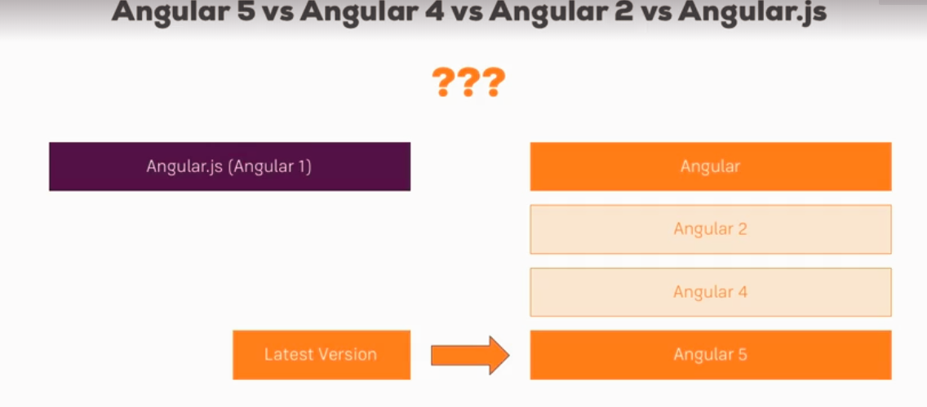

**Install Angular**

1. Install NPM
2. Cmd: npm install –g @angular/cli
3. Linux: sudo npm install –g @angular/cli
4. Create a new Angular application and name it as my-first-app

ng new my-first-app

1. Ng serve : build our source code and spin up small server to run the app

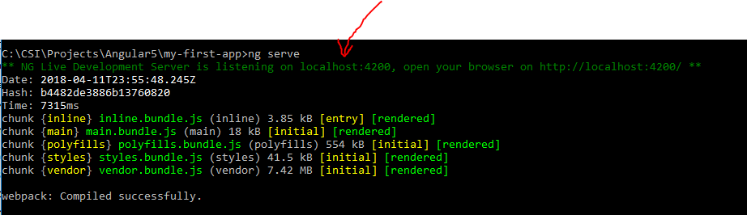

1. npm install --save bootstrap@3
2. add bootstrap css to .angular-cli.json

"styles": [

"../node_modules/bootstrap/dist/css/bootstrap.min.css",

"styles.css"

],

And hit ng-serve again

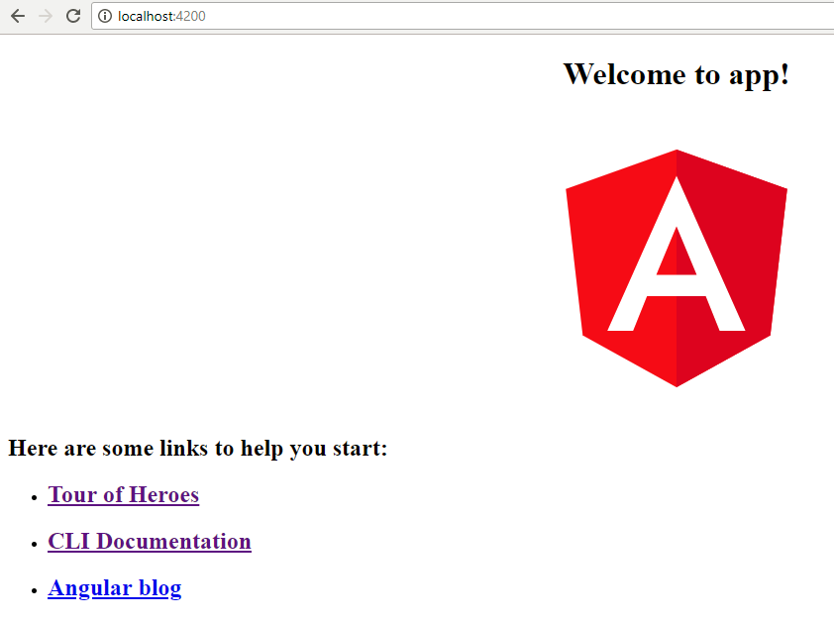

* Behind the scenes, the CLI uses Webpack, a tool which bundles all your JS and CSS files and adds them to the index.html file.
* Emmet – Intelisense
* Create component – ng generate component <component-name>– or - ng g c <component-name>