Landscape Generator

Artur Bednarczyk, Dawid Grajewski, Tomasz Januszek.

# Dobór narzędzi:

* Visual Studio 2015
* DirectX SDK
* Git
* GitHub
* Git Kraken
* SourceTree
* Git Bash

# Git Kraken:

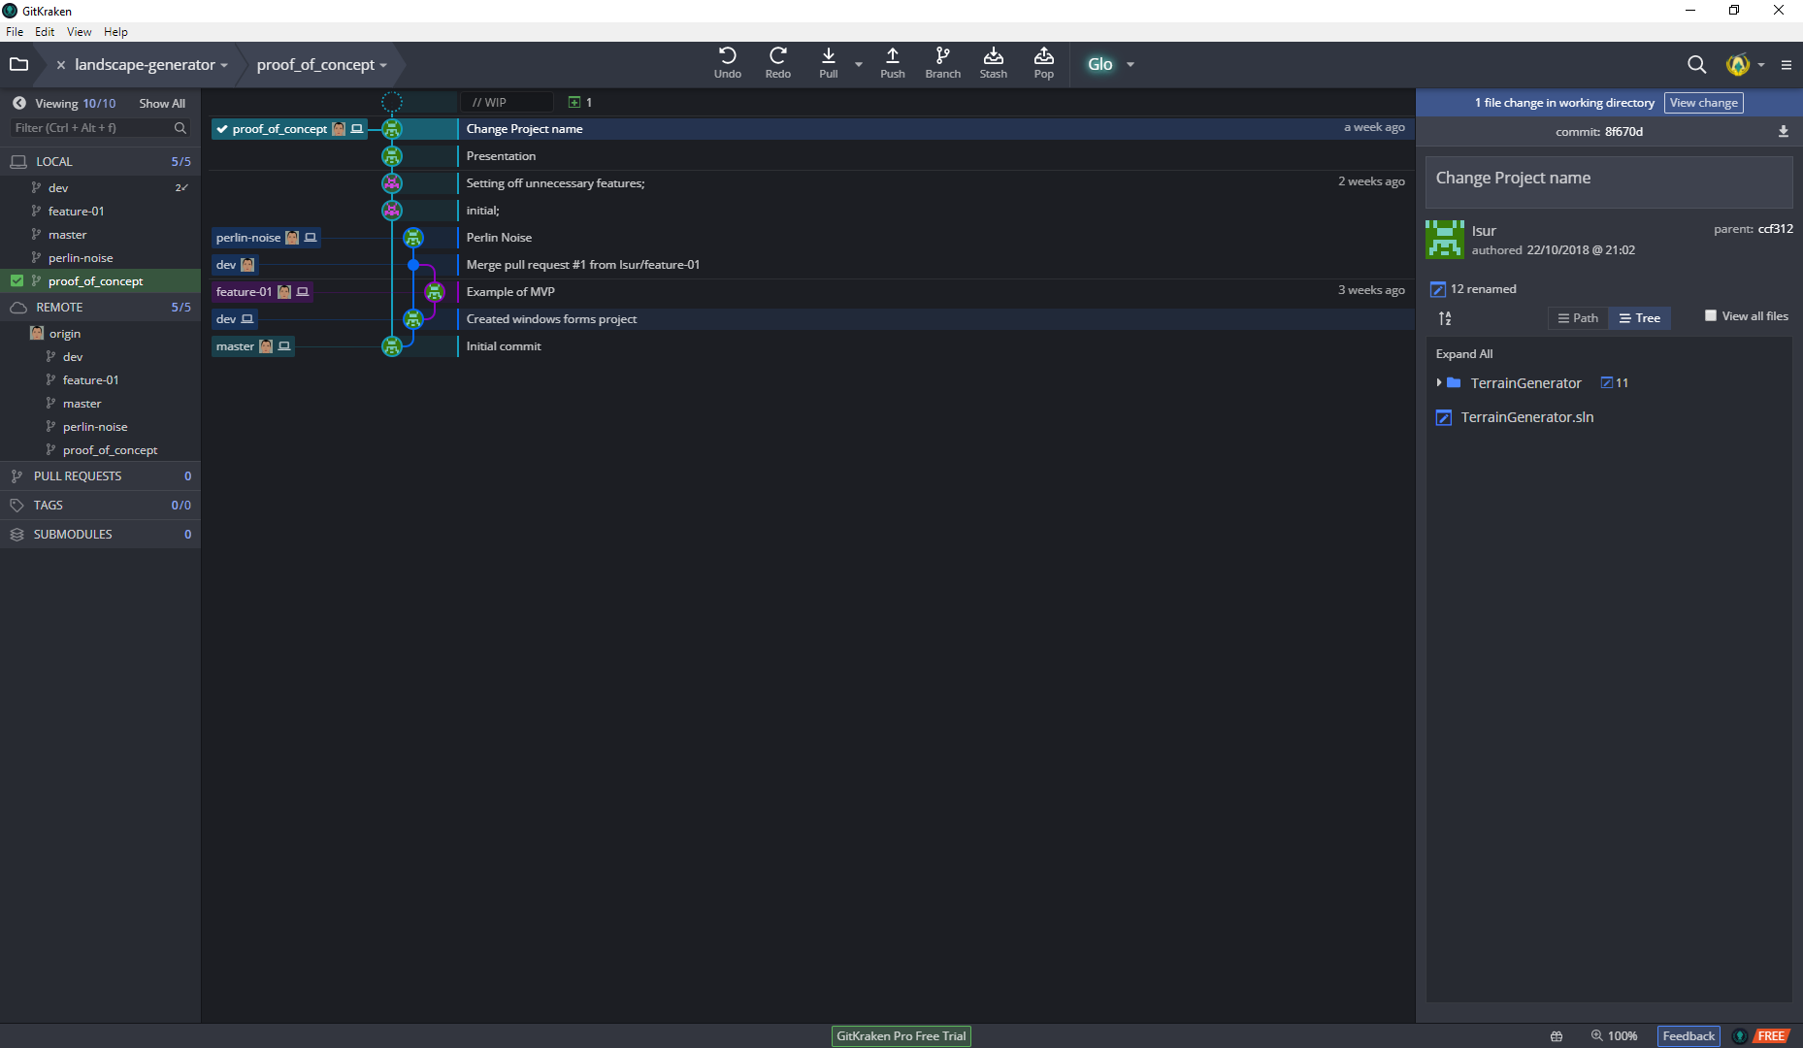

# Git log.

$ git log --all

commit 8f670dcfba6aa17306e4f2f706395c45a949d0b5 (HEAD -> proof_of_concept, origin/proof_of_concept)

Author: Isur <bednarczykartur96@gmail.com>

Date: Mon Oct 22 21:02:46 2018 +0200

Change Project name

commit ccf312fd9a532b359b8bf30d7782781853f2e8c1

Author: Isur <bednarczykartur96@gmail.com>

Date: Mon Oct 22 20:41:57 2018 +0200

Presentation

Proof of concept presentation.

commit a6f32f9593d309a5d2e698751625eb34ad717088

Author: Dawid Grajewski <dawids115@gmail.com>

Date: Sun Oct 21 16:22:03 2018 +0200

Setting off unnecessary features;

commit b625b2822149d202cf67a1f5922fef282eb05a3e

Author: Dawid Grajewski <dawids115@gmail.com>

Date: Thu Oct 18 17:33:01 2018 +0200

initial;

commit 6a5ec58a7809a982bfc2aa1d01f0dc5bbe25ce3b (origin/perlin-noise, perlin-noise)

Author: Isur <bednarczykartur96@gmail.com>

Date: Thu Oct 18 15:49:02 2018 +0200

Perlin Noise

commit b3305a2070a48079f1651b9117639708cad2d214 (origin/dev)

Merge: 178e0df 6379df6

Author: Artur Bednarczyk <bednarczykartur96@gmail.com>

Date: Wed Oct 17 11:40:25 2018 +0200

Merge pull request #1 from Isur/feature-01

Example of MVP

commit 6379df6f78087d21e0a7d4d21d9cee3ed2819072 (origin/feature-01, feature-01)

Author: Isur <bednarczykartur96@gmail.com>

Date: Wed Oct 10 20:37:01 2018 +0200

Example of MVP

commit 178e0dfeb85677e4efbc2e776d429f00e1898615 (dev)

Author: Isur <bednarczykartur96@gmail.com>

Date: Wed Oct 10 19:50:57 2018 +0200

Created windows forms project

commit a70908a6066e1b012885b431fddbcb24cd22da4f (origin/master, master)

Author: Artur Bednarczyk <bednarczykartur96@gmail.com>

Date: Tue Oct 9 18:11:02 2018 +0200

Initial commit

# System zarządzania zespołowego:

