INSTRUCTION MANUAL
CARBON MONOXIDE
TYPE RS485
JXBS-3001-CO

VER1.1

WeihaiJXCTElectronicTechnologyCo.,Ltd.

Ⅰ Brief Introduction
1.1 Product Overview
THE CARBON MONOXIDE SENSOR uses the specialized carbon monoxide concentration sensor probe as core detecting device, which has the characteristics of wide measurement range, high precision, good linearity, good versatility, convenient using, easy installation, long transmission distance and moderate price.
1.2 Primary Parameters
TABLE 1 Primary Parameters
PARAMETERS | TECHNICAL SPECIFICATIONS
MEASURING RANGE | 0-1000ppm/0-2000ppm
MEASURING MODE | Electrochemical
PRECISION | 3%F.s
WARRANTY PERIOD | 2 years ( Host ) / 1 year ( Sensor )
RESPONSE TIME | less than 15 seconds
BAUD RATE | 2400/4800/9600
COMMUNICATION PORT | RS485
POWER SUPPLY | 12-24V DC
POWER CONSUMPTION | ≤0.15w
OPERATING TEMPERATURE | -30-50 ℃
WORKING HUMIDITY ENVIRONMENT | 15-90%RH
CASE SIZE | 110 x 85 x 44mm³
PRESSURE RANGE | 0.9-1.1atm
1.3 Probe Parameters And Selection
TABLE 2 Probe Parameters And Selection
NO. | MANUFACTURER | RANGE | RESOLUTION | LIFE
1K | CHINA | 1000ppm | 500ppb | >2 years
2K | CHINA | 2000ppm | 500ppb | >2 years
2KJ | HONEYWELL | 2000ppm | 10ppm | >2 years
1.4 Cross Interference Gas
TRACER GAS | CONCENTRATION(ppm) | OUTPUT SIGNAL(amount to ppm CO)
HYDROGEN SULFIDE | 1000 | 0
SULFUR DIOXIDE | 20 | 0
HYDROGEN | 200 | 40
ETHYLENE | 100 | 80
NITRIC OXIDE | 35 | 6
NITROGEN DIOXIDE | 5 | 0
ETHANOL | 1000 | 0
1.5 System Frame Diagram
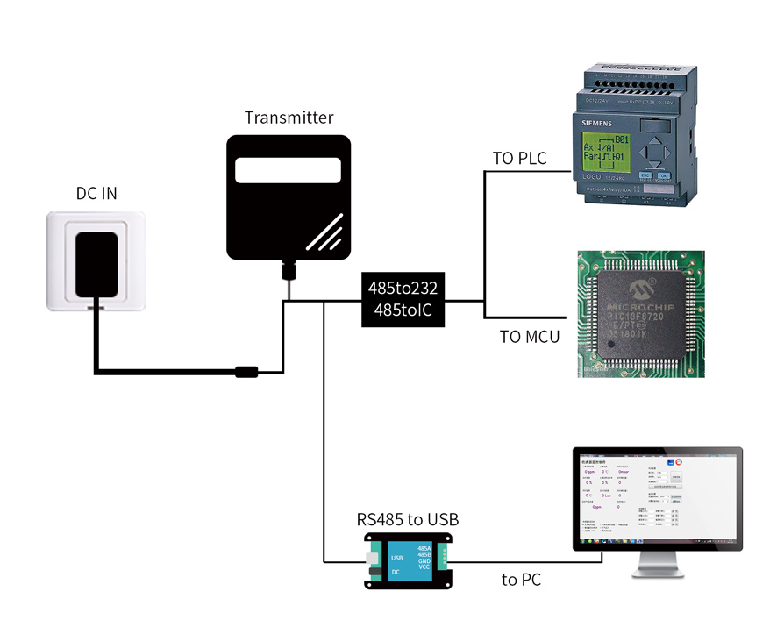
FIGURE 1 SINGLE-ENDED
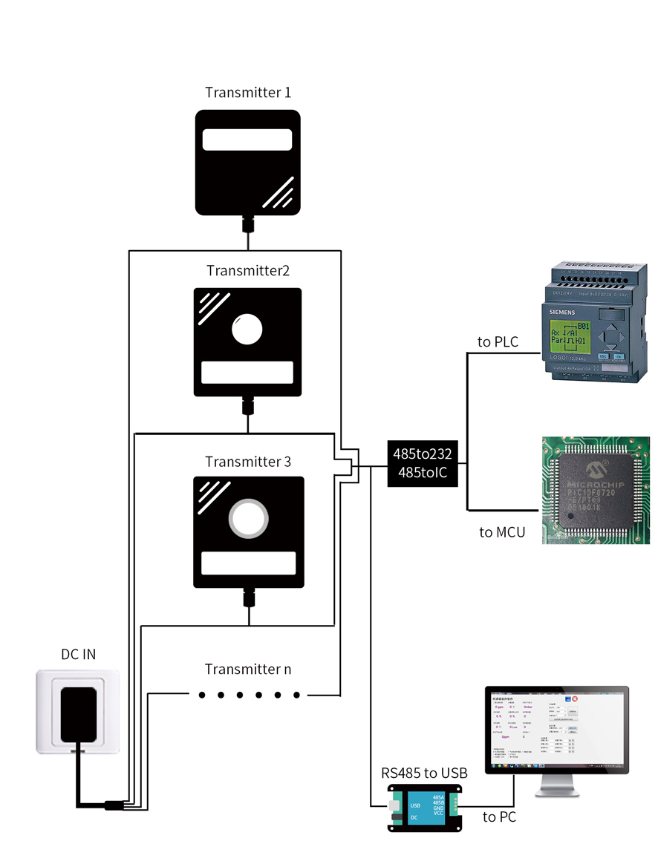
FIGURE 2 MUTIPLE-ENDED

Ⅱ Hardware Connections
2.1 CHECKING BEFORE INSTALLATION
Check the list of devices before installation:
TABLE 3 List of Devices
Name | Number
THE SENSOR DEVICE | 1
12V POWER ADAPTER（Optional） | 1
WARRANTY CARD / CERTIFICATE | 1
THE USB TO 485 DEVICE（Optional） | 1
2.2 Interface Description
Before you wiring and use, please read this article in detail, Improper use may result in irreversible damage to the product.
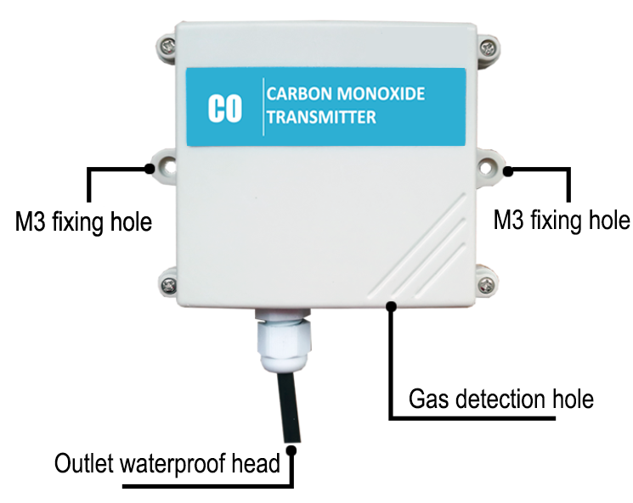
FIGURE 3 PHYSICAL PICTURE
TABLE 4 Wiring Sequence
 | Line Color |  | Description
Power | Brown |  | Power supply Positive ( 12-24V DC )
Power | Black |  | Power supply Negative
Communication | Yellow ( Gray ) |  | 485-A
Communication | Blue |  | 485-B
We provide default cable length of 0.6 meters, you can extend the cable yourself according to your needs.
2.3 Gas Detection Holes
The gas detection hole uses a polymer gas membrane to isolate the membrane. This membrane is air- and water-tight and can permeate the gas but block the moisture. Do not destroy this membrane, otherwise it will affect the life of the product.
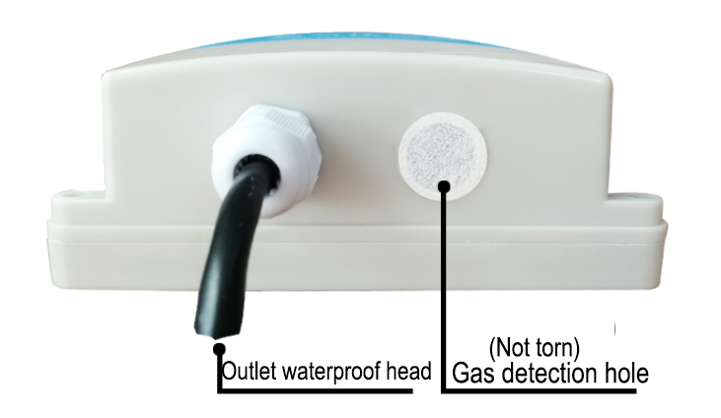
2.4 Installation Description
The equipment needs to be placed in an environment where there is no wind and no rain. The equipment needs to be installed vertically. The device has two fixed holes with a spacing of 105mm. The size of each fixing hole is 3mm.
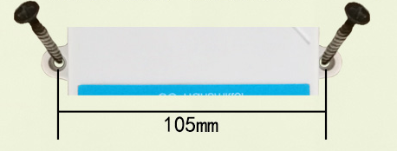
FIGURE 4 HOW FIXTURES

Ⅲ Configuration Tool Installation and use
We provide CONFIGURATION TOOL , which can be easily used to test our sensor device.
3.1 Sensor Access Computer
Transmitter can be connected to PC with the RS485 to USB adapter. You can check the COM port number through Device Manager (right click My Computer).
3.2 How To Use Configuration Tool
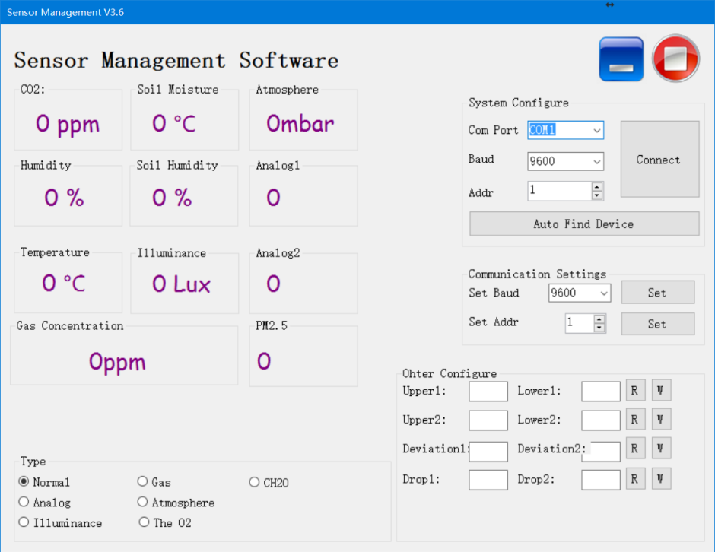
Please note that this software can only test one device at the same time. After connecting the physical device, click the CONNECT button to read the information. In the UNCONNET state, you can modify BAUD and ADDR in COMMUNICATION SETTINGS.
Under the software, different check boxes can be selected according to different situations. For example, you can choose the GAS option to test the RS485 OXYGEN SENSOR , you can choose the NORMAL option to test the RS485 TEMPERATURE AND HUMIDITY SENSOR .

Ⅳ Communication Protocol
4.1 Communication Basic Parameters
TABLE 5 Communication Basic Parameters
PARAMETERS | CONTENT
Protocol | Modbus RTU
Data bits | 8 bit
Parity bit | No
Stop bit | 1 bit
Error checking | CRC (redundant loop code)
Baud rate | 2400 bps/ 4800 bps/ 9600 bps can be set  factory defaults to 9600 bps
For more information about MODBUS RTU please visit the website"www.modbus.org ".
4.2 Register Address
Register Address | Plc Configuration Address | Content | Operation
0000H | 40001 | Humidity ( Unit 0.1%RH) | Read-Only
0001H | 40002 | Temperature ( Unit 0.1℃) | Read-Only
0006H | 40007 | Carbon Monoxide ( unit 0. 1ppm) | Read-Only
0100H | 40101 | Device Address (0-252) | R/W
0101H | 40102 | Baud Rate (2400/4800/9600) | R/W
TABLE 6 Register Address
4.3 Communication example
4.3.1 Read Device Address 0x01's Carbon Monoxide Concentration
TABLE 7 Inquiry Frame
Address Code | Function Code | Start Address | Data Length | CRC_L | CRC_H
0x01 | 0x03 | 0x00  0x06 | 0x00  0x01 | 0x64 | 0x0B
TABLE 8 Answer Frames
( For example, the reading is 18.9ppm )
Address Code | Function Code | Returns to The Number Of Valid Bytes | Carbon Monoxide Value | CRC_L | CRC_H
0x01 | 0x03 | 0x02 | 0x00  0xBD | 0x78 | 0x35
Carbon Monoxide：
00BD H ( hexadecimal ) =189=> Carbon Monoxide =18.9ppm
4.3.2 Read Device Address 0x01's Temperature And Humidity Value
TABLE 9 Inquiry Frame
Address Code | Function Code | Start Address | Data Length | CRC_L | CRC_H
0x01 | 0x03 | 0x00,0x00 | 0x00,0x02 | 0xC4 | 0x0B
TABLE 10 Answer Frame
Address Code | Function Code | Number Of Valid Bytes | Humidity Value | Temperature Value | CRC_L | CRC_H
0x01 | 0x03 | 0x04 | 0x00  0xFE | 0x00  0xAF | 0xDB | 0xBF
Temperature：
00AF H ( hexadecimal ) =175=> Temperature =17.5 ℃
Humidity：
00FE H ( hexadecimal ) =254=> Humidity =25.4%RH
4.3.3 Read Device Address 0x01's Temperature And Humidity, Carbon Monoxide Concentration Value
TABLE 11 Inquiry Frame
Address Code | Function Code | Start Address | Data Length | CRC_L | CRC_H
0x01 | 0x03 | 0x00,0x00 | 0x00,0x07 | 0x04 | 0x08
TABLE 12 Answer Frame
Address Code | Function Code | Number Of Valid Bytes | Humidity Value | Temperature Value
0x01 | 0x03 | 0x0E | 0x03  0x14 | 0x01  0x1B
8 Useless Bytes |  | Carbon Monoxide Value | CRC_L | CRC_H
0x00 ... |  | 0x00  0x28 | 0x50 | 0x3B
Temperature：
011B H ( hexadecimal ) =283=> Temperature =28.3 ℃
Humidity：
0314 H ( hexadecimal ) =788=> Humidity =78.8%RH
Carbon Monoxide：
0028 H ( hexadecimal ) =40=> Carbon Monoxide =4.0ppm

