IT21207754

GitHub repository:

<https://github.com/Isuru-rangana/DL_Lab/tree/main/Lab08/CompletedLab08>

SE4050 – Deep Learning

Question 1: Markov Decision Process and Q-Learning

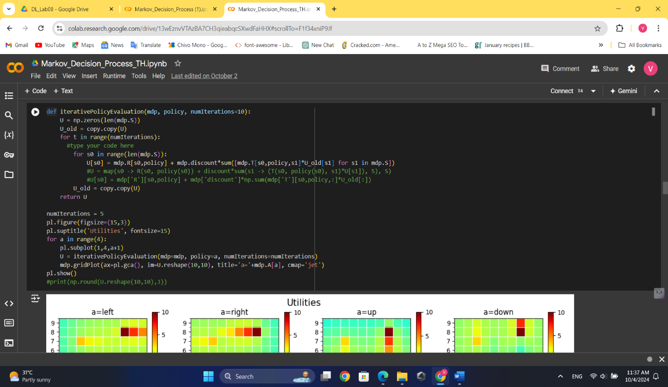

Gridworld.ipynb

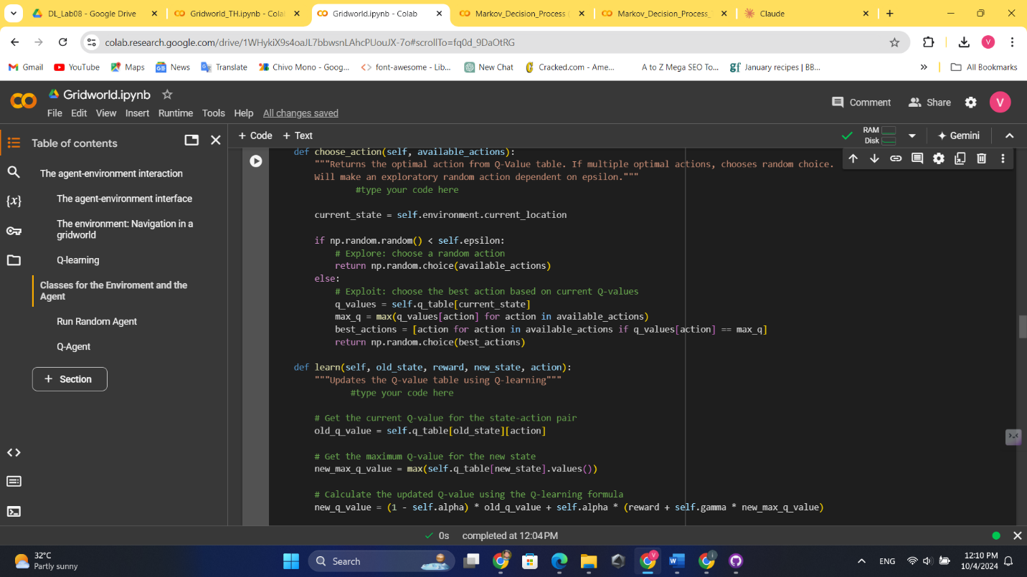

Question 2: Model-Based vs Model-Free Reinforcement Learning

Implement the Model-Based Approach (Value Iteration)

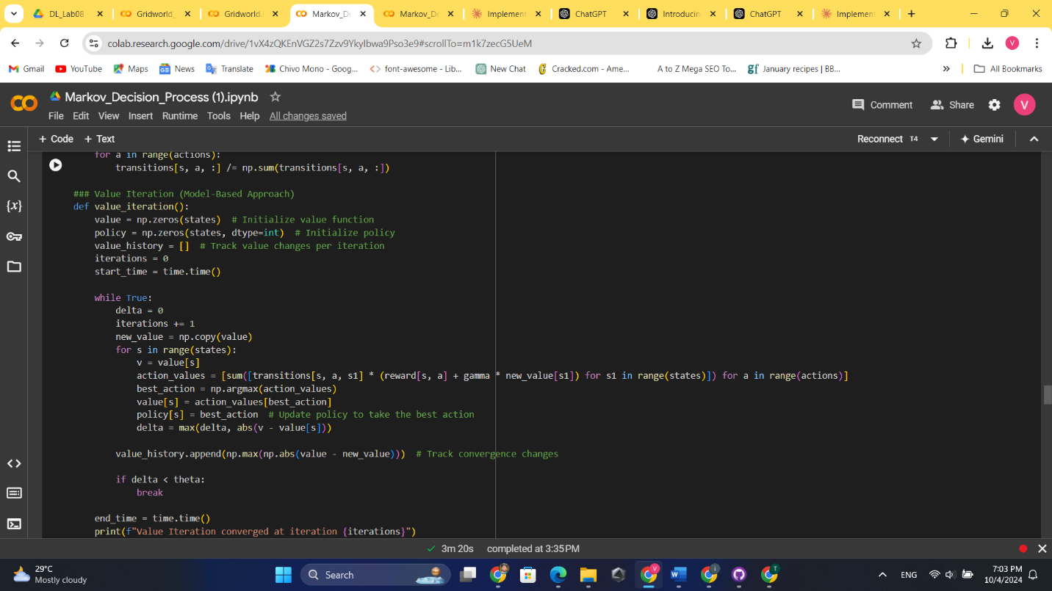

Implement the Model-Free Approach (Q-Learning)

 Visualize Value Iteration Convergence

2. Explain the difference between Model-Based and Model-Free algorithms briefly.

**Model-Based algorithms use an explicit model of the environment to make decisions. They learn or are given a representation of how the environment works, including state transitions and rewards. These algorithms plan actions by simulating possible outcomes using this model.**

**Model-Free algorithms, on the other hand, learn directly from experience without using an explicit model of the environment. They interact with the environment through trial and error, updating their understanding based on the outcomes they observe**

Question 3: Introduction to Deep Q-Learning (DQN)

DQN agent interacts with the environment.

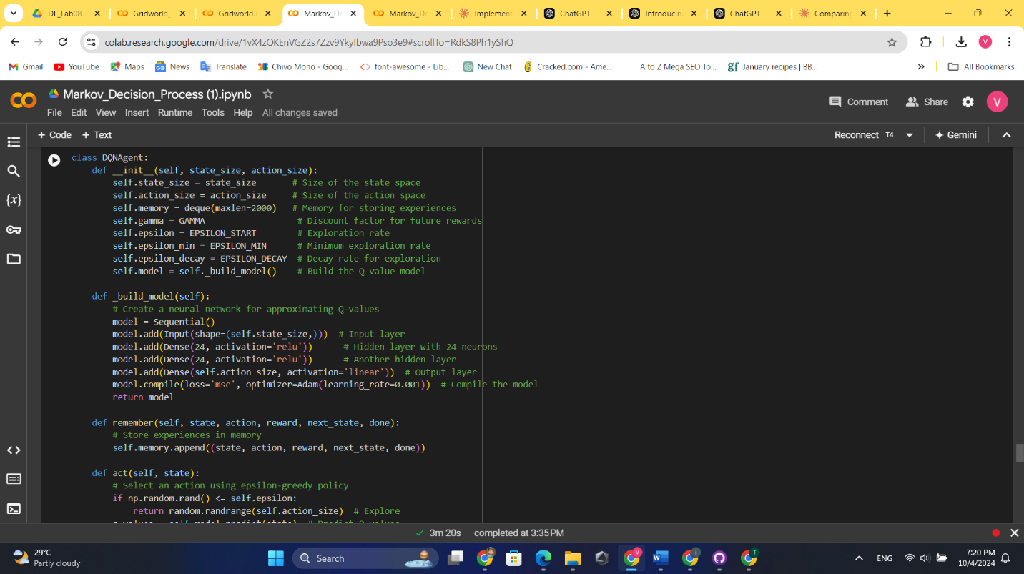

Train the DQN agent.

Plotting & dqn performance with different Values

