ITE 3962 – Final Year Project

Project Proposal

NutriSafe AI: A Multi Modal Explainable AI System for Personalized Pediatric Food Additive Risk and Chemical Interaction Assessment

Submitted by:
E2529001
P.K.R. Abeysekara
Bachelor of Information Technology (External Degree)
Faculty of Information Technology
University of Moratuwa

Table of Contents

List of Figures ii
List of Tables iii
List of Abbreviations iv
List of Appendices v
1. Introduction 1
2. Background & Motivation 1
3. Literature Review 2
3.1 Existing Consumer Food-Scanning Solutions 2
3.2 Related Academic Research 3
3.3 Research Gap 3
4. Problem Addressed 3
5. Aim & Objectives 4
Objectives 4
6. Proposed Solution 5
6.1 Stakeholder Modules 5
6.2 Technical Architecture & AI Pipeline 6
6.3 Technology Stack 7
6.4 Project Scope & Phased Delivery 8
6.5 Feasibility, Academic Contribution, Limitations & Evaluation 9
Reference List 10
Appendix A – Eight-Month Plan of Action 11

List of Figures

Figure 1: NutriSafe AI – System Architecture Overview 7

List of Tables

Table 1: Comparison of Existing Food-Scanning Solutions 2
Table 2: Summary of System Technology Stack 8
Table 3: Proposed Project Plan 11

List of Abbreviations

Abbreviation | Description
AI | Artificial Intelligence
API | Application Programming Interface
AUC | Area Under the Curve
F1 | F1 Score (harmonic mean of precision and recall)
FAISS | Facebook AI Similarity Search
NLP | Natural Language Processing
OCR | Optical Character Recognition
R-GCN | Relational Graph Convolutional Network
SHAP | SHapley Additive exPlanations
VLM | Vision-Language Model

List of Appendices

Appendix A – Eight-Month Plan of Action 7

1. Introduction
Processed and packaged foods marketed to children commonly contain artificial colorants, flavor enhancers, preservatives and other food additives identified by chemical names or E-Number codes. Interpreting these labels is difficult for ordinary parents, particularly when a child has allergies, food sensitivities or an existing health condition, and the difficulty grows when several additives occur in the same product or when exposure occurs repeatedly across different products.
NutriSafe AI is proposed as a multi-modal, explainable AI system that uses a smartphone camera to process food ingredient labels and QR/barcode information, and then assesses the detected additives against a personalized child health profile – moving beyond generic ingredient lookup by considering evidence-supported additive interactions, allergen/health-condition relevance and an estimated dietary exposure index over time.
The primary deliverable is a consumer mobile application for parents, with a shared backend that also supports prototype interfaces for pediatricians and food-safety authorities. The solution combines computer vision/OCR, chemical entity resolution, a chemical knowledge graph, graph-based interaction modelling, personalized risk scoring and explainable AI.

2. Background & Motivation
A substantial body of nutrition and pediatric research has investigated associations between certain synthetic food additives and adverse effects in children. A widely cited randomized, double-blind, placebo-controlled trial reported increased hyperactive behavior in young children following exposure to mixtures of artificial food colorings and sodium benzoate [1]– a finding that is particularly relevant here because it shows the importance of considering combinations of additives rather than treating every ingredient in isolation.
For an ordinary parent, an ingredient label is not an easy source of actionable information: labels may contain chemical names and E-Numbers such as E621 or E211 that require specialist knowledge to interpret, and existing food-scanning solutions generally provide generic assessments rather than one tailored to a particular child's allergies, medical conditions, age and dietary history [2],[3]. Recent advances in document understanding, chemical entity resolution, graph neural networks and explainable AI make it feasible to connect these components into one evidence-aware decision-support workflow, focused on personalized food-additive risk screening rather than diagnosis or laboratory toxicity measurement.

3. Literature Review

3.1 Existing Consumer Food-Scanning Solutions
Several consumer applications allow shoppers to scan packaged food products and retrieve ingredient or nutrition information. Yuka provides a product score based on nutritional information and selected product characteristics [2] , and Open Food Facts provides a large collaborative database of packaged-food information, ingredient lists and additive codes [3], demonstrating the practicality of barcode-to-product and ingredient lookup.
These solutions nevertheless leave opportunities for a specialized pediatric system: their assessment is generic rather than interpreted against an individual child's health profile, and they provide neither the research-oriented chemical-interaction modelling nor the personalized longitudinal exposure view proposed here. NutriSafe AI therefore focuses on combining these capabilities rather than replacing existing product databases, as summarized in Table 3.1.
Feature | Yuka | Open Food Facts | NutriSafe AI (proposed)
Barcode / product lookup | Yes | Yes | Yes
Ingredient label scanning | Limited / product dependent | Data dependent | Yes
Personalised child health profile | No | No | Yes
Evidence-supported additive interaction assessment | No | No | Yes
Estimated cumulative dietary exposure | No | No | Yes
Explainable per-decision reasoning | Partial | No | Yes (SHAP-based)
Pediatrician / regulator prototype | No | No | Yes
Table 1: Comparison of Existing Food-Scanning Solutions

3.2 Related Academic Research
The central technical challenge is assessing effects that may arise from combinations of substances. In an adjacent biomedical domain, Zitnik et al. introduced Decagon, a graph convolutional network for modelling polypharmacy side effects through a multi-relational graph [4], providing an academic precedent for representing entities and relationships in a graph and learning interaction patterns, NutriSafe AI adapts this idea to a curated food-additive dataset rather than drug pairs. Since food labels may be photographed at an angle or on curved packaging, this is also a scene text recognition problem: Zhan and Lu's iterative image-rectification approach shows the value of correcting geometric distortion before recognition [5], so image preprocessing and OCR are treated as part of the input pipeline rather than assuming a clean flat document.
For chemical terminology, biomedical language models such as BioBERT provide a basis for normalizing domain-specific terms [6], and for transparency, SHAP offers a model-agnostic framework for attributing predictions to input features, used here to explain which factors contributed to a risk score[7].

3.3 Research Gap
The literature and existing applications reviewed indicate that several capabilities exist separately – open food-product databases, document/OCR technologies, graph neural networks for interaction modelling, and explainable ML techniques – but not an integrated pediatric food-additive screening workflow that connects them around an individual child's profile. The proposed contribution is therefore not a new OCR model or toxicology database, but the design and evaluation of an integrated pipeline that:
(1) extracts and normalizes additive information from real labels
(2) represents known additive relationships in a knowledge graph
(3) compares graph-based interaction modelling against a rule-based baseline
(4) combines interaction evidence with child-specific factors into a personalized risk score
(5) explains the resulting decision.

4. Problem Addressed
Parents of young children currently lack a practical method for translating a packaged-food ingredient label into a personalized food-safety screening result. The problem has four connected aspects:
- ingredient names and E-Numbers are difficult for non-specialists to interpret
- additive combinations may require consideration beyond isolated ingredient checks
- product relevance depends on the child's allergies, sensitivities, medical conditions and prior dietary exposure
- individually recorded data is not transformed into useful longitudinal or aggregated views for clinical and regulatory demonstration.
NutriSafe AI addresses these aspects by providing an AI-assisted screening workflow that extracts ingredients, resolves them to standard chemical entities, evaluates evidence supported interactions and child specific factors, and presents an explainable risk category – intended as decision support and screening, not as a diagnostic tool or replacement for pediatric medical advice.

5. Aim & Objectives
The aim of this project is to design, develop and evaluate a multi-modal, explainable AI system that assesses the personalized food additive risk of packaged food products for children using ingredient label information, evidence supported chemical interaction modelling and child specific health and exposure factors.

Objectives
- To conduct a critical review of existing food scanning applications, pediatric food safety literature and research on chemical interaction modelling.
- To design and implement a smartphone-based image/OCR pipeline that extracts ingredient information from photographed food labels, and a chemical entity resolution process that maps ingredient names and E-Numbers to standardized additive identifiers.
- To construct evidence supported chemical interaction knowledge graph, curate a bounded dataset of approximately 100–200 interaction records from published sources, and implement and compare a rule-based baseline with a Relational Graph Convolutional Network (R-GCN).
- To develop a personalized, SHAP-explainable risk scoring model that combines detected additives, interaction evidence, allergen/health-condition relevance and an estimated dietary exposure index.
- To implement a consumer mobile application as the primary deliverable and prototype the clinician and regulatory use cases using the same backend data.
- To evaluate the system using quantitative model metrics, label/ingredient extraction accuracy, representative test cases and usability feedback.

6. Proposed Solution
NutriSafe AI will be implemented as a multi-modal decision-support platform centered on a consumer mobile application. A parent can capture an ingredient label or use a QR/barcode where available. The backend extracts ingredient information, normalizes chemical entities, consults the chemical knowledge graph and evaluates the product against the selected child's profile and estimated dietary exposure history. The result is presented as a color-coded risk category together with a human-readable explanation.
The risk assessment is deliberately defined as an estimated screening result rather than a measurement of biological toxicity. The system will not claim to measure the actual concentration of chemicals in a child's body, and it will not diagnose a medical condition. Where relevant, the system will advise the user to consult a qualified healthcare professional.

6.1 Stakeholder Modules
Consumer Mobile Application – Primary Deliverable:
- Capture food labels via camera or QR/barcode, and maintain a child profile (age, allergies, health conditions, food sensitivities).
- Display a personalized risk category (Low / Moderate / High Concern, with an underlying 0–100 score) and the contributing factors – relevant additives, interaction evidence, allergen/condition matches and exposure trends.
- Maintain a scan history and estimated dietary exposure index over time, with safer-alternative suggestions as a secondary feature.
Clinical Pediatrician Portal – Secondary Prototype: displays a child's logged product and exposure history as charts, showing the factors behind flagged products as decision-support information rather than an automated clinical decision.
Regulatory Dashboard – Secondary Prototype: uses de-identified demonstration data to show frequently flagged additives and aggregated market-level trends, designed to support future extension to formal monitoring without requiring live regulatory integration in this project.

6.2 Technical Architecture & AI Pipeline
The architecture is organized into six layers,
(1) Input and Vision/OCR – OpenCV based preprocessing and OCR/vision language processing extract ingredient text from photographed labels, with QR/barcode as an alternative input
(2) Chemical Entity Resolution – normalizes ingredient names, synonyms and E-Numbers to standardized identifiers using curated reference data and, where needed, a biomedical language model
(3) Chemical Knowledge Graph – represents additives, relationships, health effects and evidence references in Neo4j
(4) Interaction Modelling – a rule-based baseline and an R-GCN model are trained on the curated dataset and compared directly
(5) Personalized Risk – an XGBoost model combines detected additives, interaction indicators, allergen/condition relevance and exposure features into a 0–100 score and risk category
(6) Explainability & Recommendation – SHAP generates feature-level explanations, with alternative-product suggestions kept as a secondary feature.
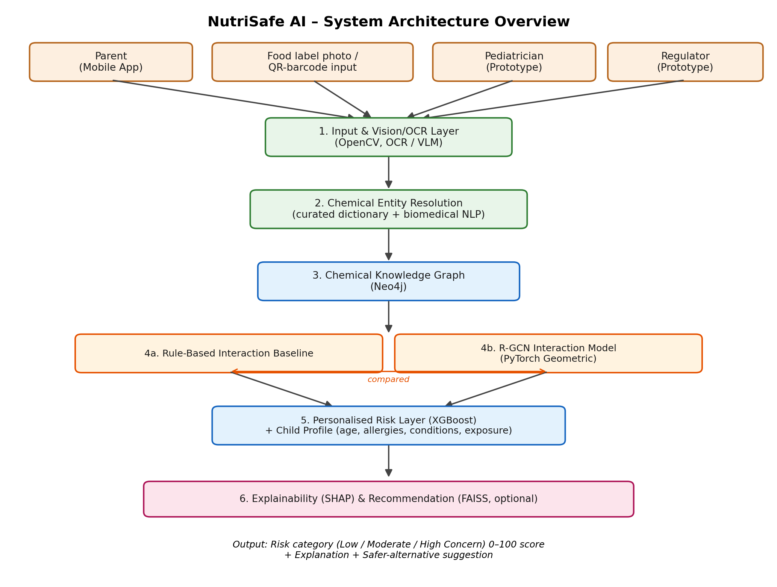
Figure 1: NutriSafe AI – System Architecture Overview
As shown in this, the rule-based baseline and R-GCN model (steps 4a and 4b) are evaluated side by side before the better-performing approach feeds into the personalized risk layer, making the comparison an explicit part of the pipeline rather than an afterthought.

6.3 Technology Stack
Component | Proposed Technology | Purpose
Mobile application | React Native or Flutter | Primary parent-facing application
Web dashboards | React.js + Tailwind CSS | Pediatrician and regulator prototypes
Backend API | Python + FastAPI | System integration and model-serving APIs
Image processing / OCR | OpenCV + OCR/VLM | Label preprocessing and ingredient extraction
Chemical entity resolution | Curated chemical dictionary + biomedical NLP where required | Standardise names and E-Numbers
Knowledge graph | Neo4j | Represent additive relationships and evidence
Graph modelling | PyTorch Geometric + R-GCN | Chemical interaction modelling
Risk modelling | XGBoost | Personalised screening score
Explainability | SHAP | Feature-level explanations
Relational data | PostgreSQL | Profiles, scan history and application data
Recommendation (optional) | FAISS | Semantic product similarity for alternatives
Table 2: Summary of System Technology Stack

6.4 Project Scope & Phased Delivery
The project is designed for approximately eight months of implementation. The scope intentionally prioritizes the core research contribution over production scale integrations.
In Scope – Core Deliverable: consumer mobile application for food-label/QR scanning and personalized results, ingredient extraction and chemical entity normalization, an evidence-supported chemical interaction knowledge graph with a bounded literature-curated dataset of approximately 100–200 records, a rule-based baseline and R-GCN interaction model with comparative evaluation, personalized risk scoring with SHAP-based explanation, product scan history and estimated dietary exposure index, and secondary functional prototypes for the pediatrician and regulatory use cases.
Optional / Lower-Priority (only if time permits): curved-label enhancement beyond the supported image quality, Lab PDF report parsing, and FAISS-based alternative-product recommendation.
Out of Scope: clinical diagnosis or autonomous medical decision-making, measurement of actual biological/physiological chemical concentration in a child, live hospital EHR or national food-regulator integration, production-scale recall infrastructure, laboratory/ wetware/ biological testing of food samples, and in app e-commerce or direct food purchasing.

6.5 Feasibility, Academic Contribution, Limitations & Evaluation
The scope is feasible for an individual final year project because the primary application relies on existing pretrained components, curated reference data and a bounded research dataset, while the clinician and regulator interfaces remain prototypes rather than full institutional systems. The academic contribution is the integration and evaluation of multiple AI techniques around a clearly defined healthcare problem – in particular, whether a relational graph model improves interaction screening over a rule based baseline, and whether combining interaction evidence with child-specific factors and SHAP-based explanations produces a more informative personalized result than an unexplained risk label.
Limitations will be reported explicitly: a screening result will not be treated as clinical proof of safety or toxicity, interaction evidence depends on the quality of published sources used to curate the dataset, and the estimated dietary exposure index reflects recorded dietary information rather than a laboratory measurement of body burden.
The system will be evaluated component-by-component and end-to-end so the final report can present quantitative results: OCR/ingredient-extraction accuracy against a labelled sample of product photographs; precision/recall/F1 for chemical entity resolution; precision/recall/F1/AUC for the R-GCN model compared directly against the rule-based baseline; accuracy and confusion-matrix analysis for personalized risk classification across the three concern categories; a qualitative review of SHAP explanations for consistency with the underlying evidence; and structured usability feedback from a small group of representative parent users.

Reference List

[1] D. McCann et al., “Food additives and hyperactive behaviour in 3-year-old and 8/9-year-old children in the community: a randomised, double-blinded, placebo-controlled trial,” Lancet, vol. 370, no. 9598, pp. 1560–1567, Nov. 2007, doi: 10.1016/S0140-6736(07)61306-3.

[2] “Yuka - The Mobile App That Scans Your Products,” Yuka. Accessed: Aug. 20, 2026. [Online]. Available: https://yuka.io/en/

[3] “https://world.openfoodfacts.org.” Accessed: Aug. 20, 2026. [Online]. Available: https://world.openfoodfacts.org

[4] M. Zitnik, M. Agrawal, and J. Leskovec, “Modeling polypharmacy side effects with graph convolutional networks,” Bioinformatics, vol. 34, no. 13, pp. i457–i466, Jul. 2018, doi: 10.1093/bioinformatics/bty294.

[5] F. Zhan and S. Lu, “ESIR: End-to-end Scene Text Recognition via Iterative Image Rectification,” Apr. 02, 2019, arXiv: arXiv:1812.05824. doi: 10.48550/arXiv.1812.05824.

[6] “BioBERT: a pre-trained biomedical language representation model for biomedical text mining | Bioinformatics | Oxford Academic.” Accessed: Aug. 20, 2026. [Online]. Available: https://academic.oup.com/bioinformatics/article/36/4/1234/5566506

[7] S. Lundberg and S.-I. Lee, “A Unified Approach to Interpreting Model Predictions,” Nov. 25, 2017, arXiv: arXiv:1705.07874. doi: 10.48550/arXiv.1705.07874.

Appendix A – Eight-Month Plan of Action

The following plan aligns the project activities with the objectives set out in Section 5 and the approximately eight-month implementation period.
Activity | M1 | M2 | M3 | M4 | M5 | M6 | M7 | M8
Planning, literature review & design
OCR & chemical entity resolution
Knowledge graph, rule baseline & R-GCN
Personalized risk model, SHAP & exposure index
Mobile app & pediatrician/regulator prototypes
Testing, evaluation & documentation
Table 3: Proposed Project Plan

