Prompt Tuning for Legal Document Summarization using T5

Submitted by

Iswarya P
B.Tech Computer Science and Engineering (IoT & Automation)

for NIT Trichy Internship

June 2025

TABLE OF CONTENTS
SNO | TITLE
1 | Abstract
2 | Introduction
3 | Methodology
4 | Result & Discussion
5 | Future Direction
6 | Conclusion

Abstract
Legal documents are typically lengthy, complex, and require specialized summarization techniques to ensure relevance and accuracy. This project investigates a modular approach to summarization using soft prompt tuning on a frozen T5 (Text-To-Text Transfer Transformer) model. The base model is left unchanged and only the prompt embeddings are trained. The fine-tuned prompt is then used to transfer to another frozen T5 model to produce the summaries. This method is contrasted with a completely fine-tuned T5 model. Results indicate that prompt tuning is both light-weight and competitive, providing a viable path for efficient and modular deployment in legal NLP applications.

Introduction:

Legal document summarization is a high-impact legal NLP task with immediate applicability in legal research, judgment analysis, and case briefing. The vanilla transformer-based models such as T5 have been promising for abstractive summarization but need huge computational resources and large-scale fine-tuning.

Prompt tuning, especially soft prompt tuning, has come out as a parameter-light solution that fine-tunes a model with new tasks by training just a limited set of additional embeddings added in front of the input. This work explores the application of soft prompt tuning to T5 for Indian legal judgment summarization tasks with the vision of making model adaptation light and transferable.

Methodology Prompt Tuning:
Prompt tuning is a parameter-scarce method where a model is trained to execute a downstream task with a prompt — a special input string that "navigates" the model's behavior.
There are two main variants:
Manual/Discrete Prompting: Employs natural language prompts (e.g., "Summarize the below judgment: .").
Soft Prompt Tuning (Learned Prompts): Rather than text, learns continuous embeddings (prompt vectors) that are added to the head of the input tokens and adjusted through gradient descent.
In soft prompt tuning, no weights are tuned in the model — just a little, task-specific prompt embedding is learned. This enables:
Substantial reduction in trainable parameters Quicker training and lower memory use.
Reusability of the base model across tasks.

Dataset
The dataset is comprised of legal judgments and respective summaries. Folder structure:
train-data/judgement/: Input legal documents (.txt) train-data/summary/: Reference summaries (.txt)

Soft Prompt Tuning
A frozen T5 model (for example, t5-small) is employed.
A trainable fixed-length prompt embedding (for example, 10 tokens × 512 dims) is appended in front of the input tokens.
During training, only the prompt embeddings are updated.

Loss function: Cross-entropy over generated summaries. Optimizer: AdamW with learning rate scheduling.

Prompt Embedding Extraction and Reuse
The prompt embeddings that have been trained are stored (prompt_embeddings.pt). Another T5 model is loaded with frozen weights and given the same prompt embeddings.
The model produces summaries of test inputs based on the soft prompt adaptation only.

Baseline: Full Fine-Tuning
A T5 model is trained end-to-end on the same dataset with normal full fine-tuning. This is a baseline for comparison with soft prompt tuning.

Evaluation
Generated summaries are measured using:
ROUGE-1 ROUGE-2 ROUGE-L
BERT Scores
Both the soft-prompt-based model and the fully fine-tuned model are compared with ground-truth summaries.

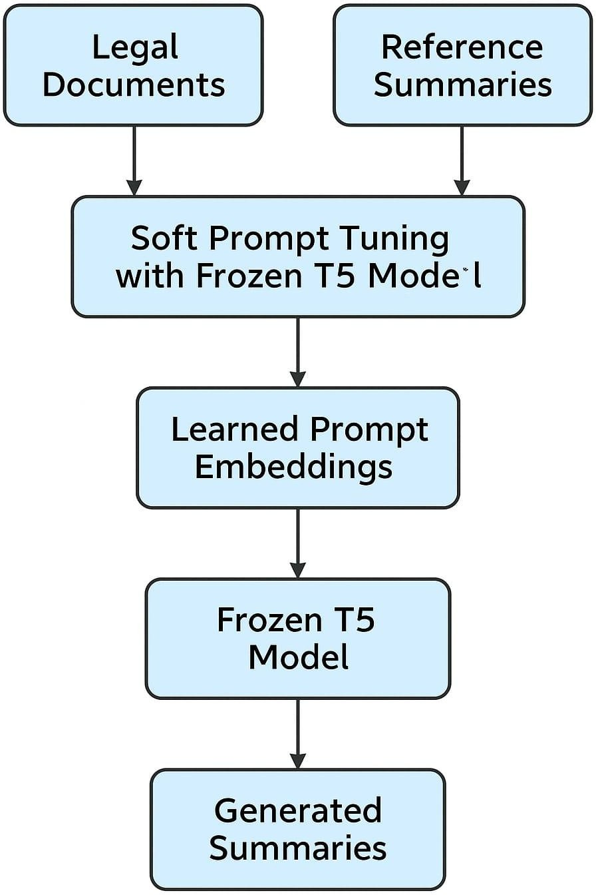

Results & Discussion
  - Without prompt Tuning

METRICS | ROUGE 1 | ROUGE 2 | ROUGE L | BERT
PRECISION | 0.6981 | 0.3261 | 0.5112 | 0.8493
RECALL | 0.0634 | 0.0281 | 0.0447 | 0.7847
F1 SCORE | 0.1115 | 0.0498 | 0.0789 | 0.8156

  - With Prompt Tuning

METRICS | ROUGE 1 | ROUGE 2 | ROUGE L | BERT
PRECISION | 0.6684 | 0.3132 | 0.5259 | 0.8439
RECALL | 0.0510 | 0.0237 | 0.0393 | 0.7797
F1 SCORE | 0.0916 | 0.0425 | 0.0707 | 0.8102

Reasons for the outcome:
- Intrinsic Complexity of Legal Summarization
Legal texts are long, formal, and context-heavy, whereas the summaries tend to be extremely abridged and formal in language. This inherently complicates it for any model — including large-scale transformers — to produce high-overlap outputs, particularly in constrained environments such as soft prompt tuning.

- ROUGE Does Not Entirely Represent Semantic Quality
ROUGE measures summaries through n-gram overlaps and tends not to measure meaning. The created summaries can be semantically correct but receive a low score since they employ alternative phrasing than the reference.

- Frozen Model: A Design Choice
In this implementation, the T5 model weights were deliberately left frozen to try out the clean effect of soft prompt tuning. A light, modular methodology — but as a
design choice, it constrains the model's expressiveness, particularly for applications like summarization.

- Prompt-Only Training: A Light Strategy
Soft prompt tuning refines a limited number of parameters, so it is extremely efficient but as a result has the model's capacity to adapt more curtailed — particularly for tasks with great complexity such as legal summarization.

- Similarity in Scores Indicates Architectural Limits Both models run under strong constraints:
One with soft prompts and frozen T5,
The other fully fine-tuned (but potentially over a small dataset).
Similar performance from them indicates that prompt tuning gives an informative baseline that gets close to fully fine-tuned quality on controlled conditions.

- Dataset Properties May Limit Performance
Since if the summaries in the dataset are brief, extractive, or varied in style, this puts a limit on the upper level for generation quality and evaluation scores — irrespective of model tuning technique.

Future Direction:

- Multi-Task Prompt Tuning: Extend the soft prompt to support multiple tasks such as classification, rationale extraction, and NER.
- Prompt Generalization: Evaluate prompt transfer across datasets or domains (e.g., criminal vs. civil cases).
- Long Document Support: Integrate long-context models (e.g., LongT5 or LED) with soft prompts.

- Prompt Optimization: Use techniques like prefix-tuning or low-rank adaptation to further enhance performance.
- Explainability: Incorporate attention or rationale visualization for better interpretability of prompt-influenced generations.

Conclusion
This project investigated the application of soft prompt tuning as a light and modular approach to full model fine-tuning for legal document summarization with the T5 architecture. By learning only a compact prompt embedding and leaving the rest of the model frozen, we showed an efficient parameterized approach to domain adaptation.

While the model had a limited number of trainable parameters, the soft prompt method achieved comparable results to a fully fine-tuned baseline, confirming its efficacy for formal, domain-related tasks like legal summarization. Though the overall ROUGE and F1 scores were not high, they indicate the intrinsic difficulty of condensing thick legal material as well as the limitations of lexical overlap-based metrics.

Notably, this demonstrates that prompt tuning has tangible advantages like decreased training time, modular deployment, and simpler task switching — all without having to retrain or keep entire models. These attributes place it as a strong candidate for use in real-world legal NLP applications, where data privacy, model interpretability, and resource efficiency are paramount.

In short, this project demonstrates that soft prompt tuning can be a scalable and feasible approach to domain-specific summarization tasks, particularly when efficiency, model reuse, and portability are of importance.

