|  |  |
| --- | --- |
|  |  |
|  |  |
|  | **MOVIE-FINDER**  **SIVASUBRAMANIAM Iswarya**  **DOLLET Maryam**  **ARTAUD Lucas**  **LESNÉ Baptiste**  **DIA1 TEAM 4** |
|  |  |

Table des matières

1. Executive Summary 3

2. Project objectives 3

3. Project scope/ perimeter 4

Calendar 4

Deliverables 5

4. Business requirements 5

5. Key stakeholders 5

6. Project constraints 5

7. Cost-benefit analysis 6

8. Benchmark 6

9. Marketing 9

Strategy: 9

Targeted User: 9

# Executive Summary

Our small company plans to start a new website which goal is to help find similar films based on different preference filters.

Finding a movie can be a tough task, with Movie Finder we can find movies according to your previously liked films with high accuracy.

# Project objectives

The objective of our project is to help people who have difficulty finding a film. It can be an individual or a group of people who want to find a good film.

As a company, we want to make revenue out of it. We will achieve a base revenue based on ads, and maybe, after some post-development based on subscriptions for producers and/or movie dealers.

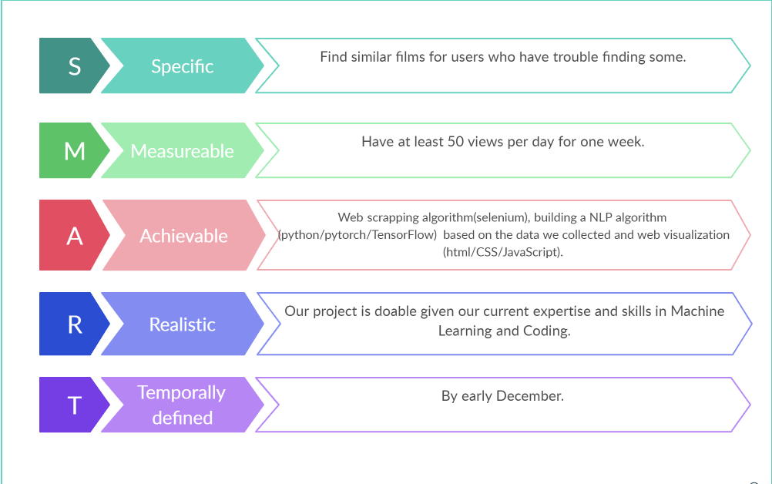

# Project scope/ perimeter

### Calendar

<https://drive.google.com/file/d/1mKhcxNhAZroZH7rOV6jCnOmaV71Kmz5-/view?usp=sharing>

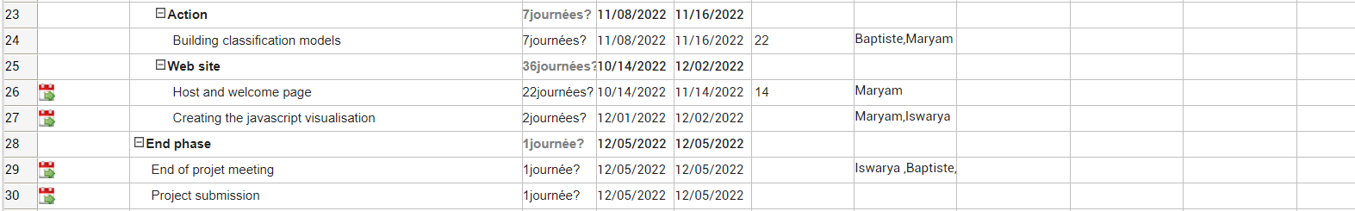

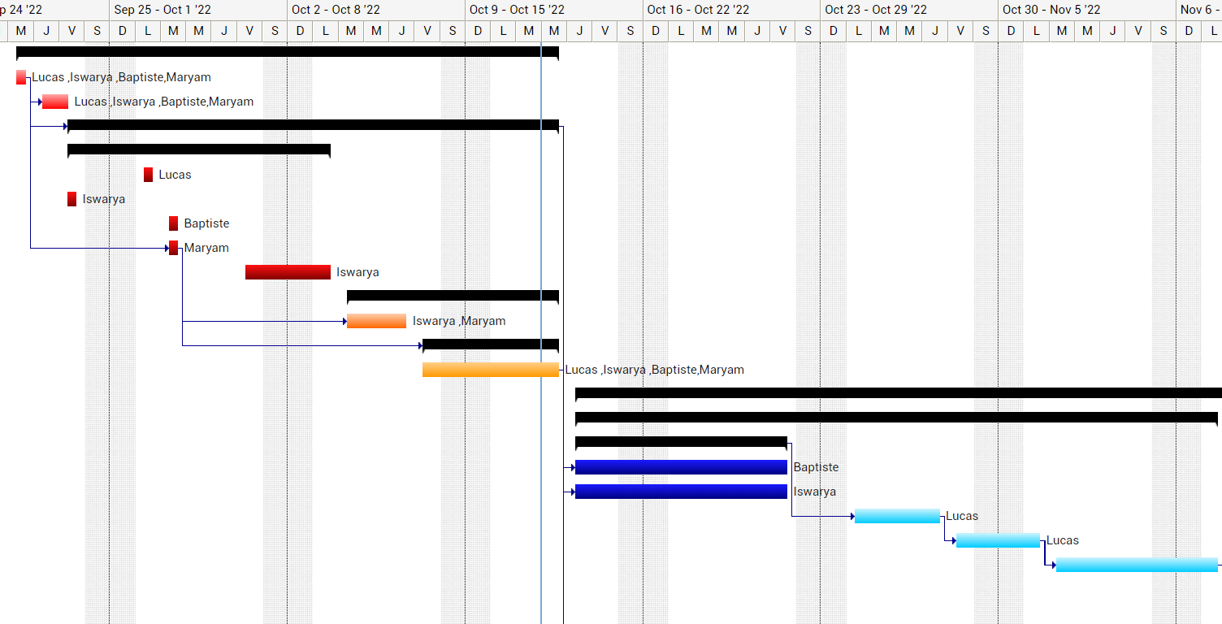

### Deliverables

|  |  |
| --- | --- |
| **Deliverables** | **Date** |
| Business requirement document | 08 October 2022 |
| Software Requirement Specification | 08 October 2022 |
| Model Web Interface | 31 October 2022 |
| Web site with all the data implemented | 15 November 2022 |
| Functional web site | 05 December 2022 |

# Business requirements

|  |  |  |
| --- | --- | --- |
| **Priority level** | **Criticality level** | **Requirement description** |
| 1 | High | Tasks scheduling |
| 2 | Medium | Website development |
| 3 | Low | CRM |
| 4 | Low | SEO |

# Key stakeholders

|  |  |  |
| --- | --- | --- |
| **Name** | **Job role** | **Duties** |
| Maryam Dollet | Project manager | Head of the project |
| Lucas Artaud | Chief Financial Officer (CFO) | Supervise accounting, financial reporting, tax, business control and treasury. |
| Iswarya Sivasubramaniam | Chief Marketing Officer (CMO) | Develop the strategy for corporate advertising and branding. |
| Baptiste Lesné | Chief Technical Officer (CTO) | In charge of technical innovation and technology deployment. |

The clients and the end users are the same people in our project🡪 it will be the users of our website.

# Project constraints

|  |  |
| --- | --- |
| **Constraint** | **Description** |
| Deadlines | Respect the various deadlines |
| Budget | Not exceed the project budget |
| Team member availability | Plan meetings in agreement to each member’s schedule |
| Project risk | Not get enough visitors in our website |

# Cost-benefit analysis

|  |  |  |
| --- | --- | --- |
| **Cost** | **Benefit** | |
| Team member time | Create deliverables for the website that can last |
| High ranking on Google | Ads (Google, Unity, …) |
| Launch our website | Subscriptions for movie producers and/or movie dealers who want a better visibility |
| SEO software |  |
| Website hosting |  |
| Advertisement on social networks |  | |
| Total cost = $10 000/month | Expected ROI = $15 000/month |

# Benchmark

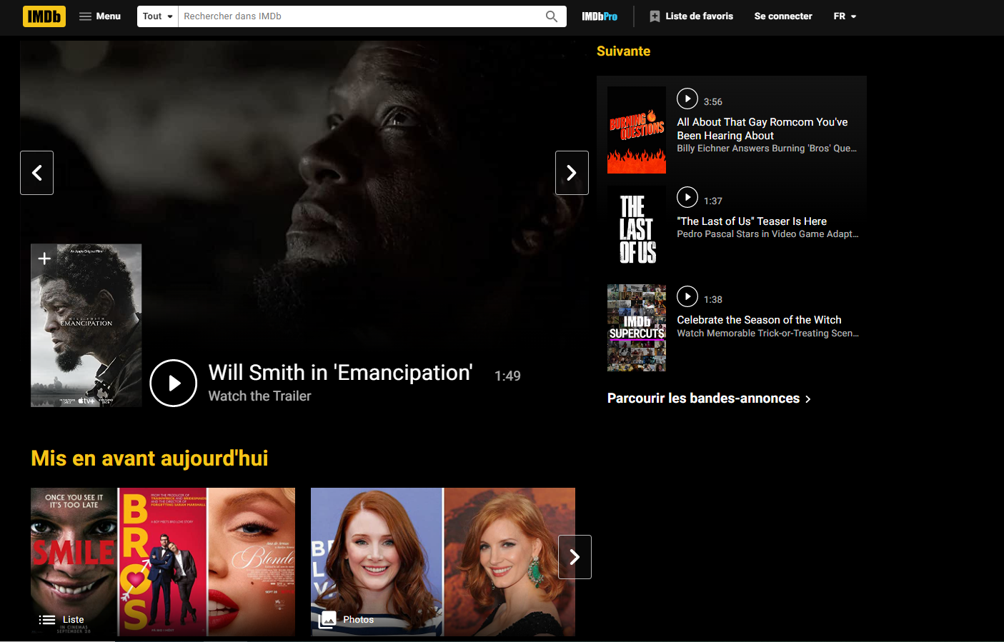

|  |  |  |
| --- | --- | --- |
| Signe pouce en haut avec un remplissage uni  **Pros** | Pouce en bas avec un remplissage uni  **Cons** | |
| * More than 3 250 000 movies * Movie reviews * Encyclopaedia | * It is not dedicated to movie finding |

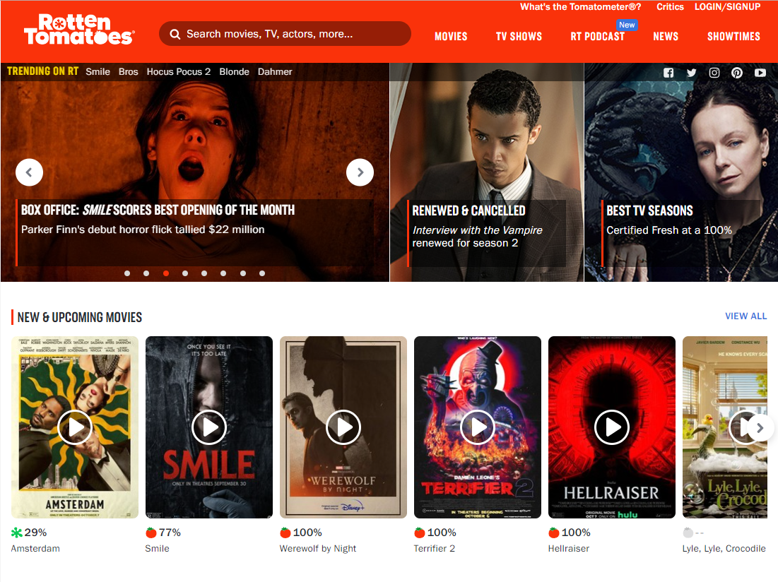

|  |  |  |
| --- | --- | --- |
| Signe pouce en haut avec un remplissage uni  **Pros** | Pouce en bas avec un remplissage uni  **Cons** | |
| * Movie reviews from critics and the general audience * Average rating between different press sites | * Doesn’t have any movie recommendation segment * It is only an algorithm that compiles ratings from other sites |

|  |  |  |
| --- | --- | --- |
| Signe pouce en haut avec un remplissage uni  **Pros** | Pouce en bas avec un remplissage uni  **Cons** | |
| * Searching movies * Show where to watch at what price   (Cinema, digital, Blu-ray) | * Not a sophisticated recommendation * It is showing the other movies currently in cinemas. |

# Marketing

## Strategy:

## Targeted User: