|  |  |
| --- | --- |
|  |  |
|  |  |
|  | **MOVIE-FINDER**  **SIVASUBRAMANIAM Iswarya**  **DOLLET Maryam**  **ARTAUD Lucas**  **LESNÉ Baptiste**  **DIA1 TEAM 4** |
|  |  |

Table of Contents

1. Introduction 3

Scope 3

Value of the product 3

Target audience 3

Intended use 3

General Description 3

Definitions and acronyms 3

2. Functional requirements 3

Web site Structure 3

Data Gathering and Analysis 4

Domain name 4

3. Non-functional requirements 4

Security 4

Capacity 5

Compatibility 5

Reliability 5

Scalability 5

Maintainability 5

Usability 5

4. External interface requirements 5

User Interface Requirements 5

Hardware Interface Requirements 5

Software Interface Requirements 5

Communication Interface Requirements 5

# Introduction

## Scope

Movie Finder TM is a website where films are gathered and processed to give predictions based on the preferences of the user.

## Value of the product

It will give the user the films that are the most relevant based on current and past favourites.

## Target audience

The target audience is in the age group below 40 years, we want to mainly target the people who watch films on streaming sites and/or often go to the cinema.

## Intended use

The user inputs a film in the search bar, and the software will link the film with other films based on the similarities between them.

The user can save a list of preferences, and our algorithm outputs based on this list.

## General Description

An AI will be trained with a database extracted from the Internet; we will create a database using Web scraping). The AI will then choose from a Database a list of films based on the user’s input.

## Definitions and acronyms

NLP: Neural language processing

KNN: k-Nearest neighbours

# Functional requirements

## Web site Structure

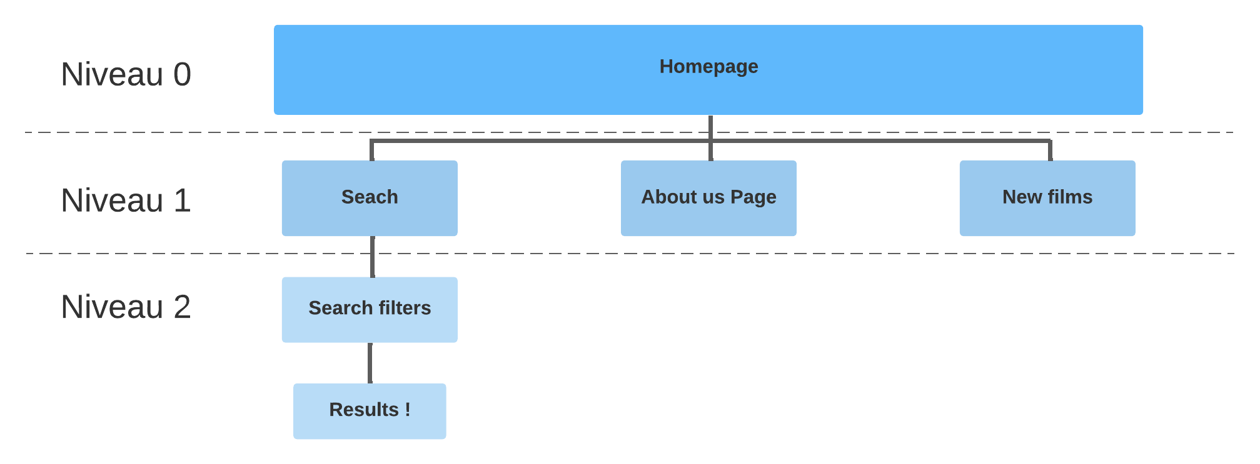

**Search**

**LEVEL 2**

**LEVEL 0**

**LEVEL 1**

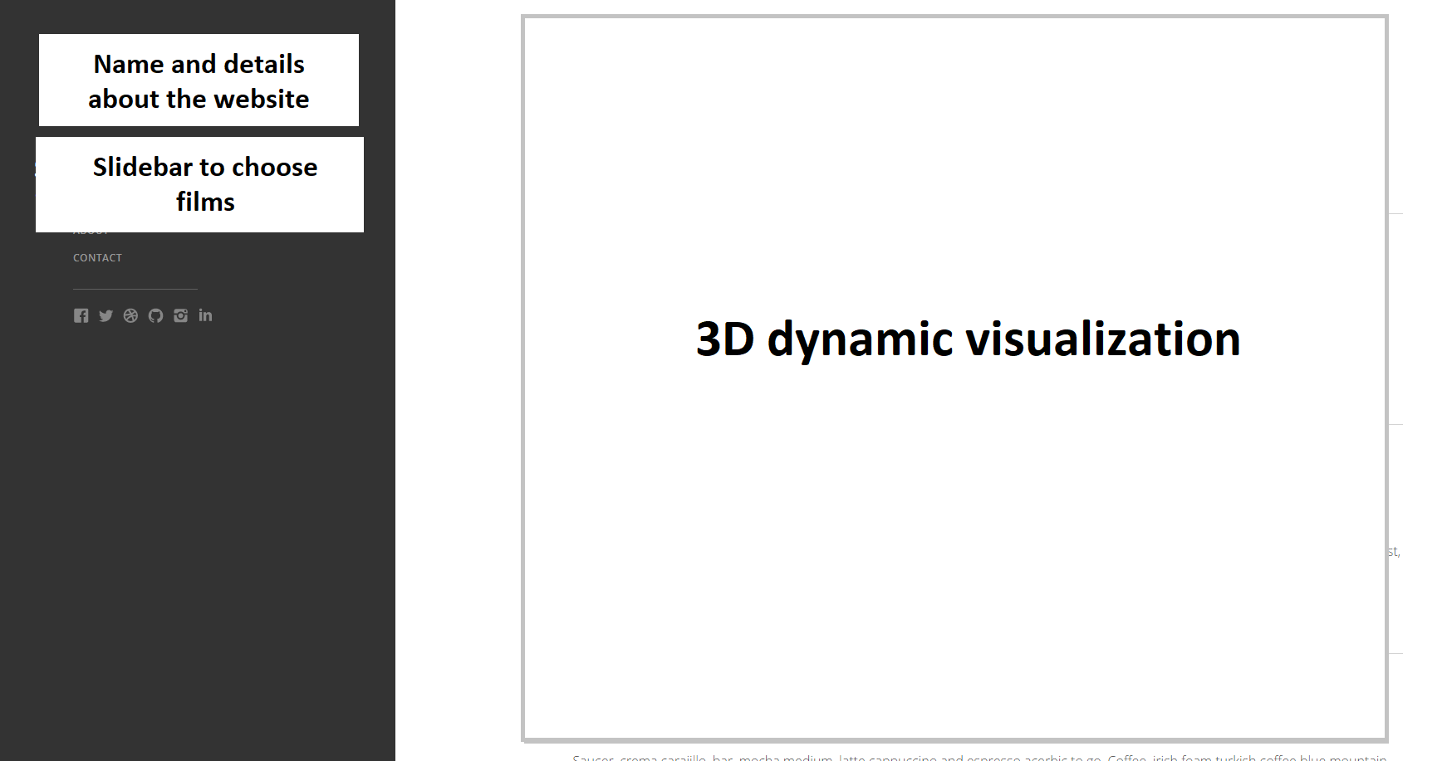

Design requirements: Homepage, List page, About page

Graphics requirements: 3D dynamic point display

Product constraints: It must work on laptop and phone. The website must be responsive.

## Data Gathering and Analysis

* Data scrapping on IMDb
* Feature extraction (of all available data) via NLP
* Classification (various technics)

## Domain name

“ <https://movie-finder.com> “

# Non-functional requirements

The site respects [the 80 good SEO practices of the OPQUAST repository](https://checklists.opquast.com/en/web-quality-assurance/).

## Security

The following points must be anticipated and realized, in order to secure our website:

* Install the SSL certificate to switch the site to HTTPS. Also gives an advantage in the Google search.
* Update the website regularly and make backups
* Make backups in case there is a problem (use backup plugins).
* Choose a secure web host
* Install plugins to secure the site and anti-malware on the hosting side. These plugins will allow us to block brute force attacks and malicious IPs, scan software that is supposed to be malicious, and set up an additional firewall.
* Secure the user input to prevent uninvited command injection

For database security:

* Only 4 members to access the database
* Backup and copies of our database

Protection of the general data: Get and remain GDPR compliant.

## Capacity

During the initial stage of our project, we will be using about 7 800 movie references. In the future we will extend it up 3 to 4 folds.

## Compatibility

The website needs to be compatible with laptops and mobiles.

## Reliability

For a website with a normal server, we can have up to 5Go/month of website traffic.

## Scalability

Simply scale the server and/or retrain the NLP once more films are in the database.

## Maintainability

Each time we have a bug in our website we will proceed to a backup and then we will solve the problem. The website will notify us when there will be a bug.

## Usability

The user should, in 2 or 3 clicks, find the best result. The user enters the website, enters some movie names and he will have his result.

# External interface requirements

## User Interface Requirements

The site must have a clear screen layout and buttons.

Indeed, it should be inclusive for all users.

## Hardware Interface Requirements

Supported hardware: computer and mobile phone

Supported processors: x86 and ARM

Memory: 4 Gb RAM minimum

Supported screen resolutions: 720p, 1080p, 1440p and 2160p. All in between.

## Software Interface Requirements

Supported OS: Windows 10, Windows 11, macOS 12 Monterey and Linux

Supported browsers: Latest Google Chrome, Firefox, Microsoft Edge and Safari versions

## Communication Interface Requirements

Communication standard: HTTPS