Project Report Complete

1.INTRODUCTION

1.1 Overview

Infographic uses in Canva

1.20 Purpose

Help people understand complex concepts.

2.Problem Definition & Design Thinking

2.1 Empathy map

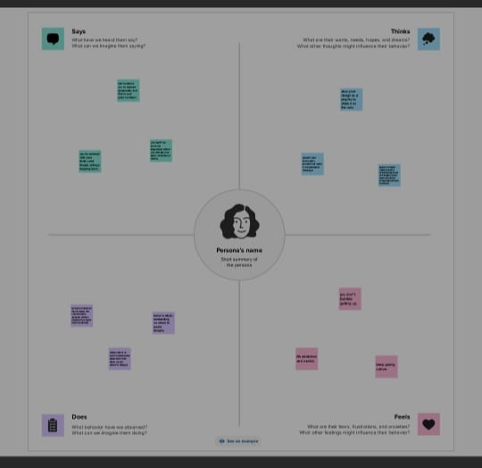

2.2 Ideation & Brainstorming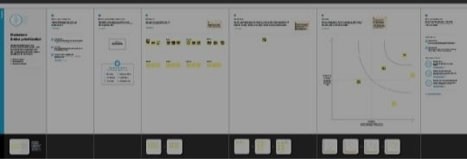 Map

3.Result

4. ADVANTAGES & DISADVANTAGES

Canva is very simple to use and user friendly:from

Layout of the platfor to guided Templates, basically a drag and drop

Design platform

It’s disadvantages is although canvas contribution is

growing every month there is a Limitation to Templates design

ans stock photography

5. Application

Mention your personal details and & contact information

6. Conclusion

We learn a lot of new thinks about editing and make eat

Useful for others