修改属性为：

"C:\Program Files (x86)\Beyond Compare 3\BComp.exe" %base %mine /title1=%bname /title2=%yname /leftreadonly

"C:\Program Files (x86)\Beyond Compare 3\BCompare.exe"

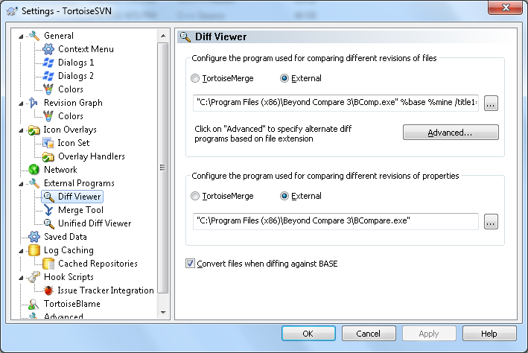

修改属性为：

"C:\Program Files (x86)\Beyond Compare 3\BComp.exe" %mine %theirs %base %merged /title1=%yname /title2=%tname /title3=%bname /title4=%mname

