1. Which of the following is not a part of C#?
2. Dynamic arrays
3. Implementing many interfaces
4. Run time type checking
5. None of the above
6. What will this code produce?

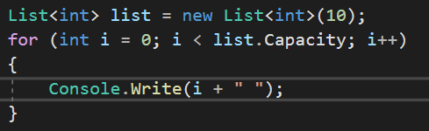

1. 1 2 3 4 5 6 7 8 9 10
2. Nothing
3. Compile time error
4. 0 1 2 3 4 5 6 7 8 9
5. Which of the following is value type in C# (can be more than 1)?
6. Int32
7. Bool
8. Decimal[]
9. Float
10. What is nullable type (can be more than 1)?
11. It allows assignment of null value to reference type.
12. It allows assignment of null value to static class.
13. It is always null.
14. None of the above.
15. 10 > 9 ? "10 is greater than 9” : "9 is greater than 10” is an example of?
16. Conditional operator
17. Null operator
18. Inverse operator
19. Ternary operator
20. What will this code produce?

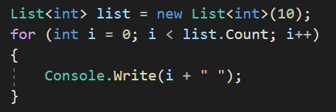

1. 1 2 3 4 5 6 7 8 9 10
2. Nothing
3. Compile time error
4. 0 1 2 3 4 5 6 7 8 9
5. Which of the following is not C# type (can be more than 1)
6. Int8
7. Uint64
8. BigInteger
9. BigDecimal
10. Which of the following is the right way of declaring an array?
11. int[] arr = new int[]
12. int arr[] = new int[5]
13. int[] arr = new int[5]
14. int[5] arr = new int[]
15. What will this code produce?

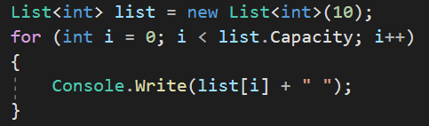

1. 0 0 0 0 0 0 0 0 0 0
2. Compile time error
3. Nothing
4. Run time error
5. Which line will match this regex - [A-Z][a-z]+ [A-Z][a-z]{4}
6. AAb Baaa
7. Xyzz T1234
8. Aazz Azzzzz
9. Yp Pyyyy
10. None of the above
11. What is the time complexity of Merge sort (average)?
12. O(N)
13. O(log N)
14. O(N log N)
15. O(1)
16. None of the above
17. What is the base type of all C# types?
18. dynamic
19. variable
20. object
21. class
22. C# supports multiple inheritance?
23. True
24. False
25. What will this code produce?

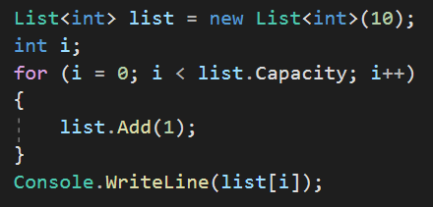

1. 9
2. 10
3. 1
4. Nothing
5. Run time error
6. Compile time error
7. None of the above
8. What is the difference between Git and GitHub?
9. What is the best name for a class that calculates expressions?
10. Class1
11. Program
12. Elka
13. ExpressionCalculator
14. In OOP, SOLID principles stands for?

S -

O -

L -

I -

D –

1. Calculate the statements
2. 1101 AND 1010 =
3. 100011 OR 110100 =
4. 1010 NOT 1000 =
5. 11111110 XOR 11111111 =
6. What is specific about abstract classes in C#?
7. Cannot have implementation of its methods
8. Cannot have private members
9. Cannot be instanced
10. All of the above
11. C# is one of the most used functional programing languages?
12. True
13. False
14. You have a deck of 52 cards. 13 of the cards are upside down. Is it possible to split the deck of two parts and in each part to have equal number of cards that are upside down?

Solution:

1. There is an aquarium with 200 fishes. 99% of the fishes are red. How many fishes you have to remove in order get 98% red fishes?

Solution:

1. You have 9 coins. One of the coins is fake and its weight is less than the others are. If you have scales, how many measures you need to find the fake coin?

Solution: