## Lab5 – IT21258794

1. In the below given cell, shape of the boxes.eval() is (1783,4). Why are there 1783 boxes? Explain the reason for it
   * input image has been divided into a 19x19 grid, and for each grid cell, 5 anchor boxes are predicted.So total number of boxes before filtering is 19 * 19* 5 = 1805 . This represents the number of anchor boxes across the entire grid.using a threshold value (0.5) all those 1805 prediction were filterd and after filtering, 1,783 boxes were retained, meaning 22 boxes were discarded because their confidence scores were below 0.5.
   * maximum number = 19 * 19* 5 = 1805
   * minimum number = 0
2. Change the values like mean and stddev in lines 2 and 4 as well as threshold value in line 5 and observe the different values you get for the boxes.eval().shape

with tf.compat.v1.Session() as test_a:

box_confidence = tf.compat.v1.random_normal([19, 19, 5, 1], mean=2, stddev=5, seed = 1)

boxes = tf.compat.v1.random_normal([19, 19, 5, 4], mean=1, stddev=4, seed = 1)

box_class_probs = tf.compat.v1.random_normal([19, 19, 5, 80], mean=2, stddev=5, seed = 1)

scores, boxes, classes = yolo_filter_boxes(box_confidence, boxes, box_class_probs, threshold = 0.6)

print("scores[2] = " + str(scores[2].eval()))

print("boxes[2] = " + str(boxes[2].eval()))

print("classes[2] = " + str(classes[2].eval()))

print("scores.shape = " + str(scores.shape))

print("boxes.shape = " + str(boxes.shape))

print("classes.shape = " + str(classes.shape))

print(boxes.eval().shape)

Tensor("boolean_mask_12/GatherV2:0", shape=(None,), dtype=float32) Tensor("random_normal_14:0", shape=(19, 19, 5, 4), dtype=float32) Tensor("GreaterEqual_4:0", shape=(19, 19, 5), dtype=bool)

scores[2] = 26.533358

boxes[2] = [-1.8915889 0.7749185 3.5741792 -0.05729628]

classes[2] = 7

scores.shape = (None,)

boxes.shape = (None, 4)

classes.shape = (None,)

(1792, 4)

1. yolo_anchors.txt contains 10 values. They can be considered as height and width of 5 anchor boxes. What is the advantage of using such anchor boxes? What was the method used to determine the sizes of these anchor boxes?
   * **Efficiency in Object Detection**: By using anchor boxes, the model can quickly predict bounding boxes for objects with different sizes and shapes without having to start from scratch.
   * **Flexibility for Detecting Multiple Object Sizes**: Anchor boxes provide a set of templates that help the model handle objects of various scales and aspect ratios within a single image.
   * **Improved Convergence During Training**: The use of anchor boxes can lead to faster and more stable convergence during training.
   * K-means clustering algorithm

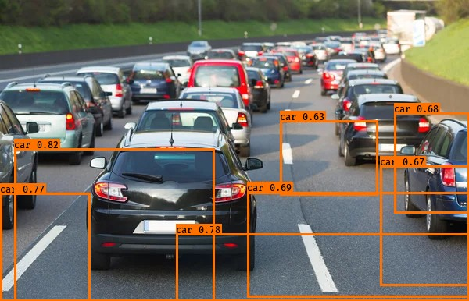

* Not only the car the roads are also includes in the boxes. Not either one of them are successfully detected

* The car coming towards the camara deleted as a car but the truck which is long distantly Infront of the camara could not detected. Also, the water pipe like thing is detected. but color lights are not detected.

1. Change the max_boxes [integer value] to a different value but use the original values for other 2 variables. Rerun the required cells to get the output images for the autonomous driving dataset. Observe if this result in improvement compared to step 10 for the same two images. If there are any improvements, write them in the word file.

Max_boxes = 20

* Nothing changes

* Nothing changes

1. Change the score_threshold [value between 0-1] to a different value but use the original values for other 2 variables. Rerun the required cells to get the output images for the autonomous driving dataset. Observe if this result in improvement compared to step 10 for the same two images. If there are any improvements, write them in the word file. Include the new 2 output images

score_threshold : 0.1

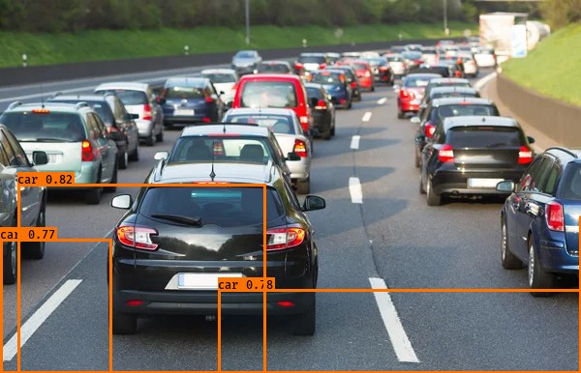

* Thes boxes are reduce but nothing improved

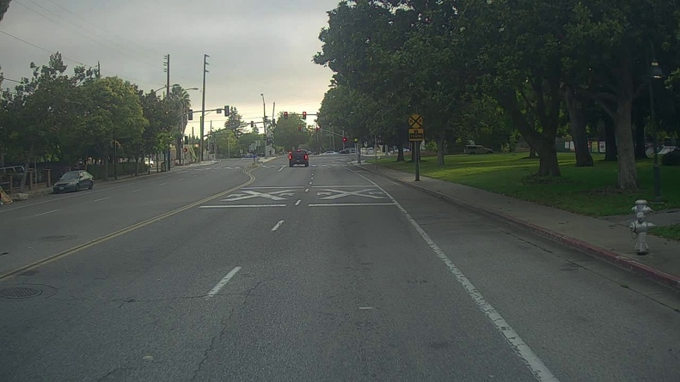

* Nothing detected

1. Change the iou_threshold [value between 0-1] to a different value but use the original values for other 2 variables. Rerun the required cells to get the output images for the autonomous driving dataset. Observe if this result in improvement compared to step 10 for the same two images. If there are any improvements, write them in the word file. Include the new 2 output images

iou_threshold : 0.8

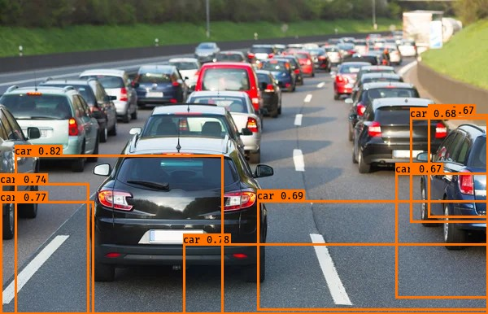

* Boxes are increased and one of the cars detected properly. Bit improved than first result
* Not improved compare to first result