Commercial PA – Insufficient Information/Changing Responses (RPh ONLY)

RPh Protocol for Changing Responses in CAS
Reviewing Formulary Alternative Documentation
RPh Protocol for Insufficient Information
Pending Fax Queues and Insufficient Queues
Related Documents

Description: This document outlines the Commercial pharmacist process for reviewing PA requests that are missing information or require responses to be changed in CAS.

RPh Protocol for Changing Responses in CAS

Utilize Edit if changes are needed to Qset responses. Refer to Commercial PA -Using the Edit Button in CAS (078963).
- Modifying a response will lock all prior questions and clear any answers that follow.
- By selecting Next, CAS will apply skip logic based on the criteria mapping.
It is essential to ensure user’s edits are necessary and accurate because once the later questions are cleared, they cannot be repopulated with user’s previous responses.

Responses received from MDO must be changed in CAS when:

- The criteria require responses to be changed if needed to generate the auto-populated denial.
- See General Criteria Question Guidance section in General Criteria Review and Formulary Alternative Considerations (045268).

Note: Documentation questions are not to be changed from Yes to No unless changing to generate auto-populated denial. The RPh is to simply document in their notes if the intent of the question was not met.

Unanswered questions must be marked by the RPh when:

- The criteria require responses to be answered if needed to generate the auto-populated denial.
- It can be determined that the intent of the question was either met or not met.
Note: If a diagnosis question is unanswered, and RPh is unable to answer favorably based on provided information, fax out the criteria.
  - If the MDO does not answer the diagnosis question or provide an approved indication, the RPh should deny for the diagnosis question as insufficient, as there is a possibility that patient may have additional diagnoses not provided by MDO.

Suggested terminology for PA notes for clarity:

- Use “marked” when unanswered question is marked by RPh .
Example: Q1 marked Yes by RPH based on DX.
- Use “answered” when question is answered by doctor’s office (MDO).
Example: Q1,2 answered Yes by MDO per fax.
- Use “changed” when MDO answer is changed by RPh.
Example: Q1 was changed to No based on DX.

It is required to document in PA Notes what response(s) were changed or answered and the reason for that change. Proper documentation is important for auditing purposes and subsequent PA follow up.

Top of the Document

Reviewing Formulary Alternative Documentation

The chart below lists commonly encountered scenarios when the MDO answers the formulary alternative question “Yes” and documentation is required.

Insufficient Information Clinical Denial Scenarios | Sufficient Information Clinical Denial Scenarios
Sufficient number of appropriate alternatives are listed but lack documentation of failure reason or date of trial (if required on that particular form). | Alternatives are provided (with or without complete documentation) and the patient has not tried the required number of alternatives, or the alternatives given are not correct or clinically appropriate.  Example 1: MDO documented “Lovastatin – therapeutic failure, Pravastatin – therapeutic failure” – this is a sufficient information denial, required trial and failure of 3 statins has not been met.  Example 2: MDO documented “Lovastatin, Pravastatin” (without reason for failure) – this is a sufficient information denial, required trial and failure of 3 statins has not been met.
No documentation is provided at all.

MDO gives reasons for failure without providing drug names.

Example 1: MDO documented “failed all alternatives” – this is insufficient, it is assumed from the statement that the patient has met the requirement of trial of all alternatives, but the drug names are missing.

Example 2: MDO documented “lovastatin, pravastatin, simvastatin” – this is insufficient, the patient has met the requirement of trial of 3 alternatives but the reasons for failure are missing.

Top of the Document

RPh Protocol for Insufficient Information

Perform the steps below:

If… | Then…
Call and Fax origin PAs with insufficient information | - Check to verify there is a documented technician note indicating an OBC was made to the MDO.  - If there is no documentation that an OBC was made, the RPh is to make an OBC attempt and enter a note in CAS. The RPh is to enter an error on the technician in CAS.  - If there is documentation that an OBC was already made, prior to a PA being closed for insufficient information, one RFI with clinical information must be made to complete the criteria.  - Refer to Pharmacist PA Review Process in CAS Web (080372) for additional information.  - For PG & 24/7 clients, RPh is required to make an OBC if initial OBC was not made by rep.  - The RPh may choose to make an additional outbound call (OBC) if they determine appropriate.  - Only 1 OBC is required, but an additional OBC is OK.  - The OBC attempt should be documented in the PA notes of CAS.
Urgent and non-urgent ePAs with insufficient information | - Prior to an ePA being closed for insufficient information, one RFI with clinical information must be made to complete the criteria.  - For details, refer to ePA RPh process - Incorrect Criteria Form (RPh Only) and Insufficient Urgent ePAs (028209)

The RPh may review PA history as appropriate to obtain the missing information:
- If information from a previous PA is applied to the current PA, press the SET button for the completed received timestamp.
  - Document the additional information added in PA Notes.
  - See Pharmacist PA Review Process in CAS Web (080372) for instructions regarding clinical consistency.

In an effort to meet TAT, the criteria should be “RFI- with clinical” to the MDO a total of 1 time (whether fulfilled by representative or RPh). This applies even if the MDO does not fax that criteria back. (Example: MDO fax back chart notes without the criteria, do not fax them again). It will be assumed they have seen the criteria since it has been faxed and the RPh should work the PA with the information provided.

ALWAYS check the Activities tab to determine if the criteria has already been “RFI with clinical” to the MDO. This information can be found under the Notes column.

Initial RPh Reviewer:

If incomplete information was received via… | Then…
Call/Fax | Determine if there is documentation of an OBC being made.
 | If… | Then…
 | No | The RPh will:  - Make an OBC attempt and enter a note in CAS.  - Enter an error on the technician in CAS.
 | Yes | Prior to a PA being closed for insufficient information, one RFI with clinical information must be made to complete the criteria.  Note: Even if the representative previously selected the RFI-With Clinical Info close option, the RPh is still responsible for selecting the RFI-Without Clinical Info close option if no clinical information has been received prior to closing the case.
ePA | If no RFI with clinical attempts have previously been made, the reviewing RPh will send the RFI request to the MDO to complete the criteria.  Notes:  - Urgent PAs must have the urgent indicator flagged when faxing out.  - Cases with low TAT for 24/7 clients:  - For 24/7 clients, TAT is not reset based on updated timestamp.  - If the case is low/negative TAT, verify OBC attempt has been made and close case promptly.  - As best practice when faxing out, mark and notate the question that needs to be answered and provide form alts for NFME/VF criteria.  Example: Please completely fill out the attached criteria, starting with question <insert question number>, and provide supporting documentation so we may complete your PA request. Requested information may be called or faxed to numbers provided on the form. Thank you. Approved formulary alternatives: <insert formulary alternatives>.

Top of the Document
Subsequent RPh Reviewer:
If the fax with clinical/outreach attempt has been made and the criteria are still not complete, the subsequent RPh is to follow the steps below:
Note: Abbreviations are to be spelled out or removed.
Step | Action
1 | To close a PA for insufficient information the RPh should:  - Press the SET button for completed received timestamp.  - Include in PA notes: “Insufficient information” at the beginning of the PA notes.
2 | Select the most appropriate close option “Insufficient Clinical Info” or “Insufficient Info w/ Partial Qty Approved” when available.  - Close the PA accordingly based on denial verbiage scenario. See examples below:  Example 1: Criteria with auto-populated denial. Deny with the auto-populated denial.  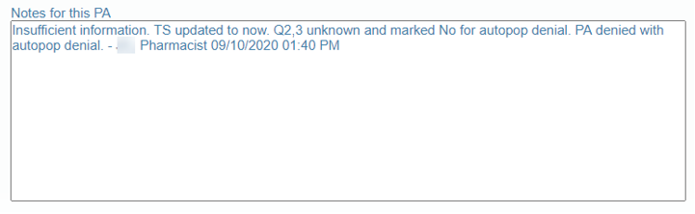  Example 2: Criteria that uses client approved or custom verbiages. Check the WI tab of CAS and CAS guidelines for client approved or custom verbiages. WI tab denial verbiage will always trump CAS guidelines or auto-populated denials.  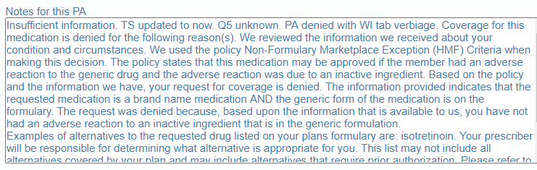  Example 3: All others with no auto-populated denial, guidelines denial, or WI tab denial (Free-Form denial). Deny for the first unknown question using standard denial template and add “… if it is unknown…” to the verbiage. Alternatively, if pre-made denials are available in team resources, RPh may use the pre-made denial. The denial letter is ultimately required to reflect the reason for denial OR reflect what the drug would have been approved for (had the information been provided).  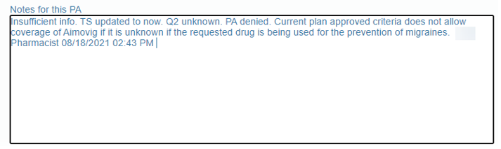

Top of the Document

Pending Fax Queues and Insufficient Queues

PAs in these two types of queues contain clinical information and have had the criteria faxed to the MDO in an attempt to complete the criteria or required documentation.

- Type 1 - Pending Fax Queues
- Type 2 - Insufficient Queues

Type 1 - Pending Fax Queues:
The pending fax queue set up relies on the working RPh to manually determine whether the cases are ready to be closed. The MDO should be given 48 hours (from the original criteria fax out) to respond to the request for more clinical information. The Edit date column in the pending fax queues will usually correspond with the date that the criteria was faxed to MDO.
- Pending fax queues are located under the Grid Queues section in CAS and named “Pending Faxes w/ Clinical.” The queue name will NOT contain the word “Holding.”

- 24/7 Clients:
For PAs in Pending Faxes w/ Clinical 24/7 or Pending Faxes w/ Clinical 24/7 the RPh is to complete the PA when 12 hours or less remain. These 24/7 cases should NEVER go negative and they must be fully closed within the TAT (including MD review &/or QC).

Type 2 - Insufficient Queues:
The insufficient queue set up relies on the CAS system to ensure TATs are met on cases that may have insufficient information and to give prescribers an allotted period of time (usually 48 hours) to respond before a PA is closed as insufficient.

- Cases from Holding Queues automatically move into Insufficient Queues:

    - For clients set up to use the insufficient queues, the system will automatically pend the PA in a holding queue (Pending Faxes w/Clinical Holding) when a criteria is faxed to MDO. When the case has met the required time and is ready for RPh review, the PA will drop the corresponding insufficient queue. RPhs should not be touching/working PAs in holding queues.

    - Insufficient Queues are located under the Get Next Queues section in CAS and queue name will contain“-Insuff.”

Note: Cases in insufficient queues are ready to be completed by the RPh at the time they drop into the queue. Do not need to wait before closing the case.
- Special instructions regarding insufficient/urgent cases and TAT considerations can be found in the bi-weekly game plan sent via email.

Top of the Document

Related Documents
Parent Document: PAR-0011: Prior Authorization Process
Abbreviations/Definitions: Commercial PA – Prior Authorization, Exceptions, Exchanges Glossary of Terms (012831)

Top of the Document

Not To Be Reproduced Or Disclosed To Others Without Prior Written Approval
ELECTRONIC DATA = OFFICIAL VERSION / PAPER COPY = INFORMATIONAL ONLY

