**Assignment 04**

1. Display the PNAME and COLOR from the P table for the CITY=”London”.

Ans. Select pname, color from p where city= 'London ' ;

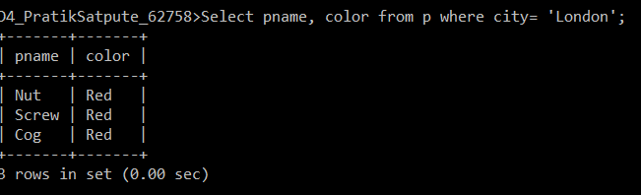

1. Display all the Suppliers from London

Ans: select * from s where city = 'London';

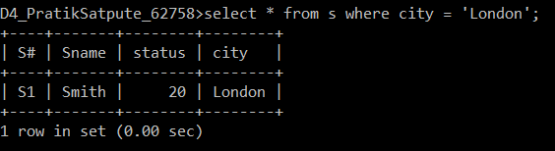

1. Display all the Suppliers from Paris or Athens.

Ans: select * from s where city IN( 'Athens','Paris') ;

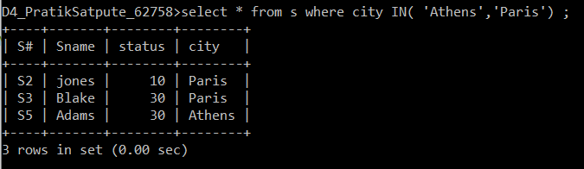

1. Display all the Projects in Athens.

Ans: select * from j where city = 'Athens';

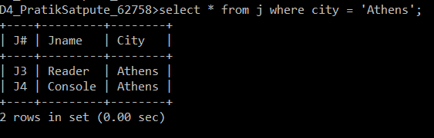

1. Display all the Part names with the weight between 12 and 14 (inclusive of both).

Ans: Select pname from P where weight Between 12 AND 14;

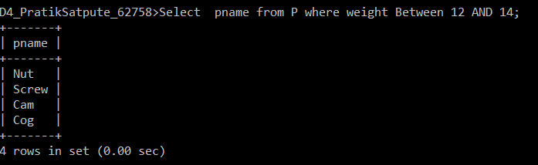

1. Display all the Suppliers with a Status greater than or equal to 20.

Ans: Select * from S where status >=20;

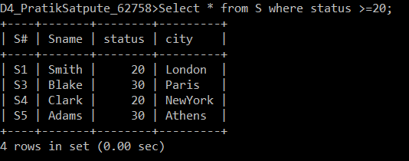

1. Display all the Suppliers except the Suppliers from London.

Ans: Select * from S where city != 'london';

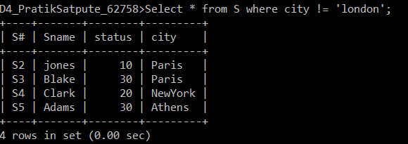

1. Display only the Cities from where the Suppliers come from.

Ans: select city from S;

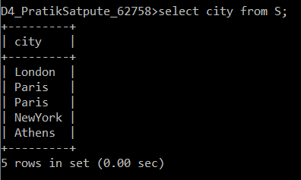

1. Display the Supplier table in the descending order of CITY.

Ans: select * from S order by city desc;

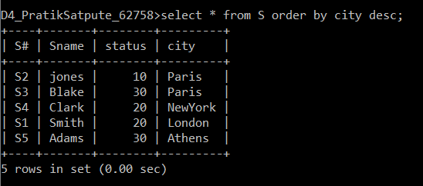

1. Display the Part Table in the ascending order of CITY and within the city in the ascending order of Part names.

Ans: select * from P order by city , pname;

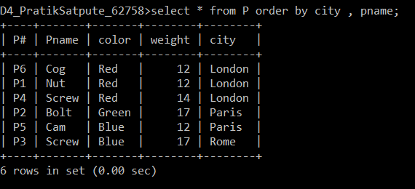

1. Display all the Suppliers with a status between 10 and 20.

Ans: select * from S where status between 10 and 20;

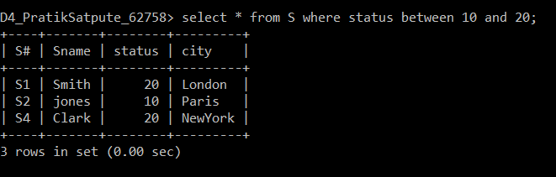

1. Display all the Parts and their Weight, which are not in the range of 10 and 15

Ans: select pname, weight from p where weight not between 10 and 15;

