**Assignment 05**

1. Display first name and last name after converting the first letter of each name to upper case and the rest to lower case.

Ans:

select Concat (Upper(left (First_name,1)), lower(substring(First_name,2))) as First_name,Concat(Upper(left (last_name,1)), lower(substring(last_name,2)))as Last_name from employees LIMIT 15;

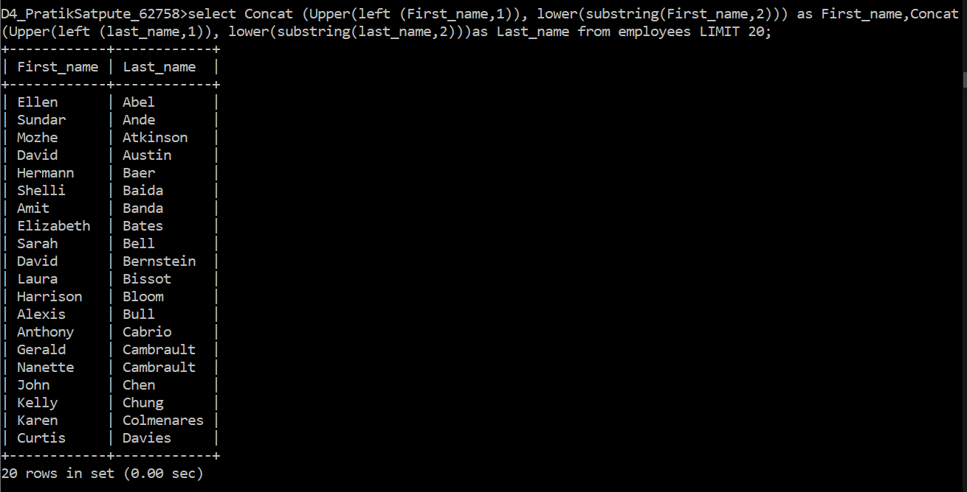

1. Display the first word in job title.

Ans: select Left(job_title,1) from jobs;

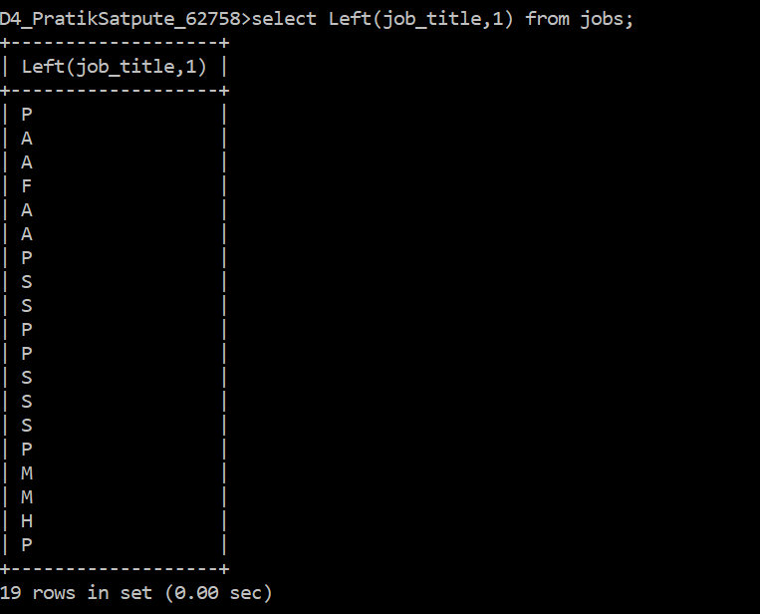

1. Display the length of first name for employees where last name contain character ‘b’ after 3rd position.

Ans: select length(First_name) from employees where Last_name like '__b%';

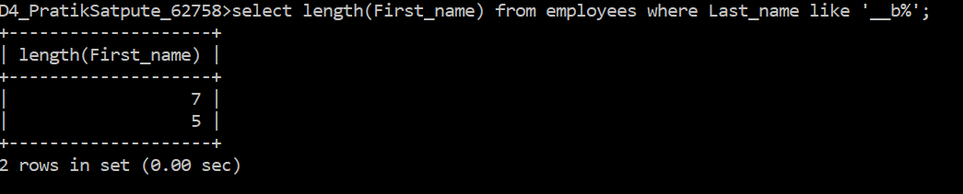

1. Display first name in upper case and email address in lower case for employees where the first name and email address are same irrespective of the case.

Ans: Select Upper(First_name), Lower(Email) from employees where First_name = email;



1. Display first name, salary, and round the salary to thousands.

Ans: select First_name , round(salary,-3) As Salary from employees Limit 20;

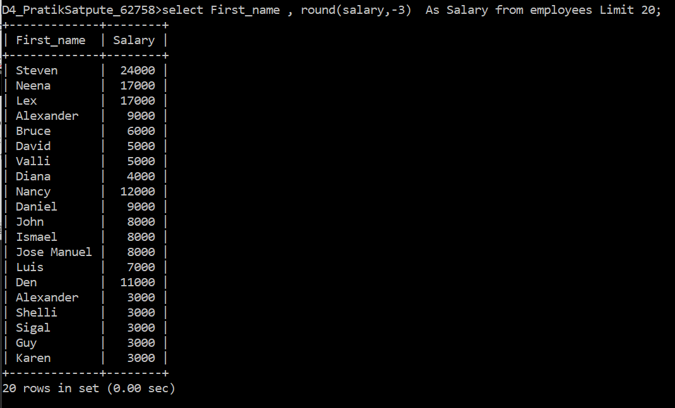

1. Display employee ID and the date on which he ended his previous job.

Ans:

Select employee_id, End_date as Last_day_of_previous_job from job_history;

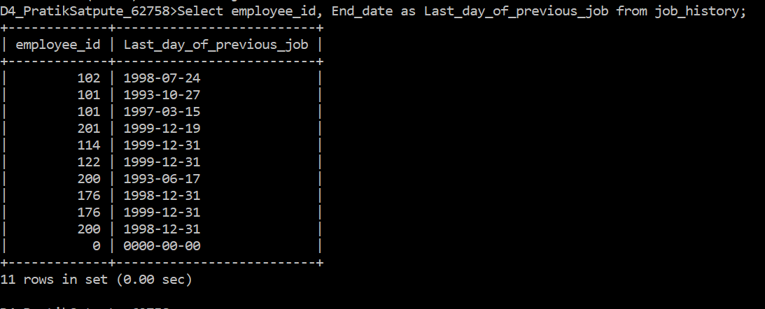

1. Display first name and date of first salary of the employees

Ans: select First_name, Date_Add(Hire_date,Interval 1 Month) as Date_of_First_salary from employees;

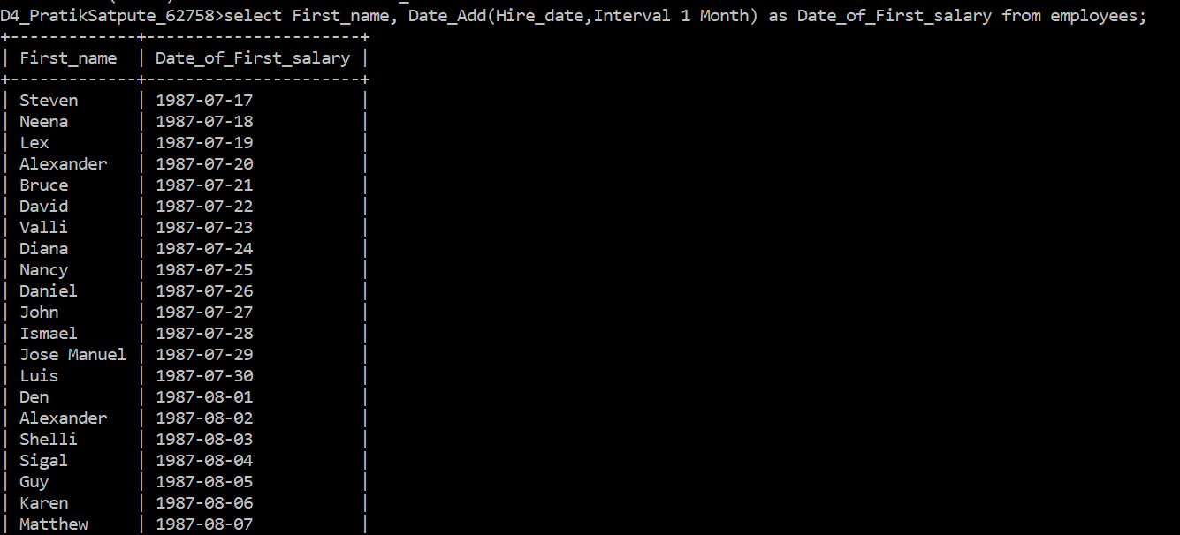

1. Display first name and experience of the employees.

Ans: Select First_name, concat (timestampdiff(year,hire_date,now()),' years ', timestampdiff(Month, Hire_date, Now())%12,' months') as Experience_in_current_compony from employees LIMIT 10;

