**Assignment 06**

1. **Display manager ID and number of employees managed by the manager.**

**Ans :** select manager_id, count(*) from employees group by manager_id;

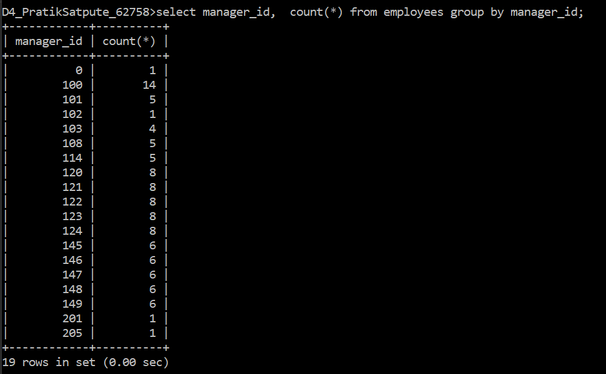

1. **Display the country ID and number of cities we have in the country.**

**Ans :**

Select country_id , count(*) from locations group by country_id;

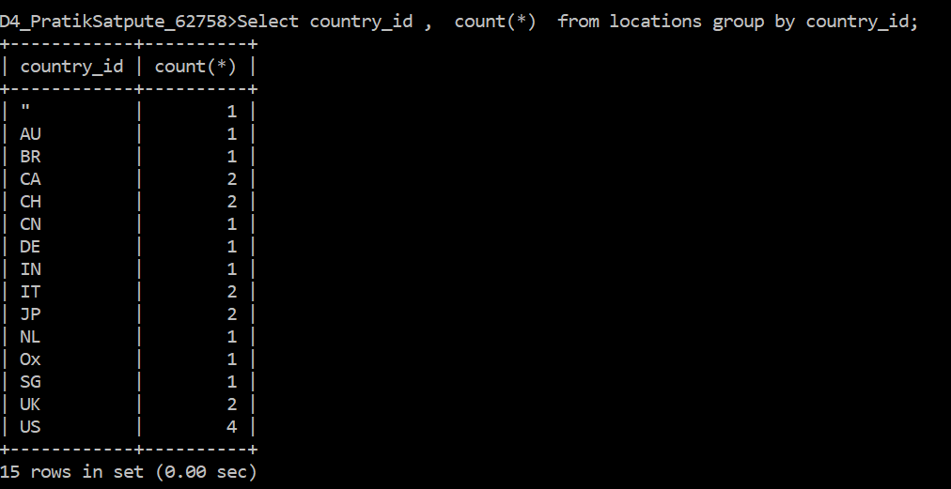

1. **Display average salary of employees in each department who have commission percentage.**

**Ans:** select avg(salary) from employees where commission_pct is not null;

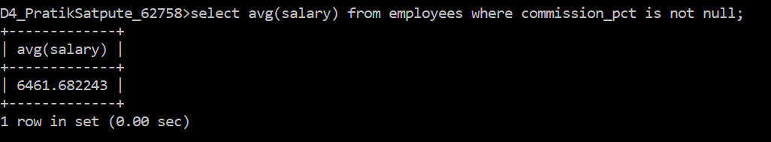

1. **Display job ID, number of employees, sum of salary, and difference between highest salary and lowest salary of the employees of the job.**

**Ans:**

Select Job_ID ,count(*) as 'No. of Employees ', sum(salary) as 'Total salary ', (max(salary)-min(salary)) As 'difference between max and min salary ' from employees group by job_id;

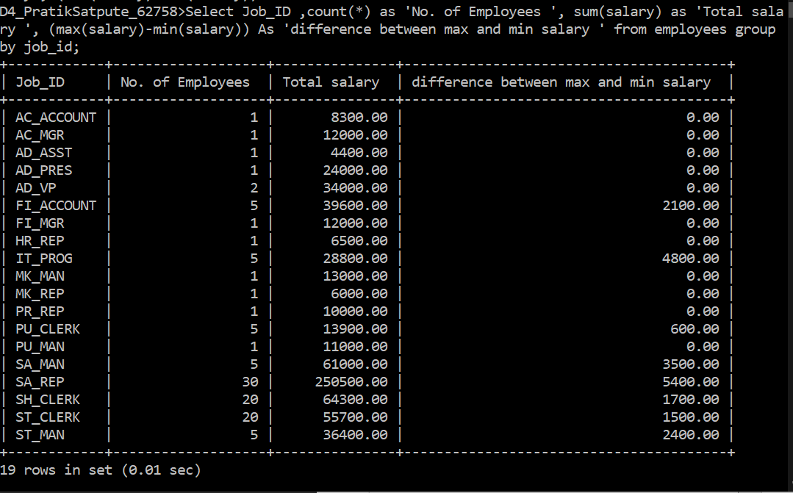

1. **Display job ID for jobs with average salary more than 10000.**

**Ans :**

Select Job_ID, round (avg(salary),1) as 'Average Salary ' from employees group by job_id having Avg(Salary)>10000 ;

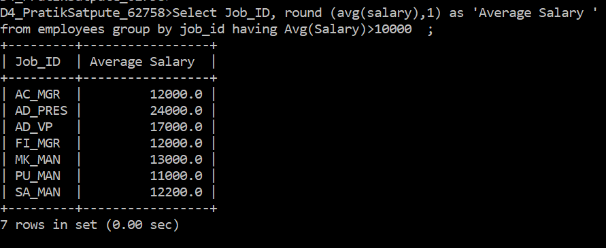

1. **Display years in which more than 10 employees joined.**

**Ans:** select year(hire_date), count(*) from employees group by year(hire_date) having count(*) >10;

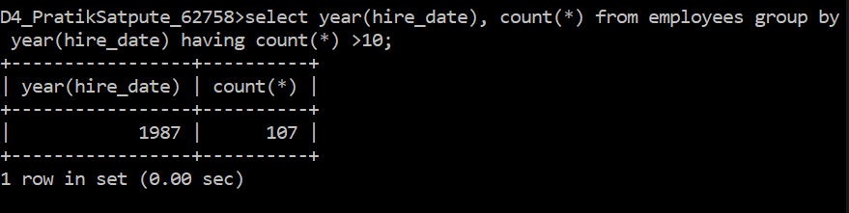

1. **Display departments in which more than five employees have commission percentage.**

**Ans:** select Department_ID, count(*)from employees group by department_Id;

1. **Display employee ID for employees who did more than one job in the past.**

**Ans:** select Employee_ID ,count(*) from job_history group by employee_id having count(*)>1;

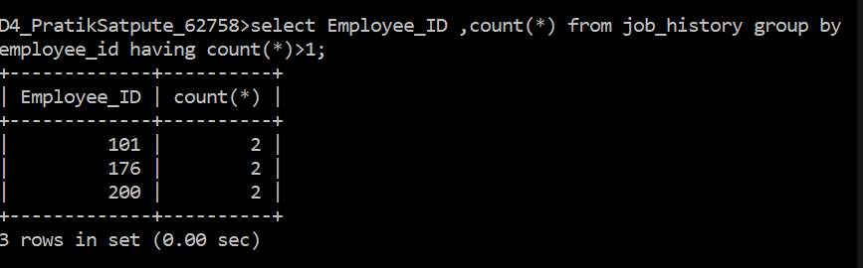

1. **Display job ID of jobs that were done by more than 3 employees for more than 100 days.**

**Ans:** Select job_id from employees where datediff(now(), hire_date)>100 group by job_id having count(job_id)>3;

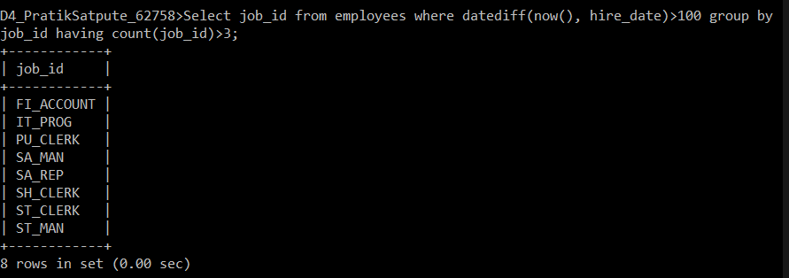

1. **Display department ID, year, and Number of employees joined.**

**Ans:** select department_ID , round(AVG(year(hire_date))) ,count(employee_id) from employees group by department_id;

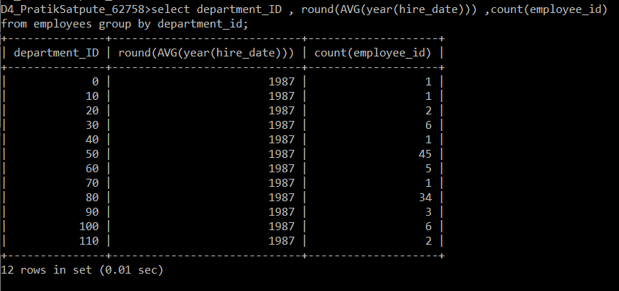

1. **Display how many employees joined in each month of the current year.**

**Ans:** Select count(employee_id) as employee_count from employees where year(now())= year(hire_date);

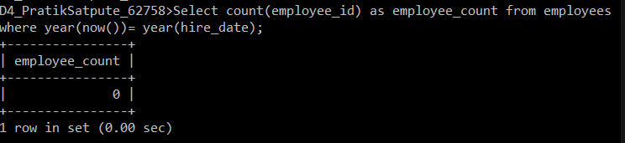

1. **Display details of departments in which the maximum salary is more than 10000**

**Ans:** Select d.department_id, d.department_name, e.salary from departments d INNER JOIN Employees e ON e.salary>10000; 