Assignment 07

**Based on Sales database**

1. **Write a query that lists each order number followed by the name of the customer who made the order.**

**Ans :** Select o.onum as Order_number, c.cname as Customer_name from orders o inner join customers c ON o.cnum = c.cnum;

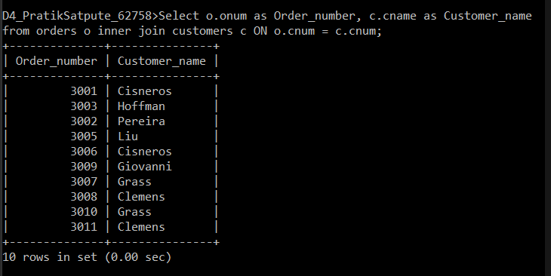

1. **Write a query that gives the names of both the salesperson and the customer for each order along with the order number.**

**Ans:** Select s.sname as Sales_Person, c.cname as Customer from salespeople s inner join customers c ON s.snum = c.snum;

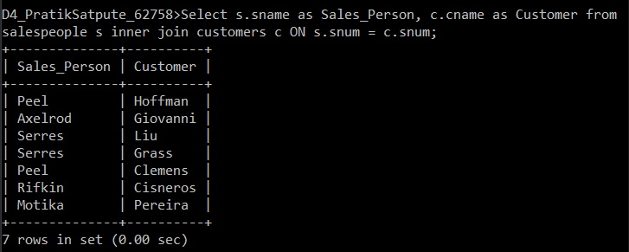

1. **Write a query that produces all customers serviced by salespeople with a commission above 12%. Output the customer’s name, the salesperson’s name, and the salesperson’s rate of commission.**

**Ans:** Select c.cname as Customer_name, s.sname as Salesperson_name, s.comm as Rate_of_commission from salespeople s right outer join customers c ON c.snum = s.snum where s.comm>0.12 ;

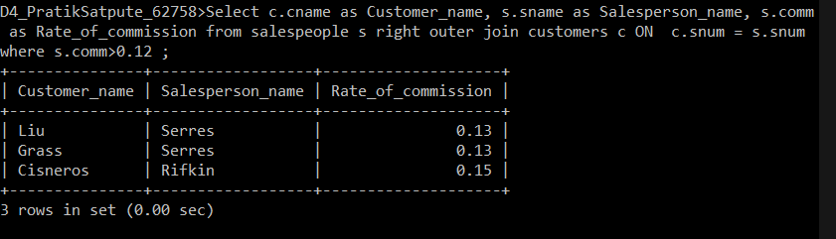

1. **Write a query that calculates the amount of the salesperson’s commission on each order by a customer with a rating above 100.**

**Ans :** Select o.onum as Order_No, (o.amt*s.comm) as Commission from orders o inner join salespeople s on o.snum= s.snum

Inner join customers c on s.snum = c.snum where c.rating>100;

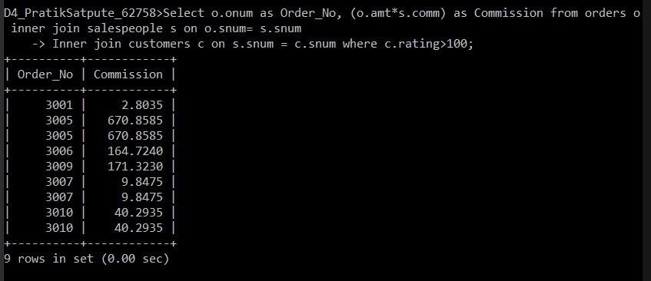

1. **Write a query that produces all pairs of salespeople who are living in the same city.Exclude combinations of salespeople with themselves as well as duplicate rows with the order reversed**

**Ans.** Select s.sname , m.sname from salespeople s inner join salespeople m on s.city = m.city where (s.snum!=m.snum) And (s.sname > m.sname) ;

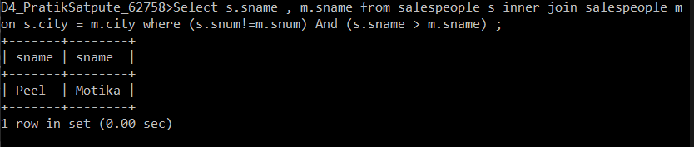

**Based on SPJ database**

1. **Display the Supplier name and the Quantity sold.**

**Ans:**

Select s.sname As Suppliers_name, sum(sp.qty) As Quantity_sold from S s inner join SP sp on s.`s#` = sp.`s#` group by s.sname;

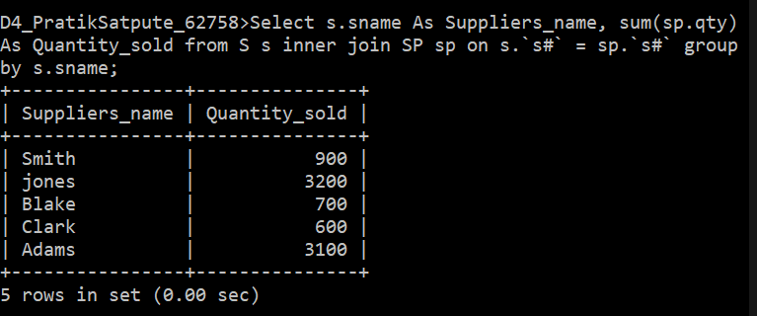

1. **Display the Part name and Quantity sold.**

**Ans:**

Select p.pname as Part_name, sum(sp.qty) As Quantity_sold from P p inner join SP sp on p.`p#` = sp.`p#` group by p.pname ;

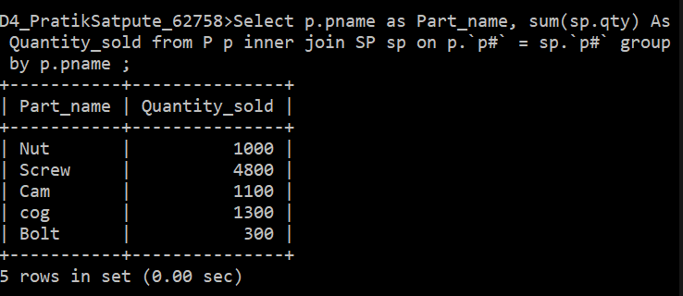

1. **Display the Project name and Quantity sold.**

**Ans :**

Select j.jname as Project_name, sum(sp.qty) As Quantity_sold from J j inner join SP sp on j.`j#` = sp.`j#` group by j.jname;

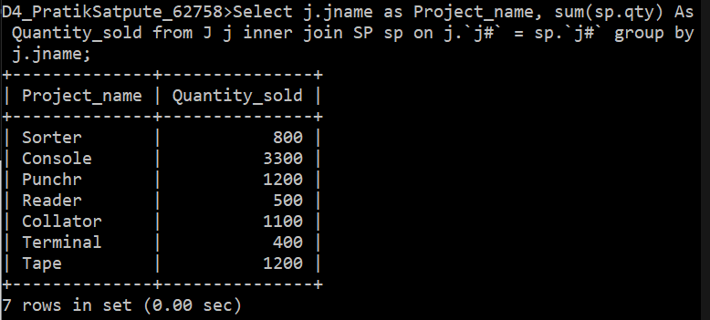

1. **Display the Supplier name, Part name, Project name and Quantity sold.**

**Ans :**

Select s.sname as Supplier_name , p.pname As Part_name , j.jname As Project_name, sp.qty as Quantity from S s

Inner join SP sp ON s.`s#`=sp.`s#`

Inner join P p On p.`p#` = sp.`p#`

Inner join J j ON j.`j#` = sp.`j#`;

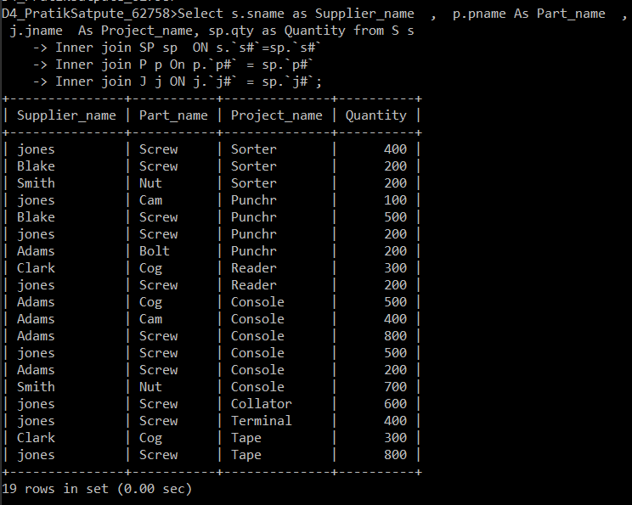

1. **Display the Supplier name, Supplying Parts to a Project in the same City.**

**Ans:** SELECT sname AS Supplier_name,pname As Part_name, jname AS Project_name ,s.city FROM s INNER JOIN p ON s.city=p.city INNER JOIN j ON p.city=j.city;

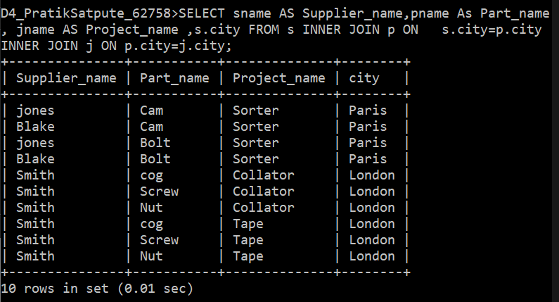

1. **Display the Part name that is ‘Red’ is color, and the Quantity sold.**

**Ans:**

Select p.pname , p.color, sum(sp.qty) from P p Inner join sp sp ON p.`p#`= sp.`p#` where color = 'red' group by p.pname ,p.color ;

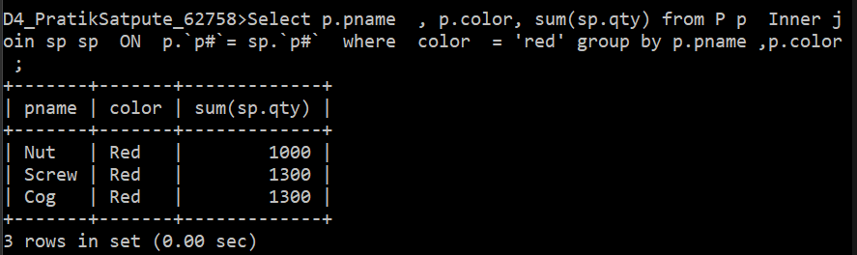

1. **Display all the Quantity sold by Suppliers with the Status = 20.**

**Ans:**

Select s.sname as Supplier , s.status, sum(sp.qty) from S s inner join SP sp ON s.`s#` = sp.`s#` Where s.status = 20 group by s.sname;

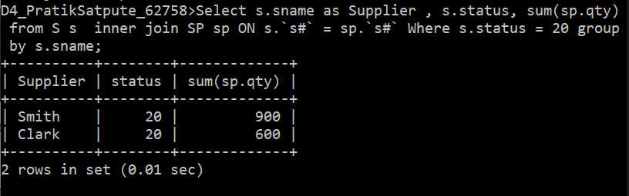

1. **Display all the Parts and Quantity with a Weight > 14.**

**Ans:**

Select p.pname , p.weight , sum(sp.qty) AS Quantity from P p left outer join SP sp ON p.`p#`= sp.`p#` where p.weight >14 group by p.pname, p.weight ;

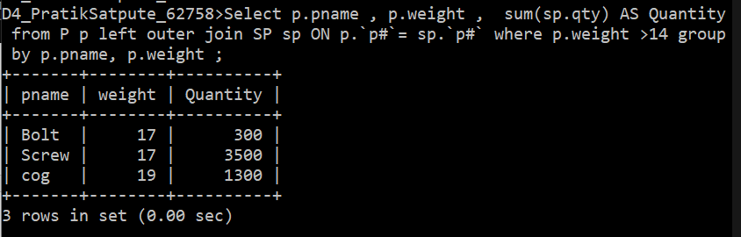

1. **Display all the Project names and City, which has bought more than 500 Parts.**

**Ans:**

Select j.jname As Project_name, j.city As City from j j left outer join SP sp ON j.`j#` = sp.`j#` where sp.qty>500 ;

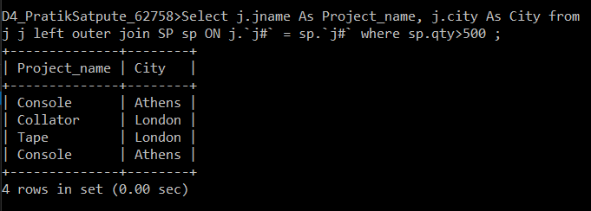

1. **Display all the Part names and Quantity sold that have a Weight less than 15.**

**Ans:**

Select p.pname as Part_name, weight , sum(sp.qty) as Quantity from P p join sp sp ON p.`p#`= sp.`p#` where p.weight <15 group by p.pname, weight;

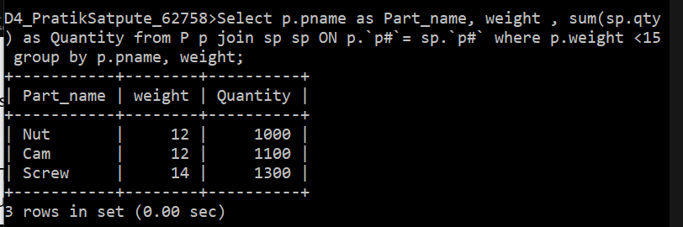

1. **Display all the Suppliers with the same Status as the supplier, ‘CLARK’.**

**Ans:**

Select s.sname from s s inner join S p ON s.sname = p.sname where s.status = 20 AND s.sname <> 'clark';

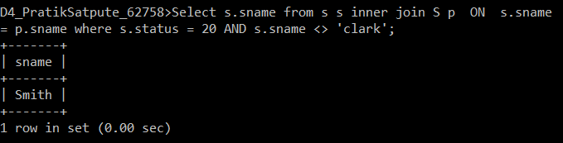

1. **Display all the Parts which have more Weight than all the Red parts**

**Ans :**

SELECT p1.`p#`,p1.pname,p1.weight,p1.color FROM p JOIN p p1 ON p.color='red' AND p1.weight>p.weight WHERE p1.color NOT LIKE 'red' GROUP BY p1.pname,p1.color,p1.weight,p1.`p#`;

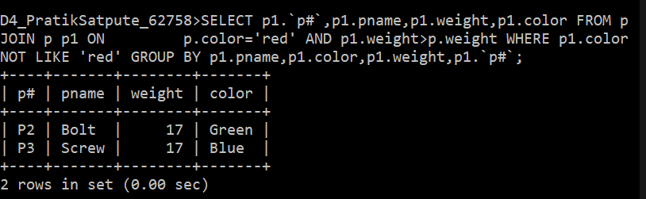

1. **Display all the Projects going on in the same city as the project ‘TAPE’.**

**Ans:** Select j.jname , m.city from J j inner join J m On j.jname = m.jname where j.city = 'London' AND j.jname != 'Tape';

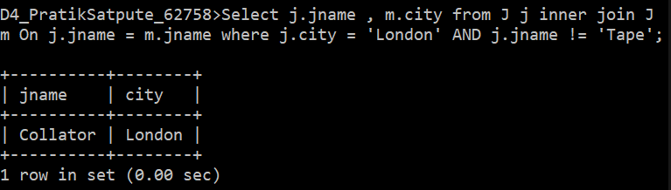

1. **Display all the Parts with Weight less than all the Green parts**

**Ans:**

Select m.pname , m.color, m.weight from p p left outer join p m On p.color='green' AND m.weight<p.weight where p.pname NOT LIKE m.pname ;

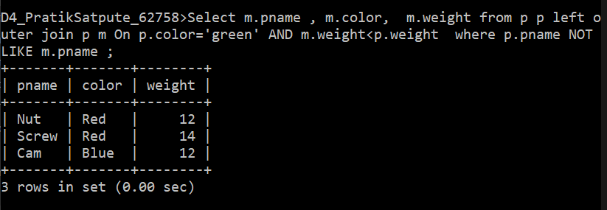

1. **Display the name of the Supplier who has sold the maximum Quantity (in onesale)**

**Ans:**

Select s.sname, sp.qty from S s left outer join SP sp ON s.`s#`=sp.`s#` order by sp.qty desc Limit 1;

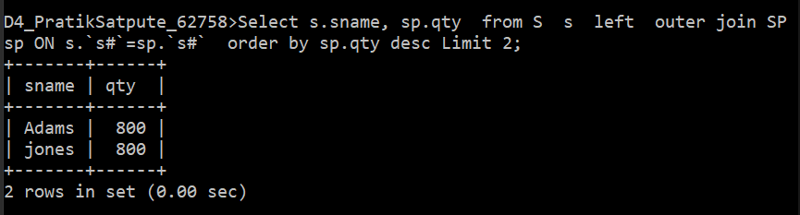

1. **Display the name of the Supplier who has sold the maximum overall Quantity (sumof Sales).**

**Ans:**

Select s.sname as Supplier_name, sum(sp.qty) as Total_Quantiy from S s left outer join SP sp ON s.`s#`=sp.`s#` group by s.sname order by sum(sp.qty) DESC Limit 1 ;

