Assignment 08

1. **Give UPDATE privileges on BOOKS table to sunbeam.**

**Ans:** GRANT ALL PRIVILEGES ON classwork.books TO sunbeam;

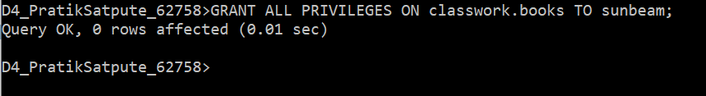

1. **Give sunbeam the right to SELECT the data from BOOKS,EMP,DEPT tables.**

**Ans:** Grant select ON Classwork.books TO sunbeam;

Grant select ON Classwork.dept TO sunbeam;

Grant select ON Classwork.emp TO sunbeam;

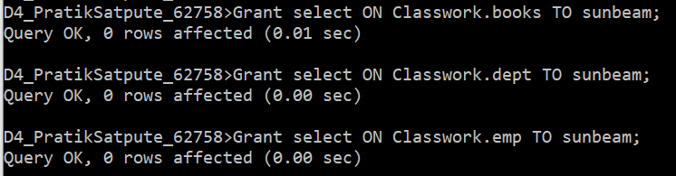

1. **Give INSERT privilage on EMP table to sunbeam**

**Ans:** GRANT INSERT ON Classwork.emp TO sunbeam;

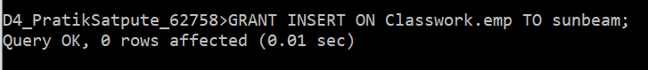

1. **Give DELETE privileges on DEPT table to sunbeam**

**Ans:** GRANT DELETE ON Classwork.dept TO sunbeam;



1. **Take the UPDATE privilege on BOOKS table away from sunbeam.**

**Ans:** REVOKE UPDATE ON Classwork.books From sunbeam;

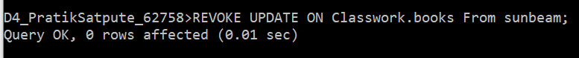

1. **Take the INSERT privilege on EMP table away from sunbeam.**

**Ans:** REVOKE INSERT ON Classwork.emp From sunbeam;



1. **Take the DELETE privilege on DEPT table away from sunbeam**

**Ans:** REVOKE DELETE ON Classwork.dept from sunbeam;

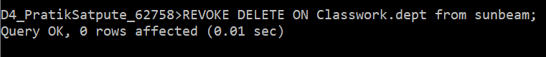

1. **Take the SELECT privilege on BOOKS,EMP,DEPT tables away from sunbeam**

**Ans:** REVOKE select ON Classwork.books From sunbeam;

REVOKE select ON Classwork.dept From sunbeam;

REVOKE select ON Classwork.emp From sunbeam;

