Assignment 09

1. **Write a query that uses a subquery to obtain all orders for the customer named Cisneros. Assume you do not know his customer number (cnum).**

**Ans:** select * from orders where cnum =(select cnum from customers where cname = 'Cisneros');

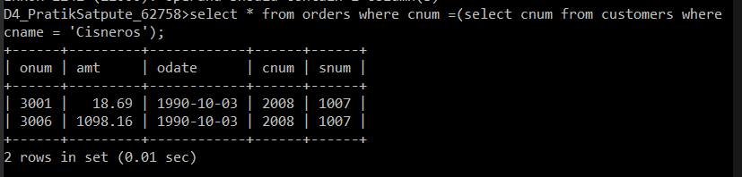

1. **Write a query that produces the names and ratings of all customers who have above average orders**

**Ans :** Select c.cname as Customer_name , c.rating from customers c Inner join orders o ON c.cnum= o.cnum where o.amt > (select avg(amt) from orders) Group by c.cname, c.rating ;

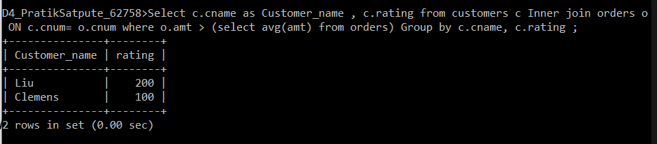

1. **Write a query that selects the total amount in orders for each salesperson for whom this total is greater than the amount of the largest order in the table.**

**Ans:** Select snum , sum(amt) from orders group by snum having sum(amt)>(select Max(amt) from orders); 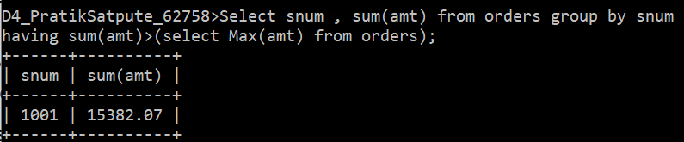

1. **Write a query that selects all customers whose ratings are equal to or greater than ANY of Serres’.**

**Ans:** Select * from customers where rating >= ANY(select rating from customers where snum = ANY(select snum from salespeople where sname = 'Serres')) ;

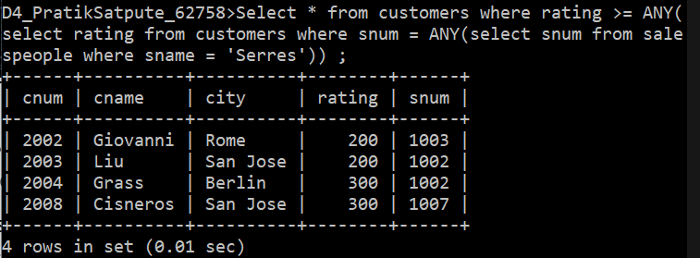

1. **Write a query using ANY or ALL that will find all salespeople who have no customers located in their city.**

**Ans:** Select * from salespeople where city != ALL(select city from customers);

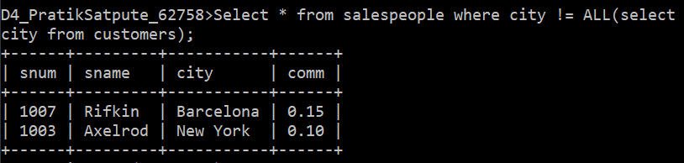

1. **Write a query that selects all orders for amounts greater than any for the customers in London.**

**Ans:** Select * from orders where amt > ANY(select amt from orders where cnum =ANY(select cnum from customers where city ='London'));

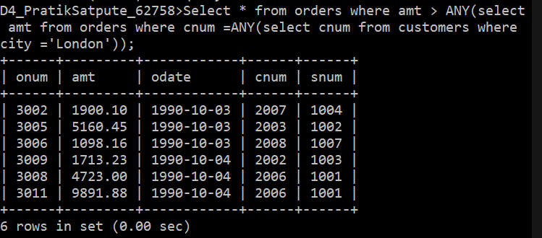

1. **Extract all the orders of Motika.**

**Ans:** Select * from orders where snum = ALL(select snum from salespeople where sname='Motika');

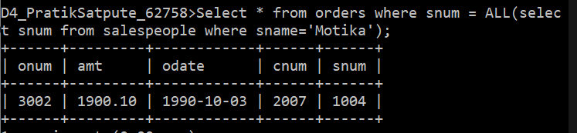

Select s.sname, o.onum, o.amt,o.odate, o.cnum,o.snum from salespeople s inner join orders o ON s.snum = o.snum where o.snum = ALL(select snum from salespeople where sname='Motika');

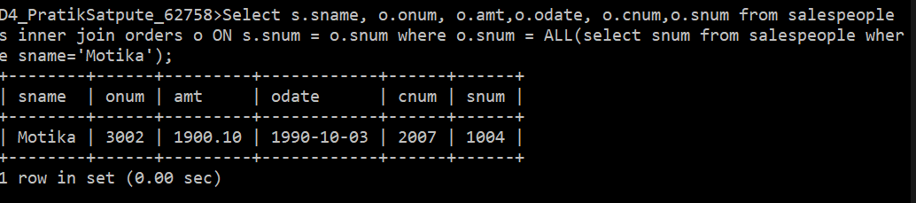

1. **Find all the order attribute to salespeople servicing customers in London.**

**Ans:** Select * from orders where snum = ALL(select snum from salespeople Where snum = ALL(select snum from customers where city ='London'));

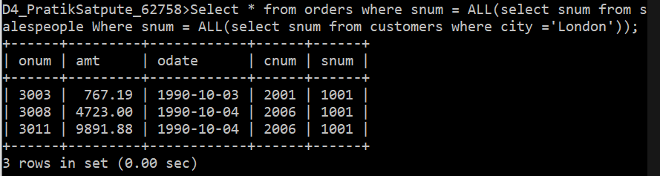

Select * from orders where snum = ALL(select snum from customers where city ='London');

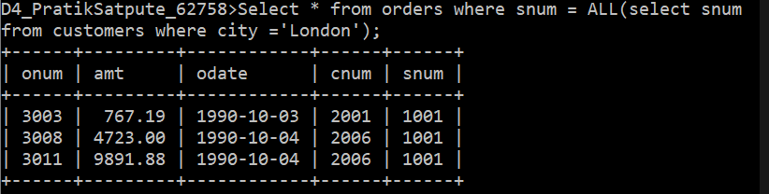

1. **Find names and numbers of all salesperson who have more than one customer**

**Ans:** Select * from salespeople where snum= ANY(select snum from customers group by snum having count(snum)>=2);

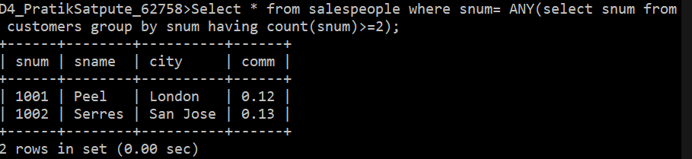

1. **Find salespeople number,name and city who have multiple customers**

**Ans:** Select snum , sname, city from salespeople where snum = ANY(select snum from customers group by snum having count(snum)>1 );

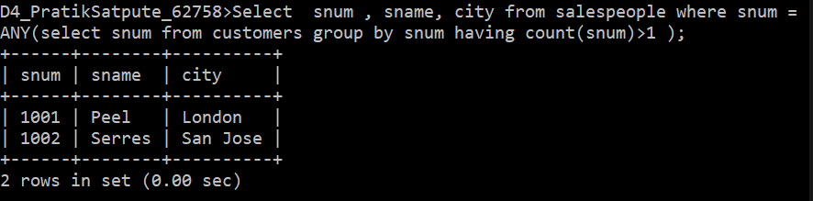

1. **Select customers who have a greater rating than any other customer in Rome.**

**Ans:** Select * from customers where rating = ANY(select rating from customers where city='Rome') AND city != 'Rome';

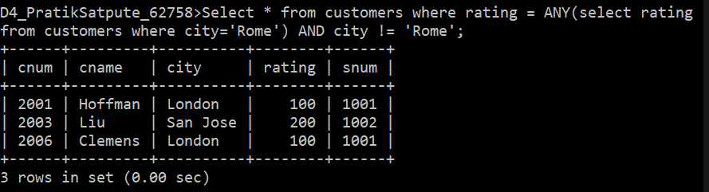

1. **Select all orders that had amounts that were greater that at least one of the orders from ‘1990-10-04’ .**

**Ans:**

Select * from orders where amt >ANY(select amt from orders where odate='1990-10-04');

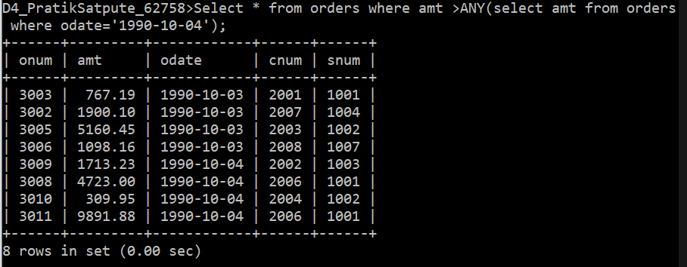

Select * from orders where amt >(select min(amt) from orders where odate='1990-10-04');

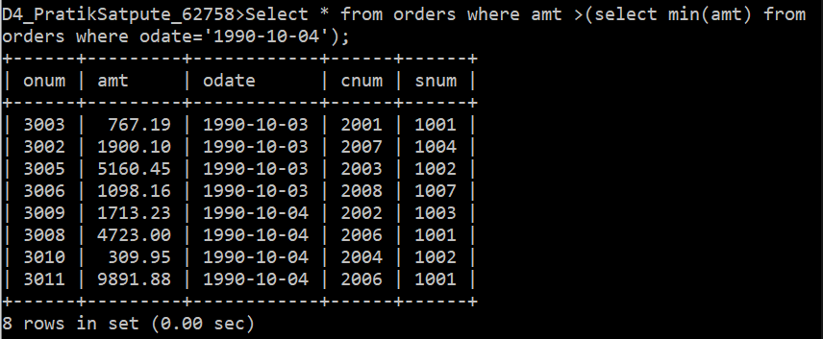

1. **Find all orders with amounts smaller than any amount for a customer in San Jose.**

**Ans:** Select * from orders where snum < ANY(select snum from customers where city = 'San jose');

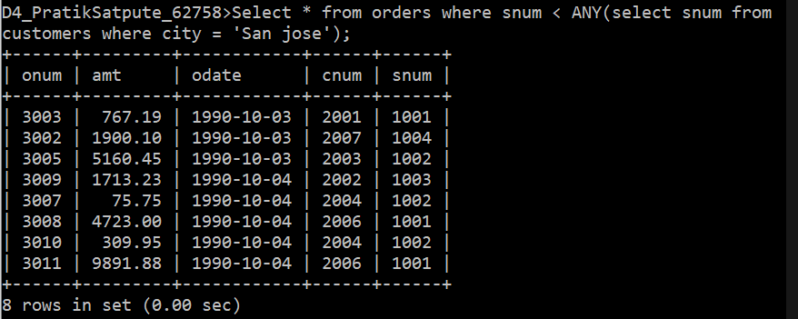

1. **Select those customers whose rating are higher than every customer in Paris.**

**Ans:** Select * from customers where rating > ALL(select rating from customers where city ='Paris');

