Assignment 10

1. **Create an index that will enable a user to pull orders for ‘1990-10-03’ out of the Orders table quickly.**

**Ans:**

Create INDEX idx_orders_odate ON Orders(odate);

Select * from orders where odate = '1990-10-03';

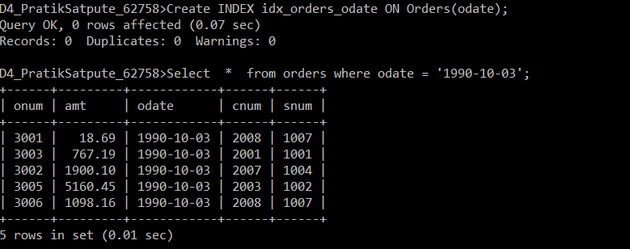

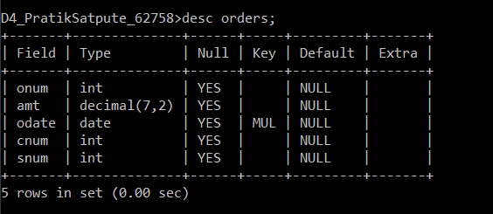

1. **If the Orders table has already been created, how can you force the onum field to be unique (assume all current values are unique)?**

**Ans:** Create UNIQUE INDEX idx_orders_onum ON Orders(onum);

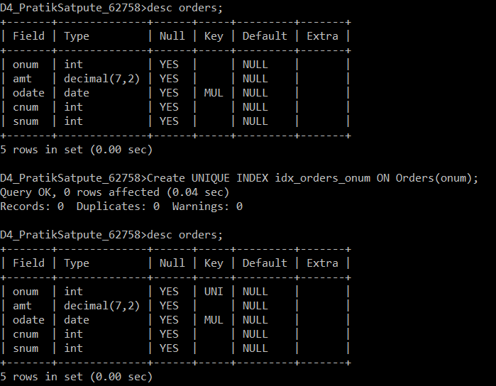

1. **Create an index that would permit salesperson to retrieve his orders.**

**Ans:** Create INDEX idx_orders_snum ON Orders(snum);

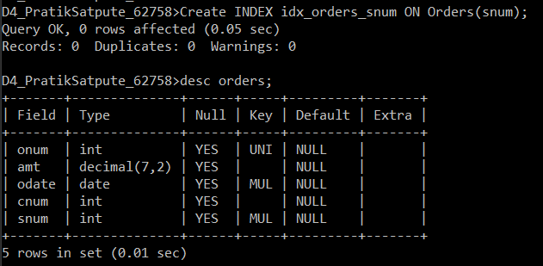

1. **Let us assume that each salesperson is to have only one customer of a given rating, and that this is currently the case. Create an index that enforces it.**

**Ans:** Create UNIQUE INDEX idx_customers_rating_snum ON customers(rating ASC ,snum ASC);

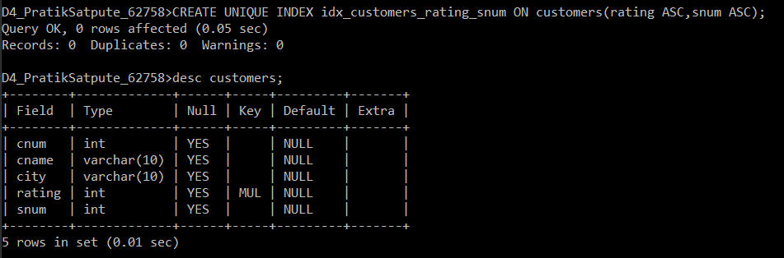

1. **Let us assume that each salesperson is to have only one customer of a given rating, and that this is currently the case. Create an index that enforces it.**

**Ans:**

Create INDEX idx_orders_odate_cnum ON Orders (odate ASC , cnum ASC);