**Table :**

**Dept_tb :**

Create table Dept_tb (Dept_id INT primary key, Dept CHAR(20));

insert into Dept_tb values(1,'Batsman'),(2,'Bowler'),(3,'Support_staff');

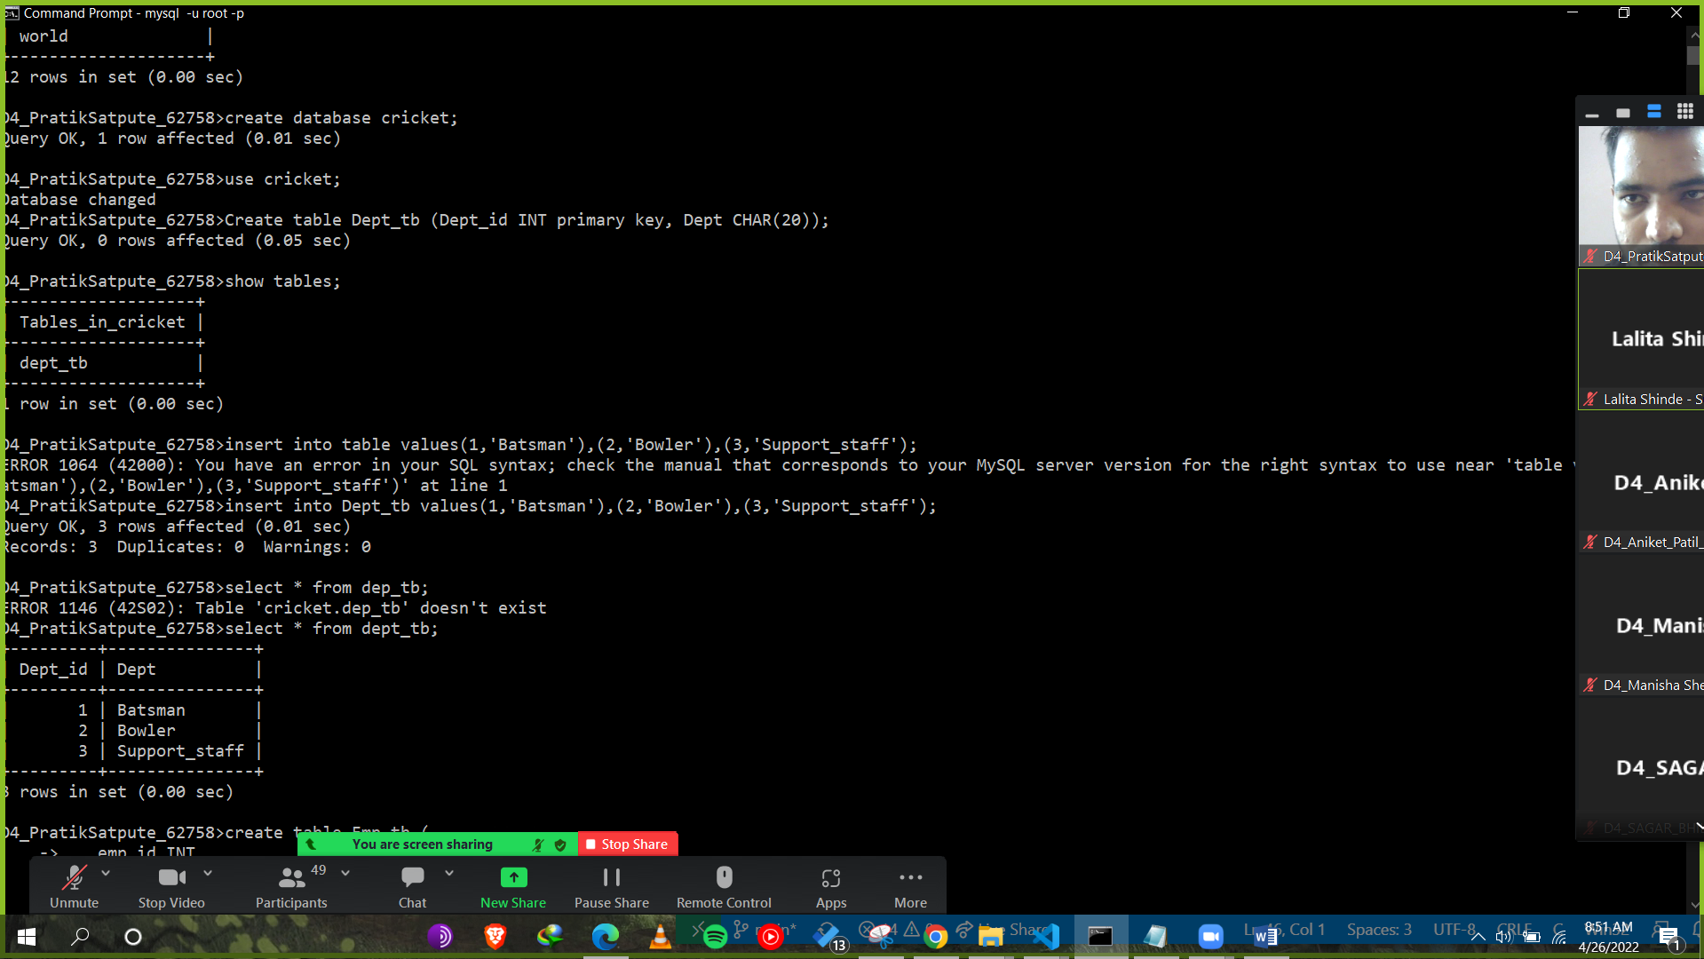

**Emp_tb:**

Create table Emp_tb (

emp_id INT ,

Name CHAR(10),

City CHAR(15),

State CHAR(5),

salary INT,

Dept_id INT,

primary key (Emp_id),

foreign key(Dept_id) references dept_tb(dept_id)

);

insert into EMp_tb values (1,'Virat','Banglore','KA',12000,1),

(2,'Thakur','Mumbai','MH',15000,2),

(3,'Dhoni','Chennai','TN',7000,1),

(4,'Rahul','Lucknow','UP',19000,1),

(5,'Ravi','Lucknow','UP',7000,3),

(6,'Malik','Hydrabad','TL',10000,2);

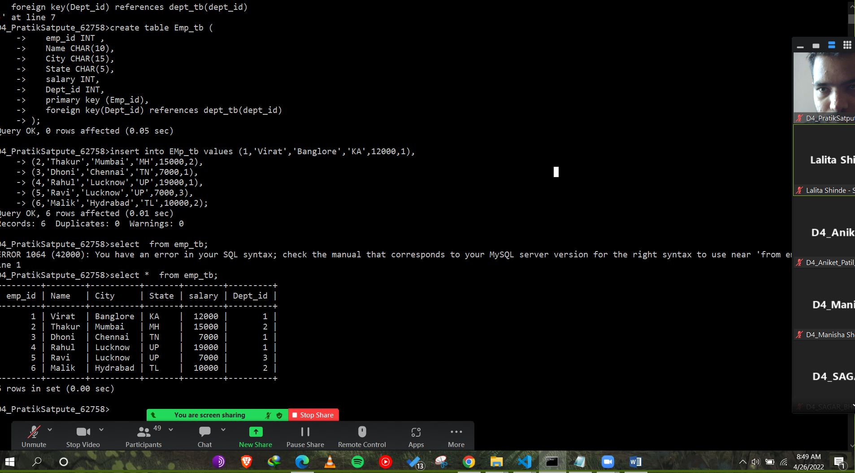

1. **List name of employees who is working in Dept "Batsman" ?.(using sub query)**

**ANS:** Select name from emp_tb where dept_id = (select dept_id from dept_tb where dept = 'Batsman');

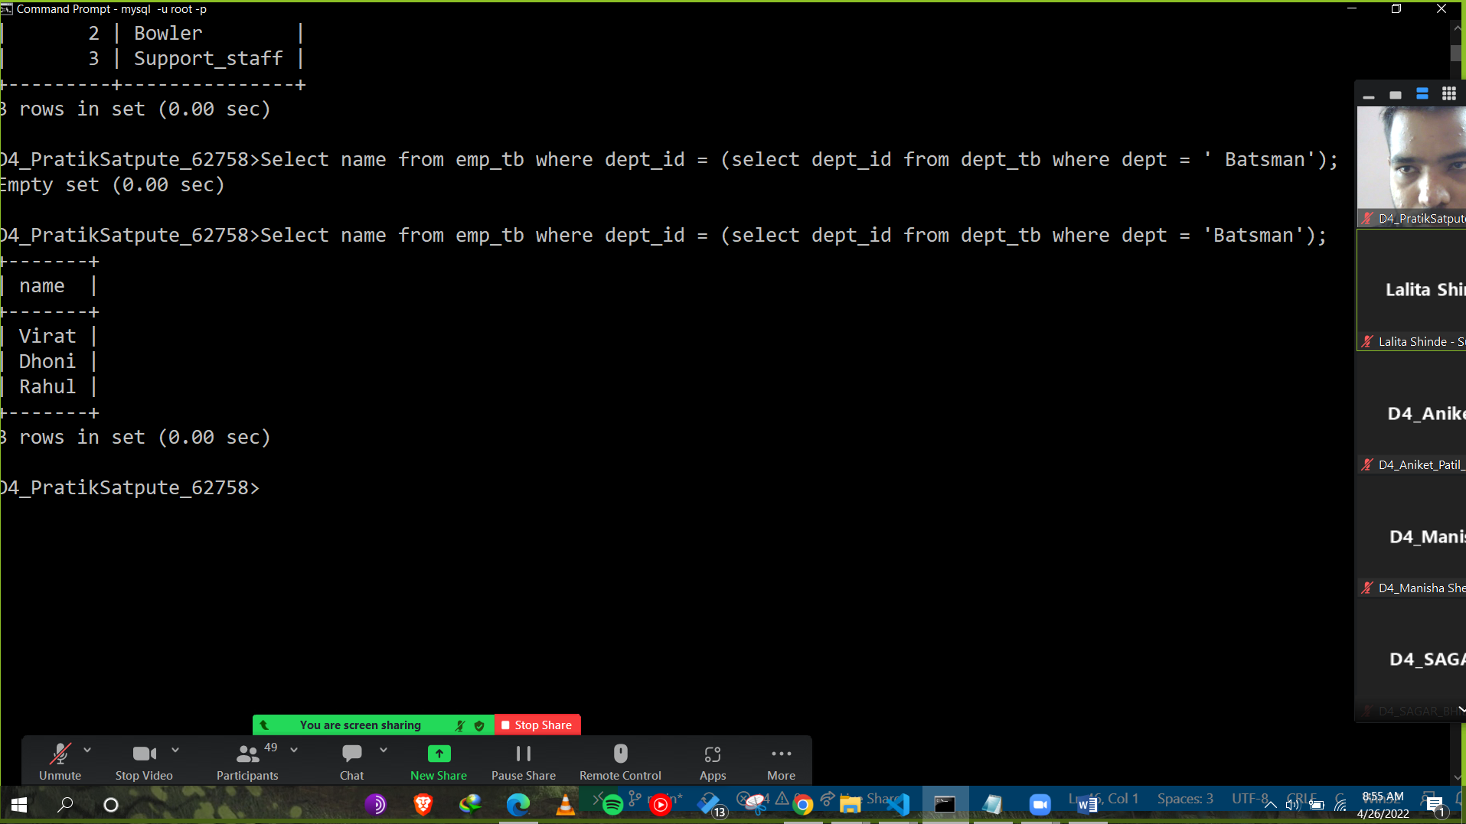

1. **Find all the department which have more than and equal 2 Players.(Use having clause)**

**Ans:** Select Dept_id, count(dept_id) from emp_tb group by dept_id having count(dept_id)>=2;

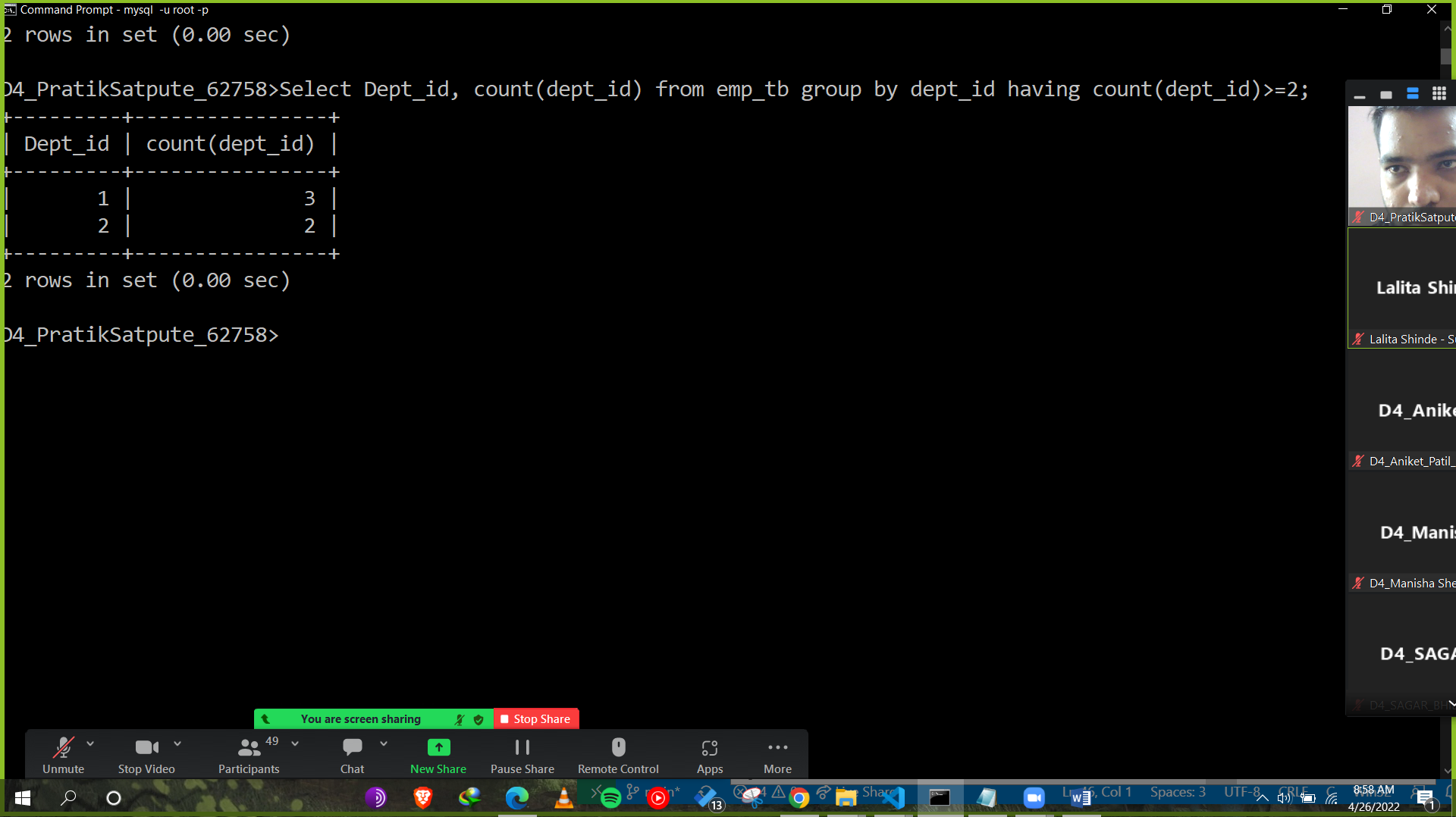

1. **Display the Position at which the string 'Dh' occurs in name.**

**Ans:** Select name from emp_tb where name LIKE('Dh%');

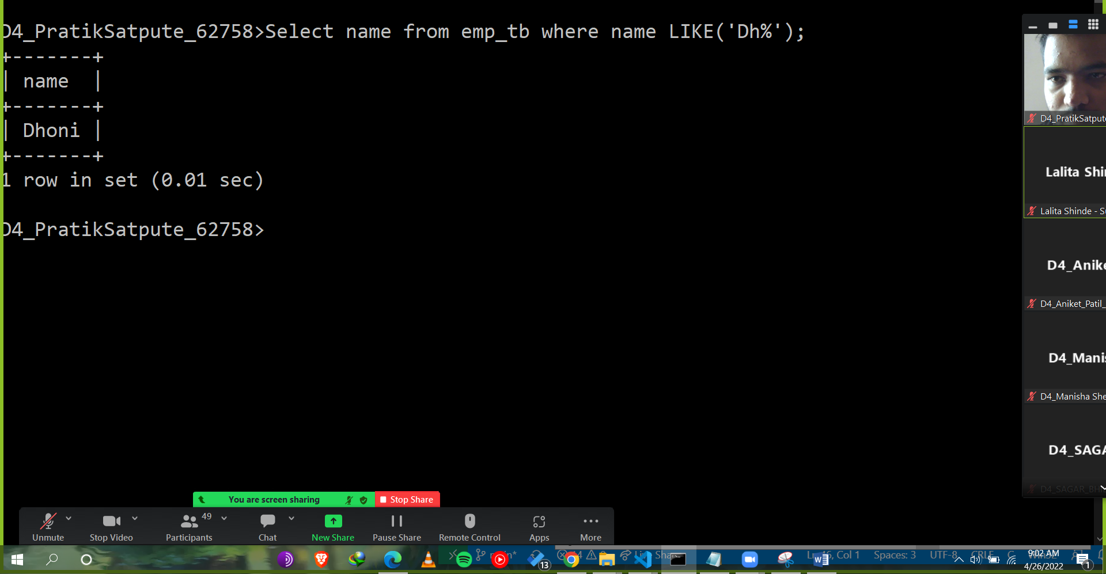

1. **Change name of column "Salary" to "Sal".**

**Ans:** Alter table emp_tb Rename column salary to Sal;

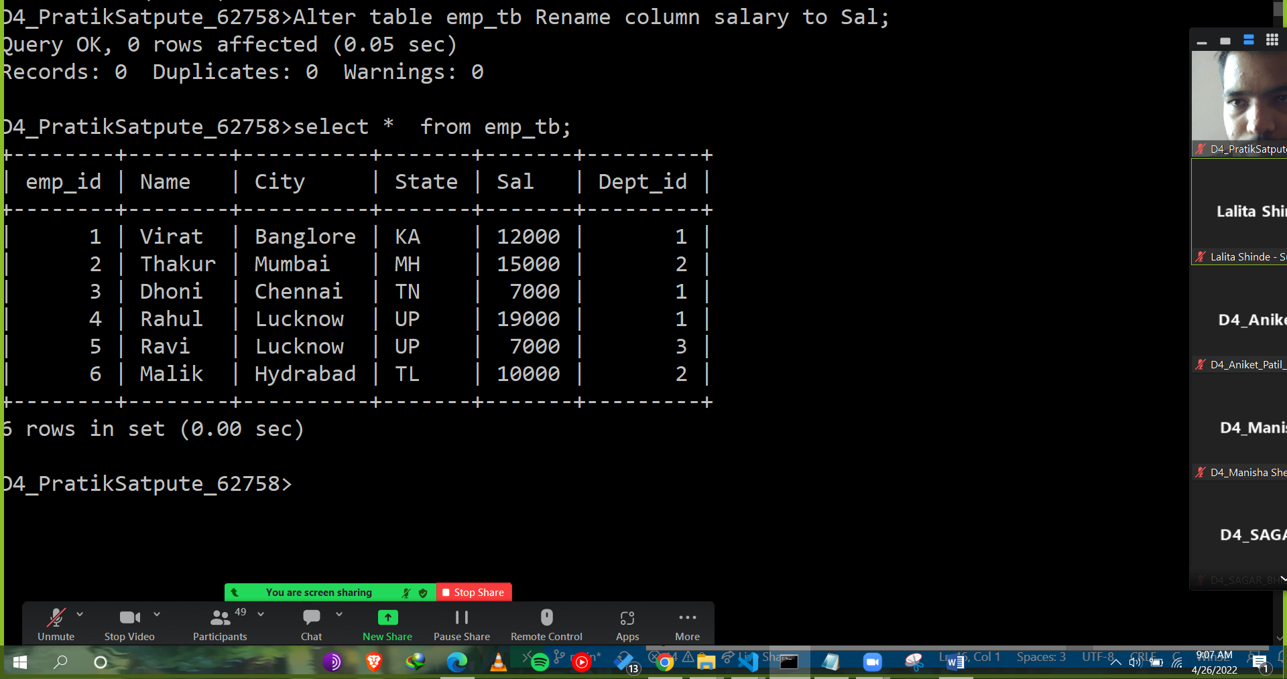

1. **Print Current date in following format. e.g  Tuesday,26th April 2022.**

**Ans:** Select Date_format(Current_date(),'%W %D %M %Y');

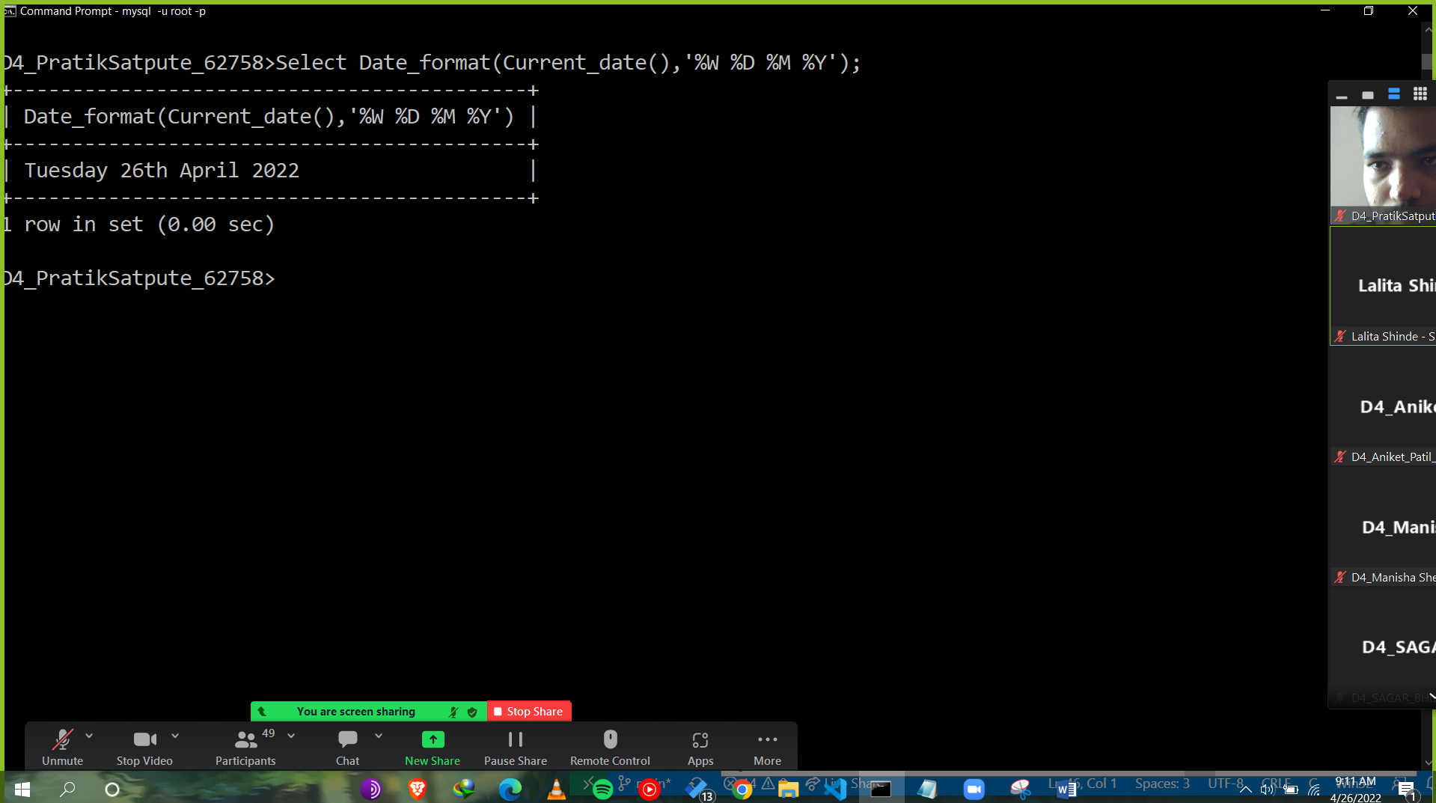

1. **Write query for to increment sal 10% whose dept_id=1,increament sal 20% whose dept_id=2 and other 30% .(Use only case)**

**Ans: update Emp_tb set SAL=(CASE**

**when (dept_id =1) then (Sal*1.1)**

**when (dept_id =2) then (Sal*1.2)**

**when (dept_id =3) then (Sal*1.3)**

**END);**

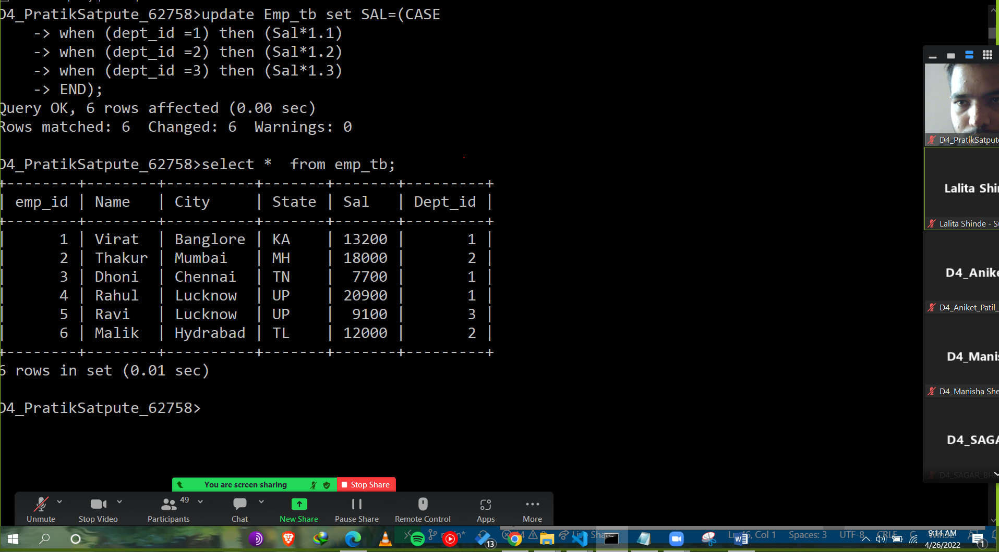

1. **List of Players while names start with 'T' and ends with 'r'.**

**Ans:** Select name from emp_tb where name LIKE('T%') AND name LIKE ('%r');

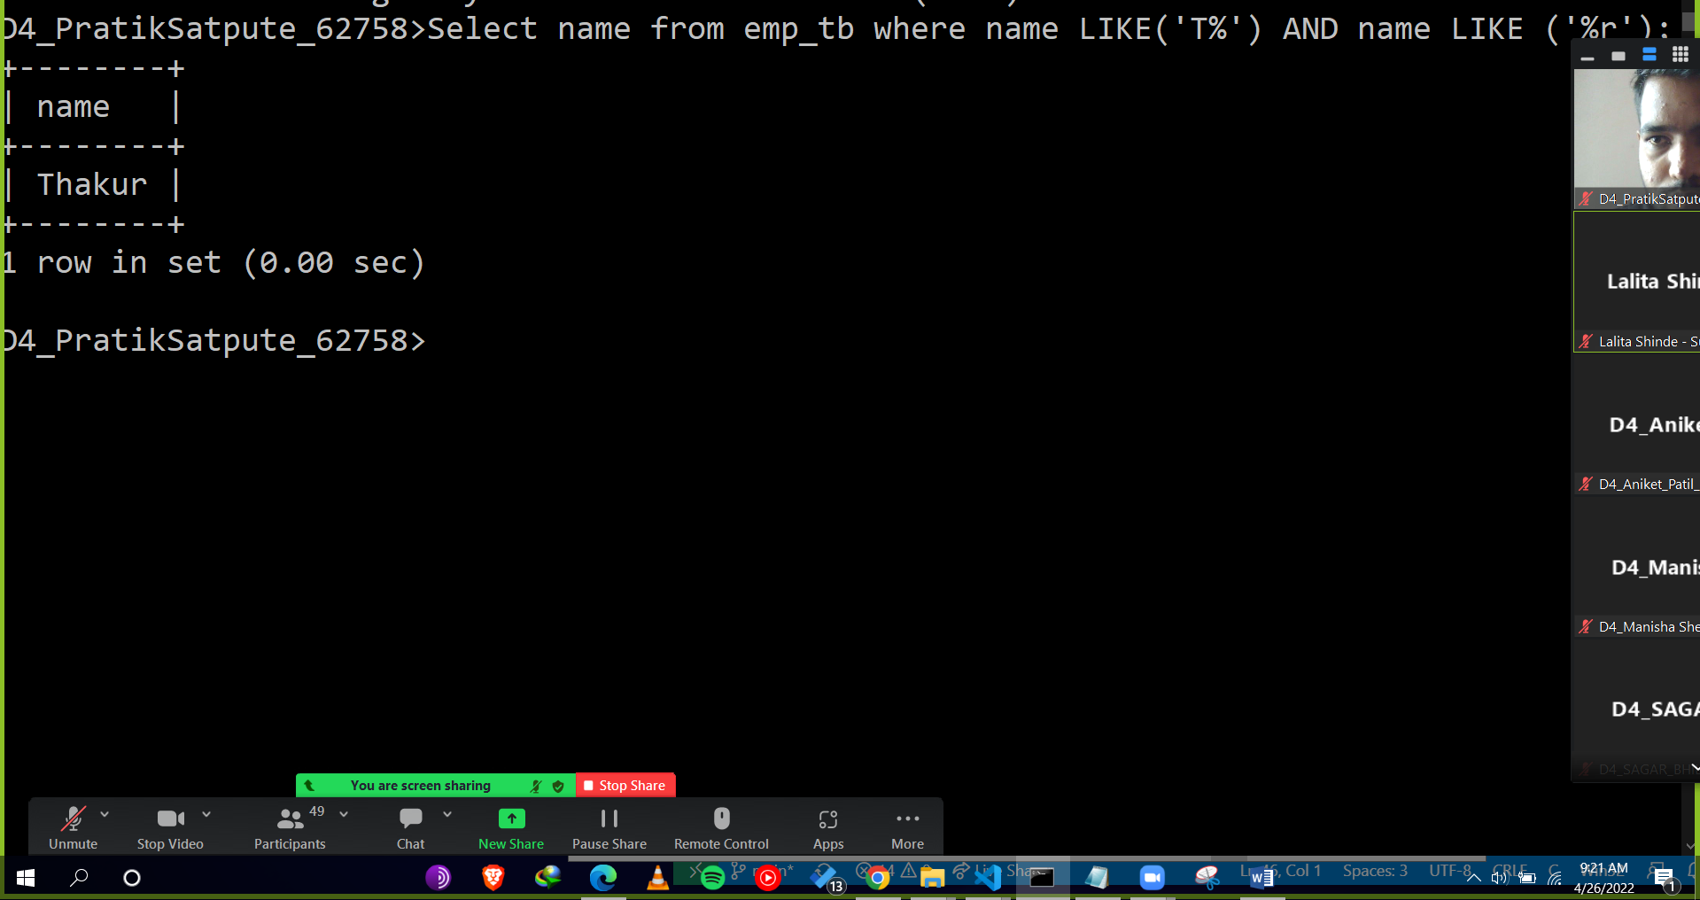

1. **List all the Players who are located in Lucknow.**

**Ans:** Select * from emp_tb where city ='Lucknow';

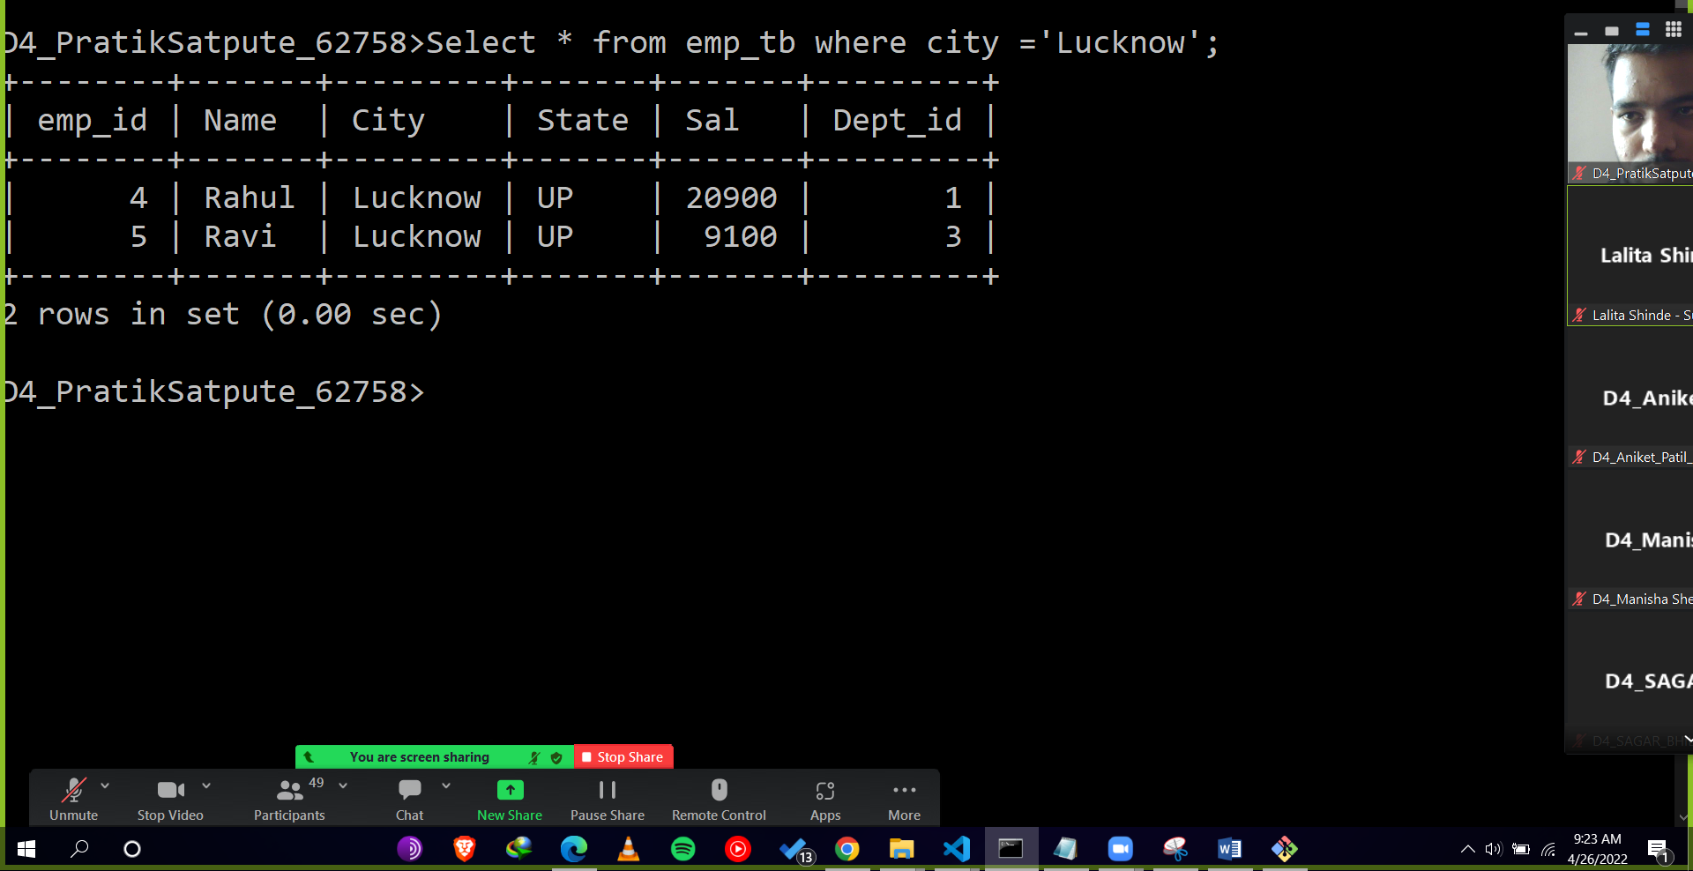

1. **List the Players Name that start with 'R'.**

**Ans:** Select name from emp_tb where name LIKE('R%');

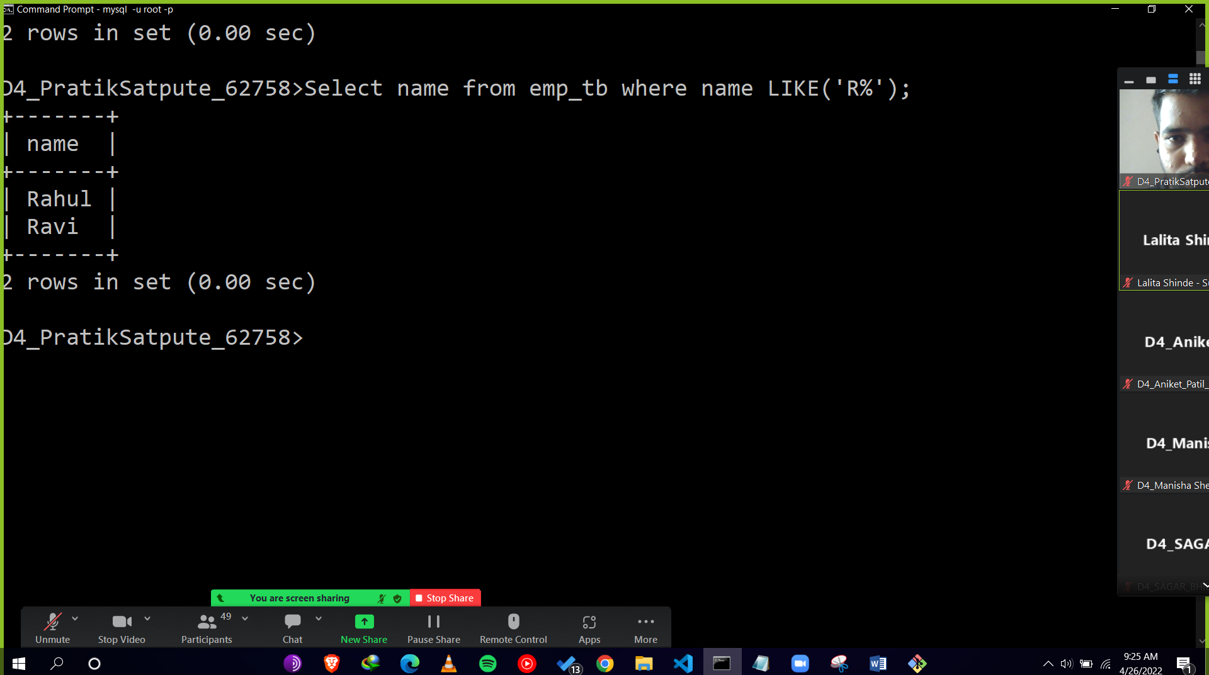

1. **select all Players whose Dept is other than Batsman and salary is less than 15000.(use sub query)**

**Ans:** Select name from Emp_tb where sal<15000 AND dept_id = ANY( select dept_id from dept_tb where dept!= 'Batsman');

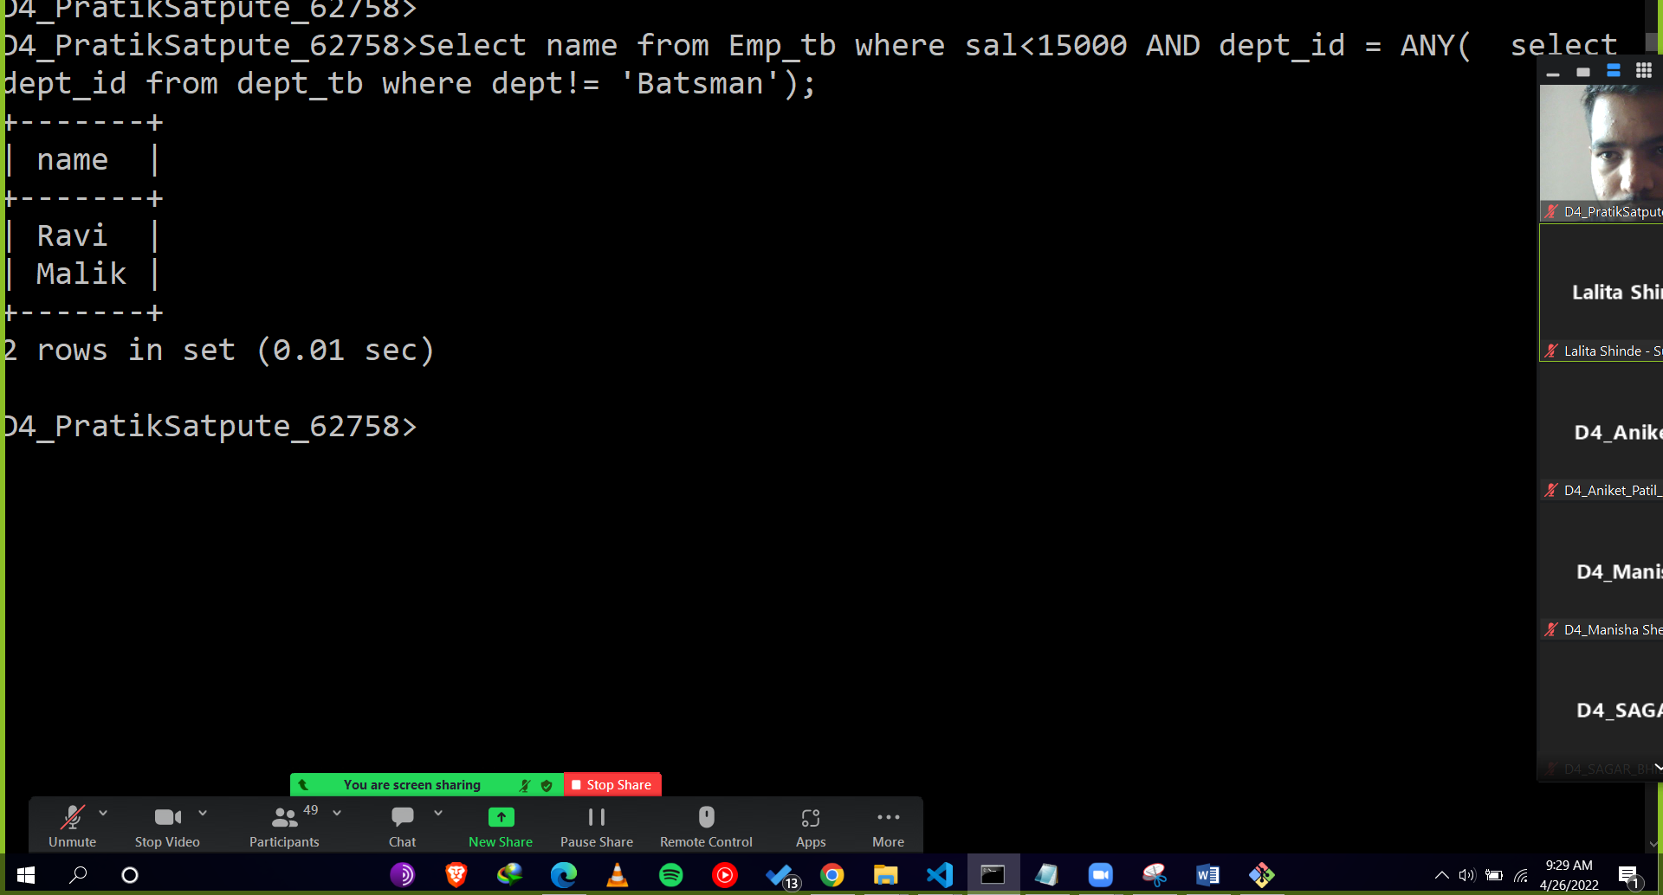

**PL/SQL**

**1 . Write a stored procedure for addition of digit. e.g 1234=10 Out put Should be inserted into temp table like (1234,10),(22,4),.\**