**UC1-** Creating Address Book Service DB.

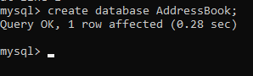

**UC2-** Create AddressBook table with first and last names, address, city, state, zip, phone number and email as its attributes.

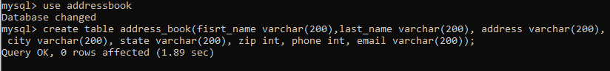

**UC3-** Insert new Contact

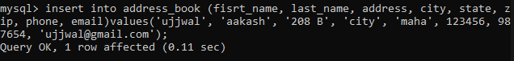

**UC4-** edit existing contact

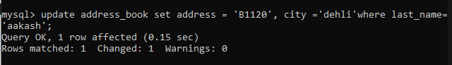

**UC5-** Delete contact use name



**UC6-** Retrieve person belonging to a city or state from the address book.

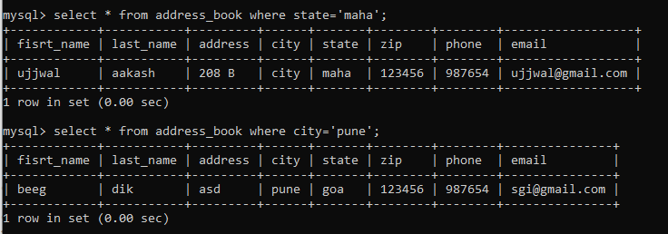

**UC7-**  understanding the size of address book by city.

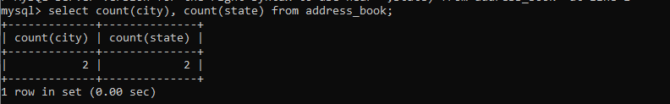

**UC8-** to retrieve entries sorted alphabetically by Person’s name for a given city.

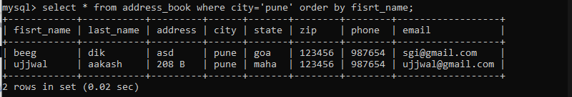

**UC9-** Ability to identify each Address Book with name and Type.

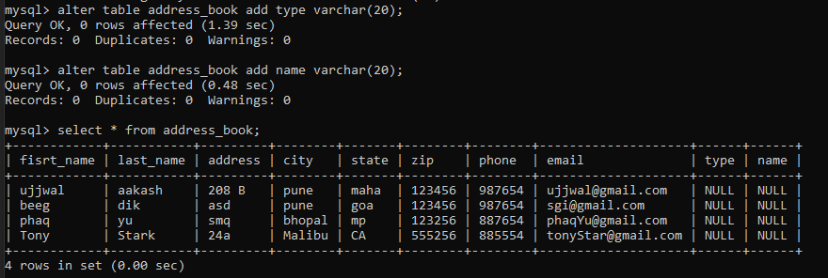

**UC10-**

