**UC1-**

mysql> create database payroll_service;

Query OK, 1 row affected (0.79 sec)

UC2-

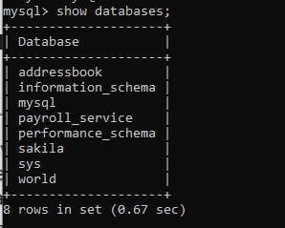

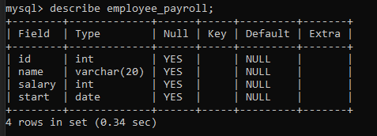

Uc3-



Uc4-

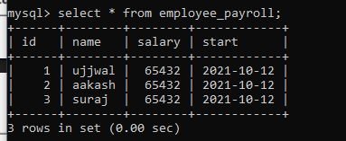

UC5-





UC6-

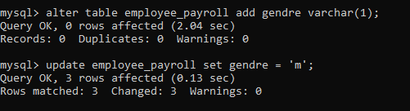

UC7-

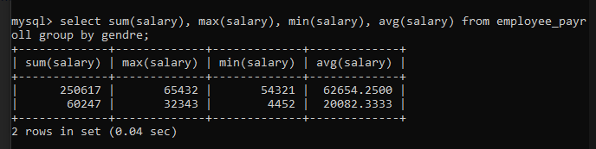

UC8-

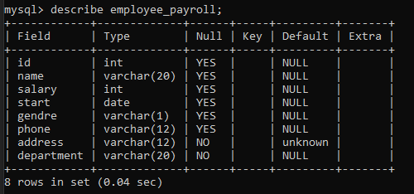

UC9-

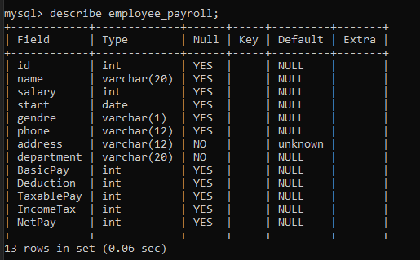

UC10-



UC11-

