Intro To ML – HW2

students:

Dor Bank - 301380416 - dorbank@gmail.com, Avi Caciularu - 203056585 - avi.c33@gmail.com

**Programming Questions**

**Question 1:**

1. the table is printed out during the code. also, its result are listed here:

|  |  |  |  |
| --- | --- | --- | --- |
|  | mean | 5% | 95% |
| n=5 | 0.822451 | 0.580348 | 0.935005 |
| n=10 | 0.864985 | 0.692426 | 0.949335 |
| n=50 | 0.921760 | 0.803480 | 0.969806 |
| n=100 | 0.920793 | 0.817298 | 0.969806 |
| n=500 | 0.925855 | 0.842375 | 0.972876 |
| n=1000 | 0.927963 | 0.791709 | 0.972876 |
| n=5000 | 0.924693 | 0.823439 | 0.972364 |

as we can see from the mean column, the more samples we get, the better our model will be. In addition, we can see from the 5% that it is also harder to get "unlucky" with the training samples and order when we have more samples. about the 95% these are cases we got "lucky". we see that the differences in this case are much more minor which also makes sense because with 100 experiments it seems right we will get close to the optimal w possible a few times.

1. to get a good w, we ran the perceptron algorithm 100 times (just like the previous section) and took the w with the highest test accuracy. the result:

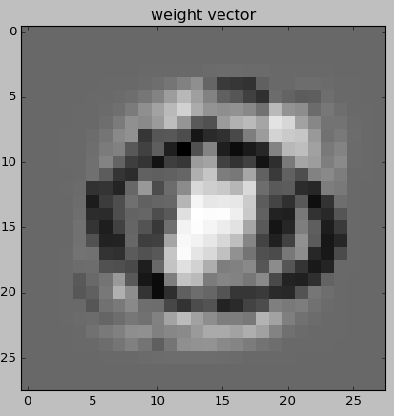

explanation: remember that '8' is marked at the perceptron algorithm as 1 and '0' as -1. also, the higher a value at w is, the brighter it is in the picture. this means that the brighter a pixel is, the more it is likely to appear in '8' and not in '0'.

now notice that the middle pixels (which really are far more related to '8') are white, while a black circle marks the pixels which are far more related to '0' than '8'.

that surrounding pixels are grey because they aren't relevant for deciding.

interestingly, there are bright-grey pixels above and below the black circles. these pixels overlap the '8' and '0' digits. this probably means that most '0's are flatter than most '8's.

1. since we ran the perceptron 100 times, we made the code print the mean accuracy (so we can verify it is better than n=5000), and the best accuracy (so we can know our chosen w accuracy).

prints from the code:

('fully trained perceptron accuracy meaned by 100 experiments: ', 0.93354657113613104)

('fully trained perceptron best test accuracy: ', 0.98106448311156602)

1. please notice that our code chooses 1 misclassified sample at random, so at each run you will get a different misclassified sample with an explanation at the title. in our run we got:

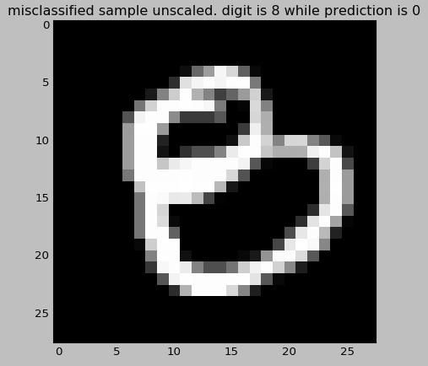

Explanation: In continuation to our explanation to w, we can see than the bottom circle of this 8 overlaps our black circle at w which corresponds to '0'. also, this '8' is flatter than the average '8' and overlaps some of the left black pixels of w. finally, we will point that this '8' misses part of the brightest pixels at w which are most distinctive towards '8'.

**Question 2:**

**Question 3:**

1. We performed green search:
2. Firstly, for $η_{0}∈\{{10}^{-10},{10}^{-9},…,1,10,…{10}^{10}\}$ we found that $η_{0}=10$ gives the best accuracy.
3. Secondly, for $η_{0}∈\{1,2,…,30\}$ we found that $η_{0}=12$ gives the best accuracy.
4. Thirdly, for $η_{0}∈\{11,11.1,11.2,…13\}$ we found that $η_{0}=12.1$ gives the best accuracy.
5. And last, for $η_{0}∈\{12.1,12.11,12.12,…12.2\}$ we found that $η_{0}=12.13$ gives the best accuracy.