Intro To ML – HW3

students:

Dor Bank - 301380416 - [dorbank@gmail.com](mailto:dorbank@gmail.com),

Avi Caciularu - 203056585 - <avi.c33@gmail.com>

**Theory Questions**

**Question 1:**

We will show a lower bound: . Let be a unit vector from the standard basis of length .

First, we will show that the set can be shattered by . To show that, we should prove that every label assignment for is consistent with some hypothesis in . Let be the assignment for the vectors . Define hypothesis as:

.

Furthermore, for the computation of the result at the output node we will set:

We get

Note that here we assume that .

**Question 2:**

In this questions we will use the following lemmas, proved in recitation 7:

Lemma 1:

Lemma 2:

Lemma 3:

1. Denote the function family of each node in layer as . In our case, since the node separators are independent one of each other, we get that for each layer , . Because there are nodes at each layer, we can see that all s are equal to our wanted . From Radon's theorem, we get that for each , . from Lemma 2 we get that
2. is simply composed of concatenating the family times:

. From Lemma 3 we get that

1. For every node, we have parameters for the weight vector w, and more for the bias . In total, we have parameters, layers with nodes, and layer (the final one) with one node. Combining all together we get

.

1. Assume . First notice that . otherwise we get which is surely not true for a large enough .

Now, by taking the log of each size we get:

1. We get that . Now, let be a set of size which is shattered. Then . Combining this with the inequality above, we get that . Combining the result from section (d), we get that . Thus, we conclude that .

**Question 3:**

1. Consider the new primal problem of SVM:

The regular SGD step was:

Denote so

We will show that:

And then the new SGD with the “Subgradient Projection Method” step would be:

The definition of the projection of on ( ) is .

If then the trivial solution is , so we will assume that :

* If so and then .
* If so and we get that the normalized vector and then , because is the optimal solution for .

1. Let be a convex set, and .

Because is a convex set, there is so that .

Let (it comes from the Pythagorean theorem). Particularly, this equality is correct for : Hence . From the Pythagorean theorem, we get that meaning that . Hence, we get by the triangle inequality.

1. We have the same requirements of the original proof, and (because we get it in the last iteration). Hence the expression in the equation after (12) fulfills:

.

After that, we continue the analysis and get:

and after that (only after equation (13)), the rest of the proof remains the same, and Theorem 1.1 still holds for stochastic subgradient projection Method.

**Question 4:**

1. By substituting in the given problem, we get the following loss function:

Where .

Now, map the set into . So now and meaning , and we get ( instead of (.

In the binary case, recall that the best weight solutions , must be in exact opposite direction on the plain, meaning =-1. Substitute:

and we get the decision rule, detailed:

* + - if , then
    - if , then

By assigning and adding to both members we get:

* + - if , then
    - if , then

Thus, it means that which is exactly the optimal binary classifier with weight vector .

1. First, we compute the derivative of with respect to :

Denote .

Hence the gradient’s output given :

.

In total, we get: .

Using the computed gradient for our new step in our SGD algorithm, we derive the algorithm:

1. For finding the kernel version of our algorithm, we could solve the dual problem and derive the optimal , despite this, we will try to retrieve the kernel version as we did in the kernel perceptron algorithm.

As seen in section b, a weight vector can be written as:

.

We can notice that can be expressed as the following linear combination:

where the coefficient for class and time .

Combining the last section, we derive the following algorithm:

For new sample , we can use the classifier:

Where for the linear kernel, we use and .

**Question 5:**

Proof by induction on the tree height :

Base: For there can’t be any samples, so only 1 node is needed to comute the label ( or ).

Step: Assume the claim is true for a classifier with domain dimensions up to a specific . That means that there is a decision tree of height at most as stated in the question. For a classifier with dimensions, we use the first node as .

we get sub trees with dimension (which are relevant), and by the induction assumption, those sub trees are of height at most . Therefore, the new tree is of height at most as needed.

Now, notice that each binary tree of height has leaf nodes (and therefore different paths). Moreover, in domain of there can be maximum different sample vectors.

For a lower bound, we take the sample group of size which contains different vectors. Every node in the height binary tree will map to a specific sample. Each node will return the label of the corresponding label, and the correctness is obvious.

For an upper bound we tale a sample group of size . Based on what is stated before, contains samples such that and . Both samples will be mapped by the tree model to the same leaf node. Hence, by labeling those samples differently, we get that is not shattered.

Thus, we conclude that the VC-dimension of the class of decision trees over the domain of is .

**Programming Questions**

**The code source files stay under /specific/a/home/cc/students/cs/avicaciularu/ML/HW3/:**

**Q6- Q6.py**

**Q7- Q7.py**

**Question 6:**

1. We performed grid search:
2. Firstly, for we found that gives the best accuracy.
3. Secondly, for we found that gives the best accuracy.

The grid search is represented in the plotted graph (logarithmic scale), with the accuracy calculation over the validation test:

For :

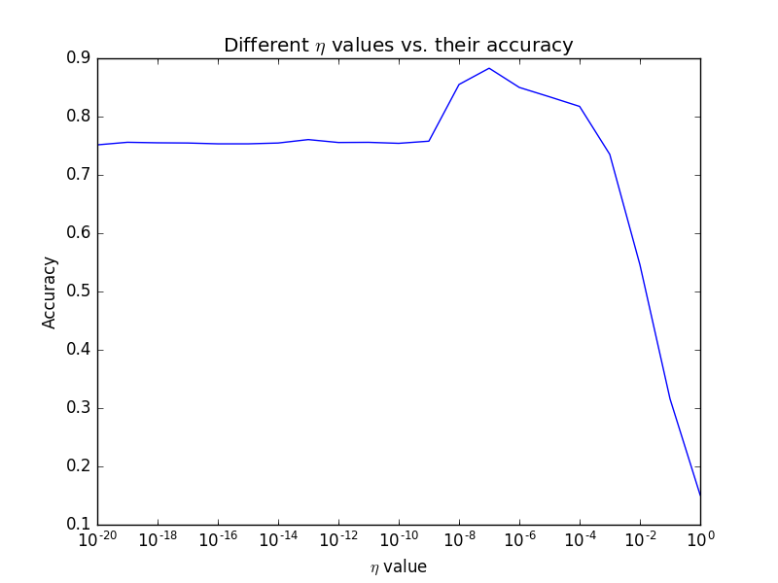

For :

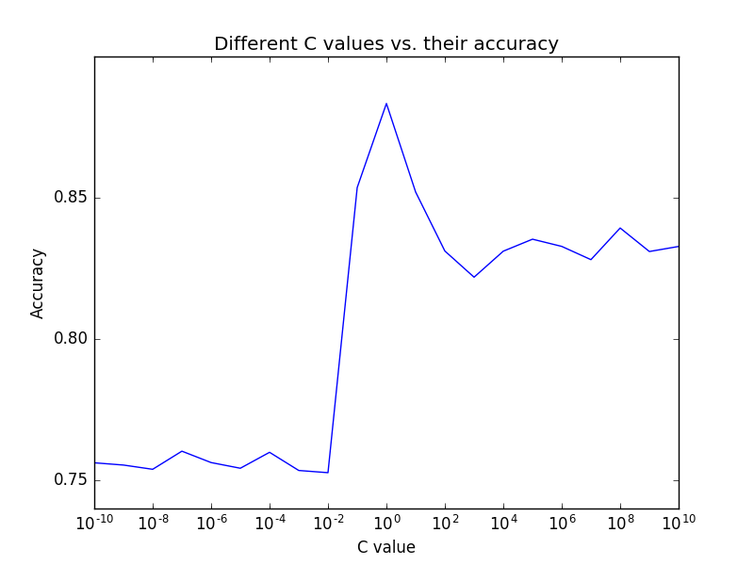

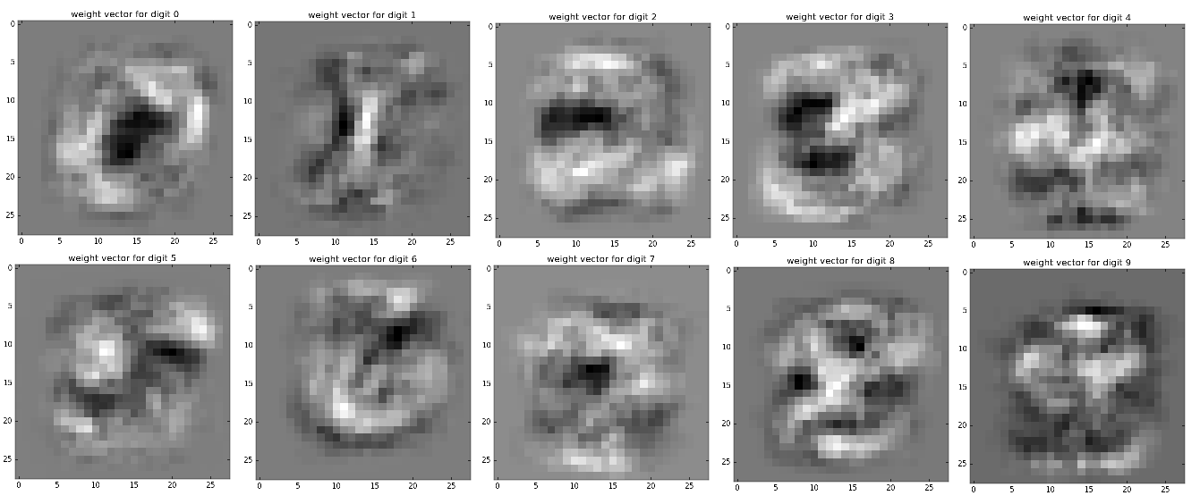

We can clearly see that each weight reflects the digit it belongs to. The brighter the pixel is, the more weight it gives to this pixel in the image we try to classify.

1. We got accuracy of over the test set.

**Question 7:**

1. We performed grid search:
2. Firstly, for we found that gives the best accuracy.
3. Secondly, for we found that gives the best accuracy.

The grid search is represented in the plotted graph (logarithmic scale), with the accuracy calculation over the validation test:

For :

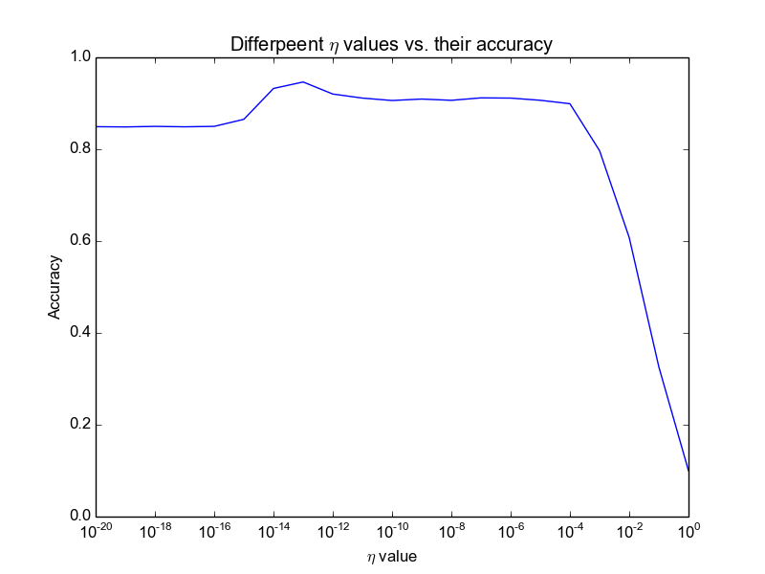

For :

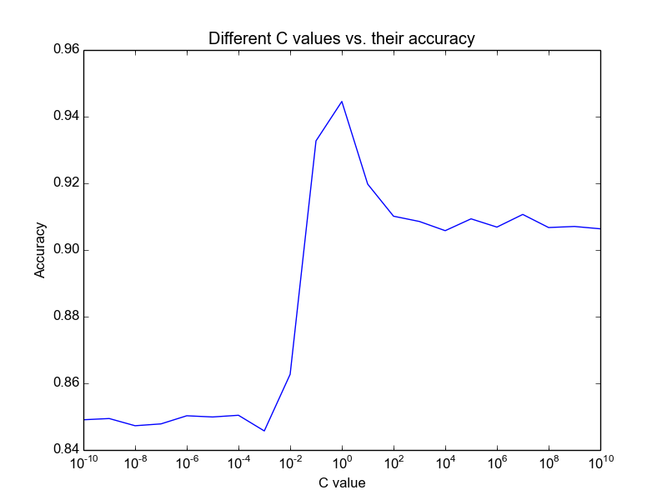

1. We got accuracy of over the test set.