

Compiled from posts on Semper Initiativus Unum by Wayne Rossi [http://initiativeone.blogspot.com](http://initiativeone.blogspot.com/)

Map by James Mishler

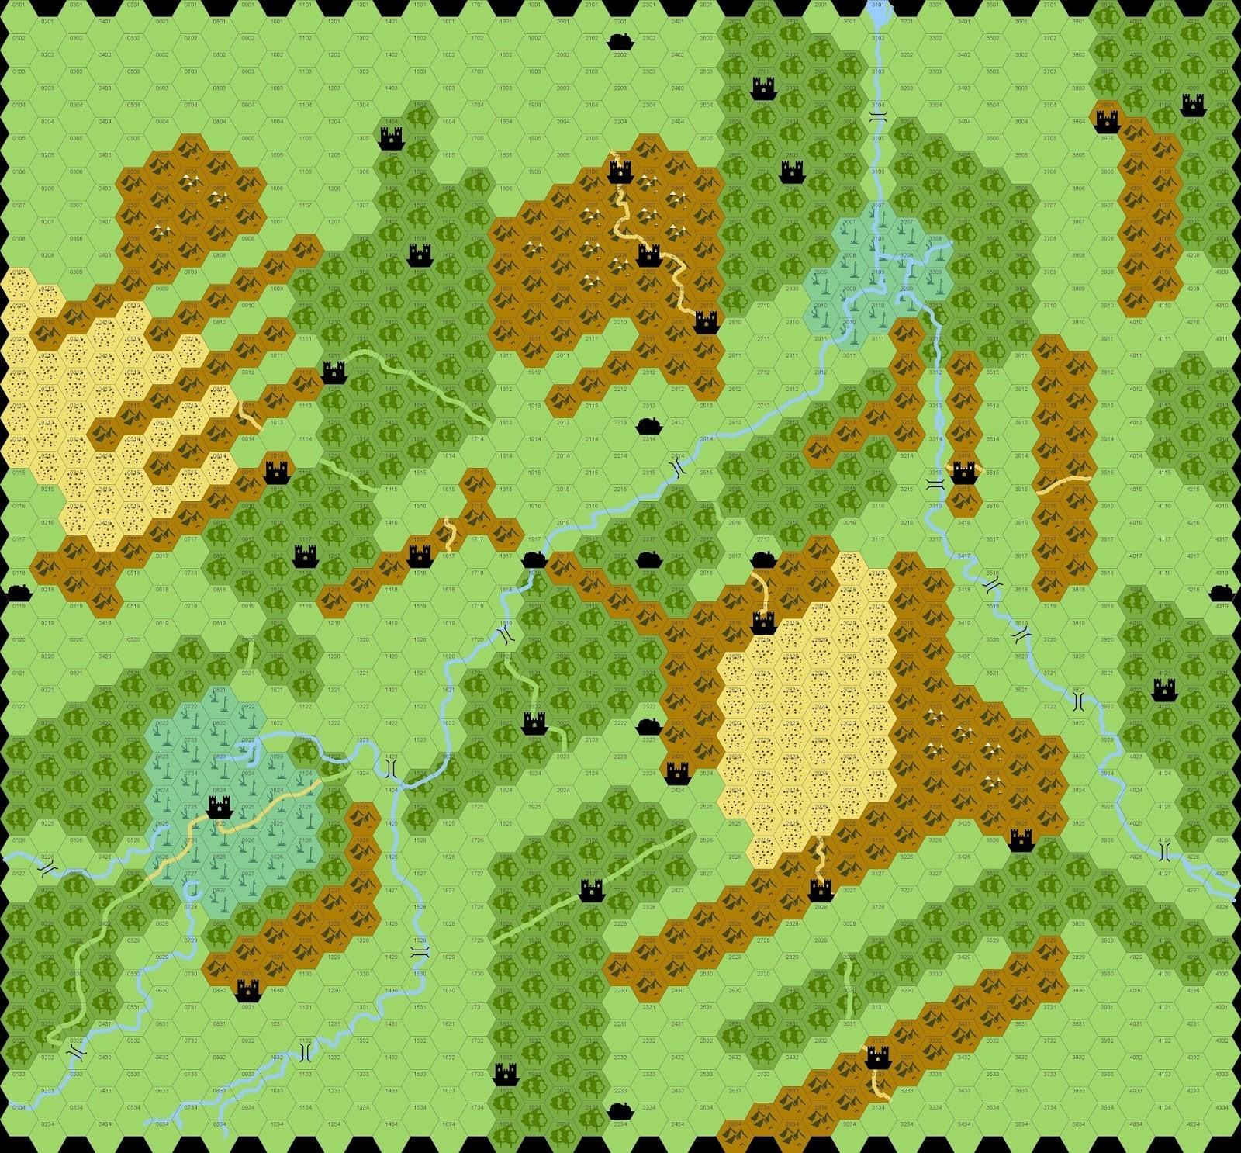

# On OD&D's Setting

The map from Avalon Hill's Outdoor Survival was the stated setting of original Dungeons & Dragons, and it's gotten a lot of love as a simple world for hexcrawling. If the hexes are 5 miles across, then it's about 175 miles by 180 miles - or 31,500 square miles, a heavily forested inland area that's around the size of South Carolina or the Czech Republic. Here is the description of this world:

The so-called Wilderness really consists of unexplored land, cities and castles, not to mention the area immediately surrounding the castle (ruined or otherwise) which housed the dungeons.

If you actually read the wilderness description in OD&D volume 3: The Underworld & Wilderness Adventures, it turns out that the implied details of the setting are weird. Fighters in castles demand to be jousted, magic-users cast Geas and send them out after treasure, clerics demand a tithe or send the characters on a Quest.

But the real weirdness, and this was apparently confirmed in Gary Gygax's campaigns, is what is there when you start wandering about the wilderness. Mountains are haunted by cavemen and necromancers; deserts are home of nomads and dervishes. The "Optional" animal listings turns swampland into the Mesozoic Era - rather than alligators and snakes it is full of tyrannosaurs and triceratops. Arid plains are Barsoomian, with banths, thoats, calots and the lot, while mountains are outright paleolithic, peopled by mammoths, titanotheres, mastodons, and sabretooth cats. Gygax confirms this:

When I was using the pre-World of Greyhawk map for my world setting, the West Coast of North America was the Pleistocene region inhabited by savage cavemen and their contemporary fauna.

This makes the Outdoor Survival map a truly wild place. That huge desert towards the center? That's running with weird creatures of Mars - and maybe Tharks, Red Martians and so on. The mountains surrounding them are the home of cavemen who hunt sabre-toothed cats. The marsh castle is overflown by pterodactyls - does its lord ride around on a triceratops?

Each type of region has its peculiarities. Only cities lack flying encounters, humanoids (labelled "giants" and including ents, elves, dwarves, and all humanoid and giant types in OD&D), animals and dragons. Lycanthropes haunt all but the deserts and the cities, while the undead are found mainly in cities and swamps. This is a truly wild land, and land for 20 miles distant from a character's stronghold can be kept clear of monsters just by holding the stronghold.

Clearing 20 miles in each direction from the swamp stronghold on the lower left would clear the entire swamp and a number of points in the surrounding forest. This area (assuming it's in hexagons) is 1,299 square miles, a bit bigger than Luxembourg, but it is almost depopulated; the average area will have 5 villages with an average of 250 inhabitants, meaning that there is slightly less than 1 person per square mile. That is slightly less than the population density of Alaska. Even with the maximum 3200 people it's still sparser than Wyoming by a factor of more than two. Presumably the whole village is in a single hex (area 21.65 square miles), and the remaining hexes are simply unpopulated.

Cities in such a place are probably small affairs. This is not the world of grand cosmopolitan wonders; it's downright post-apocalyptic and probably has a few thousand people per city. Trade is downright perilous, given that you're likely to run into dragons, or giant crabs if you follow the river, or many other horrid things.

But more and more I'm finding that I like the idea of this setting. It's radically different from, say, the more comfortable World of Greyhawk, or most other fantastic realms; it's a true outland, where civilization hangs on by a thread. It leaves open terrific possibilities; the nomads, dervishes, cavemen, and berserkers all live in the world around towns; so do centaurs and pixies and minotaurs. I want to start to go into what the oddities of this setting are, and how they fit; it's a good match for the concept of "Demon-Haunted Lands," which I'm seeing more and more as a way to make something unique out of this setting.

# A Lord in his Castle

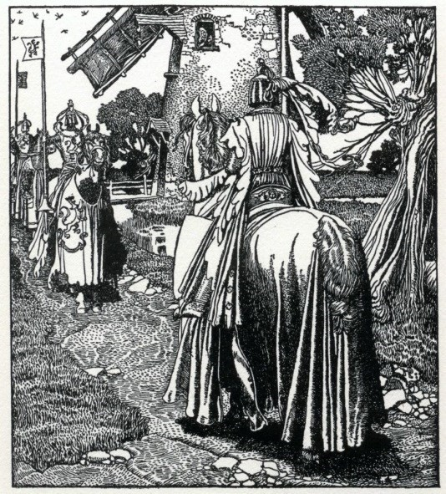As I indicated in my last post, when characters come across a castle in OD&D it is possible that a fighting-man will come out and challenge them to joust. This refers the reader back toChainmail, which has some pretty simple jousting rules (a combination of rider position and aiming point determines what happens). I find this interesting in one minor sense: it implies that Chainmail is more important than some interpreters of the original rules have made it.

Talysman on the OD&D board [pointed out](http://odd74.proboards.com/index.cgi?action=display&board=adventures&thread=8780&page=1#118247) that this brings a bit of Arthuriana to the setting. There are random knights and damsels scattered liberally throughout the OD&D world, and it's possible for a hexcrawl to look like something out of Le Morte d'Arthur, where PCs are challenged by random knights; one would hope to expand this to include being insulted by dwarves, and variously petitioned by maidens and noble ladies alike.

What's fascinating to me are the "guards / retainers" in the castle. In addition to Swashbucklers, Myrmidons, and Champions (that is, fighting-men of 5th, 6th and 7th level), a Lord or Superhero in a castle can be served by griffins (spelled "griffon"), giants, rocs or ogres. Griffins and rocs are ridden by Heroes (4th level fighting-men). This makes a

lot of sense given the setting: random encounter tables often bring out "flyers" which include everything from chimerae to dragons to balrogs.

But when you consider that A, fighting-men challenge PCs to random combat, and B, some of these fighting-men have a stable of rocs or griffins, and C, The Underworld and Wilderness Adventures dedicates three whole pages to aerial combat, this should be going somewhere a bit more fantastic than the little jousting table in Chainmail. Specifically, PCs should occasionally be challenged to an aerial joust by these fighting-men.

It also implies that there are some aerial defenses. There is a specific reference to "sling-ended catapults" - which I'd think implies a trebuchet - uses a load of small stones in a birdshot-style fashion, creating a spherical hit area. For castles without flying defenders, this is probably the main form of immediate defense from marauding dragons, balrogs, and so on. It's also stated that bombing is part of aerial warfare; basically this is equated to the largest stones that can be thrown from a catapult. Bombardier rocs, then, would be able to drop boulders on troops or fortifications in an attempt to crush them; this can deflect left or right, short or long, or both.

Little wonder that this is such a hardscrabble world! You don't just have to worry about overflights from pteranodons and balrogs and dragons, but sieges get into bombardment from above. It's interesting that this is well and thought of in OD&D's castle defenders, since it's a frequent complaint that castles would be useless against wizards and dragons; but if the castle's defenders are dropping boulders on wizards and using trebuchets to knock the dragons out of the sky, things start to make a lot more sense.

It also makes the Charm Monster spell a lot more essential - the next time you run into a roc, you should try and make it your party fighter's mount instead of killing it. That is the way it's done in the OD&D world.

# The Wizard's Tower

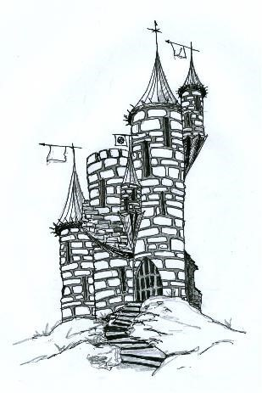In the listings for castle inhabitants, there are two types of magic-users: wizard (11th level) and necromancer (10th level). A wizard will be attended by dragons, balrogs, wyverns or basilisks; a necromancer by chimaerae, manticores, lycanthropes or gargoyles. Unlike the griffins and rocs of the fighting-men, the magic-users' retainers never have heroic mounts. In their castles, the magic-users will use Geas to send the player characters on some quest after treasure, claiming half and preferring the magic items. This is an obvious and easy way to send player characters on a perilous quest of the referee's choosing, and to make sure that the treasure thus gained does not enrich the PCs too heavily. The alternative of giving up a magic item as a toll is a good way to strip out any excess items from the party. All told, a very convenient and simple encounter type. So let's see what lies under the surface for our setting.

It's hardly a coincidence that the wizards who live in these castles are all able to cast 5th level spells. A necromancer has access to Animate Dead, so they can be true

"necromancers" in the classic sense. A 10th level magic-user casting the spell gets 2d6 skeletons or zombies at a time; one can imagine that a necromancer's tower would commonly be stocked with zombie servants who need no food and fight without reservation.

The fifth-level of magic-user spells in OD&D is practically built for mass combat. This is the level of Cloudkill and Wall of Stone, of Transmute Rock to Mud and Pass-

Wall and Conjure Elemental. It's also the level where Feeblemind comes in, the ultimate defense against magic-users attacking in such a situation. Someone laying siege to a wizard's tower could well find themselves facing a zombie army backed up by dragons or balrogs, and elementals to boot, not to mention a magic-user with three or four fireballs to throw.

There are all kinds of mini-settings here. Consider a wizard with basilisks; the basilisk-handler is reliant on his master's access to the Stone to Flesh spell, and it may be best to recruit a blind man for the task. The wizard's tower will be surrounded by a statue garden the likes of which would suggest a medusa rather than a spellcaster lives in the tower. A necromancer who keeps gargoyles may have them blend in as if they were architectural elements, and they will prove formidable foes indeed since only magical attacks effect them. The tower will seem almost defenseless until it springs to life. If it has lycanthropes, the mild-mannered residents will appear to have nothing unusual about them, until they show their nature - perhaps a Lawful magic-user will be served by ferocious werebears. Some spells also imply interesting settings; consider the wizard who casts Hallucinatory Terrain on the lands around his tower.

A proper magic-user's tower will also have a rich library; in pre-printing times that could number in the low dozens of books, including both spellbooks and tomes of magical knowledge. They're also like to have magic items, preferring the miscellaneous ones; so a wizard in his tower may well have a Crystal Ball or Medallion of ESP and be able to see his foes coming well in advance. Rare items that could be of tremendous use in defense include the Drums of Panic, scattering an invading army at a stroke.

So a wizard's tower should be a rich environment for the PCs to come upon. And after the wizard dies, there's always the possibility of what dungeons lie beneath it.

# Clerical Strongholds

There are two types of clerical strongholds: those of Patriarchs and those of Evil High Priests, their Chaotic equivalents. Clerics are served by fighters of 4th level (hero) or 8th level (superhero), ents or hippogriffs. As with griffins and rocs, the hippogriffs are ridden by heroes. EHPs have trolls, vampires, white apes or spectres as their retainers. Generally clerics only request a tithe rather than a quest, although if the tithe is refused one will be commanded.

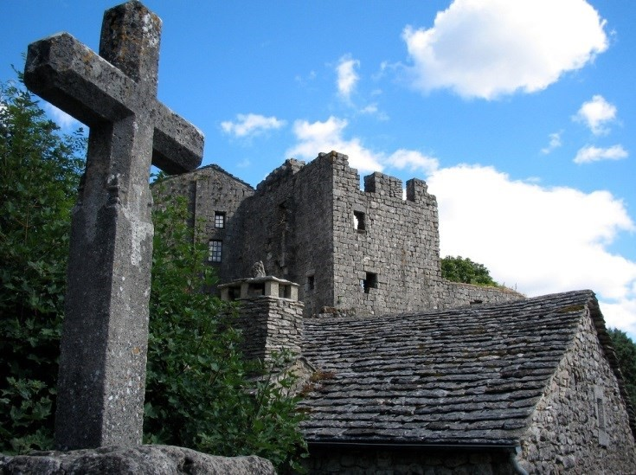One important thing to remember is that nazgûl in OD&D are assumed to be spectres (as opposed to Chainmail which treated them as wraiths). Such riders are fearsome encounters near an EHP's castle, as are leveldraining vampires. The ent, conversely, is a great subtle defender of a cleric's castle; an enemy force might ride up to the walls only to find that the trees they rode past are alive and will defend them.

The cleric in a siege is a fearsome opponent. If his castle is in a wooded area, Turn Sticks to Snakes is potentially quite deadly, as is a creative use of Speak with Plants, and Insect Plague will almost certainly turn away the footmen needed to capture the stronghold. If he has 7th level assistants casting Create Food and Create Water, or does it himself, there is no question of starving out a small but stalwart group of the faithful.

The impact of high-level clerics in the game world obviously stems from the Raise Dead spell. The character can only be dead a few days, at which point Constitution comes into play (low Con characters may not survive). Every cleric high enough in level to cast Raise Dead is also high enough in level to have their own castle. Since there are eighteen castles on the Outdoor Survival map and one-sixth of the castle inhabitants are (presumably Lawful) Patriarchs, that means there are three nonplayer clerics in this realm who can Raise a PC, unless more are in cities without a castle of their own - nothing is detailed about this, but even so one per city would give a maximum of 12 Patriarchs, none guaranteed to be within 4 days' ride of the characters.

Of course this can create an interesting opportunity. If a Patriarch is not available, perhaps an Evil High Priest could cast Raise Dead - though this would be at some terrible price. EHPs are not immediately belligerent per the rules, and could negotiate with PCs.

One reason I like the idea of clerical strongholds so much is that it reinforces the idea that a cleric is not another term for a priest. Clerics are much closer to the knight templar type, abjuring in OD&D only edged magical weapons, and leading cavalry and crossbowmen. The OD&D cleric is a templar and a vampire hunter, and I think it's interesting if their training involves the initiation into secret mysteries, only slowly being taught the true powers - after all, the cleric can't cast a single spell at first level, and must prove himself to the order in order to gain even that.

Given the castle density I would suppose that the Lawful clerics are tied to a single order rather than spread across multiple deities, while the Evil High Priests who should occupy three of the castles are each individual forces, as befits servants of Chaos. This could have interesting consequences when a PC cleric goes to build his own stronghold.

# The Woods of Myth

The woodlands of the OD&D world are thick and plentiful, second only to grasslands in terms of number of hexes. Over half of the castles are actually in wooded locations, and although they only contain one town, three others sit on the border of forests. Woods surround both swamps. They are presumably the reason for the low population density of the OD&D setting, since so much of the arable land is forested. As we will see, there may be good reason that more has not been cleared for farmland.

In the encounter tables, the most common (1 in 4 chance) are lycanthropes. Werewolves, wereboars, weretigers and werebears stalk the woods in uncommonly high numbers, and by alignment, only the werebears can be Lawful. These are mostly small family packs, and lycanthrope attacks create fresh lycanthropes. Foresters and rangers in this world must prize silver weapons, and no logging expedition would dare go out unless it was guarded by men with silver. This is a double danger since lycanthropes can be either human or animal in form, and what appears to be an encounter with bandits may suddenly turn much more dangerous.

Your "typical" humans wander the land - bandits, brigands, berserkers, and high level classed characters. These are presumably travelling parties from the leaders and defenders of the nearby castles. Bandits and brigands amass in relatively large forces, 30-300, and presumably prey upon various merchant caravans. Given the demographics, there are an extremely high number of such if you roll 30-300 men-types as per Monsters & Treasure, and each major forested area should have perhaps 2-3 groups, either bandits or brigands (like bandits but Chaotic). The brigands are presumably deserters from military service while the bandits are general outlaws from civilized society.

The real depth of the forest comes in the "Optional Woods" table of encounters which includes centaurs, unicorns, minotaurs, gorgons, pixies, manticores, dryads and medusae. Centaurs are explicitly stated to live in hidden glens and be at least semi-intelligent. In ancient Greek myth the centaurs represented barbarism and civilization was triumphant over them; in OD&D, some centaurs are actually Lawful in alignment, and fit more of a role as ancient defenders of the wood. Unicorns are always lawful and follow medieval myth in only being approached by maidens. These are powerful creatures, and a typical encounter might be with a powerful maiden-warrior who has taken a unicorn for her mount.

Minotaurs are an interesting choice, since traditionally they are so closely associated with Daedalus's labyrinth. These are obviously the awful half-man, half-bull hybrids, and they are described as man-eaters who always attack. Gorgons are, as I discussed [back in March,](http://initiativeone.blogspot.com/2013/03/turning-to-stone.html) based on an article that showed a monster like the [khalkotauros](http://en.wikipedia.org/wiki/Khalkotauroi) that had a poison breath. Manticores are straight-up horrors to cross, and I've already talked about medusae and pixies.

Dryads are interesting because they're one of the encounters that is totally non-violent but can potentially remove a character from the game; they will use Charm Person when approached, with -2 (stated as 10%) to the saving throw, on 90% of the people who approach them. It's a powerful encounter but its character-removing nature is entirely optional, since an intelligent character shouldn't go up to a dryad. It's also worth mentioning that elves don't have any of their usual immunities in OD&D and would be impacted by this just like any other character.

The woods in OD&D are a truly mythical place, full of wonderful and horrible things. Humans build castles here to huddle behind the walls - and flying defenders - when they're overflown by manticores or attacked by brigands. They hire guards armed with silver or magic against raiding wereboars and weretigers. The forest is like to be peopled by the occasional emdusa and gorgon statues; their lairs take on the "statue garden" aspect. But it is possible to ally with the occasional centaur tribe, or hope for help from a unicorn-mounted maiden. It's a place where heroes can be made, or disappear never to be seen again.

# Time-Forgotten Swamps

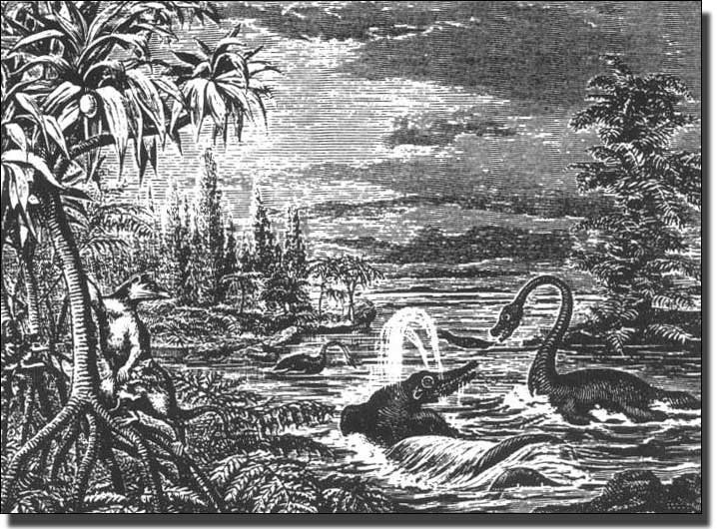The swamplands in OD&D are hardly as prolific as the forests that surround them; on the map there are only two swamps of any size. Both are large and fed by rivers, so we can say that they are freshwater wetlands; both are bordered by forests and should be considered as proper forested swamps and not reedy marshes, which likely exist in the river hexes. The southwest swamp is dominated by a castle, while the northeast swamp only has the fork of the major rivers in the area.

Every move there is a 50% chance of becoming lost and moving in a random direction, making travel particularly treacherous. Visibility is poor and there are few permanent landmarks; only the rivers can realistically be used to navigate them safely. As we'll see, I think this makes the deep swamps a particularly tricky environment.

Swamp encounters have a 25% chance of undead, and as such it's likely that the castle in the southwest swamp is that of a Necromancer or an Evil High Priest. It should go without saying that if you see a body in the swamp, it may not be at rest, and a zombie or ghoul that doesn't have to breathe could wait for weeks to find prey by hiding in the shallow waters of a swamp pool. Mummies and vampires are a bit more out of place, but a burial ground in the swamp might have some above-ground tombs reminiscent of the ones in New Orleans that could house these types.

The encounter tables also list the horrible "swimmer types," which include giant crabs, octopi, squid, snakes, leeches and fish, as well as crocodiles, mermen, nixies, sea monsters and dragon turtles. Logistically these would have to come at points where the rivers intersect with the swamps and make deeper than usual waters for habitat. Crocodiles and giant snakes being par for the course as you are going through the wetlands. Nixies are particularly nasty - rather than being physically violent, they try to charm opponents and enslave them.

It's worth talking briefly about OD&D mermen here: they are described as similar to berserkers but fighting at -1 on land. Clearly these are not mermaid-style creatures, and this is further verified in Supplement II: Blackmoor, where mermen are described as riding giant seahorses. This is a very far cry from the fish-tailed mermen that Gygax codified in theMonster Manual, more Namor than anything. They should be fearsome raiders into swamp and river territories, though - presumably eventually going to their far-off ocean homes.

But the big shift in the swamps proper is what lurks in the "optional swamps" table for animal encounters. There is an oddity in the charts - such that there is a sub-head for swamp animals, but no listing within the swamp encounter chart for "animals" that would trigger it. Obviously these are encountered somewhere, and I would suggest that it's best to substitute "Animals" out for "Swimmer" where there is no river in the swamp hex, meaning that dinosaurs are only found in the deepest reaches of the swamplands.

The inhabitants of these deep swamps include tyrannosaurs, pterodactyls, triceratops, brontosaurs (not yet changed to apatosaurs) and stegosaurs. OD&D has no entry whatsoever for any of these monsters, but given their location it's not entirely off-base to think that they represent the view of dinosaurs as lumbering, slow, lizard-like reptiles. This hints at a Lost World type of area, where swamp dwellers are at risk of tyrannosaurus attack. The potential interactions are fascinating: humans riding dinosaurs, an encounter interrupted by a tyrannosaur, hunting a wild brontosaurus. There's also the possibility for an Arzach type of character, riding on a giant pterosaur (assuming that the listing didn't limit us to smaller proper pterodactyls). Or of an animated tyrannosaurus skeleton.

Swamps are also the home of the black dragons, which take on their familiar aspect of acid-breathers who are less stupid than white dragons but not as wily as the other types. These are much more comfortable in the swamp, like the dinosaurs, and their lairs are likely to be the most fetid corners.

For humans, the swamps are difficult and treacherous lands. Travel through them is slow and difficult, and they contain possibly the most threatening types of encounters. It is a true land that time forgot, a treacherous place where you are as likely to meet a zombie as a tyrannosaur. Venturing into them is not for the faint of heart, and one should have a cleric as well as a strategy to face the dinosaurs and river monsters.

# In the Savage Mountains

Mountains are one of the more plentiful terrain types in the Outdoor

Survival map that is the presumed setting of original D&D. There is a nice big range in the north and center, and both the northwest and southeast quadrants of the map have what appears to be several ridges. In Snorri's map which I used in the start of this series, there are several high mountains in white. These are probably old mountains, more like the Appalachians than the Rockies. There are six castles in the mountains (one third of the castles), and these must be hard fortresses that use their natural defenses to good effect. Most of the castles with flying defenders will be in the mountains, for logistical reasons.

The mountains run with giant types (which includes humanoids, ogres, trolls, giants, and demihumans), and dragons, each being 25% of the encounters located here. Giants proper will, naturally, live in the mountain ranges, probably with various and sundry followings; there will be hill and stone giants in the caves as well as frost giants in the frozen mountains, and possibly a cloud giant castle. Other goblinoid types are probably making forays from caves deep within the mountains. Elves are the out of place encounters here.

Dragons living in the mountain range will be primarily red, although the colder northern mountains may have a few white dragons as well. The dragon chart also includes cockatrices, basilisks, wyverns, balrogs, chimerae and hydras - all of which could well be native to the mountains. This is in addition to the flyer list that includes dragons and balrogs already. Combined with the giants, we need a pretty good cavern system to support these creatures; the mountains must nearly have an underground wilderness beneath them.

Under the "Men" listing we find cavemen, the only place where they appear in the encounter lists. Cavemen in OD&D are 2nd level fightingmen, wielding clubs the equivalent of morning stars but fighting at -1 to morale. Their primitive state is indicated in Neutral alignment. Given the media of the time, it's probable that these are meant as fur-wearing Neanderthals, with primitive communication and limited technology. These are hardscrabble cavemen, who compete with various magical beasts, monsters and paleolithic predators for their living space. It's no surprise that they are bigger and stronger, but canny enough to run when cornered. If you're facing a balrog there's no reason to stay and get killed.

The animal listing for Mountains is well suited to cavemen: there are cave bears, dire wolves, sabre-toothed cats (called tigers in the OD&D books), mastodons, spotted lions, woolly rhinos, titanotheres and mammoths. What's funny is that despite it being a very common trope at the time (for instance [One Million Years B.C.),](http://en.wikipedia.org/wiki/One_Million_Years_B.C.) these cavemen are mostly distant from the dinosaurs and don't interact with them. Mammoths and mastodons make fine prey species for humans as well as the many predators of the mountains.

As with swamps, mountains are slow going, but it's harder to become lost in the ranges, and if you look, other than the north-central range, a lost party will fairly shortly find themselves outside the mountainous area; it's not hard to get to lowland if you look. In the movement rates, we also see an interesting wrinkle: the dragons can cover 24 hexes per day flying, which would get them about 2/3 of the way across the map, so a dragon could hunt 12 hexes away from its nesting area and return in a day.

Mountains are savage terrain; human toeholds barely tame them. The hardy few who live in mountain castles are seen as the defenders of the lower realms. Of course, where there are dragons there is rich treasure, and many foolhardy adventurers go off into the mountains never to be seen again...

# The Desolate Deserts

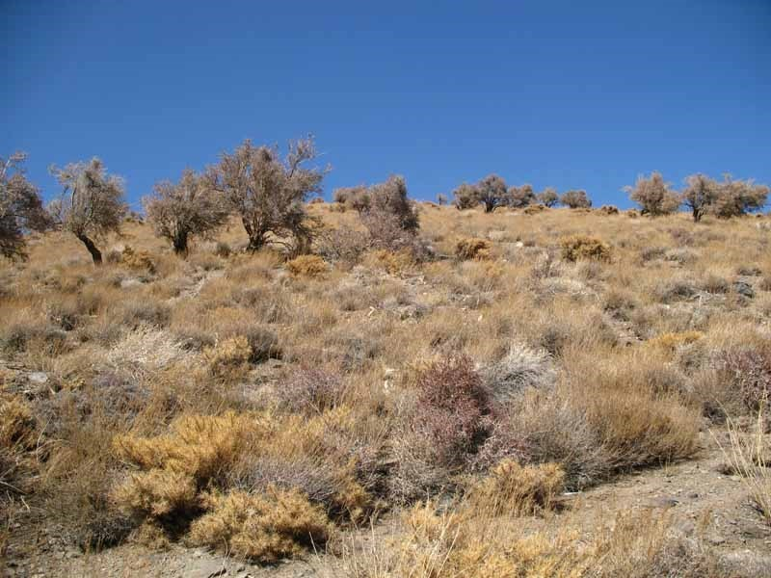In the Outdoor Survival map there are two deserts to speak of. One lies in the northwest corner, adjacent to some lines of mountains, and continues off the map to potentially more desert. The other lies in the area between two mountain ranges. Geographically, these are probably both relatively cold weather deserts, more similar to the Afghan desert pictured above than the dunes of Arabia or the sands of the Maghreb (North Africa) or the Sahara. The mountain patterns allow for the northwest desert to really be more of a steppe region, such as the Caucasus (between the Black and Caspian Seas). The southern desert is more likely caused by the rain shadow of the surrounding mountains, which absorb the wet air that blows toward it and makes the desert terribly dry.

OD&D makes its deserts particularly hard to navigate. Characters get lost in it on 1-3 in d6, and can easily find themselves wandering the desert, slowly seeking the way out as they run out of water supplies. It is not as slow going as the swamp and a party lost in a desert has a reasonable chance of finding themselves in the nearby mountains. There are no permanent settlements, either towns or castles, in either desert - indicating that they are not given to civilization at all.

The deserts are peopled, though, by nomads and dervishes. In the standard earthly desert, OD&D lists nomads as being half the encounters with humans, and the dervish type is similar enough. Random encounters will only run across a lord or a wizard, probably in transit. Nomads are the logical choice, and their mix of bowmen and mounted soldiers is generally accurate to classical and medieval dwellers who would have lived in the Caucasus or Central Asia. Dervishes are nomads who are amazing fighters, similar to berserkers, and religious fanatics. Not to mention that they've got terrific headgear. My feeling is that there are probably at most two or three groups of each, one to two for each desert.

Blue dragons are the native flyers here, and there is something particularly satisfying about having a lightning-based monster be at home in the sand and dirt of the desert. Either desert would make a fine hunting ground for red and white dragons (at home in nearby mountains) as well. A "giant" listing (including humanoids, giant-kin and demihumans) rounds things out, which leads to the very odd result that ents could well be encountered in the deserts.

At this point the referee needs to make some choices about the deserts. The "Arid Plains" listing contains a number of Barsoomian creatures -

Apts, Banths, Calots, Darseen, Orluks, Sith, Tharks, Thoats, and White Apes. Likewise the "Desert" listing under men contains Red, Black, Yellow and White Martians, as well as Tharks, listed in parentheses for "Mars." So a referee may interpret that Martian creatures and/or the races of Barsoom are also found in the deserts. The alternative, using the basic Animals chart, simply seems sadly dry and inappropriate, resulting in things like giant toads and wild boars.

If we assume that only the "Optional Arid Plains" listing applies, it uses Barsoom for some instant desert dwellers. Some feel appropriate, such as the reptilian Darseen (which may vary greatly in size and HD) or the insectoid Sith; Banths would be the terror of the desert lands. Several are polar creatures on Mars, such as the Apts, Orluks and the White Apes, but could live in the northern of the two deserts. Given the general aridity of Barsoom, perhaps some long-lost portal allowed the wildlife - and the fierce green Tharks - to migrate out into one or both of the deserts. They make it instantly an alien-dominated environment. Tharks also have the ability to communicate telepathically, which would have to be worked into the game, and it would have to be answered whether other humans have the immunity to mind-reading that John Carter possesses.

There is also some potential for cross-over here; the nomads, for instance, could have started to herd the Thoats they encountered instead of cattle, or in addition to them. Depending upon your interpretation of Orluks, they might be hunted for their fur. I think in general it may be best to limit Barsoomian creatures to a single desert, probably the northwest one where it tracks off further west and there is land for them to expand upon.

All of this gives us a desert far different from what we might have expected, i.e. a sort of Arabian style land of hot sands, shifting dunes, djinns and efreets, Berber-type nomads, etc. But it's a very rich desert to explore, and get lost in, and possibly discover something even stranger than you expected.

# Raging Rivers

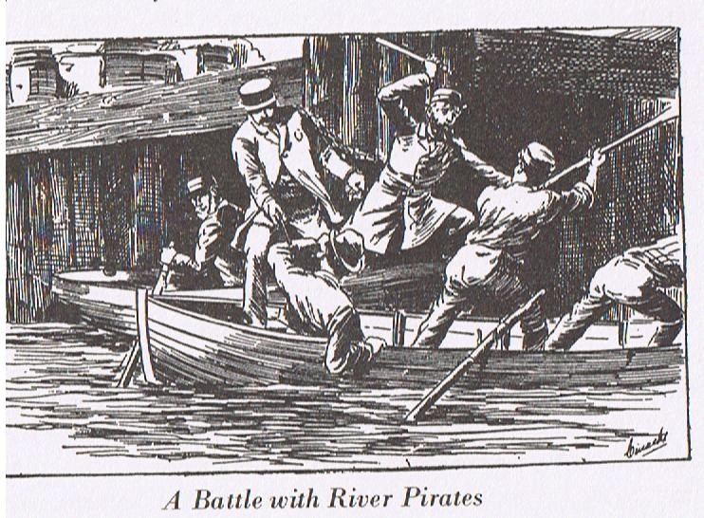The Outdoor Survival map is dominated by a river that forks at the north swamp and cuts down across the terrain. There is just a single city that actually sits on the west river; this should technically be the largest of the various towns, since it is the one that would logically have access to trading opportunities upriver. The east river is overlooked by a castle in the mountains, which form a neat valley around them, but has no towns. This valley is probably one of the richer areas under a castle's control, and pays corresponding good rents to its lord.

It is faster to travel by river than any other method in OD&D, and parties rarely get lost. However, getting out to the north requires spending a day going through the swampy terrain, even in a fast galley. Trade with the lands north requires most of a day to reach the swamp, a full day to clear it, and less than a day to get north of the map. From the castle to the southeast exit takes a bit more than a day in either boat or galley. It remains up to the referee if there are trading opportunities downstream to the southwest - the rivers appear to get narrower there.

River lands are almost entirely plains, except in the swamps and the west river which touches on forest hexes at a few points. Since the river is likely less than a half-mile across, most of the hex should follow the "normal" wilderness rules, only switching over to the "river" charts when actually at the river. This should follow Waterborne for actual on-river encounters with men, and the local area for animals.

The "Waterbourne" (sic) chart lists Buccaneers three times, Pirates (like Buccaneers but always Chaotic) twice and Mermen once. As I mentioned back under swamps, Mermen seem to be bipedal humans who live underwater. Buccaneers are Bandits but on boats, and are either footmen or crossbowmen. Pirates are Buccaneers but they're Chaotic. River pirates prowl these waters, probably hoping to harass merchant galleys travelling north. There may be a toll at the castle on the east river if it is clear of piracy.

All such piracy is likely to be of the grapple-and-board method, with small boats being used by the pirates or buccaneers to come up alongside and the crossbowmen giving fire support to the lightly armed and armored men fighting their way aboard the target ship. Large vessels may use catapults to attempt to smash through pirate boats, but largely we're talking about the need for armed guards on each ship.

Swimmers are a freakish lot, and most of the listed swimmer encounters (25% of river encounters) will be horrors you would expect in the oceans: giant squid, giant octopi, giant crabs, sea monsters and dragon turtles. The giant leeches are frightful swamp types, as are giant snakes and crocodiles, and all are well out of their normal habitats. One thing this tells us is that the river is deep to be able to accommodate these creatures; there may be points where it is 200-300 feet deep, and correspondingly quite wide at that point.

One curiosity is that giant squids are quite real in our world, and have a bit of a following on the Internet, but their flesh is high in ammonia content and totally inedible. However, the people in that one town along the west river may find that giant crab claws make a delicious hearty meal for a whole family. This also allows the referee to handle these as animals rather than pure monsters, and a giant squid is not necessarily out to re-enact every movie scene we've ever seen with a kraken.

River travel is the safest thing in OD&D simply because of its speed. A boat full of buccaneers or pirates is much easier than what you'll find on a swamp, and this world's ships must go with armed guards. But when you do hit a monster, it's likely to be a fierce one.

# Grasslands & Cities

Clear grasslands and cities are the least unique of the terrain types in OD&D. Most of the cities and towns sit in grassland hexes, and grasslands are the most numerous single type of hex. They provide the default background against which the other hex types stand out.

The list of "basic animal" encounters gives us a listing of animal types including spiders, scorpions, lions, boars, weasels, toads, apes, ants, centipedes, snakes and beetles. A note tells us that animals will "usually be of the giant variety," which means we have a world populated by giant scorpions and giant toads. Lions, boars and apes don't need to be giant as badly as the ants and spiders do in order to be threatening encounters.

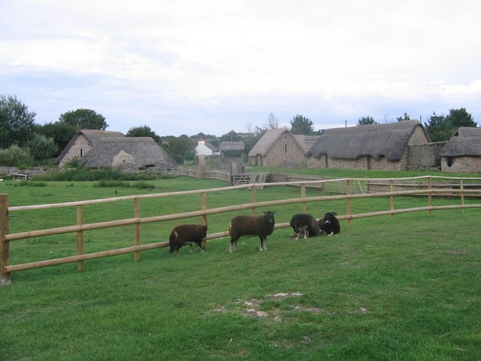It is somewhat strange to have the toads and centipedes and snakes and apes all in the clear grassland; of course they're all available in other types of terrain as well, but this table is the only one that makes up "clear" land encounters. Judging from the terrain, the animals may be better picked as wanderers from nearby areas: apes from the jungle, giant frogs from the swamps, giant scorpions out of the deserts and so on. Except in the northwest and southeast corners, almost every grassland hex is less than 3 hexes (1 day of travel) from a forest, swamp or mountain hex, so this is always workable. Perhaps giant ants (with suitable underground caverns) and some types of snake are "native" to the grasslands but little else.

The map gives us no indication of roads through the grasslands. If there are paths between the towns indicated, they must pass through forests or over mountains except for two towns in the center area. One of those towns is the only town on a river, which is a natural fit for the main commercial city of this region. Looking at the layout again, the five towns in the center of the map are relatively well protected by castles on different sides, and it is possible that the four closest ones form the only kingdom in the territory. Alternatively, the city in the woods could be an elven city and the others are the human cities that trade with it. Each town outside of the core five is somewhat peripheral to the map and may be more of an outpost or a frontier town.

These are towns that are separated by enough difficult miles that except for the four core towns, trade is probably difficult and extremely limited. This explains, FWIW, why trade goods in D&D are so damnably expensive: each town is basically running a frontier style economy, far from major centers of commerce, and even getting a shipment of goods through these lands requires an armed escort. As I said in the post that opened this series, these will of necessity be small towns, probably walled, with small out-populations supporting them.

Encounters in towns and cities are limited to two types: Men (fighters, clerics, wizards, brigands and bandits) and Undead (the whole classic list). They are literally half and half, so each town must have some fairly active necropolis attached to it, and the population must bar themselves indoors at night. Banditry and brigandage in the towns, and undead, are obviously combated to some extent by the humans who are also wandering with their retinues. These encounters are rarer than other locales, so it must be that these are simply the exceptional ones. But there has to be some role for the undead - as I discussed under wizard's castles and towers, it may be that high-level wizards routinely create non hostile undead to do their bidding. Brigands and bandits, meanwhile, easily become various toughs and hoodlums, lawless types in the city.

So this is the setting of original D&D: a frontier land, perhaps with a single state in its center, with wilderness populated by creatures of myth, legend and giant creature films. It is a world of Arthurian castles, knights templar, necromancers, dinosaurs and cavemen. It is wild, and it feels profoundly like the world someone who watched every cheesy science fiction movie about giant monsters and every classic horror film would make. This is bolted onto a world with openly Tolkienesque elements - elves, goblins, orcs, balrogs, ents, hobbits - and other entries that quickly became generic fantasy because they were in the D&D books. The result is far more gonzo and funhouse than people give D&D credit for, and I think it winds up being a good mix.